**[constr_1555]**{DRAFT} **Restriction applicable for PersistencyPortPrototypeToKeyValueStorageMapping.portPrototype**dThe reference PersistencyPortPrototypeToKeyValueStorageMapping.portPrototype shall only be used for a PortPrototype typed by a PersistencyKeyValueStorageInter-

face.c*()*

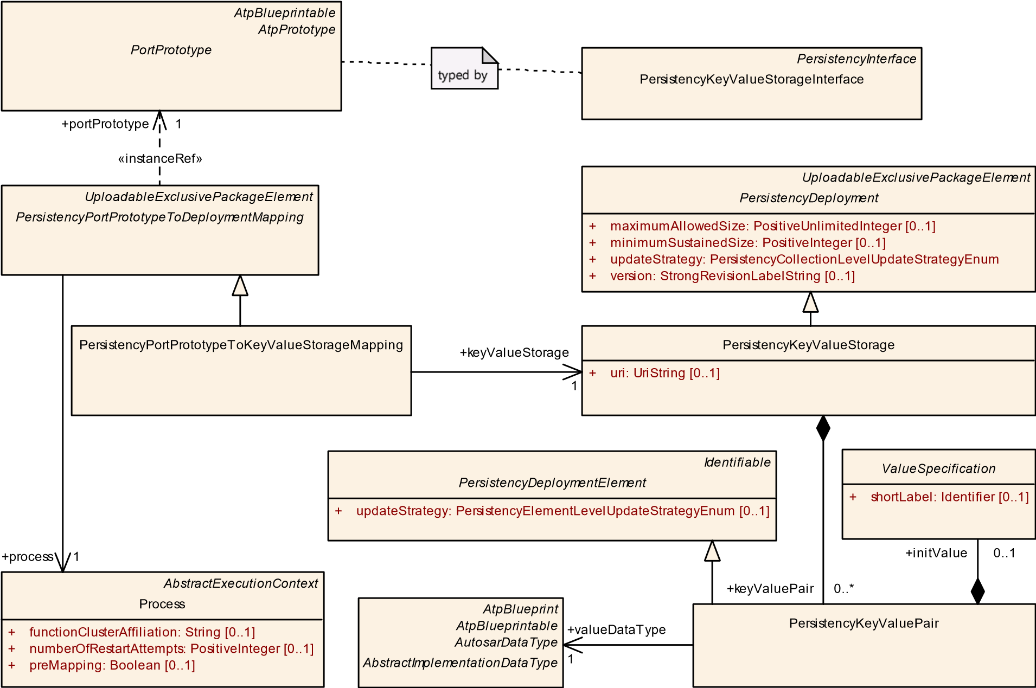

**Figure 9.5: Connect a specific PortPrototype to a PersistencyKeyValueStorage**

|  |  |  |  |  |
| --- | --- | --- | --- | --- |
| ***Class*** | **PersistencyPortPrototypeToKeyValueStorageMapping** | | | |
| ***Package*** | M2::AUTOSARTemplates::AdaptivePlatform::PlatformModuleDeployment::Persistency | | | |
| ***Note*** | This meta-class represents the ability to define a mapping between a PortPrototype and a key-value storage.  **Tags:**  atp.Status=draft  atp.recommendedPackage=PersistencyPortPrototypeToKeyValueStorageMappings | | | |
| ***Base*** | *ARElement*, *ARObject*, *CollectableElement*, *Identifiable*, *MultilanguageReferrable*, *Packageable*  *Element*, *PersistencyPortPrototypeToDeploymentMapping*, *Referrable*, *UploadableExclusivePackage Element*, *UploadablePackageElement* | | | |
| ***Attribute*** | ***Type*** | ***Mult.*** | ***Kind*** | ***Note*** |
| keyValue Storage | PersistencyKeyValue  Storage | 1 | ref | This reference represents the mapped key-value storage.  **Tags:**atp.Status=draft |

**Table 9.13: PersistencyPortPrototypeToKeyValueStorageMapping**

Please note that typically the existence of PersistencyKeyValueStorage.keyValuePair depends on the existence of PersistencyKeyValueStorageInterface.dataElement.

On the other hand, if a PersistencyKeyValueStorage contains PersistencyKeyValuePairs that do not correspond to any dataElements of the PersistencyKeyValueStorageInterface that is mapped (indirectly) via PersistencyPortPrototypeToKeyValueStorageMapping then those keyValuePairs are created within the PersistencyKeyValueStorage.

**[TPS_MANI_01146]**{DRAFT} **Initial value for PersistencyKeyValuePair** dIt is possible to define an initial value for a given PersistencyKeyValuePair by means of the aggregation of ValueSpecification in the role initValue.c*(RS_MANI_00027)*

**[constr_1554]**{DRAFT} **Restriction regarding PersistencyKeyValuePair. initValue** dThe concrete sub-class of ValueSpecification aggregated in the role PersistencyKeyValuePair.initValue shall not (after resolving a possible redirection by means of ConstantReference) be one of the following:

* ApplicationValueSpecification
* ApplicationRuleBasedValueSpecification
* ReferenceValueSpecification c*()*

**[TPS_MANI_01315]**{DRAFT}**PersistencyKeyValuePair.initValue overrides PersistencyDataRequiredComSpec.initValue** dThe value of attribute PersistencyKeyValuePair.initValue shall overrule the value of PersistencyDataRequiredComSpec.initValue for any combination of PersistencyKeyValueStorageInterface mapped to a PersistencyKeyValueStorage by means of a PersistencyPortPrototypeToKeyValueStorageMapping.c*(RS_MANI_00027)*

This means that the integrator of the software gets the authority to either agree to the designer’s point of view or else overrule the designer’s decision based on superior knowledge regarding the integration strategy.

**[constr_1582]**{DRAFT} **PersistencyKeyValuePair.valueDataType shall match to AbstractImplementationDataType for the corresponding PersistencyDataElement** dEach PersistencyKeyValuePair.valueDataType shall match the AbstractImplementationDataType that either directly or indirectly (via the applicable DataTypeMap) types the corresponding (based on identical values of the respective shortName) PersistencyDataElement.c*()*

**[constr_1666]**{DRAFT} **References from PersistencyPortPrototypeToKeyValueStorageMapping to PersistencyKeyValueStorage** dEach PersistencyKeyValueStorage shall only be referenced by at most one PersistencyPortPrototypeToKeyValueStorageMapping.c*()*

**[TPS_MANI_01323]**{DRAFT} **Matching pairs of PersistencyDataElement and**

**PersistencyKeyValuePair**dMatching pairs of PersistencyDataElement and PersistencyKeyValuePair shall be identified by having the identical value of attribute shortName within the scope of a PersistencyKeyValueStorageInterface (or a PortPrototype typed by the PersistencyKeyValueStorageInterface) mapped to a PersistencyKeyValueStorage by means of a PersistencyPortPrototypeToKeyValueStorageMapping.c*(RS_MANI_00027)*

**9.2.3 Deployment of File Storage**

**[TPS_MANI_01150]**{DRAFT} **Semantics of PersistencyFileStorage**dA PortPrototype typed by a PersistencyFileStorageInterface actually builds an abstraction for an entire directory of files.

This abstraction is also visible in the deployment by means of the existence of the companion meta-class PersistencyFileStorage.

This approach allows for the dynamic creation and/or deletion of files during runtime while still keeping the structural model of the file interaction static.c*(RS_MANI_00027)*

|  |  |  |  |  |
| --- | --- | --- | --- | --- |
| ***Class*** | **PersistencyFileStorage** | | | |
| ***Package*** | M2::AUTOSARTemplates::AdaptivePlatform::PlatformModuleDeployment::Persistency | | | |
| ***Note*** | This meta-class comes with the ability to define a collection of single files (directory) that creates the deployment-side counterpart to a PortPrototype typed by a PersistencyFileStorageInterface.  **Tags:**  atp.Status=draft  atp.recommendedPackage=PersistencyFileStorages | | | |
| ***Base*** | *ARElement*, *ARObject*, *CollectableElement*, *Identifiable*, *MultilanguageReferrable*, *PackageableElement*,  *PersistencyDeployment*, *Referrable*, *UploadableExclusivePackageElement*, *UploadablePackageElement* | | | |
| ***Attribute*** | ***Type*** | ***Mult.*** | ***Kind*** | ***Note*** |
| file | PersistencyFile | * | aggr | This aggregation represents the collection of files aggregated by the PersistencyFileStorage.  **Tags:**atp.Status=draft |
| uri | UriString | 1 | attr | This attribute holds the storage location for the PersistencyFileStorage, e.g. a directory on the file system.  **Tags:**atp.Status=draft |

**Table 9.14: PersistencyFileStorage**

At one point, however, it is necessary to boil down the relation of such a PortPrototype typed by a PersistencyFileStorageInterface to individual files and how these individual files are represented on the file system themselves.

This aspect is covered by the modeling of meta-class PersistencyPortPrototypeToFileStorageMapping, as depicted in Figure 9.6.

**[TPS_MANI_01080]**{DRAFT} **Semantics of meta-class PersistencyPortPrototypeToFileStorageMapping** dMeta-class PersistencyPortPrototypeToFileStorageMapping creates a mapping between a PortPrototype referenced in the role portPrototype to a PersistencyFileStorage referenced in the role fileStorage under consideration of a Process referenced in the role process.c*(RS_MANI_00027)*

|  |  |  |  |  |
| --- | --- | --- | --- | --- |
| ***Class*** | **PersistencyPortPrototypeToFileStorageMapping** | | | |
| ***Package*** | M2::AUTOSARTemplates::AdaptivePlatform::PlatformModuleDeployment::Persistency | | | |
| ***Note*** | This meta-class represents the ability to define a mapping between a collection of files on deployment level to a given PortPrototype.  **Tags:**  atp.Status=draft  atp.recommendedPackage=PersistencyPortPrototypeToFileStorageMappings | | | |
| ***Base*** | *ARElement*, *ARObject*, *CollectableElement*, *Identifiable*, *MultilanguageReferrable*, *Packageable*  *Element*, *PersistencyPortPrototypeToDeploymentMapping*, *Referrable*, *UploadableExclusivePackage Element*, *UploadablePackageElement* | | | |
| ***Attribute*** | ***Type*** | ***Mult.*** | ***Kind*** | ***Note*** |
| fileStorage | PersistencyFileStorage | 1 | ref | This reference represents the mapped file storage.  **Tags:**atp.Status=draft |

**Table 9.15: PersistencyPortPrototypeToFileStorageMapping**

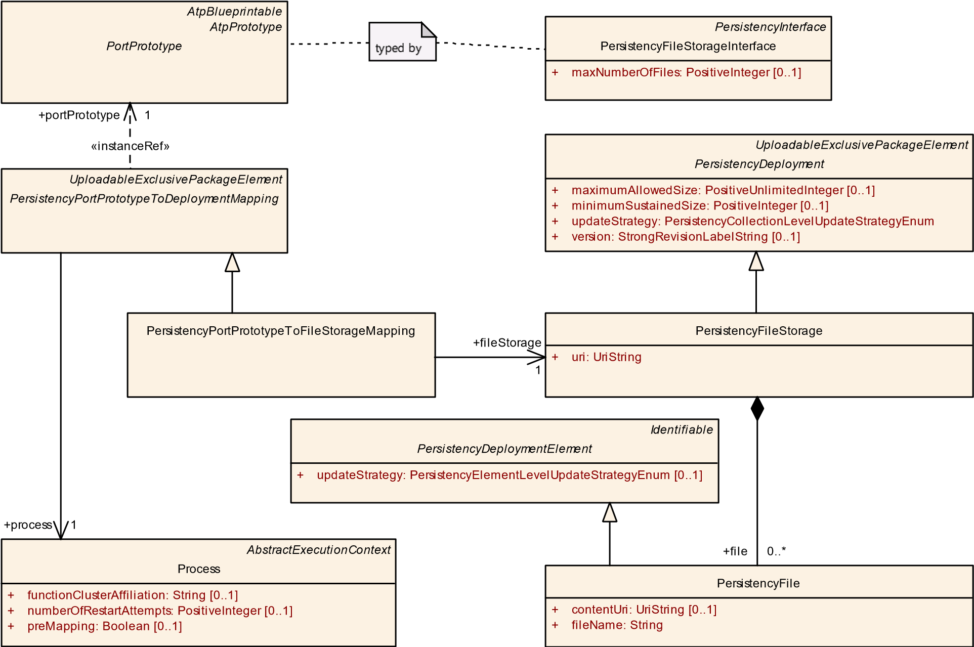

**Figure 9.6: Connect a specific PortPrototype to a PersistencyFile**

**[TPS_MANI_01149]**{DRAFT} **Semantics of PersistencyFileStorage.file** dThe usage of PersistencyFileStorage.file allows for the explicit modeling of elements of the PersistencyFileStorage.

The creation of this aggregation is optional. It can be used to define the update strategy and/or initial content of selected files.c*(RS_MANI_00027)*

**[constr_1556]**{DRAFT} **Restriction applicable for PersistencyPortPrototypeToFileStorageMapping.portPrototype** dThe reference PersistencyPortPrototypeToFileStorageMapping.portPrototype shall only be used for a PortPrototype typed by a PersistencyFileStorageInterface.c*()*

|  |  |  |  |  |
| --- | --- | --- | --- | --- |
| ***Class*** | **PersistencyFile** | | | |
| ***Package*** | M2::AUTOSARTemplates::AdaptivePlatform::PlatformModuleDeployment::Persistency | | | |
| ***Note*** | This meta-class represents the model of a file as part of the persistency on deployment level.  **Tags:**  atp.Status=draft  atp.recommendedPackage=PersistencyFiles | | | |
| ***Base*** | *ARObject*, *Identifiable*, *MultilanguageReferrable*, *PersistencyDeploymentElement*, *Referrable* | | | |
| ***Attribute*** | ***Type*** | ***Mult.*** | ***Kind*** | ***Note*** |
| contentUri | UriString | 0..1 | attr | This attribute represents the URI that identifies the initial content of the PersistencyFile.  **Tags:**atp.Status=draft |
| fileName | String | 1 | attr | This attribute holds filename part of the storage location for the PersistencyFile, e.g. file on the file system.  **Tags:**atp.Status=draft |

**Table 9.16: PersistencyFile**

**[constr_10082]**{DRAFT} **Existence of initial values for PersistencyFile** dFor each PersistencyFile, if the value of attribute updateStrategy is set to the value delete, then attribute PersistencyFile.contentUri shall not exist.c*()*

**[TPS_MANI_01179]**{DRAFT} **Semantics of PersistencyFileElement.contentUri/PersistencyFile.contentUri vs. PersistencyFileStorage.uri and PersistencyFileElement.fileName/PersistencyFile.fileName** dAttributes

PersistencyFileElement.contentUri and (after deployment) PersistencyFile.contentUri describe the URI of the file storage that is used to initialize the PersistencyFile (used during install or update).

On the other hand, the combination of PersistencyFileStorage.uri and the PersistencyFileElement.fileName or (after deployment) PersistencyFile. fileName denote the position of the PersistencyFile in the ECU (used at runtime).c*(RS_MANI_00027)*

**[constr_1589]**{DRAFT} **Value of file.fileName** dWithin the scope of any given PersistencyFileStorage, the value of all file.fileName shall be unique.

A fileName is considered unique if there are no other fileNames with **exactly** the same sequence of characters[1].c*()*

**[TPS_MANI_01187]**{DRAFT} **Matching pairs of PersistencyFileElement and**

**PersistencyFile** dMatching pairs of PersistencyFileElement and PersistencyFile shall be identified by having the identical value of attribute shortName within the scope of a PersistencyFileStorageInterface (or a PortPrototype typed by the PersistencyFileStorageInterface) mapped to a Persistency-

FileStorage by means of a PersistencyPortPrototypeToFileStorageMapping.c*(RS_MANI_00027)*

**[constr_1613]**{DRAFT} **File name of matching pairs of PersistencyFileElement and PersistencyFile**dThe value of attributes PersistencyFileElement. fileName and PersistencyFile.fileName shall be identical for matching pairs (as identified by the application of [TPS_MANI_01187]) of PersistencyFileStorage and PersistencyFile.c*()*

**[constr_1667]**{DRAFT} **References from PersistencyPortPrototypeToFileStorageMapping to PersistencyFileStorage** dEach PersistencyFileStorage shall only be referenced by at most one PersistencyPortPrototypeToFileStorageMapping.c*()*

## 9.3 Platform Health Management Deployment

**9.3.1 Overview**

This chapter explains the interaction of application software with the Platform Health Management [12].

*UploadablePackageElement*

PlatformHealthManagementContribution

*Identifiable*

SupervisionModeCondition

*Identifiable*

*HealthChannel*

*ARElement*

PhmContributionToMachineMapping

*ARElement*

*AtpStructureElement*

Machine

*Identifiable*

GlobalSupervision

*Identifiable*

SupervisionCheckpoint

+

checkpointId: PositiveInteger

[0..1]

+

machine

0..1

«atpSplitable»

+

supervisionModeCondition

0..*

+

phmContribution

0..*

«atpSplitable»

+

healthChannel

0..*

«atpSplitable»

+

checkpoint

0..*

«atpSplitable»

+

globalSupervision

0..*

**Figure 9.7: Modeling of PlatformHealthManagementContribution**

The PlatformHealthManagementContribution allows describing aspects for the deployment of configuration how the Platform Health Management shall behave during runtime.

**[TPS_MANI_03544]**{DRAFT} **Definition of PlatformHealthManagementContribution**dThe meta-class PlatformHealthManagementContribution allows to define a set of configuration entities for the Platform Health Management.c*(RS_MANI_00023, RS_MANI_00032)*

The PlatformHealthManagementContribution is structured into several aspects which will be described in the following sections:

* Supervision (section 9.3.3)
* Health channels (section 9.3.4)
* Recovery Notification (section 9.3.5)

|  |  |  |  |  |
| --- | --- | --- | --- | --- |
| ***Class*** | **PlatformHealthManagementContribution** | | | |
| ***Package*** | M2::AUTOSARTemplates::AdaptivePlatform::PlatformModuleDeployment::PlatformHealthManagement | | | |
| ***Note*** | This element defines a contribution to the Platform Health Management.  **Tags:**  atp.Status=draft  atp.recommendedPackage=PlatformHealthManagementContributions | | | |
| ***Base*** | *ARElement*, *ARObject*, *CollectableElement*, *Identifiable*, *MultilanguageReferrable*, *Packageable*  *Element*, *Referrable*, *UploadablePackageElement* | | | |
| ***Attribute*** | ***Type*** | ***Mult.*** | ***Kind*** | ***Note*** |
| checkpoint | SupervisionCheckpoint | * | aggr | Collection of checkpoints in the context of a Platform HealthManagementContribution.  **Stereotypes:** atpSplitable **Tags:**  atp.Splitkey=checkpoint.shortName  atp.Status=draft xml.sequenceOffset=10 |
| global  Supervision | GlobalSupervision | * | aggr | Collection of GlobalSupervisions in the context of a PlatformHealthManagementContribution.  **Stereotypes:** atpSplitable **Tags:**  atp.Splitkey=globalSupervision.shortName atp.Status=draft xml.sequenceOffset=30 |
| healthChannel | HealthChannel | * | aggr | Collection of HealthChannels in the context of a Platform HealthManagementContribution.  **Stereotypes:** atpSplitable **Tags:**  atp.Splitkey=healthChannel.shortName  atp.Status=draft xml.sequenceOffset=40 |
| supervision  ModeCondition | SupervisionMode  Condition | * | aggr | Collection of SupervisionModeConditions in the context of a PlatformHealthManagementContribution.  **Stereotypes:** atpSplitable **Tags:**  atp.Splitkey=supervisionModeCondition.shortName atp.Status=draft xml.sequenceOffset=20 |

**Table 9.17: PlatformHealthManagementContribution**

**[TPS_MANI_03502]**{DRAFT} **Enabling of PlatformHealthManagementContribution on a Machine** dTo enable an instance of PlatformHealthManagementContribution on a specific Machine the PlatformHealthManagementContribution shall be mapped to the Machine via a PhmContributionToMachineMapping.c*(RS_MANI_00023, RS_MANI_00032)*

**[constr_3568]**{DRAFT} **No support for cross PlatformHealthManagementContribution references** dAll references originating on elements aggregated by one PlatformHealthManagementContribution shall only refer to elements that are part of the same PlatformHealthManagementContribution aggregation chain.c

### ()

|  |  |  |  |  |
| --- | --- | --- | --- | --- |
| ***Class*** | **PhmContributionToMachineMapping** | | | |
| ***Package*** | M2::AUTOSARTemplates::AdaptivePlatform::PlatformModuleDeployment::PlatformHealthManagement | | | |
| ***Note*** | This element associates one or more PlatformHealthManagementContributions with a Machine.  **Tags:**  atp.Status=draft  atp.recommendedPackage=PhmContributionToMachineMappings | | | |
| ***Base*** | *ARElement*, *ARObject*, *CollectableElement*, *Identifiable*, *MultilanguageReferrable*, *Packageable Element*, *Referrable* | | | |
| ***Attribute*** | ***Type*** | ***Mult.*** | ***Kind*** | ***Note*** |
| machine | Machine | 0..1 | ref | This reference identifies the Machine in the context of the PhmContributionToMachineMapping.  **Tags:**atp.Status=draft |
| phm  Contribution | PlatformHealth  Management  Contribution | * | ref | This reference identifies one or more PlatformHealth ManagementContributions in the context of a Phm ContributionToMachineMapping.  **Tags:**atp.Status=draft |

**Table 9.18: PhmContributionToMachineMapping**

An application software can define the usage of several Platform Health Management supervisions (see chapter 3.9.2) and health channels (see chapter 3.9.3).

In order to define the interaction between the application software and the Platform

Health Management the PlatformHealthManagementContribution creates its own representations of the RPortPrototypes typed by the PhmSupervisedEntityInterface and PhmHealthChannelInterface and creates relations to the application software RPortPrototypes (see figure 9.8).

In chapter 3.9.2 it is explained that the application software just calls methods in the context of the respective RPortPrototypes to interact with the Platform Health Management. From the application developer these methods have no addressing information, because the identity of the RPortPrototype is the identification in the scope of the application software.

The deployed structure (according to figure 9.7) however requires more information when an API at the Platform Health Manager is called, namely:

* RPortPrototype.shortName i.e. InstanceSpecifier
* Process identification during runtime.

Application 2

SE

A

HC

B

Phm

SupervisedEntity

Interface

Platform Health Manager

Application 1

SE

D

Supervision U

Supervision V

HealthChannel W

Phm

HealthChannel

Interface

**Figure 9.8: Interaction of application software with the platform health manager**

These additional arguments have to be injected to the API by the implementation of the interaction between the software component and the Platform Health Management (which implements the relations from figure 9.7). The order of this argument injection is determined by the specification of the Platform Health Management APIs.

**9.3.2 Relation between design and deployment**

The application design in chapters 3.9.2 and 3.9.3 uses the declarations provided in the

Interface definitions for PhmSupervisedEntityInterface and PhmHealthChannelInterface. Specifically the handling of ids (checkpointId and statusId) requires a synchronized usage with the respective Interface definition.

It is required to establish a contract between the application code and the Phm deployment. The application code shall only use such id values which are declared at the respective Interface definitions (see [TPS_MANI_03623] and [TPS_MANI_03624]).

During the configuration of the PHM the PHM artifacts are created. At deployment state there is no access to the design model available, thus the numeric values used for checkpointId and statusId at the Interface definition (PhmSupervisedEntityInterface and PhmHealthChannelInterface) are not available to the Phm.

Therefore the numeric values for checkpointId and statusId are replicated in the deployment model of the PHM:

* SupervisionCheckpoint.checkpointId replicates PhmCheckpoint. checkpointId
* HealthChannelExternalReportedStatus.statusId replicates PhmHealthChannelStatus.statusId

It is a methodological task to make sure that the Ids correspond to each other and match in value. This consistency can be checked using specific tooling on the deployment model and the design model (see also [TPS_MANI_03623] and [TPS_MANI_03624]).

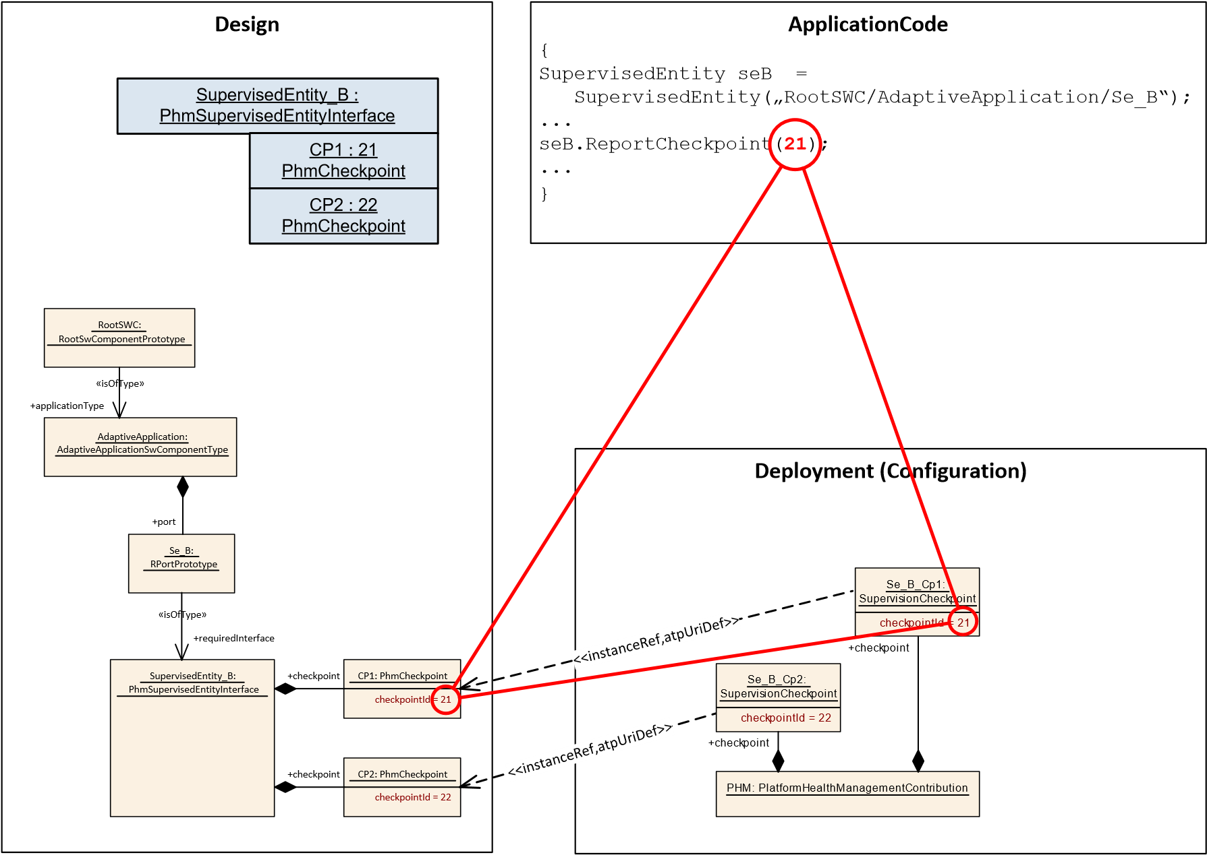

**Figure 9.9: Example how IDs have to be in sync**

The example in Figure 9.9 illustrates that the used IDs have to in sync in order to let design, code, and configuration work together.

**9.3.3 Supervision deployment**

In the application design chapter of this document the declaration of supervised entities and checkpoints has been described (see section 3.9.2). These declarations provide the view on supervision from the application software code point. Since the application Executable can be started multiple times (via individual Processes), the configuration of the Platform Health Management needs to cope with these individual Executable instances.

**[TPS_MANI_03503]**{DRAFT} **Applicability of checkpoints to a specific Process** dThe reference SupervisionCheckpoint.process defines to which specific Process this SupervisionCheckpoint definition shall be applied to.c*(RS_MANI_00023, RS_MANI_00032)*

This means that only if a PhmCheckpoint is reported from the context of this Process it is considered to be this SupervisionCheckpoint.

Note: If the SupervisionCheckpoint represents the supervision of the *Execution Management* process, it will not be possible to configure SupervisionCheckpoint. process (unless there is a dummy configuration of *Execution Management* process) as the process for Execution Management is not a modeled Process.

It is up to the Adaptive Platform Stack Vendor to define the mechanism how to identify the SupervisionCheckpoint (thereby the supervisions AliveSupervision, DeadlineSupervision, and LogicalSupervision) corresponding to the *Execution Management*.

ApplicationDesign

*AbstractRequiredPortPrototype*

RPortPrototype

*PlatformHealthManagementInterface*

PhmSupervisedEntityInterface

*AtpFeature*

PhmCheckpoint

checkpointId: PositiveInteger

+

*ARElement*

*AtpBlueprint*

*AtpBlueprintable*

*AtpType*

*PortInterface*

*Identifiable*

SupervisionCheckpoint

checkpointId: PositiveInteger

+

[0..1]

*UploadablePackageElement*

PlatformHealthManagementContribution

*AbstractExecutionContext*

Process

«atpSplitable»

+

checkpoint

0..*

+

process

0..1

checkpoint

+

0..*

«instanceR

ef,atpUriDef»

phmCheckpoint

+

0..1

«isOfType»

requiredInterface

+

0..1

redefines

{

atpType}

**Figure 9.10: Modeling of SupervisionCheckpoint**

For the Platform Health Management supervision to take effect it is required to define the instance the application is executed in, thus the reference to a Process has to be taken into account. In the model the Process also defines under which conditions (StateDependentStartupConfig) and with which arguments (ProcessArgument) the Executable will be started.

To also define the conditions for the supervision the state dependency is defined at the supervisions as well, see chapter 9.3.3.2.

For the configuration of the Platform Health Management the definition of SupervisionCheckpoint is used to stand in for the corresponding PhmCheckpoint including the execution context of the respective Process.

The attribute SupervisionCheckpoint.phmCheckpoint replicates the value of the referenced PhmCheckpoint.checkpointId. During deployment the PhmSupervisedEntityInterface and its content is no longer available and therefore needs to be made available to the Phm.

**[TPS_MANI_03626]**{DRAFT} **Consistency of SupervisionCheckpoint.phmCheckpoint and PhmCheckpoint.checkpointId** dThe value of SupervisionCheckpoint.phmCheckpoint shall be identical to the value of PhmCheckpoint.checkpointId which is referenced in SupervisionCheckpoint.phmCheckpoint.c*(RS_MANI_00023, RS_MANI_00032)*

**[TPS_MANI_03505]**{DRAFT} **Existence of SupervisionCheckpoint** dFor each

PhmCheckpoint in the scope of a RPortPrototype typed by a PhmSupervisedEntityInterface in the application definition there may be a SupervisionCheckpoint defined. The correspondence of the two is defined by the instance reference SupervisionCheckpoint.phmCheckpointc*(RS_MANI_00023, RS_MANI_00032)*

**[TPS_MANI_03506]**{DRAFT} **Optionality of SupervisionCheckpoint** dIt is not required that every PhmSupervisedEntityInterface or PhmCheckpoint used in the context of the application definition eventually has a corresponding SupervisionCheckpoint defined. There may be cases where the application software reports some checkpoints, but they are not considered for a specific supervision.c*(RS_-*

*MANI_00023, RS_MANI_00032)*

|  |  |  |  |  |
| --- | --- | --- | --- | --- |
| ***Class*** | **SupervisionCheckpoint** | | | |
| ***Package*** | M2::AUTOSARTemplates::AdaptivePlatform::PlatformModuleDeployment::PlatformHealthManagement | | | |
| ***Note*** | This element contains an instance reference to a RPortPrototype representing a checkpoint for Platform Health Management.  **Tags:**atp.Status=draft | | | |
| ***Base*** | *ARObject*, *Identifiable*, *MultilanguageReferrable*, *Referrable* | | | |
| ***Attribute*** | ***Type*** | ***Mult.*** | ***Kind*** | ***Note*** |
| checkpointId | PositiveInteger | 0..1 | attr | Defines the numeric value which is used to identify the reporting of this SupervisionCheckpoint to the Phm.  **Tags:**atp.Status=draft |
| phmCheckpoint | PhmCheckpoint | 0..1 | iref | Instance reference to the PhmCheckpoint defined in the context of a PortInterface.  **Tags:**atp.Status=draft  **InstanceRef implemented by:**PhmCheckpointIn  ExecutableInstanceRef |
| process | Process | 0..1 | ref | Reference to the Process this checkoint shall be monitored.  **Tags:**atp.Status=draft |

**Table 9.19: SupervisionCheckpoint**

**[TPS_MANI_03651]**{DRAFT} **Mandatory SupervisionCheckpoint.process reference** dUnless the SupervisionCheckpoint refers to a PhmCheckpoint which is defined in the scope of the *Execution Management*, each SupervisionCheckpoint shall define a process reference **at the time when the integration into a SoftwareCluster is finished**.c*(RS_MANI_00023, RS_MANI_00032)*

**[constr_3649]**{DRAFT} **Consistent SupervisionCheckpoint.process reference** dIf a SupervisionCheckpoint refers to a Process in the role process, then

* the SupervisionCheckpoint shall refer to a PhmCheckpoint which is defined in a PhmSupervisedEntityInterface and
* that PhmSupervisedEntityInterface types an RPortPrototype of an AdaptiveApplicationSwComponentType and
* that AdaptiveApplicationSwComponentType is used in the scope of an Executable and
* that Executable is referenced by the same Process as SupervisionCheckpoint.process.

### c()

**[constr_1742]**{DRAFT} **Multiplicity of reference SupervisionCheckpoint.phmCheckpoint**dAt the time of deployment of a SupervisionCheckpoint, one reference to meta-class PhmCheckpoint in the role phmCheckpoint shall exist.c*()*

**[constr_1764]**{DRAFT} **Counterpart of PhmCheckpoint** dEach PhmCheckpoint shall be referenced once and only once in the role targetPhmCheckpoint by a PhmCheckpointInExecutableInstanceRef with the same Executable and chain of contextComponentPrototype and contextRPortPrototype that is aggregated by a SupervisionCheckpoint in combination with a specific Process. This reference shall exist **at the time when the integration into a SoftwareCluster is finished**.c*()*

This means that each SupervisionCheckpoint is the unique representation of the corresponding PhmCheckpoint instance in the context of a PhmCheckpointInExecutableInstanceRef and one Process.

Please note that the detailed modeling of the InstanceRef from SupervisionCheckpoint to PhmCheckpoint is documented in section C.7.

**9.3.3.1 Global supervision**

The GlobalSupervision collects AliveSupervisions, LogicalSupervisions, and DeadlineSupervisions and aggregates the individual states of these supervisions into one GlobalSupervision status (see also figure 9.11).

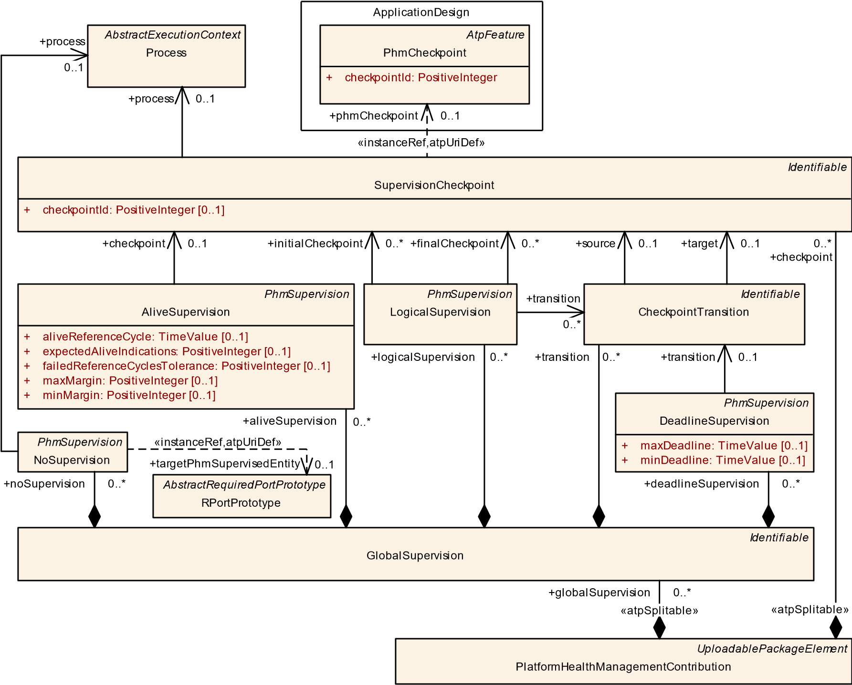

**Figure 9.11: Modeling of GlobalSupervision**

**[constr_3623]**{DRAFT} **SupervisionCheckpoints in the context of a GlobalSupervision** dAll SupervisionCheckpoints belonging to the same PhmSupervisedEntityInterface instance (SupervisionCheckpoints with identical PhmCheckpointInExecutableInstanceRef.contextRootSwComponentPrototype, contextComponentPrototype, contextRPortPrototype, and process references) shall only be referenced by PhmSupervisions which are aggregated by the same GlobalSupervision.c*()*

**[constr_3624]**{DRAFT} **At least one Supervision defined in the context of a**

**GlobalSupervision** dAt least one AliveSupervision, LogicalSupervision, or DeadlineSupervision shall be defined in the scope of a GlobalSupervision **at the time when the integration into a SoftwareCluster is finished**.c*()*

**[TPS_MANI_03512]**{DRAFT} **Applicability of global supervision without Process context** dThe aggregated AliveSupervisions, LogicalSupervisions, and DeadlineSupervisions contributing to a specific GlobalSupervision may refer to SupervisionCheckpoints where each SupervisionCheckpoint may refer to a different Process.c*(RS_MANI_00023, RS_MANI_00032)*

With [TPS_MANI_03512] the GlobalSupervision and the aggregation AliveSupervisions, LogicalSupervisions, and DeadlineSupervisions can be used to establish three use-cases:

* compose the status of one Executable instance (Process) in case all aggregated PhmSupervisions are defined with the same Process context.
* compose the status of several Executable instances (Processes) of a FunctionGroup in case the aggregated PhmSupervisions are defined with (partially) different Process contexts within a FunctionGroup context.
* compose the status of all Executable instances (Processes) of a FunctionGroup in case the aggregated PhmSupervisions are defined with (all) different Process contexts within a FunctionGroup context.

**[constr_3625]**{DRAFT} **DeadlineSupervision referencing CheckpointTransition in the context of a GlobalSupervision** dDeadlineSupervision aggregated in a GlobalSupervision shall only refer to a CheckpointTransition which is aggregated by the same GlobalSupervision.c*()*

**[constr_3626]**{DRAFT}**LogicalSupervision referencing CheckpointTransition in the context of a GlobalSupervision** dLogicalSupervision aggregated in a GlobalSupervision shall only refer to CheckpointTransitions that are aggregated by the same GlobalSupervision.c*()*

|  |  |  |  |  |
| --- | --- | --- | --- | --- |
| ***Class*** | **GlobalSupervision** | | | |
| ***Package*** | M2::AUTOSARTemplates::AdaptivePlatform::PlatformModuleDeployment::PlatformHealthManagement | | | |
| ***Note*** | This element defines a collection of AliveSupervisions, DeadlineSupervisions, and LogicalSupervisions in order to provide an aggregated supervision state.  **Tags:**atp.Status=draft | | | |
| ***Base*** | *ARObject*, *Identifiable*, *MultilanguageReferrable*, *Referrable* | | | |
| ***Attribute*** | ***Type*** | ***Mult.*** | ***Kind*** | ***Note*** |
| alive  Supervision | AliveSupervision | * | aggr | Collection of AliveSupervisions in the context of this GlobalSupervision.  **Tags:**atp.Status=draft |
| deadline  Supervision | DeadlineSupervision | * | aggr | Collection of DeadlineSupervisions in the context of this GlobalSupervision.  **Tags:**atp.Status=draft |
| logical  Supervision | LogicalSupervision | * | aggr | Collection of LogicalSupervisions in the context of this GlobalSupervision.  **Tags:**atp.Status=draft |
| noSupervision | NoSupervision | * | aggr | Collection of NoSupervisions in the context of this Global Supervision.  **Tags:**atp.Status=draft |
| supervision  Mode | SupervisionMode | * | aggr | Collection of SupervisionModes in the context of this GlobalSupervision.  **Stereotypes:** atpSplitable **Tags:**  atp.Splitkey=supervisionMode.shortName atp.Status=draft |

5

4

|  |  |  |  |  |
| --- | --- | --- | --- | --- |
| ***Class*** | **GlobalSupervision** |  |  |  |
| transition | CheckpointTransition | * | aggr | Collection of CheckpointTransitions in the context of this GlobalSupervision.  **Tags:**atp.Status=draft |

**Table 9.20: GlobalSupervision**

**9.3.3.2 Supervision Mode**

Expected execution (timing or sequence) of the Software can change based on certain conditions. Hence, the value of the Supervision attributes might have to be changed based on conditions as well. SupervisionMode defines the Supervision attributes which change based on the referenced modeCondition.

The Execution Management may use Function Groups and Function Group States to define the startup conditions of application software. The behavior of the application software can change based on the Function Group State. Hence the monitoring shall also be configurable based on Function Group State changes.

*Identifiable*

SupervisionModeCondition

*Identifiable*

*PhmSupervision*

AliveSupervision

LogicalSupervision

DeadlineSupervision

*Identifiable*

CheckpointTransition

*Identifiable*

GlobalSupervision

*Identifiable*

SupervisionMode

+

[0..1]

expiredSupervisionTolerance: TimeValue

NoSupervision

+

transition

0..*

aliveSupervision

+

0..*

+

transition

0..*

+

modeCondition

0..1

«atpSplitable»

supervisionMode

+

0..*

+

activeSupervision

0..*

+

transition

0..1

+

noSupervision

0..*

logicalSupervision

+

0..*

deadlineSupervision

+

0..*

**Figure 9.12: Mode dependent supervision**

A SupervisionMode does define a set of PhmSupervisions in the role activeSupervision which shall be active while this SupervisionMode is active. This modeling allows for one specific PhmSupervision to be defined as active in several SupervisionModes.

**[TPS_MANI_03513]**{DRAFT} **Collection of supervisions into a GlobalSupervision** dThe PhmSupervisions referenced from a SupervisionMode in the role activeSupervision are taken into account to evaluate the supervision status of the GlobalSupervision in that particular SupervisionMode.c*(RS_MANI_00023, RS_MANI_00032)*

**[TPS_MANI_03633]**{DRAFT} **Semantics of several supervisionMode references for one supervision** dIf a PhmSupervision is referenced in the role activeSupervision then this PhmSupervision will be active while the referencing SupervisionMode is active.c*(RS_MANI_00023, RS_MANI_00032)*

|  |  |  |  |  |
| --- | --- | --- | --- | --- |
| ***Class*** | **SupervisionMode** | | | |
| ***Package*** | M2::AUTOSARTemplates::AdaptivePlatform::PlatformModuleDeployment::PlatformHealthManagement | | | |
| ***Note*** | This element defines a SupervisionMode.  **Tags:**atp.Status=draft | | | |
| ***Base*** | *ARObject*, *Identifiable*, *MultilanguageReferrable*, *Referrable* | | | |
| ***Attribute*** | ***Type*** | ***Mult.*** | ***Kind*** | ***Note*** |
| active  Supervision | PhmSupervision | * | ref | The reference defines which PhmSupervisions shall be active in this specific SupervisionMode.  **Tags:**atp.Status=draft |
| expired Supervision  Tolerance | TimeValue | 0..1 | attr | Defines in this SupervisionMode the acceptable amount of time with EXPIRED supervision status of the enclosing GlobalSupervision before it is considered STOPPED.  **Tags:**atp.Status=draft |
| modeCondition | SupervisionMode  Condition | 0..1 | ref | Reference to SupervisionModeCondition (Condition under which the configuration made under this SupervisionMode are to be applied).  **Tags:**atp.Status=draft |

**Table 9.21: SupervisionMode**

**[TPS_MANI_03514]**{DRAFT} **Expiration tolerance for SupervisionMode** dThe attribute SupervisionMode.expiredSupervisionTolerance defines the time which a GlobalSupervision is maintained in the state *expired* before it is considered *stopped* in that particular SupervisionMode.c*(RS_MANI_00023, RS_MANI_00032)*

**[constr_3639]**{DRAFT} **Existence of SupervisionMode.expiredSupervisionTolerance** dFor each SupervisionMode the attribute expiredSupervisionTolerance shall exist **at the time when the integration into a SoftwareCluster is finished**.c*()*

**[constr_3640]**{DRAFT} **Existence of SupervisionMode.modeCondition** dFor each SupervisionMode the attribute modeCondition shall exist **at the time when the integration into a SoftwareCluster is finished**.c*()*

**9.3.3.3 Supervision Mode condition**

Each SupervisionMode refers to exactly one SupervisionModeCondition in the role modeCondition. The SupervisionModeCondition defines an collection of one or several stateReferences which are combined to provide a single logical state.

The reference to Function Groups and their Function Group States is essential for the definition of SupervisionModeConditions as the supervised Processes are started and stopped according to changes in Function Group States.

*ARElement*

*AtpClassifier*

FunctionGroupSet

*AtpPrototype*

ModeDeclarationGroupPrototype

*ARElement*

*AtpBlueprint*

*AtpBlueprintable*

*AtpType*

ModeDeclarationGroup

*AtpStructureElement*

*Identifiable*

ModeDeclaration

*UploadablePackageElement*

PlatformHealthManagementContribution

*Identifiable*

GlobalSupervision

*Identifiable*

SupervisionMode

[0..1]

expiredSupervisionTolerance: TimeValue

+

*Identifiable*

SupervisionModeCondition

FunctionGroupPhmStateReference

*PhmStateReference*

«isOfType»

+

type

0..1

}

redefines atpType

{

«atpSplitable»

supervisionModeCondition

+

0..*

«atpVariation»

+

modeDeclaration

0..*

modeCondition

+

0..1

stateReference

+

0..*

«instanceRef»

functionGroupState

+

0..1

+

initialMode

0..1

«atpSplitable»

globalSupervision

+

0..*

functionGroup

+

0..*

«atpSplitable»

+

supervisionMode

0..*

**Figure 9.13: Modeling of SupervisionMode**

|  |  |
| --- | --- |
| ***Class*** | **SupervisionModeCondition** |
| ***Package*** | M2::AUTOSARTemplates::AdaptivePlatform::PlatformModuleDeployment::PlatformHealthManagement |

5

4

|  |  |  |  |  |
| --- | --- | --- | --- | --- |
| ***Class*** | **SupervisionModeCondition** | | | |
| ***Note*** | This element defines a SupervisionModeCondition in the context of platform health management contribution.  **Tags:**atp.Status=draft | | | |
| ***Base*** | *ARObject*, *Identifiable*, *MultilanguageReferrable*, *Referrable* | | | |
| ***Attribute*** | ***Type*** | ***Mult.*** | ***Kind*** | ***Note*** |
| stateReference | PhmStateReference | * | aggr | Collection of stateReferences.  **Tags:**atp.Status=draft |

**Table 9.22: SupervisionModeCondition**

**[constr_3627]**{DRAFT} **Existence of SupervisionModeCondition.stateReference** dAt the time of deployment of SupervisionModeCondition, at least one aggregation of PhmStateReference in the role SupervisionModeCondition. stateReference shall exist.c*()*

|  |  |  |  |  |
| --- | --- | --- | --- | --- |
| ***Class*** | **FunctionGroupPhmStateReference** | | | |
| ***Package*** | M2::AUTOSARTemplates::AdaptivePlatform::PlatformModuleDeployment::PlatformHealthManagement | | | |
| ***Note*** | Function Group state dependency.  **Tags:**atp.Status=draft | | | |
| ***Base*** | *ARObject*, *PhmStateReference* | | | |
| ***Attribute*** | ***Type*** | ***Mult.*** | ***Kind*** | ***Note*** |
| functionGroup State | ModeDeclaration | 0..1 | iref | This represent the applicable functionGroupState.  **Tags:**atp.Status=draft  **InstanceRef implemented by:**FunctionGroupStateIn  FunctionGroupSetInstanceRef |

**Table 9.23: FunctionGroupPhmStateReference**

**[constr_3628]**{DRAFT} **Reference to Function Group State from a SupervisionModeCondition**dIf a Function Group State is referenced by a SupervisionModeCondition in the scope of one GlobalSupervision, then that same Function Group State shall NOT be referenced by any other SupervisionModeCondition in the scope of the same GlobalSupervision.c*()*

Rational for [constr_3628]: It is guaranteed that only one of the SupervisionModes is active at any point in time. The SupervisionModeConditions referenced under a GlobalSupervision in the context of SupervisionMode shall be mutually exclusive.

E.g. Following SupervisionModeConditions referenced under the same GlobalSupervision in the context of SupervisionMode is not allowed:

* SupervisionModeCondition_1:

(FunctionGroup_X in State ’a’) or (FunctionGroup_X in State ’b’)

* SupervisionModeCondition_2:

(FunctionGroup_X in State ’a’) or (FunctionGroup_X in State ’c’)

In the above example, (FunctionGroup_X in State ’a’) is common between the 2 SupervisionModeConditions.

**[constr_3629]**{DRAFT} **Identical Function Group in the scope of a GlobalSupervision** dWithin the context of one GlobalSupervision, all SupervisionMode.modeCondition shall only aggregate FunctionGroupPhmStateReferences in the role stateReference where the reference FunctionGroupPhm-

StateReference.functionGroupState.contextModeDeclarationGroupPrototype refers to the identical ModeDeclarationGroupPrototype (that implements the Function Group, as far as state management is concerned).c*()*

That is, within the context of one GlobalSupervision, all SupervisionMode.modeCondition.stateReference shall reference states(modes) of the same Function Group.

**[constr_3630]**{DRAFT} **GlobalSupervision and Process relation** dWithin the context of one GlobalSupervision, all aggregated PhmSupervisions shall refer to SupervisionCheckpoints where the referenced Process aggregates a stateDependentStartupConfig that in turn refers to a functionGroupState where the contextModeDeclarationGroupPrototype refers to the identical ModeDeclarationGroupPrototype (that implements the Function Group, as far as state management is concerned).c*()*

That is, all PhmSupervisions aggregated in a GlobalSupervision are referencing SupervisionCheckpoints corresponding to Processes that are configured to be executed in state/s of the same Function Group.

**[constr_3631]**{DRAFT} **Global supervision restricted to one Function Group** dThe Function Group (ModeDeclarationGroupPrototype) referenced in [constr_3629] and [constr_3630] shall be identical for one particular GlobalSupervision.c*()*

*AtpPrototype*

ModeDeclarationGroupPrototype

*ARElement*

*AtpBlueprint*

*AtpBlueprintable*

*AtpType*

ModeDeclarationGroup

*AtpStructureElement*

*Identifiable*

ModeDeclaration

*Identifiable*

SupervisionMode

[0..1]

+

expiredSupervisionTolerance: TimeValue

*Identifiable*

SupervisionModeCondition

FunctionGroupPhmStateReference

*PhmStateReference*

+

modeCondition

0..1

«atpVariation»

+

modeDeclaration

0..*

+

initialMode

0..1

stateReference

+

0..*

«isOfType»

type

+

0..1

redefines atpType

{

}

«instanceRef»

functionGroupState

+

0..1

**Figure 9.14: Modeling of FunctionGroupPhmStateReference**

**[constr_3632]**{DRAFT} **Supervision of a Supervised Entity Instance in the scope of a Function Group State**dIf a Supervised Entity Instance is configured to be supervised (has AliveSupervision / DeadlineSupervision / LogicalSupervision configured) in at least one Function Group State, then it shall be configured to be supervised or not supervised (NoSupervision configured) in all Function Group states in which the corresponding Process is configured to be executed.c*()*

Rationale for [constr_3632]: The configuration of supervision for a specific Supervised Entity Instance is not missed unintentionally in a Function Group state.

Note that [constr_3632] requires for the Supervised Entity Instance to be part of the supervision definition in all Function Group states if the Supervised Entity Instance is configured to be supervised in at least one Function Group state. In case there is no supervision required in a specific Function Group state (because the Supervised Entity Instance does not need to be supervised in that specific Function

Group state) then NoSupervision can be configured for that Supervised Entity Instance.

Note: If a Process survives a Function Group State change running (because the Process is defined to be running in two consecutive Function Group States), then it is important that the configuration of the activeSupervision for the Supervised Entity Instances corresponding to the Process is identical for the SupervisionModes that corresponds to the affected Function Group States. This relations can not be formally expressed (because the possible Function Group State transitions are not formalized) and therefore this restriction can not be defined as a constraint.

A possible mitigation strategy is to define different Process arguments and therefore force a re-start of the Process, even if the Function Group States have been switched consecutively.

**9.3.3.4 NoSupervision definition**

In the scope of a GlobalSupervision, a NoSupervision can be defined for a Supervised Entity Instance as a whole. A NoSupervision can be configured to indicate that this Supervised Entity Instance shall not be monitored by the Phm in a specific SupervisionMode.

The Supervised Entity Instance is identified using the NoSupervision.targetPhmSupervisedEntity instance ref and NoSupervision.process reference.

|  |  |
| --- | --- |
| ***Class*** | **NoSupervision** |
| ***Package*** | M2::AUTOSARTemplates::AdaptivePlatform::PlatformModuleDeployment::PlatformHealthManagement |
| ***Note*** | Defines explicitly that NO supervision shall be applied for a specific Supervised Entity instance.  **Tags:**atp.Status=draft |

5

4

|  |  |  |  |  |
| --- | --- | --- | --- | --- |
| ***Class*** | **NoSupervision** | | | |
| ***Base*** | *ARObject*, *Identifiable*, *MultilanguageReferrable*, *PhmSupervision*, *Referrable* | | | |
| ***Attribute*** | ***Type*** | ***Mult.*** | ***Kind*** | ***Note*** |
| process | Process | 0..1 | ref | Reference to the Process this NoSupervision applies to.  **Tags:**atp.Status=draft |
| targetPhm  Supervised  Entity | RPortPrototype | 0..1 | iref | Instance reference to the RPortPrototype which represents the Supervised Entity instance.  **Tags:**atp.Status=draft  **InstanceRef implemented by:**RPortPrototypeIn  ExecutableInstanceRef |

**Table 9.24: NoSupervision**

**[constr_3674]**{DRAFT} **Existence of NoSupervision.targetPhmSupervisedEntity** dFor each NoSupervision the attribute targetPhmSupervisedEntity shall exist **at the time when the integration into a SoftwareCluster is finished**.c*()*

**[constr_3675]**{DRAFT} **Existence of NoSupervision.process** dFor each NoSupervision the attribute process shall exist **at the time when the integration into a SoftwareCluster is finished**.c*()*

**[constr_3676]**{DRAFT} **Exclusive usage of NoSupervision** dFor a Supervised Entity Instance, in a given SupervisionMode, either Supervision ( AliveSupervision, DeadlineSupervision, and/or LogicalSupervision referencing SupervisionCheckpoint corresponding to the Supervised Entity Instance) or NoSupervision shall be configured, but not both.c*()*

**9.3.3.5 AliveSupervision definition**

In the scope of a GlobalSupervision an AliveSupervision can be defined for a specific SupervisionCheckpoint. AliveSupervision can be used to define in which timing boundaries one specific checkpoint shall be monitored.

**[TPS_MANI_03508]**{DRAFT} **Definition of an AliveSupervision for a SupervisionCheckpoint** dAn AliveSupervision definition provides attributes to configure the supervision of the referenced SupervisionCheckpoint.

* aliveReferenceCycle defines the time base used to monitor the reporting of this specific SupervisionCheckpoint
* expectedAliveIndications defines the number of indications which shall be observed during the time period defined by aliveReferenceCycle
* minMargin and maxMargin define the acceptable deviation from the expectedAliveIndications within the time period defined by aliveReferenceCycle c*(RS_MANI_00023, RS_MANI_00032)*

**[TPS_MANI_03575]**{DRAFT} **Definition of no minimum alive supervision** dIf the value AliveSupervision.minMargin equals 0, this defines that no minimum alive supervision shall be performed.c*(RS_MANI_00023, RS_MANI_00032)*

**[TPS_MANI_03576]**{DRAFT} **Definition of no maximum alive supervision** dIf the value AliveSupervision.maxMargin equals INF, this defines that no maximum alive supervision shall be performed.c*(RS_MANI_00023, RS_MANI_00032)*

**[constr_3539]**{DRAFT} **Only one AliveSupervision per SupervisionCheckpoint** dA SupervisionCheckpoint shall only be referenced up to once by an AliveSupervision in the role checkpoint in the context of an identical SupervisionMode.c*()*

**[TPS_MANI_03515]**{DRAFT} **Failure tolerance for AliveSupervision** dThe attribute AliveSupervision.failedReferenceCyclesTolerance defines the acceptable amount of AliveSupervision.aliveReferenceCycles with incorrect/failed AliveSupervision.c*(RS_MANI_00023, RS_MANI_00032)*

|  |  |  |  |  |
| --- | --- | --- | --- | --- |
| ***Class*** | **AliveSupervision** | | | |
| ***Package*** | M2::AUTOSARTemplates::AdaptivePlatform::PlatformModuleDeployment::PlatformHealthManagement | | | |
| ***Note*** | Defines an AliveSupervision for one checkpoint.  **Tags:**atp.Status=draft | | | |
| ***Base*** | *ARObject*, *Identifiable*, *MultilanguageReferrable*, *PhmSupervision*, *Referrable* | | | |
| ***Attribute*** | ***Type*** | ***Mult.*** | ***Kind*** | ***Note*** |
| aliveReference Cycle | TimeValue | 0..1 | attr | Time period at which the Alive Supervision mechanism compares the amount of received Alive Indications for the SupervisionCheckpoint against the expectedAlive Indications.  **Tags:**atp.Status=draft |
| checkpoint | SupervisionCheckpoint | 0..1 | ref | Reference to a checkpoint in the context of Alive Supervision.  **Tags:**atp.Status=draft |
| expectedAlive Indications | PositiveInteger | 0..1 | attr | Defines the amount of expected Alive Indications of the SupervisionCheckpoint within the aliveReferenceCycle.  **Tags:**atp.Status=draft |
| failedReference  Cycles  Tolerance | PositiveInteger | 0..1 | attr | This attribute defines the acceptable amount of alive ReferenceCycles with incorrect/failed AliveSupervision.  **Tags:**atp.Status=draft |
| maxMargin | PositiveInteger | 0..1 | attr | Defines the amount of Alive Indications of the Supervision Checkpoint that are acceptable to be additional to the expectedAliveIndications within the aliveReferenceCycle.  **Tags:**atp.Status=draft |
| minMargin | PositiveInteger | 0..1 | attr | Defines the amount of Alive Indications of the Supervision Checkpoint that are acceptable to be missing to the expectedAliveIndications within the aliveReferenceCycle.  **Tags:**atp.Status=draft |

**Table 9.25: AliveSupervision**

**[constr_3633]**{DRAFT} **Mandatory attributes of AliveSupervision** dThe following attributes of AliveSupervision shall be defined **at the time when the integration into a SoftwareCluster is finished**:

* aliveReferenceCycle
* checkpoint
* expectedAliveIndications
* failedReferenceCyclesTolerance
* minMargin
* maxMargin

### c()

**9.3.3.6 CheckpointTransition definition**

For the definition of further supervision strategies the need to first define possible

CheckpointTransitions between SupervisionCheckpoints arises. Since the application software design does not provide any transition definition between checkpoints, it is essential to define possible CheckpointTransitions.

The definition of CheckpointTransitions is done in the scope of the GlobalSupervision and can be used by the LogicalSupervision and DeadlineSupervision of the same GlobalSupervision.

**[TPS_MANI_03509]**{DRAFT} **Definition of a CheckpointTransition**dA CheckpointTransition defines one possible transition from the source SupervisionCheckpoint to the targetSupervisionCheckpoint.c*(RS_MANI_00023, RS_MANI_00032)*

**[constr_3634]**{DRAFT} **Multiplicity of CheckpointTransition.source and**

**CheckpointTransition.target**dEach CheckpointTransition shall define exactly one source reference and one target reference **at the time when the integration into a SoftwareCluster is finished**.c*()*

|  |  |  |  |  |
| --- | --- | --- | --- | --- |
| ***Class*** | **CheckpointTransition** | | | |
| ***Package*** | M2::AUTOSARTemplates::AdaptivePlatform::PlatformModuleDeployment::PlatformHealthManagement | | | |
| ***Note*** | Defines one transition between two checkpoints.  **Tags:**atp.Status=draft | | | |
| ***Base*** | *ARObject*, *Identifiable*, *MultilanguageReferrable*, *Referrable* | | | |
| ***Attribute*** | ***Type*** | ***Mult.*** | ***Kind*** | ***Note*** |
| source | SupervisionCheckpoint | 0..1 | ref | Reference to the source checkpoint for this transition.  **Tags:**atp.Status=draft |
| target | SupervisionCheckpoint | 0..1 | ref | Reference to the target checkpoint for this transition.  **Tags:**atp.Status=draft |

**Table 9.26: CheckpointTransition**

**9.3.3.7 LogicalSupervision definition**

The LogicalSupervision defines a supervision graph of allowed CheckpointTransitions which is monitored by the Platform Health Management without any timing considerations, just the order of reported checkpoints is considered for the monitoring.

**[constr_3540]**{DRAFT} **SupervisionCheckpoint in supervision graph** dEach SupervisionCheckpoint shall only be part of one supervision graph in the context of an identical SupervisionMode.c*()*

When a SupervisionCheckpoint belonging to the supervision graph is reported to the Platform Health Management where there is no CheckpointTransition defined from the last reported SupervisionCheckpoint as source to the current reported SupervisionCheckpoint as target, this situation violates the LogicalSupervision.

**[TPS_MANI_03510]**{DRAFT} **Definition of LogicalSupervision**dA LogicalSupervision defines relations between SupervisionCheckpoints which form a directed graph from one or more initialCheckpointSupervisionCheckpoints through a set of CheckpointTransitions defined by collection of transitions to one or more finalCheckpointSupervisionCheckpoints.c*(RS_MANI_00023,*

*RS_MANI_00032)*

|  |  |  |  |  |
| --- | --- | --- | --- | --- |
| ***Class*** | **LogicalSupervision** | | | |
| ***Package*** | M2::AUTOSARTemplates::AdaptivePlatform::PlatformModuleDeployment::PlatformHealthManagement | | | |
| ***Note*** | Defines a LogicalSupervision graph consisting of transitions, initial- and final checkpoints.  **Tags:**atp.Status=draft | | | |
| ***Base*** | *ARObject*, *Identifiable*, *MultilanguageReferrable*, *PhmSupervision*, *Referrable* | | | |
| ***Attribute*** | ***Type*** | ***Mult.*** | ***Kind*** | ***Note*** |
| finalCheckpoint | SupervisionCheckpoint | * | ref | Reference to the final Checkpoint(s) for this Logical Supervision.  **Tags:**  atp.Status=draft xml.sequenceOffset=20 |
| initialCheckpoint | SupervisionCheckpoint | * | ref | Reference to the initial Checkpoint(s) for this Logical Supervision.  **Tags:**  atp.Status=draft xml.sequenceOffset=10 |
| transition | CheckpointTransition | * | ref | Reference to the transitions for this LogicalSupervision.  **Tags:**  atp.Status=draft xml.sequenceOffset=30 |

**Table 9.27: LogicalSupervision**

**[constr_1736]**{DRAFT} **Multiplicity of reference LogicalSupervision.initialCheckpoint** dAt the time of deployment of a LogicalSupervision, at least one reference to meta-class SupervisionCheckpoint in the role initialCheckpoint shall exist.c*()*

**[constr_1737]**{DRAFT} **Multiplicity of reference LogicalSupervision.finalCheckpoint** dAt the time of deployment of a LogicalSupervision, at least one reference to meta-class SupervisionCheckpoint in the role finalCheckpoint shall exist.c*()*

**[constr_1740]**{DRAFT} **Multiplicity of reference LogicalSupervision.transition**dAt the time of deployment of a LogicalSupervision, at least one reference to meta-class CheckpointTransition in the role LogicalSupervision.transition shall exist.c*()*

**9.3.3.8 DeadlineSupervision definition**

The DeadlineSupervision defines timing attributes for one specific CheckpointTransition.

**[TPS_MANI_03511]**{DRAFT} **Definition of DeadlineSupervision**dA DeadlineSupervision defines timing attributes which are monitored by the Platform Health Management for one specific CheckpointTransition.c*(RS_MANI_00023, RS_MANI_00032)*

**[constr_3635]**{DRAFT} **Mandatory attributes of DeadlineSupervision**dThe following attributes of DeadlineSupervision shall be defined **at the time when the integration into a SoftwareCluster is finished**:

* transition
* minDeadline
* maxDeadline

### c()

**[TPS_MANI_03573]**{DRAFT} **Definition of no minimum deadline supervision** dIf the value DeadlineSupervision.minDeadline equals 0, this defines that no minimum deadline supervision shall be performed.c*(RS_MANI_00023, RS_MANI_00032)*

**[TPS_MANI_03574]**{DRAFT} **Definition of no maximum deadline supervision** dIf the value DeadlineSupervision.maxDeadline equals INF, this defines that no maximum deadline supervision shall be performed.c*(RS_MANI_00023, RS_MANI_00032)*

|  |  |  |  |  |
| --- | --- | --- | --- | --- |
| ***Class*** | **DeadlineSupervision** | | | |
| ***Package*** | M2::AUTOSARTemplates::AdaptivePlatform::PlatformModuleDeployment::PlatformHealthManagement | | | |
| ***Note*** | Defines an DeadlineSupervision for one transition.  **Tags:**atp.Status=draft | | | |
| ***Base*** | *ARObject*, *Identifiable*, *MultilanguageReferrable*, *PhmSupervision*, *Referrable* | | | |
| ***Attribute*** | ***Type*** | ***Mult.*** | ***Kind*** | ***Note*** |

5

4

|  |  |  |  |  |
| --- | --- | --- | --- | --- |
| ***Class*** | **DeadlineSupervision** |  |  |  |
| maxDeadline | TimeValue | 0..1 | attr | Defines the longest time span before which the deadline is considered to be met for transition.  **Tags:**atp.Status=draft |
| minDeadline | TimeValue | 0..1 | attr | Defines the shortest time span after which the deadline is considered to be met for transition.  **Tags:**atp.Status=draft |
| transition | CheckpointTransition | 0..1 | ref | Reference to the transition in the context of a Deadline Supervision.  **Tags:**atp.Status=draft |

**Table 9.28: DeadlineSupervision**

**9.3.4 Health channel deployment**

The HealthChannel is used as an abstraction to the Platform Health Management input for the RecoveryNotification.

*UploadablePackageElement*

PlatformHealthManagementContribution

*Identifiable*

*HealthChannel*

HealthChannelExternalStatus

HealthChannelSupervision

*Identifiable*

GlobalSupervision

*Identifiable*

RecoveryNotification

recoveryNotificationTimeout: TimeValue

[0..1]

+

*PlatformHealthManagementInterface*

PhmHealthChannelInterface

+

supervision

0..1

«instanceRef,atpUriDef»

+

healthChannel

0..1

«atpSplitable»

+

healthChannel

0..*

+

recoveryNotification

0..1

**Figure 9.15: Modeling of HealthChannel**

|  |  |
| --- | --- |
| ***Class*** | ***HealthChannel*** (abstract) |
| ***Package*** | M2::AUTOSARTemplates::AdaptivePlatform::PlatformModuleDeployment::PlatformHealthManagement |
| ***Note*** | This element defines the source of a health channel.  **Tags:**atp.Status=draft |
| ***Base*** | *ARObject*, *Identifiable*, *MultilanguageReferrable*, *Referrable* |
| ***Subclasses*** | HealthChannelExternalStatus, HealthChannelSupervision |

5

4

|  |  |  |  |  |
| --- | --- | --- | --- | --- |
| ***Class*** | ***HealthChannel*** (abstract) | |  |  |
| ***Attribute*** | ***Type*** | ***Mult.*** | ***Kind*** | ***Note*** |
| recovery  Notification | RecoveryNotification | 0..1 | aggr | Defines the RecoveryNotification.  **Tags:**atp.Status=draft |

**Table 9.29: HealthChannel**

The specialized use-cases for HealthChannels are described in the following sections. A HealthChannel can either represent

* the status of a GlobalSupervision using the HealthChannelSupervision or
* the status of a reported PhmHealthChannelInterface using the HealthChannelExternalStatus

**9.3.4.1 Supervision health channel deployment**

The HealthChannelSupervision is used to take the status of a GlobalSupervision trigger the RecoveryNotification in case a violation is detected by the Phm.

**[TPS_MANI_03516]**{DRAFT} **Status for HealthChannelSupervision** dThe status of the GlobalSupervision which is referenced in the role supervision is taken as the trigger for the RecoveryNotification.c*(RS_MANI_00023, RS_-*

*MANI_00032)*

|  |  |  |  |  |
| --- | --- | --- | --- | --- |
| ***Class*** | **HealthChannelSupervision** | | | |
| ***Package*** | M2::AUTOSARTemplates::AdaptivePlatform::PlatformModuleDeployment::PlatformHealthManagement | | | |
| ***Note*** | This element defines a health channel representing the status of a PhmSupervision.  **Tags:**atp.Status=draft | | | |
| ***Base*** | *ARObject*, *HealthChannel*, *Identifiable*, *MultilanguageReferrable*, *Referrable* | | | |
| ***Attribute*** | ***Type*** | ***Mult.*** | ***Kind*** | ***Note*** |
| supervision | GlobalSupervision | 0..1 | ref | Reference to the GlobalSupervision as source for the health channel.  **Tags:**atp.Status=draft |

**Table 9.30: HealthChannelSupervision**

**9.3.4.2 External health channel deployment**

The HealthChannelExternalStatus is used to define a list of HealthChannelExternalReportedStatus in the role healthChannel. If for this HealthChannelExternalStatus and the referenced Process a status is reported which is part of the list in healthChannel then this HealthChannelExternalStatus is considered violated and a notification to the respective RecoveryNotification is performed.

**[TPS_MANI_03545]**{DRAFT} **Existence of HealthChannelExternalStatus** dFor each RPortPrototype typed by a PhmHealthChannelInterface there may be a HealthChannelExternalStatus defined.c*(RS_MANI_00023, RS_MANI_00032)*

The attribute HealthChannelExternalReportedStatus.statusId replicates the value of the referenced PhmHealthChannelStatus.statusId. During deployment the PhmHealthChannelInterface and its content is no longer available and therefore needs to be made available to the Phm.

**[TPS_MANI_03625]**{DRAFT} **Consistency of HealthChannelExternalReportedStatus.statusId and PhmHealthChannelStatus.statusId** dThe value of HealthChannelExternalReportedStatus.statusId shall be identical to the value of PhmHealthChannelStatus.statusId which is referenced in HealthChannelExternalReportedStatus.status.c*(RS_MANI_00023, RS_MANI_00032)*

**[TPS_MANI_03546]**{DRAFT} **Definition of reported health status RPortPrototype** dThe RPortPrototype typed by a PhmHealthChannelInterface is used to report the status of a health channel by the application software. This specific RPortPrototype is defined as the contextRPortPrototype of the instance reference HealthChannelExternalStatus.healthChannel.c*(RS_MANI_00023, RS_MANI_00032)*

**[TPS_MANI_03517]**{DRAFT} **Evaluation of HealthChannelExternalStatus** dThe reported value of the HealthChannelExternalStatus according to [TPS_MANI_03546] will be compared to the list of statuses provided in notifiedStatus. If the reported status value matches one of the listed statusIds then this HealthChannelExternalStatus is considered violated and the respective RecoveryNotification is issued.c*(RS_MANI_00023, RS_MANI_00032)*

**[TPS_MANI_03553]**{DRAFT} **Applicability of health channel to a specific Process**dThe reference HealthChannelExternalStatus.process defines to which specific Process this HealthChannelExternalStatus definition shall be applied to.c*(RS_MANI_00023, RS_MANI_00032)*

This means that only if a PhmHealthChannelStatus is reported from the context of this Process it is considered to be this HealthChannelExternalStatus.

*Identifiable*

*HealthChannel*

HealthChannelExternalStatus

*AtpFeature*

PhmHealthChannelStatus

+

statusId: PositiveInteger

[0..1]

+

[0..1]

triggersRecoveryNotification: Boolean

*Identifiable*

RecoveryNotification

[0..1]

recoveryNotificationTimeout: TimeValue

+

*AbstractExecutionContext*

Process

*PlatformHealthManagementInterface*

PhmHealthChannelInterface

HealthChannelExternalReportedStatus

[0..1]

statusId: PositiveInteger

+

+

process

0..1

«atpUriDef»

+

status

0..1

+

notifiedStatus

0..*

+

status

0..*

«instanceRef,atpUriDef»

+

healthChannel

0..1

+

recoveryNotification

0..1

**Figure 9.16: Modeling of HealthChannelExternalStatus**

|  |  |  |  |  |
| --- | --- | --- | --- | --- |
| ***Class*** | **HealthChannelExternalStatus** | | | |
| ***Package*** | M2::AUTOSARTemplates::AdaptivePlatform::PlatformModuleDeployment::PlatformHealthManagement | | | |
| ***Note*** | This element defines a health channel representing the status of an external health channel.  **Tags:**atp.Status=draft | | | |
| ***Base*** | *ARObject*, *HealthChannel*, *Identifiable*, *MultilanguageReferrable*, *Referrable* | | | |
| ***Attribute*** | ***Type*** | ***Mult.*** | ***Kind*** | ***Note*** |
| healthChannel | PhmHealthChannel  Interface | 0..1 | iref | Refers to the HealthChannel.  **Tags:**atp.Status=draft  **InstanceRef implemented by:**PhmHealthChannelIn ExecutableInstanceRef |
| notifiedStatus | HealthChannelExternal  ReportedStatus | * | aggr | This is a list of statuses which shall trigger the Recovery Notification of this HealthChannelExternalStatus.  **Tags:**atp.Status=draft |
| process | Process | 0..1 | ref | Defines the Process this Health Channel shall be monitored.  **Tags:**atp.Status=draft |

**Table 9.31: HealthChannelExternalStatus**

|  |  |  |  |  |
| --- | --- | --- | --- | --- |
| ***Class*** | **HealthChannelExternalReportedStatus** | | | |
| ***Package*** | M2::AUTOSARTemplates::AdaptivePlatform::PlatformModuleDeployment::PlatformHealthManagement | | | |
| ***Note*** | This element defines a health channel representing the status of an external health channel.  **Tags:**atp.Status=draft | | | |
| ***Base*** | *ARObject* | | | |
| ***Attribute*** | ***Type*** | ***Mult.*** | ***Kind*** | ***Note*** |
| status | PhmHealthChannel  Status | 0..1 | ref | Reference to one status of a PhmHealthChannel.  **Stereotypes:** atpUriDef  **Tags:**atp.Status=draft |

5

4

|  |  |  |  |  |
| --- | --- | --- | --- | --- |
| ***Class*** | **HealthChannelExternalReportedStatus** | | |  |
| statusId | PositiveInteger | 0..1 | attr | Defines the numeric value which is used to identify the reporting of this HealthChannelExternalReportedStatus to the Phm.  **Tags:**atp.Status=draft |

**Table 9.32: HealthChannelExternalReportedStatus**

**9.3.5 Recovery Notification**

If Phm detects a Supervision violation or Health Channel violation then the associated RecoveryNotification at the HealthChannel is activated. This general setup is illustrated in figure 3.44. Via the RecoveryNotificationToPPortPrototypeMapping this RecoveryNotification is mapped to a dedicated PPortPrototype in the context of a dedicated Process implementing the State Management functionality.

**[constr_3612]**{DRAFT} **Multiplicity of references recoveryNotification, recoveryAction, and process at RecoveryNotificationToPPortPrototypeMapping**dThe references recoveryNotification, recoveryAction, and process shall be defined for each RecoveryNotificationToPPortPrototypeMapping **at the time when manifest creation is finished**.c*()*

**[constr_3613]**{DRAFT} **Reference to a PhmSupervisionRecoveryNotificationInterface in the context of a HealthChannelSupervision** dIf the RecoveryNotification is aggregated by a HealthChannelSupervision then the RecoveryNotificationToPPortPrototypeMapping shall refer to a PPortPrototype in the role recoveryAction typed by PhmSupervisionRecoveryNotificationInterface.c*()*

*Identifiable*

*HealthChannel*

*Identifiable*

RecoveryNotification

[0..1]

recoveryNotificationTimeout: TimeValue

+

*AbstractProvidedPortPrototype*

PPortPrototype

*AbstractExecutionContext*

Process

*UploadablePackageElement*

RecoveryNotificationToPPortPrototypeMapping

process

+

0..1

«instanceRef»

+

recoveryAction

0..1

+

recoveryNotification

0..1

+

recoveryNotification

0..1

**Figure 9.17: Modeling of RecoveryNotification**

**[constr_3614]**{DRAFT} **Reference to a PhmHealthChannelRecoveryNotificationInterface in the context of a HealthChannelExternalStatus** dIf the RecoveryNotification is aggregated by a HealthChannelExternalStatus then the RecoveryNotificationToPPortPrototypeMapping shall refer to a PPortPrototype in the role recoveryAction typed by PhmHealthChannelRecoveryNotificationInterface.c*()*

|  |  |  |  |  |
| --- | --- | --- | --- | --- |
| ***Class*** | **RecoveryNotification** | | | |
| ***Package*** | M2::AUTOSARTemplates::AdaptivePlatform::PlatformModuleDeployment::PlatformHealthManagement | | | |
| ***Note*** | This meta-class represents a PHM action that can trigger a recovery operation inside a piece of State Management software.  **Tags:**atp.Status=draft | | | |
| ***Base*** | *ARObject*, *Identifiable*, *MultilanguageReferrable*, *Referrable* | | | |
| ***Attribute*** | ***Type*** | ***Mult.*** | ***Kind*** | ***Note*** |
| recovery Notification  Timeout | TimeValue | 0..1 | attr | The maximum acceptable amount of time (in seconds), Platform Health Management waits for an acknowledgement by State Management after sending the notification.  **Tags:**atp.Status=draft |

**Table 9.33: RecoveryNotification**

|  |  |  |  |  |
| --- | --- | --- | --- | --- |
| ***Class*** | **RecoveryNotificationToPPortPrototypeMapping** | | | |
| ***Package*** | M2::AUTOSARTemplates::AdaptivePlatform::PlatformModuleDeployment::PlatformHealthManagement | | | |
| ***Note*** | This meta-class represents the ability to associate a RecoveryNotification to a PPortPrototype while also being able to identify the respective Process in which the actual recovery executes.  **Tags:**  atp.Status=draft  atp.recommendedPackage=RecoveryNotificationMappings | | | |
| ***Base*** | *ARElement*, *ARObject*, *CollectableElement*, *Identifiable*, *MultilanguageReferrable*, *Packageable*  *Element*, *Referrable*, *UploadablePackageElement* | | | |
| ***Attribute*** | ***Type*** | ***Mult.*** | ***Kind*** | ***Note*** |
| process | Process | 0..1 | ref | Reference to the process which represents the State Management instance that the recovery notification shall be applied to.  **Tags:**atp.Status=draft |
| recoveryAction | PPortPrototype | 0..1 | iref | This reference identifies the PortPrototype to be addressed as part of a PHM recovery.  **Tags:**atp.Status=draft  **InstanceRef implemented by:**PPortPrototypeIn  ExecutableInstanceRef |
| recovery  Notification | RecoveryNotification | 0..1 | ref | This reference identifies the applicable Recovery Notification to be mapped.  **Tags:**atp.Status=draft |

**Table 9.34: RecoveryNotificationToPPortPrototypeMapping**

## 9.4 Time Synchronization Deployment

**9.4.1 Overview**

This chapter explains the configuration of the Time Synchronization functional cluster.

An adaptive AUTOSAR application can utilize several (synchronized) Time-Base Resources which are provided by the Time Synchronization functional cluster [11].

The intended interaction of an adaptive AUTOSAR application with Time Synchronization is described in chapter 3.8.

Since an adaptive Machine is usually collaborating with other Machines (adaptive) and ECUs (classic), special focus has been put on the vehicle wide definition of synchronized time.

For a detailed specification please refer to the *Global Time Synchronization* chapter in the *System Template* [17].

Figure 9.18 provides an example system view on time domains and their transportation over diverse networks. In the scope of the *AUTOSAR adaptive platform* the focus is put on the Ethernet interaction with the rest of the system.

|  |  |  |
| --- | --- | --- |
| FR  ETH  **Global time master**  TM22  TM11    TM21  TG2  TS  TS  TS  sub21  sub22  sub11  TS2 | |  |
| CAN1  CAN2  TM12  TG1  TS  TS  TS  sub12  T  S1 | **Ti**  **Do** | **me**  **main** |
|  |  |

TS: GlobalTime slave TM: GlobalTime master

TG: GlobalTime gateway

**Figure 9.18: Example setup of Synchronized Global Time in AUTOSAR**

**9.4.2 Time Synchronization functional cluster configuration**

The representation of the Time Synchronization functional cluster [11] within one specific Machine is defined by the TimeSyncModuleInstantiation. The Machine has the ability to define a set of moduleInstantiations, where a specialization can be the TimeSyncModuleInstantiation.

|  |  |  |  |  |
| --- | --- | --- | --- | --- |
| ***Class*** | **TimeSyncModuleInstantiation** | | | |
| ***Package*** | M2::AUTOSARTemplates::AdaptivePlatform::PlatformModuleDeployment::TimeSync | | | |
| ***Note*** | This meta-class defines the attributes for the Time Synchronization configuration on a specific machine.  **Tags:**atp.Status=draft | | | |
| ***Base*** | *ARObject*, *AdaptiveModuleInstantiation*, *Identifiable*, *MultilanguageReferrable*, *NonOsModule Instantiation*, *Referrable* | | | |
| ***Attribute*** | ***Type*** | ***Mult.*** | ***Kind*** | ***Note*** |
| timeBase | TimeBaseResource | * | aggr | This aggregation defines the configured Time Bases for Time Synchronization.  **Tags:**atp.Status=draft |

**Table 9.35: TimeSyncModuleInstantiation**

*ARElement*

*AtpStructureElement*

Machine

trustedPlatformExecutableLaunchBehavior: TrustedPlatformExecutableLaunchBehaviorEnum

+

*Identifiable*

*AdaptiveModuleInstantiation*

*NonOsModuleInstantiation*

TimeSyncModuleInstantiation

*Identifiable*

*TimeBaseResource*

SynchronizedTimeBaseProvider

SynchronizedTimeBaseConsumer

+

timeBase

0..*

«atpSplitable»

+

moduleInstantiation

0..*

**Figure 9.19: Modeling of TimeSyncModuleInstantiation**

**9.4.3 Time Base**

The TimeSyncModuleInstantiation represents the actual instance of the Time Synchronization functional cluster executed on a specific Machine. In the scope of the TimeSyncModuleInstantiation the Time-Base Resources are defined.

**[TPS_MANI_03539]**{DRAFT} **Definition of Time-Base Resources** dThe meta-class

TimeSyncModuleInstantiation has the ability to define a set of Time-Base Resources of kind TimeBaseResource in the role timeBase.c*(RS_MANI_00040)*

There are several sub types of TimeBaseResource which will be explained in the following sections.

|  |  |  |  |  |
| --- | --- | --- | --- | --- |
| ***Class*** | ***TimeBaseResource*** (abstract) | | | |
| ***Package*** | M2::AUTOSARTemplates::AdaptivePlatform::PlatformModuleDeployment::TimeSync | | | |
| ***Note*** | This meta-class represents the attributes of one Time Base Resource for Time Synchronization.  **Tags:**atp.Status=draft | | | |
| ***Base*** | *ARObject*, *Identifiable*, *MultilanguageReferrable*, *Referrable* | | | |
| ***Subclasses*** | SynchronizedTimeBaseConsumer, SynchronizedTimeBaseProvider | | | |
| ***Attribute*** | ***Type*** | ***Mult.*** | ***Kind*** | ***Note*** |
| – | – | – | – | – |

**Table 9.36: TimeBaseResource**

**9.4.3.1 Synchronized time base**

When configuring a synchronized time base many configuration aspects are already provided by the definition of the GlobalTimeDomain and are specified in the *System Template* [17] and associated to MachineDesign.

As for the configuration of the TimeSyncModuleInstantiation the usage of the SynchronizedTimeBaseProvider respectively SynchronizedTimeBaseConsumer defines the interaction with the GlobalTimeDomain.

**[TPS_MANI_03541]**{DRAFT} **Definition of SynchronizedTimeBaseConsumer** dThe meta-class SynchronizedTimeBaseConsumer defines a Time Base which is synchronized with a time coming from the network. With the reference SynchronizedTimeBaseConsumer.networkTimeConsumer to a GlobalTimeSlave the relation to the system model is established.c*(RS_MANI_00040)*

**[TPS_MANI_03542]**{DRAFT} **Definition of SynchronizedTimeBaseProvider** dThe meta-class SynchronizedTimeBaseProvider defines a Time Base which is propagated to a time on the network. With the reference SynchronizedTimeBaseProvider.networkTimeProvider to a GlobalTimeMaster the relation to the system model is established.c*(RS_MANI_00040)*

Some aspects of the Synchronized Time Base for the *provider* role are not available in the system model, those are provided with the TimeSyncCorrection.

**[TPS_MANI_03543]**{DRAFT} **Definition of time sync correction attributes** dThe meta-class TimeSyncCorrection defines the attributes required to specify the time sync correction behavior of a SynchronizedTimeBaseProvider. The SynchronizedTimeBaseProvider aggregates the TimeSyncCorrection in the role timeSyncCorrection.c*(RS_MANI_00040)*

The synchronized global time feature also supports the definition of *offset* time domains.

**[TPS_MANI_03547]**{DRAFT} **Definition of *offset* time domains** dA GlobalTime-

Domain which has a offsetTimeDomain reference defined is considered an *offset* time domain. The reference source is the *offset* time domain. The reference *target* is the synchronized time domain.c*(RS_MANI_00040)*

The *offset* time domain is applicable to GlobalTimeMaster (therefore also SynchronizedTimeBaseProvider) and GlobalTimeSlave (therefore also SynchronizedTimeBaseConsumer).

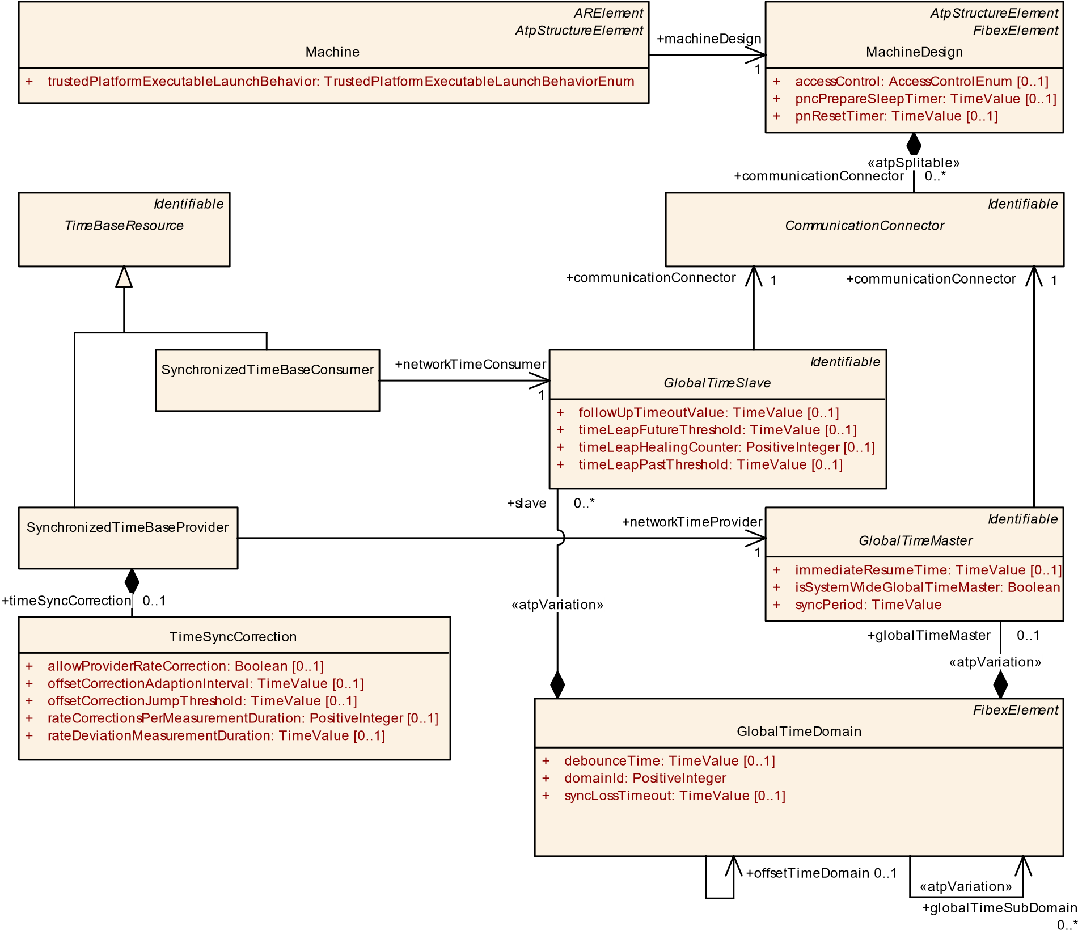

**Figure 9.20: Modeling of synchronized time bases**

|  |  |  |  |  |
| --- | --- | --- | --- | --- |
| ***Class*** | **SynchronizedTimeBaseConsumer** | | | |
| ***Package*** | M2::AUTOSARTemplates::AdaptivePlatform::PlatformModuleDeployment::TimeSync | | | |
| ***Note*** | This meta-class represents a Synchronized Time Base Consumer.  **Tags:**atp.Status=draft | | | |
| ***Base*** | *ARObject*, *Identifiable*, *MultilanguageReferrable*, *Referrable*, *TimeBaseResource* | | | |
| ***Attribute*** | ***Type*** | ***Mult.*** | ***Kind*** | ***Note*** |

5

**Table 9.37: SynchronizedTimeBaseConsumer**

|  |  |  |  |  |
| --- | --- | --- | --- | --- |
| ***Class*** | **SynchronizedTimeBaseProvider** | | | |
| ***Package*** | M2::AUTOSARTemplates::AdaptivePlatform::PlatformModuleDeployment::TimeSync | | | |
| ***Note*** | This meta-class represents a Synchronized Time Base Provider.  **Tags:**atp.Status=draft | | | |
| ***Base*** | *ARObject*, *Identifiable*, *MultilanguageReferrable*, *Referrable*, *TimeBaseResource* | | | |
| ***Attribute*** | ***Type*** | ***Mult.*** | ***Kind*** | ***Note*** |
| networkTime Provider | GlobalTimeMaster | 1 | ref | This reference defines the GlobalTime Provider which is synchronized with this Time Base.  **Tags:**atp.Status=draft |
| timeSync  Correction | TimeSyncCorrection | 0..1 | aggr | This aggregation defines the attributes used for the correction of time synchronization.  **Tags:**atp.Status=draft |

|  |  |  |  |  |
| --- | --- | --- | --- | --- |
| ***Class*** | **SynchronizedTimeBaseConsumer** | |  |  |
| networkTime Consumer | GlobalTimeSlave | 1 | ref | This reference defines the GlobalTime Consumer which is synchronized with this Time Base.  **Tags:**atp.Status=draft |

**Table 9.38: SynchronizedTimeBaseProvider**

|  |  |  |  |  |
| --- | --- | --- | --- | --- |
| ***Class*** | **TimeSyncCorrection** | | | |
| ***Package*** | M2::AUTOSARTemplates::AdaptivePlatform::PlatformModuleDeployment::TimeSync | | | |
| ***Note*** | This meta-class represents the attributes used for the correction of time synchronization.  **Tags:**atp.Status=draft | | | |
| ***Base*** | *ARObject* | | | |
| ***Attribute*** | ***Type*** | ***Mult.*** | ***Kind*** | ***Note*** |
| allowProvider  RateCorrection | Boolean | 0..1 | attr | Defines whether the rate correction value of a Time Base can be set by means of the method setRateCorrection().  false: rate correction cannot be set by method setRate Correction().  true: rate correction can be set by method setRate Correction().  **Tags:**atp.Status=draft |
| offsetCorrection AdaptionInterval | TimeValue | 0..1 | attr | Defines the interval during which the adaptive rate correction cancels out the rate and time deviation. Unit: seconds.  **Tags:**atp.Status=draft |
| offsetCorrection JumpThreshold | TimeValue | 0..1 | attr | Threshold for the correction method. Deviations below this value will be corrected by a linear reduction over a defined timespan. Values equal and greater than this value will be corrected by immediately setting the correct time and rate in form of a jump. Unit: seconds.  **Tags:**atp.Status=draft |
| rateCorrections  Per  Measurement  Duration | PositiveInteger | 0..1 | attr | Number of simultaneous rate measurements to determine the current rate deviation. **Tags:**atp.Status=draft |

5

**Table 9.39: TimeSyncCorrection**

**9.4.3.2 Persistent Time Base value storage**

The Time Synchronization functional cluster allows to define a storage for a SynchronizedTimeBaseProvider time base. During shutdown the value of that specific time base is stored in a PersistencyDeploymentElement (either PersistencyKeyValuePair or PersistencyFile) and during startup the value is read from persistency and restored at the time base.

|  |  |  |  |  |
| --- | --- | --- | --- | --- |
| ***Class*** | **TimeSyncCorrection** | |  |  |
| rateDeviation  Measurement  Duration | TimeValue | 0..1 | attr | Time span used to calculate the rate deviation. Unit: seconds.  **Tags:**atp.Status=draft |

**[TPS_MANI_03632]**{DRAFT} **Semantics of TimeBaseProviderToPersistencyMapping** dThe TimeBaseProviderToPersistencyMapping defines that the referenced SynchronizedTimeBaseProvider (TimeBaseProviderToPersistencyMapping.timeBaseProvider) time value shall be stored to persistency during shutdown and restored from persistency during startup (TimeBaseProviderToPersistencyMapping.persistencyDeploymentElement).c*(RS_MANI_00040)*

*NonOsModuleInstantiation*

TimeSyncModuleInstantiation

*Identifiable*

*TimeBaseResource*

SynchronizedTimeBaseProvider

*Identifiable*

*PersistencyDeploymentElement*

PersistencyFile

[0..1]

contentUri: UriString

+

fileName: String

+

PersistencyKeyValuePair

*FunctionalClusterInteractsWithFunctionalClusterMapping*

TimeBaseProviderToPersistencyMapping

+

persistencyDeploymentElement

0..1

timeBaseProvider

+

0..1

+

timeBase

0..*

**Figure 9.21: Modeling of TimeBaseProviderToPersistencyMapping**

|  |  |
| --- | --- |
| ***Class*** | **TimeBaseProviderToPersistencyMapping** |
| ***Package*** | M2::AUTOSARTemplates::AdaptivePlatform::PlatformModuleDeployment::TimeSync |

5

|  |  |  |  |  |
| --- | --- | --- | --- | --- |
| ***Class*** | **TimeBaseProviderToPersistencyMapping** | | | |
| ***Note*** | This meta-class represents the ability to define a mapping between a TimeBaseProvider and a PersistencyDeploymentElement for the purpose of storing and retrieving the time value.  **Tags:**  atp.Status=draft  atp.recommendedPackage=FCInteractions | | | |
| ***Base*** | *ARElement*, *ARObject*, *CollectableElement*, *FunctionalClusterInteractsWithFunctionalClusterMapping*,  *Identifiable*, *MultilanguageReferrable*, *PackageableElement*, *Referrable*, *UploadablePackageElement* | | | |
| ***Attribute*** | ***Type*** | ***Mult.*** | ***Kind*** | ***Note*** |
| persistency  Deployment  Element | PersistencyDeployment  Element | 0..1 | ref | This reference represents the PersistencyDeployment Element where the time value shall be stored in and retrieved from.  **Tags:**atp.Status=draft |
| timeBase Provider | SynchronizedTimeBase  Provider | 0..1 | ref | This reference represents the mapped TimeBase  Provider.  **Tags:**atp.Status=draft |

**Table 9.40: TimeBaseProviderToPersistencyMapping**

**[constr_3619]**{DRAFT} **Mandatory references of TimeBaseProviderToPersistencyMapping** dThe references TimeBaseProviderToPersistencyMapping.persistencyDeploymentElement and TimeBaseProviderToPersistencyMapping.timeBaseProvider shall exist **at the time when manifest creation is finished**.c*()*

**9.4.3.3 Ethernet synchronized time**

As the *AUTOSAR adaptive platform* supports Ethernet as communication network also the time synchronization using Ethernet is supported.

In order to configure the behavior of the Ethernet time synchronization the specific sub-classes are used as shown in figure 9.22.

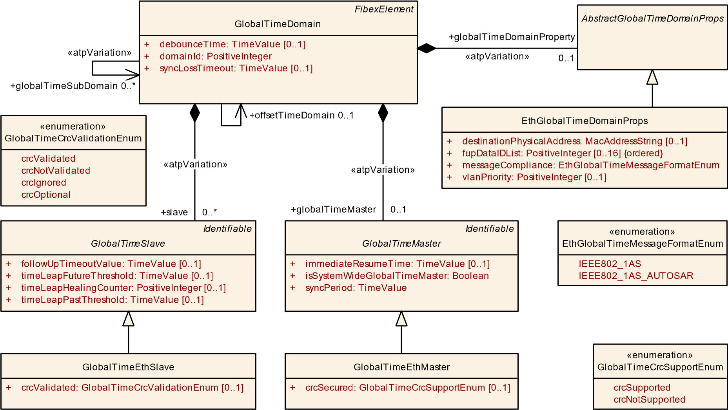

**Figure 9.22: Modeling of Ethernet synchronized time**

|  |  |  |  |  |
| --- | --- | --- | --- | --- |
| ***Class*** | **EthGlobalTimeDomainProps** | | | |
| ***Package*** | M2::AUTOSARTemplates::SystemTemplate::GlobalTime::ETH | | | |
| ***Note*** | Enables the definition of Ethernet Global Time specific properties. | | | |
| ***Base*** | *ARObject*, *AbstractGlobalTimeDomainProps* | | | |
| ***Attribute*** | ***Type*** | ***Mult.*** | ***Kind*** | ***Note*** |
| crcFlags | EthTSynCrcFlags | 0..1 | aggr | Defines the fields of the message which shall be taken into account for CRC calculation and verification. |
| destination Physical  Address | MacAddressString | 0..1 | attr | Defines the MAC multicast address the Ethernet time sync messages are communicated on. |
| fupDataIDList (ordered) | PositiveInteger | 0..16 | attr | The DataIDList for FUP messages to calculate CRC. |
| managed  CouplingPort | EthGlobalTime  ManagedCouplingPort | * | aggr | Collection of CouplingPorts which are managed in the scope of this Ethernet GlobalTimeDomain. |
| message  Compliance | EthGlobalTimeMessage  FormatEnum | 1 | attr | Defines the compliance of the Ethernet time sync messages to specific standards. |
| vlanPriority | PositiveInteger | 0..1 | attr | Defines which VLAN priority shall be assigned to a time sync message in case the message is sent using a VLAN tag. |

**Table 9.41: EthGlobalTimeDomainProps**

|  |  |  |  |  |
| --- | --- | --- | --- | --- |
| ***Class*** | **GlobalTimeEthSlave** | | | |
| ***Package*** | M2::AUTOSARTemplates::SystemTemplate::GlobalTime::ETH | | | |
| ***Note*** | This represents the specialization of the GlobalTimeSlave for Ethernet communication. | | | |
| ***Base*** | *ARObject*, *GlobalTimeSlave*, *Identifiable*, *MultilanguageReferrable*, *Referrable* | | | |
| ***Attribute*** | ***Type*** | ***Mult.*** | ***Kind*** | ***Note*** |

5

4

|  |  |  |  |  |
| --- | --- | --- | --- | --- |
| ***Class*** | **GlobalTimeEthSlave** | |  |  |
| crcValidated | GlobalTimeCrc  ValidationEnum | 0..1 | attr | Definition of whether or not validation of the CRC is supported. |

**Table 9.42: GlobalTimeEthSlave**

|  |  |  |  |  |
| --- | --- | --- | --- | --- |
| ***Class*** | **GlobalTimeEthMaster** | | | |
| ***Package*** | M2::AUTOSARTemplates::SystemTemplate::GlobalTime::ETH | | | |
| ***Note*** | This represents the specialization of the GlobalTimeMaster for Ethernet communication. | | | |
| ***Base*** | *ARObject*, *GlobalTimeMaster*, *Identifiable*, *MultilanguageReferrable*, *Referrable* | | | |
| ***Attribute*** | ***Type*** | ***Mult.*** | ***Kind*** | ***Note*** |
| crcSecured | GlobalTimeCrcSupport  Enum | 0..1 | attr | Definition of whether or not CRC is supported. This is only relevant for selected bus systems. |
| subTlvConfig | EthTSynSubTlvConfig | 0..1 | aggr | Defines the subTLV fields which shall be included in the time sync message. |

**Table 9.43: GlobalTimeEthMaster**

**9.4.4 Time Base to Port Prototype mapping**

The TimeBaseResource definition of chapter 9.4.3 and the RPortPrototype typed by a sub-class of AbstractSynchronizedTimeBaseInterface of chapter 3.8 have to be mapped to each other in order to define the binding of application software to the platform foundation software implementing the time synchronization.

**[TPS_MANI_03548]**{DRAFT} **Definition of TimeSyncPortPrototypeToTimeBaseMapping** dA TimeSyncPortPrototypeToTimeBaseMapping is used to define a mapping between a TimeBaseResource and a RPortPrototype typed by a sub-class of AbstractSynchronizedTimeBaseInterface in the context of a Process.c*(RS_MANI_00040)*

The TimeSyncPortPrototypeToTimeBaseMapping takes the Process into account so that every instantiation of an Executable (and the resulting instantiation of all the RPortPrototypes typed by a sub-class of AbstractSynchronizedTimeBaseInterface) can be mapped individually to TimeBaseResources.

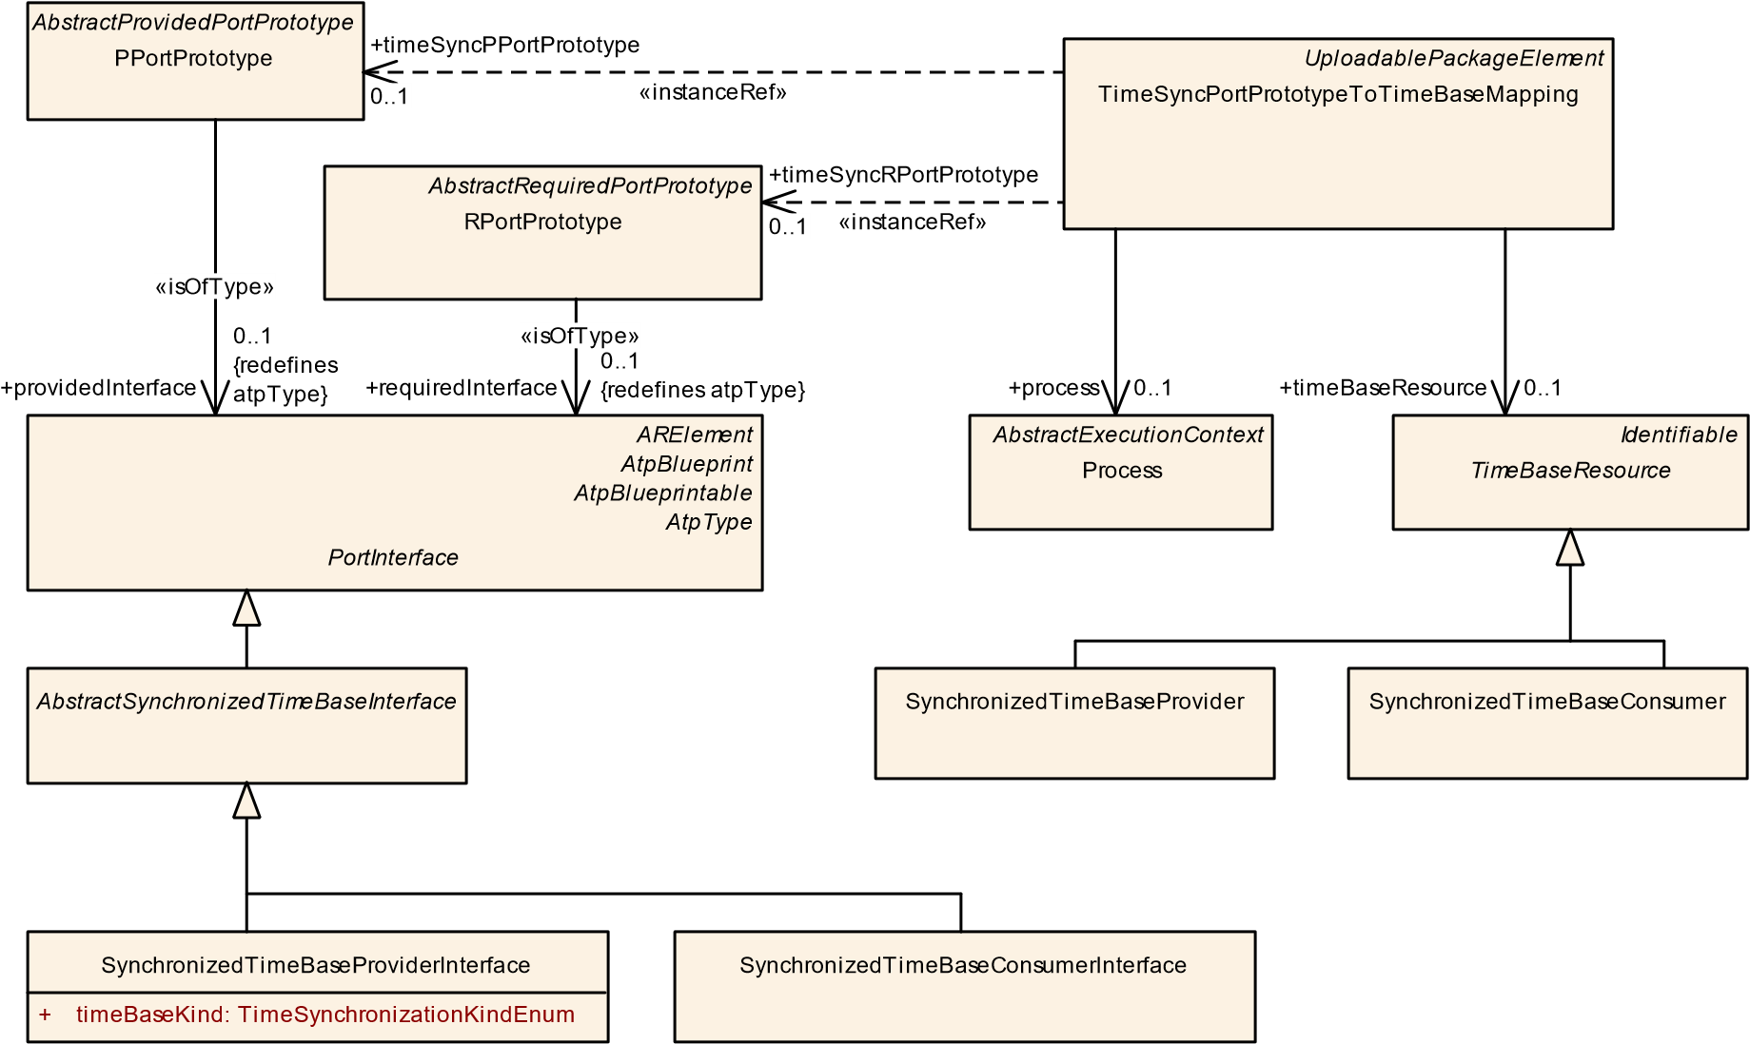

**Figure 9.23: Modeling of TimeSyncPortPrototypeToTimeBaseMapping**

|  |  |  |  |  |
| --- | --- | --- | --- | --- |
| ***Class*** | **TimeSyncPortPrototypeToTimeBaseMapping** | | | |
| ***Package*** | M2::AUTOSARTemplates::AdaptivePlatform::PlatformModuleDeployment::TimeSync | | | |
| ***Note*** | This meta-class provides the ability to map a PortPrototype typed by a AbstractSynchronizedTimeBase Interface to a TimeBaseResource in the context of a Process.  **Tags:**  atp.Status=draft  atp.recommendedPackage=TimeSyncPortPrototypeToTimeBaseMappings | | | |
| ***Base*** | *ARElement*, *ARObject*, *CollectableElement*, *Identifiable*, *MultilanguageReferrable*, *Packageable*  *Element*, *Referrable*, *UploadablePackageElement* | | | |
| ***Attribute*** | ***Type*** | ***Mult.*** | ***Kind*** | ***Note*** |
| process | Process | 0..1 | ref | Reference to the context Process this mapping applies to.  **Tags:**atp.Status=draft |
| timeBase Resource | TimeBaseResource | 0..1 | ref | Reference to the mapped TimeBaseResource.  **Tags:**atp.Status=draft |
| timeSyncPPort Prototype | PPortPrototype | 0..1 | iref | Instance reference to the mapped PPortPrototype typed by a AbstractSynchronizedTimeBaseInterface.  **Tags:**atp.Status=draft  **InstanceRef implemented by:**PPortPrototypeIn  ExecutableInstanceRef |
| timeSyncRPort Prototype | RPortPrototype | 0..1 | iref | Instance reference to the mapped RPortPrototype typed by a AbstractSynchronizedTimeBaseInterface.  **Tags:**atp.Status=draft  **InstanceRef implemented by:**RPortPrototypeIn  ExecutableInstanceRef |

**Table 9.44: TimeSyncPortPrototypeToTimeBaseMapping**

The example shown in figure 9.24 illustrates the mapping of RPortPrototypes typed by one of the sub-classes of AbstractSynchronizedTimeBaseInterface to actually configured TimeBaseResources at the Time Sync Management.

Application

1

tb

P

tb

C1

tb

C2

Time

Sync

Management

SynchronizedTime

BaseConsumer_2

SynchronizedTime

BaseConsumer_1

SynchronizedTime

BaseProvider_1

TimeSyncPortPrototypeToTimeBaseMappings

**Figure 9.24: Example PortPrototype to TimeBase mapping**

## 9.5 DoIP configuration

**[TPS_MANI_03164]**{DRAFT} **Machine-specific configuration settings for DoIP** dThe Machine-specific configuration settings for DoIP are collected in DoIpInstantiation.c*(RS_MANI_00023)*

|  |  |  |  |  |
| --- | --- | --- | --- | --- |
| ***Class*** | **DoIpInstantiation** | | | |
| ***Package*** | M2::AUTOSARTemplates::AdaptivePlatform::PlatformModuleDeployment::AdaptiveModule Implementation | | | |
| ***Note*** | This meta-class defines the attributes for the DoIP configuration on a specific machine.  **Tags:**atp.Status=draft | | | |
| ***Base*** | *ARObject*, *AdaptiveModuleInstantiation*, *Identifiable*, *MultilanguageReferrable*, *NonOsModule Instantiation*, *Referrable* | | | |
| ***Attribute*** | ***Type*** | ***Mult.*** | ***Kind*** | ***Note*** |
| eid | PositiveUnlimitedInteger | 0..1 | attr | Configured EID (Entity ID) used for VehicleIdentification Request. If configured, take this value, if not configured use MAC address.  **Tags:**atp.Status=draft |
| entityStatusMax ByteFieldUse | Boolean | 1 | attr | This attribute is used to distinguish the optional support of the Max data size element of a diagnostic entity status response.  **Tags:**atp.Status=draft |

5

4

|  |  |  |  |  |
| --- | --- | --- | --- | --- |
| ***Class*** | **DoIpInstantiation** | | | |
| gid | PositiveUnlimitedInteger | 0..1 | attr | Configured GID (Group ID) used for VehicleIdentification Request. If configured, take this value (and set "Further action required" byte to 0x00="No further action required"), if not configured use ServiceInterface Do IPGroupIdentification to retrieve GID and ’further action required’ values.  **Tags:**atp.Status=draft |
| gidInvalidity Pattern | PositiveInteger | 1 | attr | Specifies the Byte pattern that is used for response messages if no valid GID could be retrieved. Only the value ’0’ or ’255’ is allowed.  **Tags:**atp.Status=draft |
| logicalAddress | PositiveInteger | 1 | attr | Describes the logical address of the DoIP entity, which is used for VehicleAnnouncement and RoutingActivation responses.  **Tags:**atp.Status=draft |
| maxRequest Bytes | PositiveInteger | 1 | attr | Specifies the maximum allowed bytes of a DoIP message request without the DoIP header.  **Tags:**atp.Status=draft |
| network  Interface | DoIpNetwork  Configuration | * | aggr | Network interface specific DoIP properties.  **Tags:**atp.Status=draft |
| request  Configuration | DoIpRequest  Configuration | * | aggr | Request configuration that is used to determine whether an incoming DiagnosticMessage request needs to be interpreted as PHYSICAL or FUNCTIONAL. Any request with target address not within the configured target address range will be rejected.  **Tags:**atp.Status=draft |
| vinInvalidity Pattern | PositiveInteger | 1 | attr | Specifies the Byte pattern that is used for response messages if no valid VIN could be retrieved. Only the value ’0’ or ’255’ is allowed.  **Tags:**atp.Status=draft |

**Table 9.45: DoIpInstantiation**

**[constr_3425]**{DRAFT} **Restriction of DoIpInstantiations on a Machine** dEach Machine shall aggregate at most one DoIpInstantiation in the role moduleInstantiation.c*()*

**[constr_3495]**{DRAFT} **Supported value range for attribute DoIpInstantiation.eid** dThe supported value range of attribute DoIpInstantiation.eid is limited to the interval [0..281474976710655].c*()*

**[constr_3496]**{DRAFT} **Supported value range for attribute DoIpInstantiation.gid** dThe supported value range of attribute DoIpInstantiation.gid is limited to the interval [0..281474976710655].c*()*

**[constr_3497]**{DRAFT} **Supported value range for attribute DoIpInstantiation.maxRequestBytes**dThe supported value range of attribute DoIpInstantiation.maxRequestBytes is limited to the interval [0..4294967295].c*()*

**[constr_3498]**{DRAFT} **Supported value range for attribute DoIpInstantiation.logicalAddress** dThe supported value range of attribute DoIpInstantiation.logicalAddress is limited to the interval [0..65535].c*()*

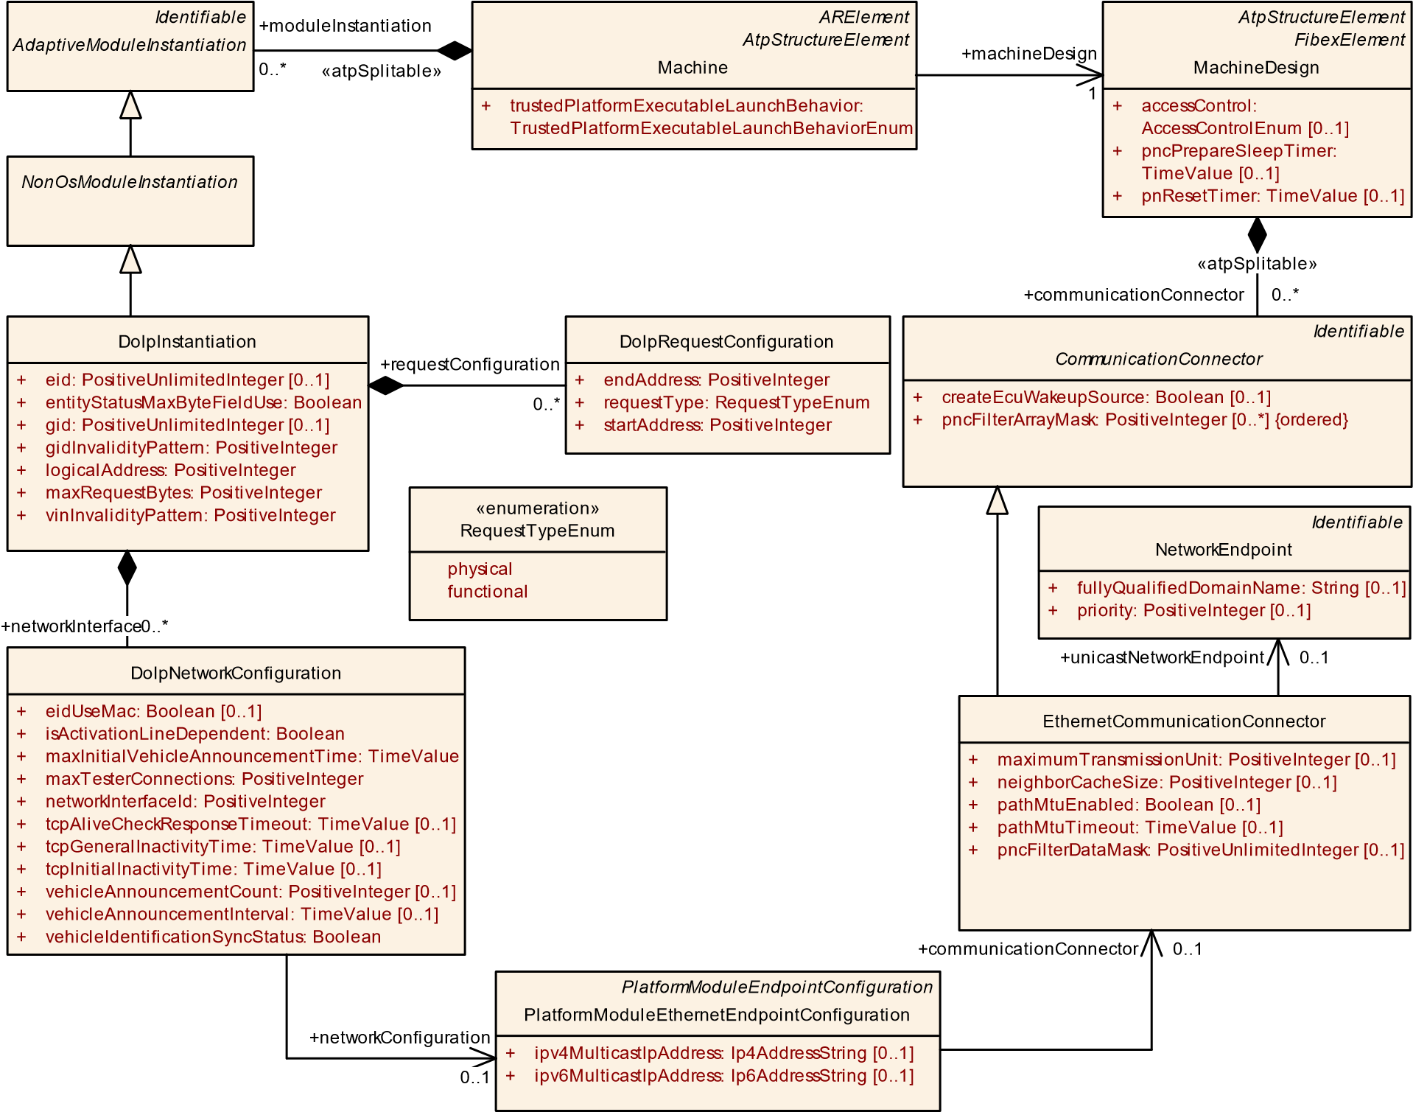

**Figure 9.25: DoIP configuration**

**[TPS_MANI_03165]**{DRAFT} **Network Interface configuration for DoIP** dThe DoIpNetworkConfiguration contains all configuration settings that are specific for a configured network connection. The network connection is configured with the

PlatformModuleEthernetEndpointConfiguration that is referenced by the DoIpNetworkConfiguration in the role networkConfiguration.

The tcpPort and udpPort references to the ApApplicationEndpoint are used to configure the Transport Protocol (Udp or Tcp) and the used Port number. The IP Address is configured in the NetworkEndpoint that is referenced by the Platform-

ModuleEthernetEndpointConfiguration via the EthernetCommunication-

Connector.c*(RS_MANI_00023)*

|  |  |
| --- | --- |
| ***Class*** | **DoIpNetworkConfiguration** |
| ***Package*** | M2::AUTOSARTemplates::AdaptivePlatform::PlatformModuleDeployment::AdaptiveModule Implementation |
| ***Note*** | This element collects DoIP properties that are network interface specific.  **Tags:**atp.Status=draft |

5

4

|  |  |  |  |  |
| --- | --- | --- | --- | --- |
| ***Class*** | **DoIpNetworkConfiguration** | | | |
| ***Base*** | *ARObject* | | | |
| ***Attribute*** | ***Type*** | ***Mult.*** | ***Kind*** | ***Note*** |
| eidUseMac | Boolean | 0..1 | attr | This attribute defines whther the MAC of the network interface is used as eid. True: MAC is used False: eid needs to be configured manually by DoIpInstantiation.eid.  **Tags:**atp.Status=draft |
| isActivationLine Dependent | Boolean | 1 | attr | This attribute defines whether the network interface   * is started "on-demand" when an activation line is sensed or * is always available.   **Tags:**atp.Status=draft |
| maxInitial  Vehicle  Announcement  Time | TimeValue | 1 | attr | Upper bound for the time to wait in [s] for sending first vehicle anouncement message after IP address assignment. Represents parameter A_DoIP_Announce_ Wait of ISO 13400-2:2012. The value of this timing shall be determined randomly in the closed interval [0..max InitialVehicleAnnouncementTime].  **Tags:**atp.Status=draft |
| maxTester  Connections | PositiveInteger | 1 | attr | Maximum amount of tester connections that shall be maintained at one time before alive check is performed.  **Tags:**atp.Status=draft |
| network  Configuration | PlatformModule  EthernetEndpoint  Configuration | 0..1 | ref | Network configuration (Protocol, Port, IP Address) for transmission of DoIP messages on a specific VLAN.  **Tags:**atp.Status=draft |
| network  InterfaceId | PositiveInteger | 1 | attr | This attribute defines the identifier for the DoIPInterface.  **Tags:**atp.Status=draft |
| tcpAliveCheck  Response  Timeout | TimeValue | 0..1 | attr | Timeout in [s] for waiting for a response to an Alive Check request before the connection is considered to be disconnected. Represents parameter T_TCP_AliveCheck of ISO 13400-2:2012.  **Tags:**atp.Status=draft |
| tcpGeneral  InactivityTime | TimeValue | 0..1 | attr | Timeout in [s] for maximum inactivity of a TCP socket connection before the DoIP module will close the according socket connection. Represents parameter T_ TCP_General_Inactivity of ISO 13400-2:2012.  **Tags:**atp.Status=draft |
| tcpInitial  InactivityTime | TimeValue | 0..1 | attr | Timeout in [s] used for initial inactivity of a connected TCP socket connection directly after socket connection. Represents parameter T_TCP_Initial_Inactivity of ISO 13400-2:2012.  **Tags:**atp.Status=draft |
| vehicle Announcement  Count | PositiveInteger | 0..1 | attr | Number of vehicle announcement messages on IP address assignment. Represents parameter A_DoIP_ Announce_Num of ISO 13400-2:2012.  **Tags:**atp.Status=draft |
| vehicle Announcement  Interval | TimeValue | 0..1 | attr | Time to wait in [s] for sending subsequent vehicle anouncement messages. Represents parameter A_Do IP_Announce_Interval of ISO 13400-2:2012.  **Tags:**atp.Status=draft |

5 4

|  |  |  |  |  |
| --- | --- | --- | --- | --- |
| ***Class*** | **DoIpNetworkConfiguration** | |  |  |
| vehicle Identification  SyncStatus | Boolean | 1 | attr | Defines if the optional VIN/GID synchronization status is  used additionally in the vehicle identification/ announcement.  **Tags:**atp.Status=draft |

**Table 9.46: DoIpNetworkConfiguration**

Please note that it is possible to define several networkInterfaces in a DoIpInstantiation. For each network connection individual configuration settings can be set with the attributes that are defined in the DoIpNetworkConfiguration element, e.g. it is possible to configure the vehicle announcement for different network connections differently.

**[constr_5046]**{DRAFT} **Usage of DoIpNetworkConfiguration.eidUseMac** dIf DoIpInstantiation.eid is not configured, the value of DoIpNetworkConfiguration.eidUseMac shall be set to true.c*()*

**[TPS_MANI_03218]**{DRAFT} **Default value for the attribute tcpInitialInactivityTime of meta-class DoIpNetworkConfiguration** dIf no value for the attribute DoIpNetworkConfiguration.tcpInitialInactivityTime is defined then the default value of 2 seconds shall be assumed.c*(RS_MANI_00023)*

**[TPS_MANI_03219]**{DRAFT} **Default value for the attribute tcpGeneralInactivityTime of meta-class DoIpNetworkConfiguration** dIf no value for the attribute DoIpNetworkConfiguration.tcpGeneralInactivityTime is defined then the default value of 300 seconds shall be assumed.c*(RS_MANI_00023)*

**[TPS_MANI_03220]**{DRAFT} **Default value for the attribute vehicleAnnouncementCount of meta-class DoIpNetworkConfiguration** dIf no value for the attribute DoIpNetworkConfiguration.vehicleAnnouncementCount is defined then the default value of 3 shall be assumed.c*(RS_MANI_00023)*

**[TPS_MANI_03221]**{DRAFT} **Default value for the attribute vehicleAnnouncementInterval of meta-class DoIpNetworkConfiguration** dIf no value for the attribute DoIpNetworkConfiguration.vehicleAnnouncementInterval is defined then the default value of 0,5 seconds shall be assumed.c*(RS_MANI_00023)*

**[TPS_MANI_03222]**{DRAFT} **Default value for the attribute tcpAliveCheckResponseTimeout of meta-class DoIpNetworkConfiguration** dIf no value for the attribute DoIpNetworkConfiguration.tcpAliveCheckResponseTimeout is defined then the default value of 0,5 seconds shall be assumed.c*(RS_MANI_00023)*

During vehicle discovery the DoIP module responds by informing the tester about its own address, configured as the logicalAddress. The tester will approach the ECU under this UDS target address, thus the ECU should have a SoftwareCluster that is configured to respond to this UDS target address.

The list of available target addresses may or may not be obtainable from the SoftwareCluster with the logicalAddress.

In some cases, this SoftwareCluster may have the ability to inform the tester which other existing physical and/or logical addresses are available.

|  |  |  |  |  |
| --- | --- | --- | --- | --- |
| ***Class*** | **DoIpRequestConfiguration** | | | |
| ***Package*** | M2::AUTOSARTemplates::AdaptivePlatform::PlatformModuleDeployment::AdaptiveModule Implementation | | | |
| ***Note*** | This meta-class specifies a range of target addresses and its interpretation as either physical or functional request.  **Tags:**atp.Status=draft | | | |
| ***Base*** | *ARObject* | | | |
| ***Attribute*** | ***Type*** | ***Mult.*** | ***Kind*** | ***Note*** |
| endAddress | PositiveInteger | 1 | attr | End address for range of target-addresses (including this address).  **Tags:**atp.Status=draft |
| requestType | RequestTypeEnum | 1 | attr | Determines the type of request.  **Tags:**atp.Status=draft |
| startAddress | PositiveInteger | 1 | attr | Start address for range of target-addresses (including this address).  **Tags:**atp.Status=draft |

**Table 9.47: DoIpRequestConfiguration**

**[constr_3492]**{DRAFT}**DoIpInstantiation.logicalAddress shall be defined as member in the DoIpRequestConfiguration** dThe DoIpInstantiation. logicalAddress shall be a member of the intervals of available physical addresses configured for the DoIpInstantiation in the requestConfiguration.c*()*

On top of that, there is the expectation that the configured diagnosticProps.diagnosticAddresses of SoftwareClusters deployed to the Machine fit to the intervals defined in the context of the DoIpInstantiation in the requestConfiguration.

Please note that the DoIpRequestConfiguration corresponds to Table 39 that is defined in ISO-13400-2 [22].

**[constr_3499]**{DRAFT} **Supported value range for attribute DoIpRequestConfiguration.startAddress** dThe supported value range of attribute

DoIpRequestConfiguration.startAddress is limited to the interval [0..65535].c

### ()

**[constr_5000]**{DRAFT} **Supported value range for attribute DoIpRequestConfiguration.endAddress** dThe supported value range of attribute DoIpRequestConfiguration.endAddress is limited to the interval [0..65535].c*()*

**[constr_3414]**{DRAFT} **Allowed usage of PlatformModuleEthernetEndpointConfiguration attributes** dTable 9.48 shows PlatformModuleEthernetEndpointConfiguration attributes that are allowed to be used to configure the network communication in the different platform modules.c*()*

|  |  |  |
| --- | --- | --- |
|  | Element | |
| **PlatformModuleEthernetEndpointConfiguration**  **attributes** | **Usage in DoIpInstantiation** | **Usage in DltLogSink** |
| **tcpPort** | Optional | Optional |
| **udpPort** | Optional | Optional |
| **ipv4MulticastIpAddress** | N/A | N/A |
| **ipv6MulticastIpAddress** | N/A | N/A |
| **communicationConnector** | Mandatory | Mandatory |

**Table 9.48: Allowed usage of PlatformModuleEthernetEndpoint-**

**Configuration attributes**

## 9.6 Log and Trace module configuration

The Log and Trace functionality in AUTOSAR supports the monitoring of applications and provides means to forward logging information onto the communication bus, the console, or to the file system.

The logging information is put into a standardized delivery and presentation format that is described in more detail in the Log and Trace Protocol specification [23].The format contains meta-data that identifies for example the application that produces the logging information.

This chapter describes settings that are available in the Machine Manifest to configure the logging framework and defines the relation between the application design and the deployment model.

Please note that the modeling elements described in this chapter are using elements from the Log And Trace Extract Template that defines a AUTOSAR platform independent format for description of log and trace messages and the source that produces these log and trace messages.

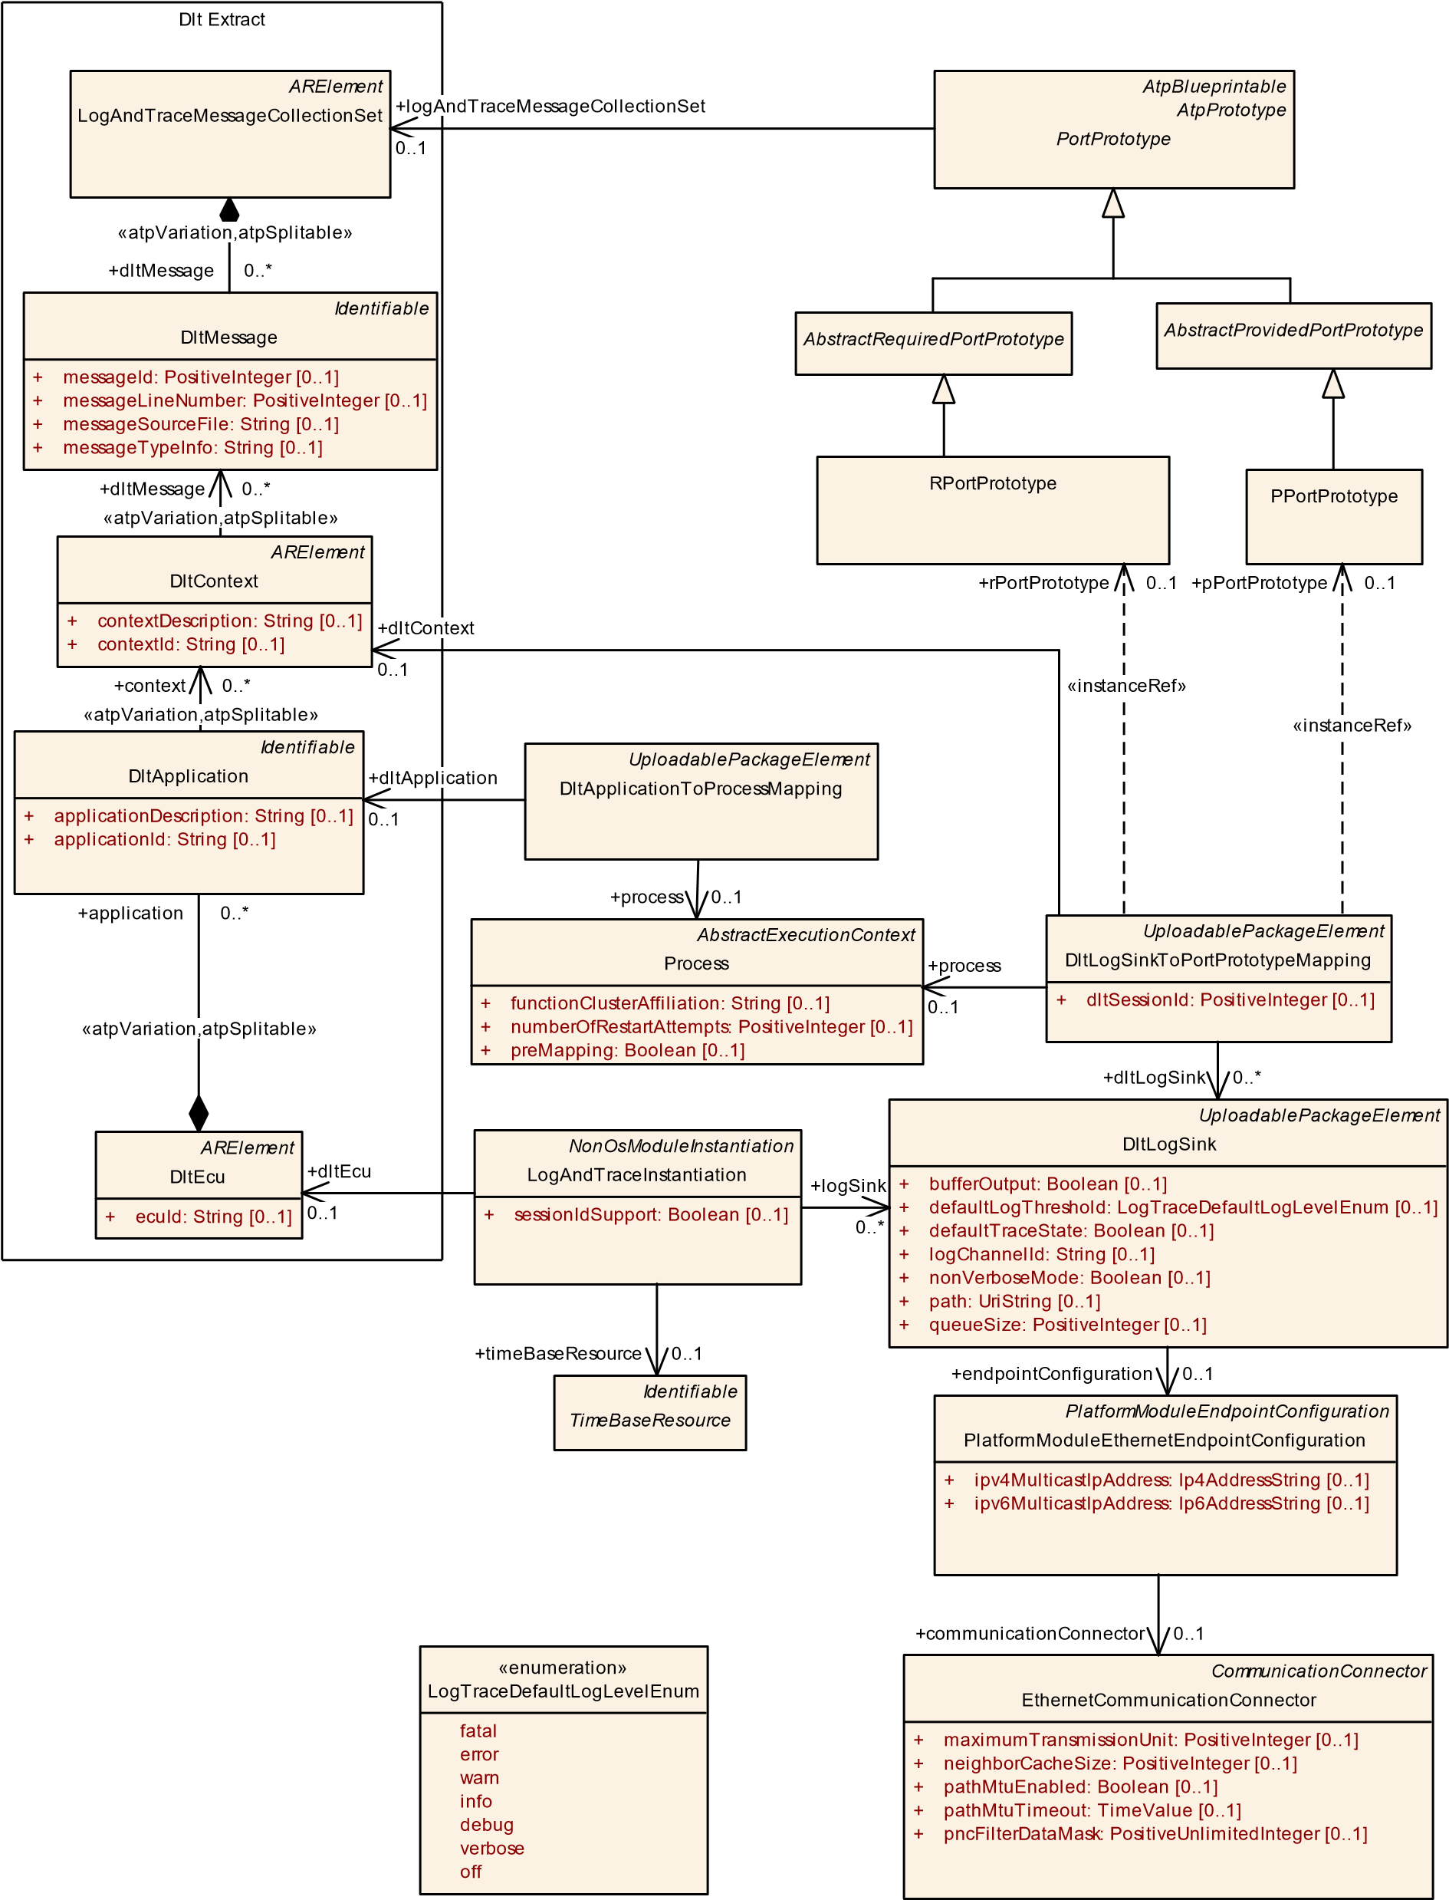

**Figure 9.26: Log and Trace module configuration**

**9.6.1 Log and trace deployment**

**[TPS_MANI_03162]**{DRAFT}**Machine-specific configuration settings for the Log and Trace functional cluster** dThe Machine-specific configuration settings for the Log and Trace functional cluster are collected in LogAndTraceInstantiation.c *(RS_MANI_00023)*

**[TPS_MANI_03282]**{DRAFT} **Assignment of a Dlt Ecu Identifier to a LogAndTraceInstantiation**dThe Machine is represented in the Log And Trace Extract by the DltEcu that is referenced from the LogAndTraceInstantiation in the role dltEcu. The referenced DltEcu defines the ecuId that is transported in the standard header of the log and trace message.c*(RS_MANI_00023)*

|  |  |  |  |  |
| --- | --- | --- | --- | --- |
| ***Class*** | **LogAndTraceInstantiation** | | | |
| ***Package*** | M2::AUTOSARTemplates::AdaptivePlatform::PlatformModuleDeployment::LogAndTrace | | | |
| ***Note*** | This meta-class defines the attributes for the Log&Trace configuration on a specific machine.  **Tags:**atp.Status=draft | | | |
| ***Base*** | *ARObject*, *AdaptiveModuleInstantiation*, *Identifiable*, *MultilanguageReferrable*, *NonOsModule Instantiation*, *Referrable* | | | |
| ***Attribute*** | ***Type*** | ***Mult.*** | ***Kind*** | ***Note*** |
| dltEcu | DltEcu | 0..1 | ref | Reference to the Ecu representation in the Log And Trace  Extract.  **Tags:**atp.Status=draft |
| logSink | DltLogSink | * | ref | Reference to output sinks for log or trace messages that are produced on the Machine.  **Tags:**atp.Status=draft |
| sessionId Support | Boolean | 0..1 | attr | This attribute defines whether the sessionId is used or not.  **Tags:**atp.Status=draft |
| timeBase Resource | TimeBaseResource | 0..1 | ref | This reference is used to describe to which time base the  Log and Trace module has access. From the Time Base Resource the Log and Trace module gets the needed information to generate the time stamp.  **Tags:**atp.Status=draft |

**Table 9.49: LogAndTraceInstantiation**

**[constr_5275]**{DRAFT} **Existence of LogAndTraceInstantiation.dltEcu** dFor each LogAndTraceInstantiation the reference to DltEcu in the role dltEcu shall exist at the time when the creation of the manifest is finished.c*()*

**[constr_5276]**{DRAFT} **Existence of LogAndTraceInstantiation.logSink** dEach LogAndTraceInstantiation shall reference at least one DltLogSink in the role logSink at the time when the creation of the manifest is finished.c*()*

**[TPS_MANI_03274]**{DRAFT} **Configuration of log and trace sinks** dThe output sinks for log or trace messages that are produced on the Machine are defined by

DltLogSinks that are referenced in the role logSink from the LogAndTraceInstantiation.c*(RS_MANI_00023)*

|  |  |  |  |  |
| --- | --- | --- | --- | --- |
| ***Class*** | **DltLogSink** | | | |
| ***Package*** | M2::AUTOSARTemplates::AdaptivePlatform::PlatformModuleDeployment::LogAndTrace | | | |
| ***Note*** | The meta-class defines the output sink for DltLogMessages  **Tags:**  atp.Status=draft  atp.recommendedPackage=DltLogSinks | | | |
| ***Base*** | *ARElement*, *ARObject*, *CollectableElement*, *Identifiable*, *MultilanguageReferrable*, *Packageable*  *Element*, *Referrable*, *UploadablePackageElement* | | | |
| ***Attribute*** | ***Type*** | ***Mult.*** | ***Kind*** | ***Note*** |
| bufferOutput | Boolean | 0..1 | attr | This attribute defines whether a buffer is used in case that the output sink is the console.  **Tags:**atp.Status=draft |
| defaultLog Threshold | LogTraceDefaultLog  LevelEnum | 0..1 | attr | This attribute allows to set a log level Threshold for Log  Level filtering.  **Tags:**atp.Status=draft |
| defaultTrace State | Boolean | 0..1 | attr | This attributes defines the default trace status.  **Tags:**atp.Status=draft |
| endpoint  Configuration | PlatformModule  EthernetEndpoint  Configuration | 0..1 | ref | Network configuration (Protocol, Port, IP Address) for transmission of dlt messages on a specific VLAN.  **Tags:**atp.Status=draft |
| logChannelId | String | 0..1 | attr | This attribute identifies the LogChannel for usage within the Log And Trace protocol.  **Tags:**atp.Status=draft |
| nonVerbose Mode | Boolean | 0..1 | attr | This attribute defines whether this DltLogSink supports non-Verbose Dlt messages. If disabled only verbose mode messages shall be used.  **Tags:**atp.Status=draft |
| path | UriString | 0..1 | attr | This attribute defines the path to the file that is used as output sink.  **Tags:**atp.Status=draft |
| queueSize | PositiveInteger | 0..1 | attr | Length of the queue (in which messages can be stored before processing) in the unit "Log message".  **Tags:**atp.Status=draft |

**Table 9.50: DltLogSink**

|  |  |
| --- | --- |
| ***Enumeration*** | **LogTraceDefaultLogLevelEnum** |
| ***Package*** | M2::AUTOSARTemplates::SystemTemplate::Dlt |
| ***Note*** | This enum defines available log&trace log levels that may be used to define the severity level of a log message. |
| ***Literal*** | ***Description*** |
| debug | Detailed information for programmers  **Tags:**atp.EnumerationLiteralIndex=4 |
| error | Error with impact to correct functionality  **Tags:**atp.EnumerationLiteralIndex=1 |
| fatal | Fatal error  **Tags:**atp.EnumerationLiteralIndex=0 |
| info | High level information  **Tags:**atp.EnumerationLiteralIndex=3 |

5

4

|  |  |
| --- | --- |
| ***Enumeration*** | **LogTraceDefaultLogLevelEnum** |
| off | logging is turned off  **Tags:**atp.EnumerationLiteralIndex=6 |
| verbose | Verbose debug message  **Tags:**atp.EnumerationLiteralIndex=5 |
| warn | Warning if correct behavior cannot be ensured  **Tags:**atp.EnumerationLiteralIndex=2 |

**Table 9.51: LogTraceDefaultLogLevelEnum**

**[TPS_MANI_03283]**{DRAFT} **Standardized values for attribute DltLogSink.category** dAUTOSAR reserves the following values for attribute DltLogSink.category:

* DLT_LOGSINK_REMOTE
* DLT_LOGSINK_DLT
* DLT_LOGSINK_FILE
* DLT_LOGSINK_CONSOLE c*(RS_MANI_00023)*

**[TPS_MANI_02384]**{DRAFT}**DltLogSink with categoryDLT_LOGSINK_REMOTE** dDltLogSink with category DLT_LOGSINK_REMOTE provides means to forward logging information to a Dlt log channel defined by logChannelId.c*(RS_MANI_00023)*

**[TPS_MANI_02385]**{DRAFT} **DltLogSink with category DLT_LOGSINK_DLT** d DltLogSink with categoryDLT_LOGSINK_DLT provides means to forward logging information onto on a specific VLAN configured by endpointConfiguration via a Dlt log channel defined by logChannelId.c*(RS_MANI_00023)*

**[TPS_MANI_02386]**{DRAFT} **DltLogSink with categoryDLT_LOGSINK_FILE** d DltLogSink with categoryDLT_LOGSINK_FILE provides means to forward logging information to a file in path of a file system.c*(RS_MANI_00023)*

**[TPS_MANI_02387]**{DRAFT} **DltLogSink with category DLT_LOGSINK_CON-**

**SOLE**dDltLogSink with categoryDLT_LOGSINK_CONSOLE provides means to forward logging information to the console.c*(RS_MANI_00023)*

**[constr_5277]**{DRAFT} **applicable DltLogSink categories** dTable 9.52 defines the applicable DltLogSinkcategorys vs. DltLogSink attributes.c*()*

**[TPS_MANI_03163]**{DRAFT} **Network configuration for Log and Trace messages** dThe output channel on Ethernet for Log and Trace messages is configured with the

PlatformModuleEthernetEndpointConfiguration that is referenced by the DltLogSink in the role endpointConfiguration. The attributes tcpPort and udpPort are used to configure the Transport Protocol (Udp or Tcp) and the used Port number. The IP Address is configured in the NetworkEndpoint that is referenced by the PlatformModuleEthernetEndpointConfiguration via the EthernetCommunicationConnector.c*(RS_MANI_00023)*

|  |  |  |  |  |  |
| --- | --- | --- | --- | --- | --- |
| **Category** | **Applicable to ...** | | | | |
|  | **DltLogSink**  **.**  **logChannelId** | **DltLogSink**  **.**  **endpointConfiguration** | **DltLogSink**  **.**  **path** | **DltLogSink**  **.**  **bufferOutput** | **DltLogSink**  **.**  **nonVerboseMode** |
| **DLT_LOGSINK_REMOTE** | x |  |  |  |  |
| **DLT_LOGSINK_DLT** | x | x |  |  | x |
| **DLT_LOGSINK_FILE** |  |  | x |  |  |
| **DLT_LOGSINK_CONSOLE** |  |  |  | x |  |

**Table 9.52: Usage of category for DltLogSink**

**[constr_5278]**{DRAFT} **DltLogSink with category DLT_LOGSINK_REMOTE is only allowed to be referenced by DltLogSinkToPortPrototypeMapping**dDltLogSink with category DLT_LOGSINK_REMOTE shall not be referenced by LogAndTraceInstantiation in the role logSink.c*()*

**[constr_5279]**{DRAFT} **DltLogSink with categoryDLT_LOGSINK_DLT is only allowed to be referenced by LogAndTraceInstantiation** dDltLogSink with categoryDLT_LOGSINK_DLT shall not be referenced by DltLogSinkToPortPrototypeMapping in the role dltLogSink.c*()*

**[constr_5280]**{DRAFT} **Existence of DltLogSink.defaultLogThreshold** dFor each DltLogSink, attribute defaultLogThreshold shall exist at the time when the creation of the manifest is finished.c*()*

**[constr_5281]**{DRAFT} **Existence of DltLogSink.defaultTraceState** dFor each DltLogSink, attribute defaultTraceState shall exist at the time when the creation of the manifest is finished.c*()*

**9.6.2 Relation between design and deployment**

The relation between the DltLogSink and applications that are monitored and are producing the logging information is created with the DltLogSinkToPortPrototypeMapping.

**[TPS_MANI_02388]**{DRAFT} **Semantics of DltLogSinkToPortPrototypeMapping** dMeta-class DltLogSinkToPortPrototypeMapping has the ability to map a specific PortPrototype referenced in the role rPortPrototype or pPortPrototype to a DltLogSink referenced in the role dltLogSink. The dltContext reference to the DltContext that is defined in the Log And Trace Extract defines the relationship to DltMessages that the application produces.

The mapping also comprises a reference to meta-class Process in order to accommodate for the fact that identical combinations of DltLogSink and PortPrototype may or may not apply for a given Process that represents the enclosing Executable at runtime.c*(RS_MANI_00023)*

**[constr_5282]**{DRAFT} **Existence of DltLogSinkToPortPrototypeMapping. process** dEach DltLogSinkToPortPrototypeMapping shall reference a Process in the role process at the time when the creation of the manifest is finished.c

### ()

**[constr_5283]**{DRAFT} **Existence of DltLogSinkToPortPrototypeMapping. dltLogSink** dEach DltLogSinkToPortPrototypeMapping shall reference at least one DltLogSink in the role dltLogSink at the time when the creation of the manifest is finished.c*()*

**[constr_5284]**{DRAFT} **Existence of DltLogSinkToPortPrototypeMapping. dltContext** dEach DltLogSinkToPortPrototypeMapping shall reference a DltContext in the role dltContext at the time when the creation of the manifest is finished.c*()*

**[constr_5285]**{DRAFT} **Existence of PortPrototype references in DltLogSinkToPortPrototypeMapping** dEach DltLogSinkToPortPrototypeMapping shall reference exactly one PortPrototype in the role rPortPrototype or pPortPrototype at the time when the creation of the manifest is

finished.c*()*

|  |  |  |  |  |
| --- | --- | --- | --- | --- |
| ***Class*** | **DltLogSinkToPortPrototypeMapping** | | | |
| ***Package*** | M2::AUTOSARTemplates::AdaptivePlatform::PlatformModuleDeployment::LogAndTrace | | | |
| ***Note*** | This meta-class maps a PortPrototype to an output sink of a log and trace message.  **Tags:**  atp.Status=draft  atp.recommendedPackage=DltLogSinkToPortPrototypeMappings | | | |
| ***Base*** | *ARElement*, *ARObject*, *CollectableElement*, *Identifiable*, *MultilanguageReferrable*, *Packageable*  *Element*, *Referrable*, *UploadablePackageElement* | | | |
| ***Attribute*** | ***Type*** | ***Mult.*** | ***Kind*** | ***Note*** |
| dltContext | DltContext | 0..1 | ref | Assignement of the DltContext that groups log and trace messages that will be transmitted to the DltLogSink.  **Tags:**atp.Status=draft |
| dltLogSink | DltLogSink | * | ref | Reference to the output sink to which the log or trace message will be transmitted,  **Tags:**atp.Status=draft |

5

4

|  |  |  |  |  |
| --- | --- | --- | --- | --- |
| ***Class*** | **DltLogSinkToPortPrototypeMapping** | | |  |
| dltSessionId | PositiveInteger | 0..1 | attr | This attribute allows distinguishing log/trace messages from different instances of the same SW-C.  **Tags:**atp.Status=draft |
| pPortPrototype | PPortPrototype | 0..1 | iref | Reference to PPortPrototype that is mapped to the DltLog Sink.  **Tags:**atp.Status=draft  **InstanceRef implemented by:**PPortPrototypeIn  ExecutableInstanceRef |
| process | Process | 0..1 | ref | This reference represents the process required as context for the mapping.  **Tags:**atp.Status=draft |
| rPortPrototype | RPortPrototype | 0..1 | iref | Reference to RPortPrototype that is mapped to a DltLog Sink  **Tags:**atp.Status=draft  **InstanceRef implemented by:**RPortPrototypeIn  ExecutableInstanceRef |

**Table 9.53: DltLogSinkToPortPrototypeMapping**

**[constr_5286]**{DRAFT} **Restriction applicable for DltLogSinkToPortPrototypeMapping.rPortPrototype** dThe reference DltLogSinkToPortPrototypeMapping.rPortPrototype shall only be used for a RPortPrototype typed by a LogAndTraceInterface or by a ServiceInterface.c*()*

**[constr_5287]**{DRAFT} **Restriction applicable for DltLogSinkToPortPrototypeMapping.pPortPrototype** dThe reference DltLogSinkToPortPrototypeMapping.pPortPrototype shall only be used for a PPortPrototype typed by a ServiceInterface.c*()*

With the possibility to map a DltLogSink to a PortPrototype typed by a ServiceInterface it is possible to describe the ara::com communication that is monitored by Log And Trace.

**[TPS_MANI_03286]**{DRAFT} **Assignment of DltApplication to a Process** dMeta-class DltApplicationToProcessMapping has the ability to map a specific DltApplication that defines the applicationId used in the Log And Trace Protocol to a Process.c*(RS_MANI_00023)*

**[constr_5292]**{DRAFT} **Assigned dltSessionId shall be consistent for the same PortPrototype** dIf several DltLogSinkToPortPrototypeMappings are referencing the same PortPrototype in the role rPortPrototype or pPortPrototype then the value for the dltSessionId in all these DltLogSinkToPortPrototypeMappings shall be the same.c*()*

|  |  |
| --- | --- |
| ***Class*** | **DltApplicationToProcessMapping** |
| ***Package*** | M2::AUTOSARTemplates::AdaptivePlatform::PlatformModuleDeployment::LogAndTrace |

5

|  |  |  |  |  |
| --- | --- | --- | --- | --- |
| ***Class*** | **DltApplicationToProcessMapping** | | | |
| ***Note*** | This element assigns a DltApplicationId to a Process.  **Tags:**  atp.Status=draft  atp.recommendedPackage=DltApplicationToProcessMappings | | | |
| ***Base*** | *ARElement*, *ARObject*, *CollectableElement*, *Identifiable*, *MultilanguageReferrable*, *Packageable*  *Element*, *Referrable*, *UploadablePackageElement* | | | |
| ***Attribute*** | ***Type*** | ***Mult.*** | ***Kind*** | ***Note*** |
| dltApplication | DltApplication | 0..1 | ref | Reference to a DltApplication that defines the application Id  **Tags:**atp.Status=draft |
| process | Process | 0..1 | ref | Reference to the process that is assigned to a Log And Trace applicationId.  **Tags:**atp.Status=draft |

**Table 9.54: DltApplicationToProcessMapping**

**[constr_5288]**{DRAFT} **Existence of process reference in DltApplicationTo-**

**ProcessMapping** dEach DltApplicationToProcessMapping shall reference a

Process in the role process at the time when the creation of the manifest is finished.c

### ()

**[constr_5289]**{DRAFT} **Existence of dltApplication reference in DltApplicationToProcessMapping** dEach DltApplicationToProcessMapping shall reference a DltApplication in the role dltApplication at the time when the creation of the manifest is finished.c*()*

## 9.7 Network Management configuration

**[TPS_MANI_03166]**{DRAFT} **Machine-specific configuration settings for NM module** dThe Machine-specific configuration settings for Nm are collected in NmInstantiation.c*(RS_MANI_00023)*

**[TPS_MANI_03226]**{DRAFT} **Collection of partialNetworks and VLANs in NmNetworkHandle** dThe NmNetworkHandle element is used to describe a collection of partialNetworks and vlans that can be controlled collectively by the State Management.c*(RS_MANI_00023)*

The UdpNmCluster with all included UdpNmNodes is described in the System design model. With the reference NmNode.machine the relation between the System design model and the NmInstantiation on a Machine is established.

Typically, the System design model is provided by an OEM that defines the network configuration and provides all configuration settings that are relevant for a network management cluster to an integrator. The NM configuration options that will typically be set by an Integrator are collected in the NmInstantiation element. The Machine Manifest delivery to configure UdpNm consists of both, the NmInstantiation settings together with the UdpNmCluster and UdpNmNode settings.

The NmConfig element is a wrapper that contains all network management specific configuration settings in the System model.

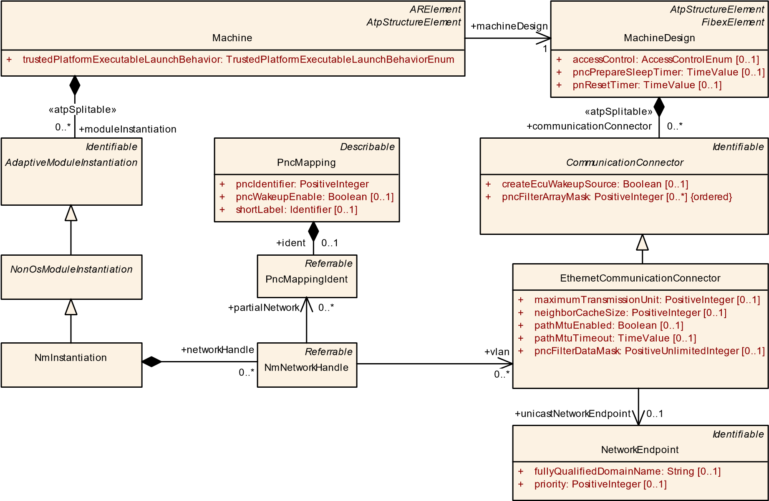

**Figure 9.27: Network configuration for Nm**

|  |  |  |  |  |
| --- | --- | --- | --- | --- |
| ***Class*** | **NmInstantiation** | | | |
| ***Package*** | M2::AUTOSARTemplates::AdaptivePlatform::PlatformModuleDeployment::AdaptiveModule Implementation | | | |
| ***Note*** | This meta-class defines the attributes for the Nm configuration on a specific machine.  **Tags:**atp.Status=draft | | | |
| ***Base*** | *ARObject*, *AdaptiveModuleInstantiation*, *Identifiable*, *MultilanguageReferrable*, *NonOsModule Instantiation*, *Referrable* | | | |
| ***Attribute*** | ***Type*** | ***Mult.*** | ***Kind*** | ***Note*** |
| networkHandle | NmNetworkHandle | * | aggr | Supported NmNetworkHandles used to control Partial Network Clusters/VLANs.  **Tags:**atp.Status=draft |

**Table 9.55: NmInstantiation**

|  |  |  |  |  |
| --- | --- | --- | --- | --- |
| ***Class*** | **NmNetworkHandle** | | | |
| ***Package*** | M2::AUTOSARTemplates::AdaptivePlatform::PlatformModuleDeployment::AdaptiveModule Implementation | | | |
| ***Note*** | Group of partialNetworks and/or VLANs that can be controlled collectively.  **Tags:**atp.Status=draft | | | |
| ***Base*** | *ARObject*, *Referrable* | | | |
| ***Attribute*** | ***Type*** | ***Mult.*** | ***Kind*** | ***Note*** |

5

|  |  |  |  |  |
| --- | --- | --- | --- | --- |
| ***Class*** | **NmNetworkHandle** |  |  |  |
| partialNetwork | PncMappingIdent | * | ref | Reference to a Partial Network that is included in the Nm NetworkHandle.  **Tags:**atp.Status=draft |
| vlan | EthernetCommunication  Connector | * | ref | Reference to a VLAN that is included in the NmNetwork Handle.  **Tags:**atp.Status=draft |

**Table 9.56: NmNetworkHandle**

AUTOSAR Adaptive Network Management is based on periodic NM messages, which are received by all UdpNmNodes in the UdpNmCluster via multicast. Reception of NM packets indicates that sending UdpNmNodes want to keep the UdpNmCluster awake.

If any node is ready to go to sleep mode, it stops sending NM messages, but as long as NM packets from other UdpNmNodes are received, it postpones transition to sleep mode.

**[TPS_MANI_03167]**{DRAFT} **Network configuration for Nm** dThe UDP multicast connection over which Network Management messages are transported is configured with the UdpNmNetworkConfiguration that is aggregated by the UdpNmCluster in the role networkConfiguration. The attribute udpPort is used to configure the port number over which the Nm message is transmitted and received. The IP Address is configured either by ipv4MulticastIpAddress or ipv6MulticastIpAddress.c*(RS_MANI_00023)*

**[TPS_MANI_03279]**{DRAFT} **Priority of Nm messages** dThe attribute priority in the UdpNmNetworkConfiguration can be used to assign a VLAN priority to Network Management messages that are transmitted over the Socket defined by the UdpNmNetworkConfiguration.udpPort and ipv4MulticastIpAddress or ipv6MulticastIpAddress.c*(RS_MANI_00023)*

**[constr_3419]**{DRAFT} **Allowed usage of UdpNmNetworkConfiguration attributes** dThe UdpNmNetworkConfiguration that is aggregated by UdpNmCluster in the role networkConfiguration shall have either • ipv4MulticastIpAddress or

• ipv6MulticastIpAddress. c*()*

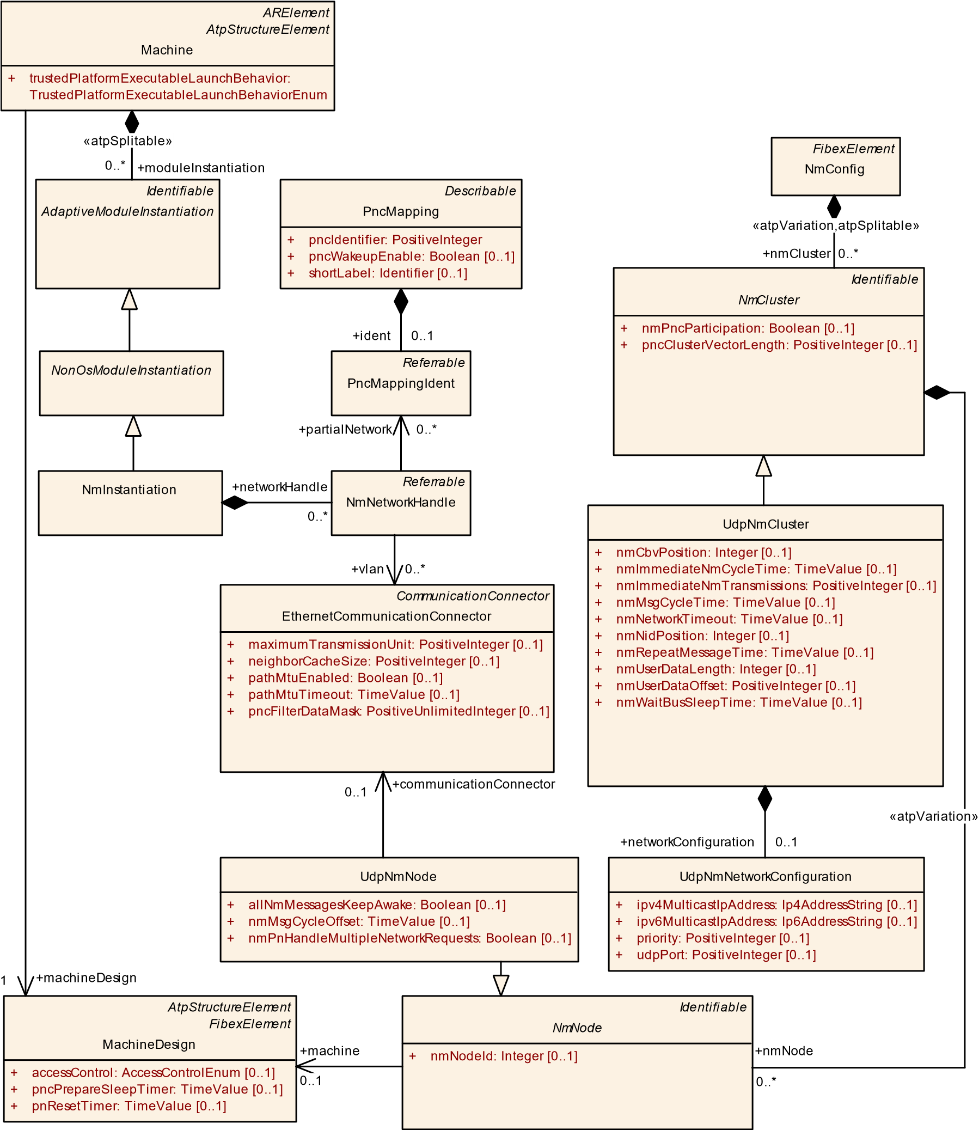

**Figure 9.28: NM Cluster configuration**

|  |  |  |  |  |
| --- | --- | --- | --- | --- |
| ***Class*** | **NmConfig** | | | |
| ***Package*** | M2::AUTOSARTemplates::SystemTemplate::NetworkManagement | | | |
| ***Note*** | Contains the all configuration elements for AUTOSAR Nm.  **Tags:**atp.recommendedPackage=NmConfigs | | | |
| ***Base*** | *ARObject*, *CollectableElement*, *FibexElement*, *Identifiable*, *MultilanguageReferrable*, *Packageable Element*, *Referrable* | | | |
| ***Attribute*** | ***Type*** | ***Mult.*** | ***Kind*** | ***Note*** |

5

|  |  |  |  |  |
| --- | --- | --- | --- | --- |
| ***Class*** | **NmConfig** |  |  |  |
| nmCluster | NmCluster | * | aggr | Collection of NM Clusters atpVariation: Derived, because cluster can be variable.  **Stereotypes:** atpSplitable; atpVariation **Tags:**  atp.Splitkey=nmCluster.shortName, nmCluster.variation Point.shortLabel  vh.latestBindingTime=postBuild |

**Table 9.57: NmConfig**

|  |  |  |  |  |
| --- | --- | --- | --- | --- |
| ***Class*** | ***NmCluster*** (abstract) | | | |
| ***Package*** | M2::AUTOSARTemplates::SystemTemplate::NetworkManagement | | | |
| ***Note*** | Set of NM nodes coordinated with use of the NM algorithm. | | | |
| ***Base*** | *ARObject*, *Identifiable*, *MultilanguageReferrable*, *Referrable* | | | |
| ***Subclasses*** | CanNmCluster, FlexrayNmCluster, UdpNmCluster | | | |
| ***Attribute*** | ***Type*** | ***Mult.*** | ***Kind*** | ***Note*** |
| communication Cluster | CommunicationCluster | 0..1 | ref | Association to a CommunicationCluster in the topology description. |
| nmNode | NmNode | * | aggr | Collection of NmNodes of the NmCluster.  atpVariation: Derived, because NmNode can be variable.  **Stereotypes:** atpVariation  **Tags:**vh.latestBindingTime=postBuild |
| nmPnc  Participation | Boolean | 0..1 | attr | Defines whether this NmCluster contributes to the partial network mechanism. |
| pncCluster  VectorLength | PositiveInteger | 0..1 | attr | Optionally defines the length of the PNC Vector per CommunicationCluster (and VLAN in case of UdpNm). If not defined then System.pncVectorLength applies.  Should only make the PNC Vector shorter (or same length as defined in System.pncVectorLength).  **Tags:**atp.Status=draft |

**Table 9.58: NmCluster**

|  |  |  |  |  |
| --- | --- | --- | --- | --- |
| ***Class*** | **UdpNmCluster** | | | |
| ***Package*** | M2::AUTOSARTemplates::SystemTemplate::NetworkManagement | | | |
| ***Note*** | Udp specific NmCluster attributes | | | |
| ***Base*** | *ARObject*, *Identifiable*, *MultilanguageReferrable*, *NmCluster*, *Referrable* | | | |
| ***Attribute*** | ***Type*** | ***Mult.*** | ***Kind*** | ***Note*** |
| network  Configuration | UdpNmNetwork  Configuration | 0..1 | aggr | Configuration of a UDP port and UDP multicast IP address of the Nm communication on a VLAN.  **Tags:**atp.Status=draft |
| nmCbvPosition | Integer | 0..1 | attr | Defines the position of the control bit vector within the Nm Pdu (Byte position). If this attribute is not configured, the Control Bit Vector is not used. |
| nmImmediate NmCycleTime | TimeValue | 0..1 | attr | Defines the immediate NmPdu cycle time in seconds which is used for nmImmediateNmTransmissions NmPdu transmissions. This attribute is only valid if nmImmediate NmTransmissions is greater one. |

5

|  |  |  |  |  |
| --- | --- | --- | --- | --- |
| ***Class*** | **UdpNmCluster** |  | | |
| nmImmediate  Nm  Transmissions | PositiveInteger | 0..1 | attr | Defines the number of immediate NmPdus which shall be transmitted. If the value is zero no immediate NmPdus are transmitted. The cycle time of immediate NmPdus is defined by nmImmediateNmCycleTime. |
| nmMsgCycle Time | TimeValue | 0..1 | attr | Period of a NmPdu in seconds. It determines the periodic rate in the periodic transmission mode with bus load reduction and is the basis for transmit scheduling in the periodic transmission mode without bus load reduction. |
| nmNetwork Timeout | TimeValue | 0..1 | attr | Network Timeout for NmPdus in seconds. It denotes the time how long the UdpNm shall stay in the Network Mode before transition into Prepare Bus-Sleep Mode shall take place. |
| nmNidPosition | Integer | 0..1 | attr | Defines the byte position of the source node identifier within the NmPdu. If this attribute is not configured, the Node Identification is not used. |
| nmRepeat  MessageTime | TimeValue | 0..1 | attr | Timeout for Repeat Message State in seconds. Defines the time how long the NM shall stay in the Repeat Message State. |
| nmUserData Length | Integer | 0..1 | attr | Defines the length in bytes of the user data contained in the Nm message. User data excludes the PN information. |
| nmUserData  Offset | PositiveInteger | 0..1 | attr | Specifies the offset (in bytes) of the user data information in the NM message. User data excludes the PN information.  **Tags:**atp.Status=draft |
| nmWaitBus SleepTime | TimeValue | 0..1 | attr | Timeout for bus calm down phase in seconds. It denotes the time how long the CanNm shall stay in the Prepare Bus-Sleep Mode before transition into Bus-Sleep Mode shall take place. |
| vlan | EthernetPhysical  Channel | 0..1 | ref | Reference to the vlan (represented by the Ethernet  PhysicalChannel) this UdpNmCluster shall apply to. |

**Table 9.59: UdpNmCluster**

|  |  |  |  |  |
| --- | --- | --- | --- | --- |
| ***Class*** | ***NmNode*** (abstract) | | | |
| ***Package*** | M2::AUTOSARTemplates::SystemTemplate::NetworkManagement | | | |
| ***Note*** | The linking of NmEcus to NmClusters is realized via the NmNodes. | | | |
| ***Base*** | *ARObject*, *Identifiable*, *MultilanguageReferrable*, *Referrable* | | | |
| ***Subclasses*** | CanNmNode, FlexrayNmNode, UdpNmNode | | | |
| ***Attribute*** | ***Type*** | ***Mult.*** | ***Kind*** | ***Note*** |
| machine | MachineDesign | 0..1 | ref | Reference to the machine that contains the NmNode.  **Tags:**atp.Status=draft |
| nmNodeId | Integer | 0..1 | attr | Node identifier of local NmNode. Shall be unique in the NmCluster. |

**Table 9.60: NmNode**

|  |  |
| --- | --- |
| ***Class*** | **UdpNmNode** |
| ***Package*** | M2::AUTOSARTemplates::SystemTemplate::NetworkManagement |
| ***Note*** | Udp specific NM Node attributes. |
| ***Base*** | *ARObject*, *Identifiable*, *MultilanguageReferrable*, *NmNode*, *Referrable* |

5

|  |  |  |  |  |
| --- | --- | --- | --- | --- |
| ***Class*** | **UdpNmNode** | | | |
| ***Attribute*** | ***Type*** | ***Mult.*** | ***Kind*** | ***Note*** |
| allNmMessages KeepAwake | Boolean | 0..1 | attr | Specifies if Nm drops irrelevant NM PDUs.  false: Only NM PDUs with a Partial Network Information Bit (PNI) = true and containing a Partial Network request  for this ECU trigger the standard RX indication handling and thus keep the ECU awake  true: Every NM PDU triggers the standard RX indication handling and keeps the ECU awake |
| communication Connector | EthernetCommunication  Connector | 0..1 | ref | Reference to the CommunicationConnector that represents the UdpNmNode in the topology description.  **Tags:**atp.Status=draft |
| nmMsgCycle  Offset | TimeValue | 0..1 | attr | Node specific time offset in the periodic transmission node. It determines the start delay of the transmission.  Specified in seconds. |
| nmPnHandle  MultipleNetwork  Requests | Boolean | 0..1 | attr | Specifies if NM performs an additional transition from Network Mode to Repeat Message State (true) or not  (false). |

**Table 9.61: UdpNmNode**

**[TPS_MANI_01343]**{DRAFT} **Relation between Function Group states and NmNetworkHandle** dAn essential part of the network management on the *AUTOSAR adaptive platform* is the understanding which function group state requires network access. This relation can be expressed by means of meta-class NmHandleToFunctionGroupStateMapping.c*(RS_MANI_00023)*

*NonOsModuleInstantiation*

NmInstantiation

*Referrable*

NmNetworkHandle

*AtpPrototype*

ModeDeclarationGroupPrototype

*ARElement*

*AtpClassifier*

FunctionGroupSet

*UploadablePackageElement*

NmHandleToFunctionGroupStateMapping

*ARElement*

*AtpBlueprint*

*AtpBlueprintable*

*AtpType*

ModeDeclarationGroup

*AtpStructureElement*

*Identifiable*

ModeDeclaration

«atpVariation»

+

modeDeclaration

0..*

networkHandle

+

0..*

initialMode

+

0..1

«isOfType»

+

type

0..1

{

redefines atpType

}

+

functionGroup

0..*

nmHandle

+

0..1

«instanceRef»

functionGroup

+

0..*

**Figure 9.29: Mapping between NmNetworkHandle and function group states**

|  |  |
| --- | --- |
| ***Class*** | **NmHandleToFunctionGroupStateMapping** |
| ***Package*** | M2::AUTOSARTemplates::AdaptivePlatform::PlatformModuleDeployment::AdaptiveModule Implementation |
| ***Note*** | This meta-class represents the ability to create a mapping between an NmNetworkHandle and a collection of function group states. This way, the impact of function groups on the network management can be specified.  **Tags:**  atp.Status=draft  atp.recommendedPackage=NmHandleToFunctionGroupStateMappings |

5

**Table 9.62: NmHandleToFunctionGroupStateMapping**

**9.7.1 UdpNm configuration constraints**

Please note that the Classic Platform and the Adaptive Platform are using the same model for configuration of UdpNm. Some Classic Platform features like the NmCoordinator and UdpNmClusterCoupling are not supported in Adaptive Autosar.

But the TPS_SystemTemplate [17] contains a more detailed description of UdpNmClusters and UdpNmNodes and defines modeling constraints that are also valid for the Adaptive Platform.

The following constraints of the TPS_SystemTemplate [17] shall be considered if a UdpNmCluster with UdpNmNodes is described:

|  |  |  |  |  |
| --- | --- | --- | --- | --- |
| ***Class*** | **NmHandleToFunctionGroupStateMapping** | | | |
| ***Base*** | *ARElement*, *ARObject*, *CollectableElement*, *Identifiable*, *MultilanguageReferrable*, *Packageable*  *Element*, *Referrable*, *UploadablePackageElement* | | | |
| ***Attribute*** | ***Type*** | ***Mult.*** | ***Kind*** | ***Note*** |
| functionGroup | ModeDeclaration | * | iref | This reference identifies the collection of function group states in the context of the mapping.  **Tags:**atp.Status=draft  **InstanceRef implemented by:**FunctionGroupStateIn  FunctionGroupSetInstanceRef |
| nmHandle | NmNetworkHandle | 0..1 | ref | This reference identifies the applicable NmNetwork Handle in the context of the mapping.  **Tags:**atp.Status=draft |

* [constr_3041]
* [constr_3042]
* [constr_3078]
* [constr_3079]
* [constr_3080]
* [constr_5223]
* [constr_5224]
* [constr_5225]
* [constr_5226]

In addition the following Adaptive Platform specific constraints are valid:

**[constr_5227]**{DRAFT} **Mandatory elements of UdpNmCluster** dThe following attributes shall always be defined for the UdpNmCluster:

* nmMsgCycleTime
* nmNetworkTimeout
* nmRepeatMessageTime
* nmWaitBusSleepTime
* communicationCluster c*()*

**[constr_5228]**{DRAFT} **Partial Networking timing constraint** dFor Partial Networking the following timing constraints shall be ensured: (MachineDesign.pnReset-

Timer + MachineDesign.pncPrepareSleepTimer) < UdpNmCluster.nmNetworkTimeoutc*()*

## 9.8 Update and Configuration Management

**[TPS_MANI_01226]**{DRAFT} **Machine-specific configuration settings for the UCM module** dThe Machine-specific configuration settings for Ucm are collected in meta-class UcmModuleInstantiation.c*(RS_MANI_00023)*

|  |  |  |  |  |
| --- | --- | --- | --- | --- |
| ***Class*** | **UcmModuleInstantiation** | | | |
| ***Package*** | M2::AUTOSARTemplates::AdaptivePlatform::PlatformModuleDeployment::Ucm | | | |
| ***Note*** | This meta-class represents the ability to define a definition of a UCM instantiation.  **Tags:**atp.Status=draft | | | |
| ***Base*** | *ARObject*, *AdaptiveModuleInstantiation*, *Identifiable*, *MultilanguageReferrable*, *NonOsModule Instantiation*, *Referrable* | | | |
| ***Attribute*** | ***Type*** | ***Mult.*** | ***Kind*** | ***Note*** |
| identifier | String | 1 | attr | This represents the identification of a UCM.  **Tags:**atp.Status=draft |
| maxNumberOf  Parallel  Transfers | PositiveInteger | 0..1 | attr | This attribute supports the configuration of the maximum number of parallel transfers that the Ucm on the enclosing Machine is allowed to create.  **Tags:**atp.Status=draft |
| ucmSoftware Version | StrongRevisionLabel  String | 0..1 | attr | This attribute defines the software version of the UCM on this platform.  Note that the definition of the ucmSoftwareVersion is required if the ability of the SoftwarePackage to require a minimum version of the UCM is utilized.  **Tags:**atp.Status=draft |

**Table 9.63: UcmModuleInstantiation**

*Identifiable*

*AdaptiveModuleInstantiation*

UcmModuleInstantiation

+

identifier: String

+

maxNumberOfParallelTransfers: PositiveInteger

[0..1]

+

ucmSoftwareVersion: StrongRevisionLabelString

[0..1]

*NonOsModuleInstantiation*

**Figure 9.30: Modeling of UcmModuleInstantiation**

**[TPS_MANI_01227]**{DRAFT} **Semantics of attribute UcmModuleInstantiation. identifier** dAttribute UcmModuleInstantiation.identifier shall be used to identify a specific Ucm on a specific Machine during a service discovery run by a master UCM or VUM.c*(RS_MANI_00023)*

The usage of attribute UcmModuleInstantiation.identifier is documented in Figure 9.31. The master UCM or VUM acts as a client in a service discovery that is configured to search for *any* server.

The individual UCMs offer their service and then the master UCM as the client calls a specific method in the server’s ServiceInterface to reveal the identifier of each server.

Master UCM/VUM

RPort

Slave UCM

UcmModuleInstantiation.

identifier = 1

Slave UCM

UcmModuleInstantiation.

identifier = 2

Slave UCM

UcmModuleInstantiation.

identifier = 3

PPort

PPort

PPort

Proxy

id = 1

Proxy

id = 2

Proxy

id = 3

container = FindService();

proxies = CreateProxies(container);

for (proxy p : proxies) {

if (2 == p.GetId()) {

...

}

}

**Figure 9.31: Identification of slave UCM modules by the master UCM**

In the case of this example there are three slave UCMs with identifier set to 1, 2, and 3. The master UCM instantiates a proxy for each of the slave UCMs such that the value of the respective identifier can be retrieved from the proxy in order to be able to communicate with a specific slave UCM.

The master UCM or VUM can then instantiate proxies for each service offer and programmatically access the respective server going forward.

**[constr_1691]**{DRAFT}**UcmModuleInstantiation.identifier shall be unique** dThe value of attribute UcmModuleInstantiation.identifier shall be unique for each Machine in a given vehicle.c*()*

## 9.9 IAM configuration

The definition of the deployment for the *Identity and Access Manager* represents the creation of actual grants, as opposed to the definition of grants on design level.

One important aspect of the modeling on deployment level is that it is not intended to include a large portion of the design model. The goal is to keep the deployment part as self-contained as possible.

While this approach represents a significant benefit for the size of deployment models it also creates some sort of disconnect between design and deployment. In other words, the connection of the modeling of a specific Grant to the respective intent in the design model is not immediately obvious.

To mitigate this issue, AUTOSAR introduced the GrantDesign that in turn allows for the identification of the corresponding intent modeling. When loading the design model and deployment model together into a suitable tool it would still be possible to run an analysis in terms of completeness of the overall IAM configuration.

The enforcement of access restrictions is not mandatory for a Machine. Therefore, the existence of a Grant by itself is not sufficient to activate the IAM mechanisms.

*Identifiable*

*AdaptiveModuleInstantiation*

*NonOsModuleInstantiation*

IamModuleInstantiation

[0..1]

localComAccessControlEnabled: Boolean

+

[0..1]

remoteAccessControlEnabled: Boolean

+

*ARElement*

*Grant*

«atpSplitable»

+

grant

0..*

**Figure 9.32: Modeling of the IamModuleInstantiation**

**[constr_1695]**{DRAFT} **Semantics of a Grant depends on the existence of IamModuleInstantiation** dThe existence of Grants shall only be enforced if in the context of the enclosing Machine an IamModuleInstantiation has been defined and is referencing the Grant.c*()*

**[constr_3677]**{DRAFT} **ComGrants referencing DDS Service Instances** dCom-

Grants associated with DdsProvidedServiceInstances or DdsRequiredServiceInstances via the serviceInstance attribute shall not be referenced by IamModuleInstantiation.grant, since access control in the DDS Network Binding is delegated to DDS Security.c*()*

Further information about DDS Security can be found in section 10.5.3.

**9.9.1 Com Grant Deployment**

**[TPS_MANI_01237]**{DRAFT} **Semantics of meta-class ComFieldGrant** dMetaclass ComFieldGrant shall be used to award access to a given field (identified by means of the reference to meta-class ServiceFieldDeployment in the role serviceDeployment) in the context of a given AdaptivePlatformServiceInstance referenced in the role serviceInstance.c*(RS_MANI_00060)*

In other words, if a given AdaptivePlatformServiceInstance and the respective ServiceFieldDeployment are not referenced from a ComFieldGrant and an IamModuleInstantiation exists **then this specific communication shall be suppressed**.

|  |  |  |  |  |
| --- | --- | --- | --- | --- |
| ***Class*** | **ComFieldGrant** | | | |
| ***Package*** | M2::AUTOSARTemplates::AdaptivePlatform::PlatformModuleDeployment::IdentityAccessManagement | | | |
| ***Note*** | This meta-class represents the ability to grant access to a ServiceInterface.field.  **Tags:**  atp.Status=draft  atp.recommendedPackage=Grants | | | |
| ***Base*** | *ARElement*, *ARObject*, *CollectableElement*, *ComGrant*, *Grant*, *Identifiable*, *MultilanguageReferrable*, *PackageableElement*, *Referrable* | | | |
| ***Attribute*** | ***Type*** | ***Mult.*** | ***Kind*** | ***Note*** |
| design | ComFieldGrantDesign | 0..1 | ref | This reference identifies the ComFieldGrantDesign that the enclosing ComFieldGrant was created from.  **Stereotypes:** atpUriDef **Tags:**atp.Status=draft |
| role | FieldAccessEnum | 1 | attr | This attribute provides the ability to further specify the access to the ServiceInterface.field.  **Tags:**atp.Status=draft |
| service  Deployment | ServiceField  Deployment | 1 | ref | This reference identifies the applicable deployment within the context of an AdaptivePlatformServiceInstance for which the grant applies. **Tags:**atp.Status=draft |

**Table 9.64: ComFieldGrant**

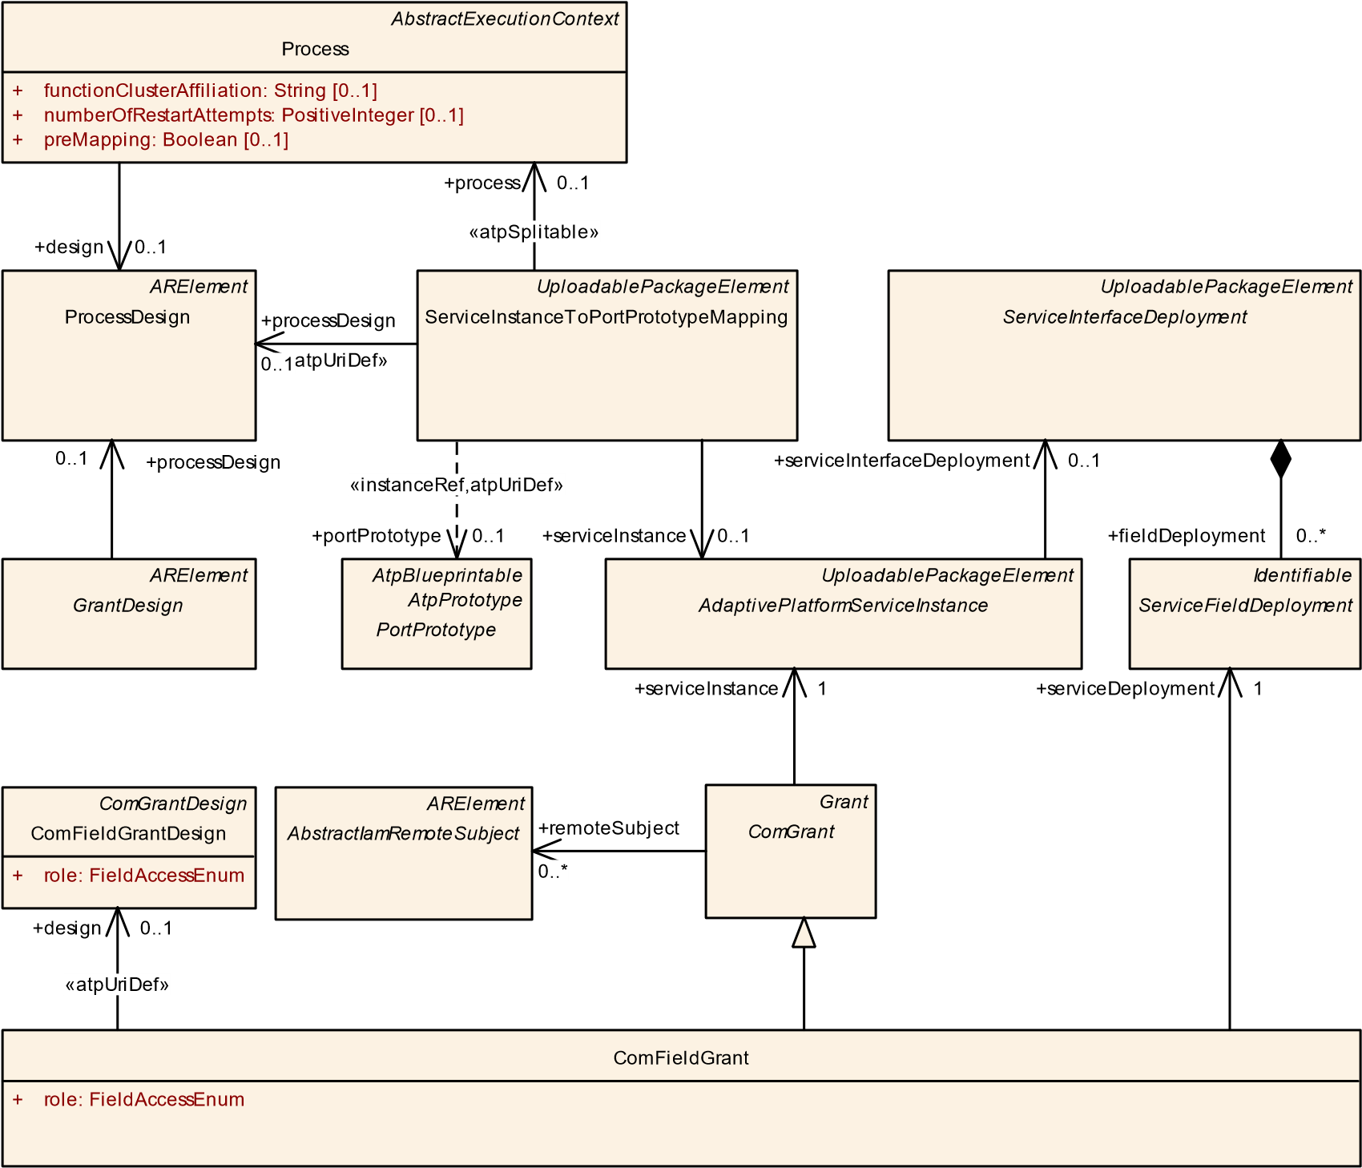

**Figure 9.33: Modeling of the ComFieldGrant**

**[TPS_MANI_01238]**{DRAFT} **Semantics of meta-class ComMethodGrant** dMetaclass ComMethodGrant shall be used to clear the call of a given method (identified by means of the reference to meta-class ServiceMethodDeployment in the role serviceDeployment) in the context of a given AdaptivePlatformServiceInstance referenced in the role serviceInstance.c*(RS_MANI_00060)*

In other words, if a given AdaptivePlatformServiceInstance and the respective ServiceMethodDeployment are not referenced from a ComMethodGrant and an IamModuleInstantiation exists **then this specific communication shall be suppressed**.

|  |  |
| --- | --- |
| ***Class*** | **ComMethodGrant** |
| ***Package*** | M2::AUTOSARTemplates::AdaptivePlatform::PlatformModuleDeployment::IdentityAccessManagement |
| ***Note*** | This meta-class represents the ability to grant access to a ServiceInterface.method.  **Tags:**  atp.Status=draft  atp.recommendedPackage=Grants |
| ***Base*** | *ARElement*, *ARObject*, *CollectableElement*, *ComGrant*, *Grant*, *Identifiable*, *MultilanguageReferrable*, *PackageableElement*, *Referrable* |

5

4

|  |  |  |  |  |
| --- | --- | --- | --- | --- |
| ***Class*** | **ComMethodGrant** | |  |  |
| ***Attribute*** | ***Type*** | ***Mult.*** | ***Kind*** | ***Note*** |
| design | ComMethodGrant  Design | 0..1 | ref | This reference identifies the ComMethodGrantDesign that the enclosing ComMethodGrant was created from.  **Stereotypes:** atpUriDef  **Tags:**atp.Status=draft |
| service  Deployment | ServiceMethod  Deployment | 1 | ref | This reference identifies the applicable deployment within the context of an AdaptivePlatformServiceInstance for which the grant applies. **Tags:**atp.Status=draft |

**Table 9.65: ComMethodGrant**

*ARElement*

ProcessDesign

*ARElement*

*GrantDesign*

*AbstractExecutionContext*

Process

[0..1]

functionClusterAffiliation: String

+

numberOfRestartAttempts: PositiveInteger

+

[0..1]

+

[0..1]

preMapping: Boolean

*UploadablePackageElement*

*AdaptivePlatformServiceInstance*

*UploadablePackageElement*

*ServiceInterfaceDeployment*

*UploadablePackageElement*

ServiceInstanceToPortPrototypeMapping

*AtpBlueprintable*

*AtpPrototype*

*PortPrototype*

*Identifiable*

*ServiceMethodDeployment*

*ComGrantDesign*

ComMethodGrantDesign

ComMethodGrant

*ARElement*

*AbstractIamRemoteSubject*

*Grant*

*ComGrant*

serviceInterfaceDeployment

+

0..1

+

methodDeployment

0..*

+

processDesign

0..1

serviceDeployment

+

1

+

remoteSubject

0..*

+

design

0..1

«atpUriDef»

+

processDesign

0..1

«atpSplitable»

process

+

0..1

«atpUriDef»

+

design

0..1

+

serviceInstance

0..1

«instanceRef,atpUriDef»

portPrototype

+

0..1

+

serviceInstance

1

**Figure 9.34: Modeling of the ComMethodGrant**

**[TPS_MANI_01239]**{DRAFT} **Semantics of meta-class ComEventGrant** dMetaclass ComEventGrant shall be used to award access to a given event or trigger (identified by means of the reference to meta-class ServiceEventDeployment in the role serviceDeployment) in the context of a given AdaptivePlatformServiceInstance referenced in the role serviceInstance.c*(RS_MANI_00060)*

In other words, if a given AdaptivePlatformServiceInstance and the respective ServiceEventDeployment are not referenced from a ComEventGrant and an IamModuleInstantiation exists **then this specific communication shall be suppressed**.

*ARElement*

ProcessDesign

*ARElement*

*GrantDesign*

*AbstractExecutionContext*

Process

functionClusterAffiliation: String

+

[0..1]

[0..1]

numberOfRestartAttempts: PositiveInteger

+

[0..1]

+

preMapping: Boolean

*UploadablePackageElement*

*AdaptivePlatformServiceInstance*

*UploadablePackageElement*

*ServiceInterfaceDeployment*

*UploadablePackageElement*

ServiceInstanceToPortPrototypeMapping

*AtpBlueprintable*

*AtpPrototype*

*PortPrototype*

ComEventGrant

*ComGrantDesign*

ComEventGrantDesign

*Identifiable*

*ServiceEventDeployment*

*ARElement*

*AbstractIamRemoteSubject*

*Grant*

*ComGrant*

eventDeployment

+

0..*

+

processDesign

0..1

+

remoteSubject

0..*

«atpUriDef»

+

processDesign

0..1

+

design

0..1

«atpUriDef»

+

design

0..1

serviceDeployment

+

1

«instanceRef,atpUriDef»

portPrototype

+

0..1

«atpSplitable»

process

+

0..1

+

serviceInstance

1

serviceInstance

+

0..1

serviceInterfaceDeployment

+

0..1

**Figure 9.35: Modeling of the ComEventGrant**

|  |  |  |  |  |
| --- | --- | --- | --- | --- |
| ***Class*** | **ComEventGrant** | | | |
| ***Package*** | M2::AUTOSARTemplates::AdaptivePlatform::PlatformModuleDeployment::IdentityAccessManagement | | | |
| ***Note*** | This meta-class represents the ability to grant access to a ServiceInterface.event.  **Tags:**  atp.Status=draft  atp.recommendedPackage=Grants | | | |
| ***Base*** | *ARElement*, *ARObject*, *CollectableElement*, *ComGrant*, *Grant*, *Identifiable*, *MultilanguageReferrable*, *PackageableElement*, *Referrable* | | | |
| ***Attribute*** | ***Type*** | ***Mult.*** | ***Kind*** | ***Note*** |
| design | ComEventGrantDesign | 0..1 | ref | This reference identifies the ComEventGrantDesign that the enclosing ComEventGrant was created from.  **Stereotypes:** atpUriDef **Tags:**atp.Status=draft |

5

4

|  |  |  |  |  |
| --- | --- | --- | --- | --- |
| ***Class*** | **ComEventGrant** |  |  |  |
| service  Deployment | ServiceEvent  Deployment | 1 | ref | This reference identifies the applicable deployment within the context of an AdaptivePlatformServiceInstance for which the grant applies. **Tags:**atp.Status=draft |

**Table 9.66: ComEventGrant**

The enforcement of service discovery rights is modeled by means of meta-classes ComOfferServiceGrant and ComFindServiceGrant.

**[TPS_MANI_01240]**{DRAFT} **Semantics of meta-class ComOfferServiceGrant** dMeta-class ComOfferServiceGrant shall be used to award the right to offer the referenced AdaptivePlatformServiceInstance.c*(RS_MANI_00060)*

|  |  |  |  |  |
| --- | --- | --- | --- | --- |
| ***Class*** | **ComOfferServiceGrant** | | | |
| ***Package*** | M2::AUTOSARTemplates::AdaptivePlatform::PlatformModuleDeployment::IdentityAccessManagement | | | |
| ***Note*** | This meta-class represents the ability to grant the offering of a service.  **Tags:**  atp.Status=draft  atp.recommendedPackage=Grants | | | |
| ***Base*** | *ARElement*, *ARObject*, *CollectableElement*, *Grant*, *Identifiable*, *MultilanguageReferrable*, *Packageable Element*, *Referrable* | | | |
| ***Attribute*** | ***Type*** | ***Mult.*** | ***Kind*** | ***Note*** |
| design | ComOfferServiceGrant  Design | 0..1 | ref | This reference identifies the ComOfferServiceGrant Design that the enclosing ComOfferServiceGrant was created from.  **Stereotypes:** atpUriDef  **Tags:**atp.Status=draft |
| serviceInstance | AdaptivePlatform  ServiceInstance | 1 | ref | This reference identifies the AdaptivePlatformService Instances for which the grant applies.  **Tags:**atp.Status=draft |

**Table 9.67: ComOfferServiceGrant**

**[TPS_MANI_01241]**{DRAFT} **Semantics of meta-class ComFindServiceGrant** dMeta-class ComFindServiceGrant shall be used to award the right to start a find of the referenced AdaptivePlatformServiceInstance.c*(RS_MANI_00060)*

|  |  |  |  |  |
| --- | --- | --- | --- | --- |
| ***Class*** | **ComFindServiceGrant** | | | |
| ***Package*** | M2::AUTOSARTemplates::AdaptivePlatform::PlatformModuleDeployment::IdentityAccessManagement | | | |
| ***Note*** | This meta-class represents the ability to grant the finding a service.  **Tags:**  atp.Status=draft  atp.recommendedPackage=Grants | | | |
| ***Base*** | *ARElement*, *ARObject*, *CollectableElement*, *Grant*, *Identifiable*, *MultilanguageReferrable*, *Packageable Element*, *Referrable* | | | |
| ***Attribute*** | ***Type*** | ***Mult.*** | ***Kind*** | ***Note*** |

5

4

|  |  |  |  |  |
| --- | --- | --- | --- | --- |
| ***Class*** | **ComFindServiceGrant** |  |  |  |
| design | ComFindServiceGrant  Design | 0..1 | ref | This reference identifies the ComFindServiceGrantDesign that the enclosing ComFindServiceGrant was created from.  **Stereotypes:** atpUriDef  **Tags:**atp.Status=draft |
| serviceInstance | AdaptivePlatform  ServiceInstance | 0..1 | ref | This reference identifies the AdaptivePlatformService Instances for which the grant applies.  **Tags:**atp.Status=draft |

**Table 9.68: ComFindServiceGrant**

**9.9.2 Grant Deployment for Raw Streaming Data**

The definition of abstract meta-class RawDataStreamGrant on the level of deployment complements the existence of RawDataStreamGrantDesign on design level.

*ARElement*

ProcessDesign

*ARElement*

*GrantDesign*

*AbstractExecutionContext*

Process

[0..1]

functionClusterAffiliation: String

+

[0..1]

numberOfRestartAttempts: PositiveInteger

+

[0..1]

+

preMapping: Boolean

*ARElement*

*Grant*

RawDataStreamGrantDesign

*RawDataStreamGrant*

*UploadablePackageElement*

*RawDataStreamMapping*

EthernetRawDataStreamGrant

*EthernetRawDataStreamMapping*

[0..*]

+

socketOption: String

*AbstractRequiredPortPrototype*

RPortPrototype

design

+

0..1

+

ethernetRawDataStreamMapping

0..1

«atpUriDef»

+

design

0..1

processDesign

+

0..1

+

process

0..1

«instanceRef,atpUriDef»

portPrototype

+

0..1

**Figure 9.36: Modeling of the RawDataStreamGrant**

**[TPS_MANI_01307]**{DRAFT} **Semantics of meta-class EthernetRawDataStreamGrant** dMeta-class EthernetRawDataStreamGrant provides the deployment-level IAM semantics for raw data streams that run on TCP/IP sockets. For this purpose, the reference in the role ethernetRawDataStreamMapping to meta-class EthernetRawDataStreamMapping exists.c*(RS_MANI_00060, RS_MANI_00067)*

|  |  |  |  |  |
| --- | --- | --- | --- | --- |
| ***Class*** | ***RawDataStreamGrant*** (abstract) | | | |
| ***Package*** | M2::AUTOSARTemplates::AdaptivePlatform::PlatformModuleDeployment::IdentityAccessManagement | | | |
| ***Note*** | This abstract meta-class represents the ability to define the IAM configuration for a RawDataStream on deployment level.  **Tags:**atp.Status=draft | | | |
| ***Base*** | *ARElement*, *ARObject*, *CollectableElement*, *Grant*, *Identifiable*, *MultilanguageReferrable*, *Packageable Element*, *Referrable* | | | |
| ***Subclasses*** | EthernetRawDataStreamGrant | | | |
| ***Attribute*** | ***Type*** | ***Mult.*** | ***Kind*** | ***Note*** |
| design | RawDataStreamGrant  Design | 0..1 | ref | This reference identifies the RawDataStreamGrantDesign that the enclosing RawDataStreamEventGrant was created from.  **Stereotypes:** atpUriDef  **Tags:**atp.Status=draft |

**Table 9.69: RawDataStreamGrant**

|  |  |  |  |  |
| --- | --- | --- | --- | --- |
| ***Class*** | **EthernetRawDataStreamGrant** | | | |
| ***Package*** | M2::AUTOSARTemplates::AdaptivePlatform::PlatformModuleDeployment::IdentityAccessManagement | | | |
| ***Note*** | This meta-class represents the ability to define the IAM configuration for a EthernetRawDataStream on deployment level.  **Tags:**  atp.Status=draft  atp.recommendedPackage=Grants | | | |
| ***Base*** | *ARElement*, *ARObject*, *CollectableElement*, *Grant*, *Identifiable*, *MultilanguageReferrable*, *Packageable Element*, *RawDataStreamGrant*, *Referrable* | | | |
| ***Attribute*** | ***Type*** | ***Mult.*** | ***Kind*** | ***Note*** |
| ethernetRaw DataStream  Mapping | EthernetRawData  StreamMapping | 0..1 | ref | This reference identifies the applicable EthernetRawData Stream to which the enclosing EthernetRawDataStream Grant shall apply.  **Tags:**atp.Status=draft |

**Table 9.70: EthernetRawDataStreamGrant**

**9.9.3 Remote access control**

The overview of the remote access control was already introduced in chapter 3.20.3. Please note that for the modeling of AbstractIamRemoteSubjects the same approach is used in the Design and in the Deployment. So if AbstractIamRemoteSubjects were defined during the design phase they can be taken over into the deployment.

This chapter defines how ComGrants with a defined remoteSubjects shall be interpreted.

**[TPS_MANI_03245]**{DRAFT} **Definition of ComMethodGrant.remoteSubjects on server side** dIf the ComMethodGrant references a ProvidedApServiceInstance in the role serviceInstance then the ComMethodGrant.remoteSubject reference defines the remoteSubjects that are allowed to call the defined method that is referenced by the ComMethodGrant in the role serviceDeployment.c*(RS_MANI_00060)*

**[TPS_MANI_03246]**{DRAFT} **Definition of ComMethodGrant.remoteSubjects on client side** dIf the ComMethodGrant references a RequiredApServiceInstance in the role serviceInstance then the ComMethodGrant.remoteSubject reference defines the remoteSubjects to which a ServiceMethodDeployment. method call is allowed to be sent.c*(RS_MANI_00060)*

**[TPS_MANI_03247]**{DRAFT} **Definition of ComEventGrant.remoteSubjects on provider side** dIf the ComEventGrant references a ProvidedApServiceInstance in the role serviceInstance then the ComEventGrant.remoteSubject reference defines the remoteSubjects to which an ServiceEventDeployment.event is allowed to be sent.c*(RS_MANI_00060)*

**[TPS_MANI_03248]**{DRAFT} **Definition of ComEventGrant.remoteSubjects on receiver side** dIf the ComEventGrant references a RequiredApServiceInstance in the role serviceInstance then the ComEventGrant.remoteSubject reference defines the remoteSubjects from which an ServiceEventDeployment.event is allowed to be received.c*(RS_MANI_00060)*

**[TPS_MANI_03249]**{DRAFT} **Definition of ComFieldGrant.remoteSubjects on provider side** dIf the ComFieldGrant references a ProvidedApServiceInstance in the role serviceInstance then the ComFieldGrant.remoteSubject reference defines the remoteSubjects that are allowed to access the Field that is referenced by the ServiceFieldDeployment that in turn is referenced by the ComFieldGrant in the role serviceDeployment. This allows the following communication between the local Machine and the AbstractIamRemoteSubject:

* the Field notifier is allowed to be sent to remoteSubjects,
* if ComFieldGrant.role equals setter or getterSetter, then the setter call is allowed to be received from the remoteSubjects,
* if ComFieldGrant.role equals setter or getterSetter, then the setter return is allowed to be sent to remoteSubjects,
* if ComFieldGrant.role equals getter or getterSetter, then the getter call is allowed to be received from the remoteSubjects,
* if ComFieldGrant.role equals getter or getterSetter, then the getter return is allowed to be sent to remoteSubjects.

c*(RS_MANI_00060)*

**[TPS_MANI_03250]**{DRAFT} **Definition of ComFieldGrant.remoteSubjects on client side** dIf the ComFieldGrant references a RequiredApServiceInstance in the role serviceInstance then the ComFieldGrant.remoteSubject reference defines the remoteSubjects that are allowed to provide the Field for access that is referenced by the ServiceFieldDeployment that in turn is referenced by the ComFieldGrant in the role serviceDeployment. This will allow the following communication between the local Machine and the AbstractIamRemoteSubject:

* the Field notifier is allowed to be received from remoteSubjects,
* if ComFieldGrant.role equals setter or getterSetter, then the setter call is allowed to be sent to the remoteSubjects,
* if ComFieldGrant.role equals setter or getterSetter, then the setter return is allowed to be received from remoteSubjects,
* if ComFieldGrant.role equals getter or getterSetter, the getter call is allowed to be sent to the remoteSubjects,
* if ComFieldGrant.role equals getter or getterSetter, the getter return is allowed to be received from remoteSubjects.

c*(RS_MANI_00060)*

Please note that a ComGrant with the remoteSubject reference defines that a remote access control for this ComGrant will be performed. Such a ComGrant with the remoteSubject reference does not enforce any Machine local access restrictions.

To enforce local access restrictions for the same ServiceInterface element of the same AdaptivePlatformServiceInstance an additional ComGrant needs to be defined that points to the same serviceInstance and to the same Com-

FieldGrant.serviceDeployment or ComEventGrant.serviceDeployment or

ComMethodGrant.serviceDeployment but does not contain the remoteSubject reference.

## 9.10 Crypto Deployment

This chapter explains the configuration of the Crypto functional cluster and the interaction of application Software with the Crypto stack [13].

**[TPS_MANI_03260]**{DRAFT} **Semantics of meta-class CryptoModuleInstantiation** dThe representation of the Crypto functional cluster [13] within one specific Machine is defined by the CryptoModuleInstantiation.c*(RS_MANI_00023)*

|  |  |  |  |  |
| --- | --- | --- | --- | --- |
| ***Class*** | **CryptoModuleInstantiation** | | | |
| ***Package*** | M2::AUTOSARTemplates::AdaptivePlatform::PlatformModuleDeployment::CryptoDeployment | | | |
| ***Note*** | This meta-class defines the configuration for the Crypto stack on a specific machine.  **Tags:**atp.Status=draft | | | |
| ***Base*** | *ARObject*, *AdaptiveModuleInstantiation*, *Identifiable*, *MultilanguageReferrable*, *NonOsModule Instantiation*, *Referrable* | | | |
| ***Attribute*** | ***Type*** | ***Mult.*** | ***Kind*** | ***Note*** |

5

4

|  |  |  |  |  |
| --- | --- | --- | --- | --- |
| ***Class*** | **CryptoModuleInstantiati** | **on** |  |  |
| certificateToKey SlotMapping | CryptoCertificateTo  CryptoKeySlotMapping | * | aggr | List of CryptoCertificateToCryptoKeySlotMappings available in the CryptoStack.  **Tags:**atp.Status=draft |
| crypto  Certificate | CryptoCertificate | * | aggr | List of CryptoCertificates managed in the CryptoStack  **Tags:**atp.Status=draft |
| cryptoProvider | CryptoProvider | * | aggr | List of CryptoProviders provided by the CryptoStack  **Tags:**atp.Status=draft |

**Table 9.71: CryptoModuleInstantiation**

*ARElement*

*AtpStructureElement*

Machine

trustedPlatformExecutableLaunchBehavior

+

:

TrustedPlatformExecutableLaunchBehaviorEnum

*Identifiable*

*AdaptiveModuleInstantiation*

*NonOsModuleInstantiation*

CryptoModuleInstantiation

*Identifiable*

CryptoKeySlot

allocateShadowCopy: Boolean

+

[0..1]

[0..1]

cryptoAlgId: String

+

[0..1]

cryptoObjectType: CryptoObjectTypeEnum

+

[0..1]

+

slotCapacity: PositiveInteger

+

slotType: CryptoKeySlotTypeEnum

[0..1]

*Identifiable*

CryptoCertificate

[0..1]

isPrivate: Boolean

+

CryptoCertificateToCryptoKeySlotMapping

*Identifiable*

CryptoProvider

*ARElement*

Documentation

CryptoKeySlotAllowedModification

[0..1]

allowContentTypeChange: Boolean

+

[0..1]

exportability: Boolean

+

[0..1]

maxNumberOfAllowedUpdates: PositiveInteger

+

[0..1]

+

restrictUpdate: Boolean

CryptoKeySlotContentAllowedUsage

allowedKeyslotUsage: String

+

[0..1]

«atpSplitable»

moduleInstantiation

+

0..*

cryptoCertificate

+

0..*

cryptoCertificate

+

1

keySlotContentAllowedUsage

+

0..*

+

certificateToKeySlotMapping

0..*

«atpSplitable»

keySlot

+

0..*

+

cryptoKeySlot

0..2

cryptoProviderDocumentation

+

0..1

+

cryptoProvider

0..*

+

keySlotAllowedModification

0..1

**Figure 9.37: CryptoModuleInstantiation Overview**

**9.10.1 Crypto Provider**

**[TPS_MANI_03261]**{DRAFT} **Support of CryptoProviders** dThe Crypto functional cluster is able to support multiple CryptoProviders. Each CryptoProvider implements a software- or a hardware-based cryptographic library.c*(RS_MANI_00023)*

|  |  |  |  |  |
| --- | --- | --- | --- | --- |
| ***Class*** | **CryptoProvider** | | | |
| ***Package*** | M2::AUTOSARTemplates::AdaptivePlatform::PlatformModuleDeployment::CryptoDeployment | | | |
| ***Note*** | CryptoProvider implements cryptographic primitives (algorithms) supported by the stack. Implementation of this component may be software or hardware based (HSM/TPM).  **Tags:**atp.Status=draft | | | |
| ***Base*** | *ARObject*, *Identifiable*, *MultilanguageReferrable*, *Referrable* | | | |
| ***Attribute*** | ***Type*** | ***Mult.*** | ***Kind*** | ***Note*** |
| cryptoProvider Documentation | Documentation | 0..1 | ref | Documentation of the CryptoProvider that describes the implemented cryptographic primitives.  **Tags:**atp.Status=draft |
| keySlot | CryptoKeySlot | * | aggr | This aggregation represents the key slots that are allocated by the CryptoProvider.  **Stereotypes:** atpSplitable **Tags:**  atp.Splitkey=keySlot.shortName atp.Status=draft |

**Table 9.72: CryptoProvider**

Please note that each CryptoProvider can be described in more detail with the cryptoProviderDocumentation that uses the Documentation element to provide means for a more detailed description.

**[TPS_MANI_03262]**{DRAFT} **Semantics of CryptoProviderToPortPrototypeMapping** dMeta-class CryptoProviderToPortPrototypeMapping has the ability to map a specific PortPrototype referenced in the role portPrototype to a CryptoProvider referenced in the role cryptoProvider.

The mapping also comprises a reference to meta-class process in order to accommodate for the fact that identical combinations of cryptoProvider and portPrototype may or may not apply for a given Process that represents the enclosing Executable at runtime.c*(RS_MANI_00023)*

**[constr_5240]**{DRAFT} **Restriction applicable for CryptoProviderToPortPrototypeMapping.portPrototype** dThe reference CryptoProviderToPortPrototypeMapping.portPrototype shall only be used for an RPortPrototype typed by a CryptoProviderInterface.c*()*

The application developer uses the ara::core::InstanceSpecifier as local identifier in the API call that represents the path to the modeled RPortPrototype. The Integrator maps the RPortPrototype in the deployment model with the CryptoProviderToPortPrototypeMapping to the concrete CryptoProvider.

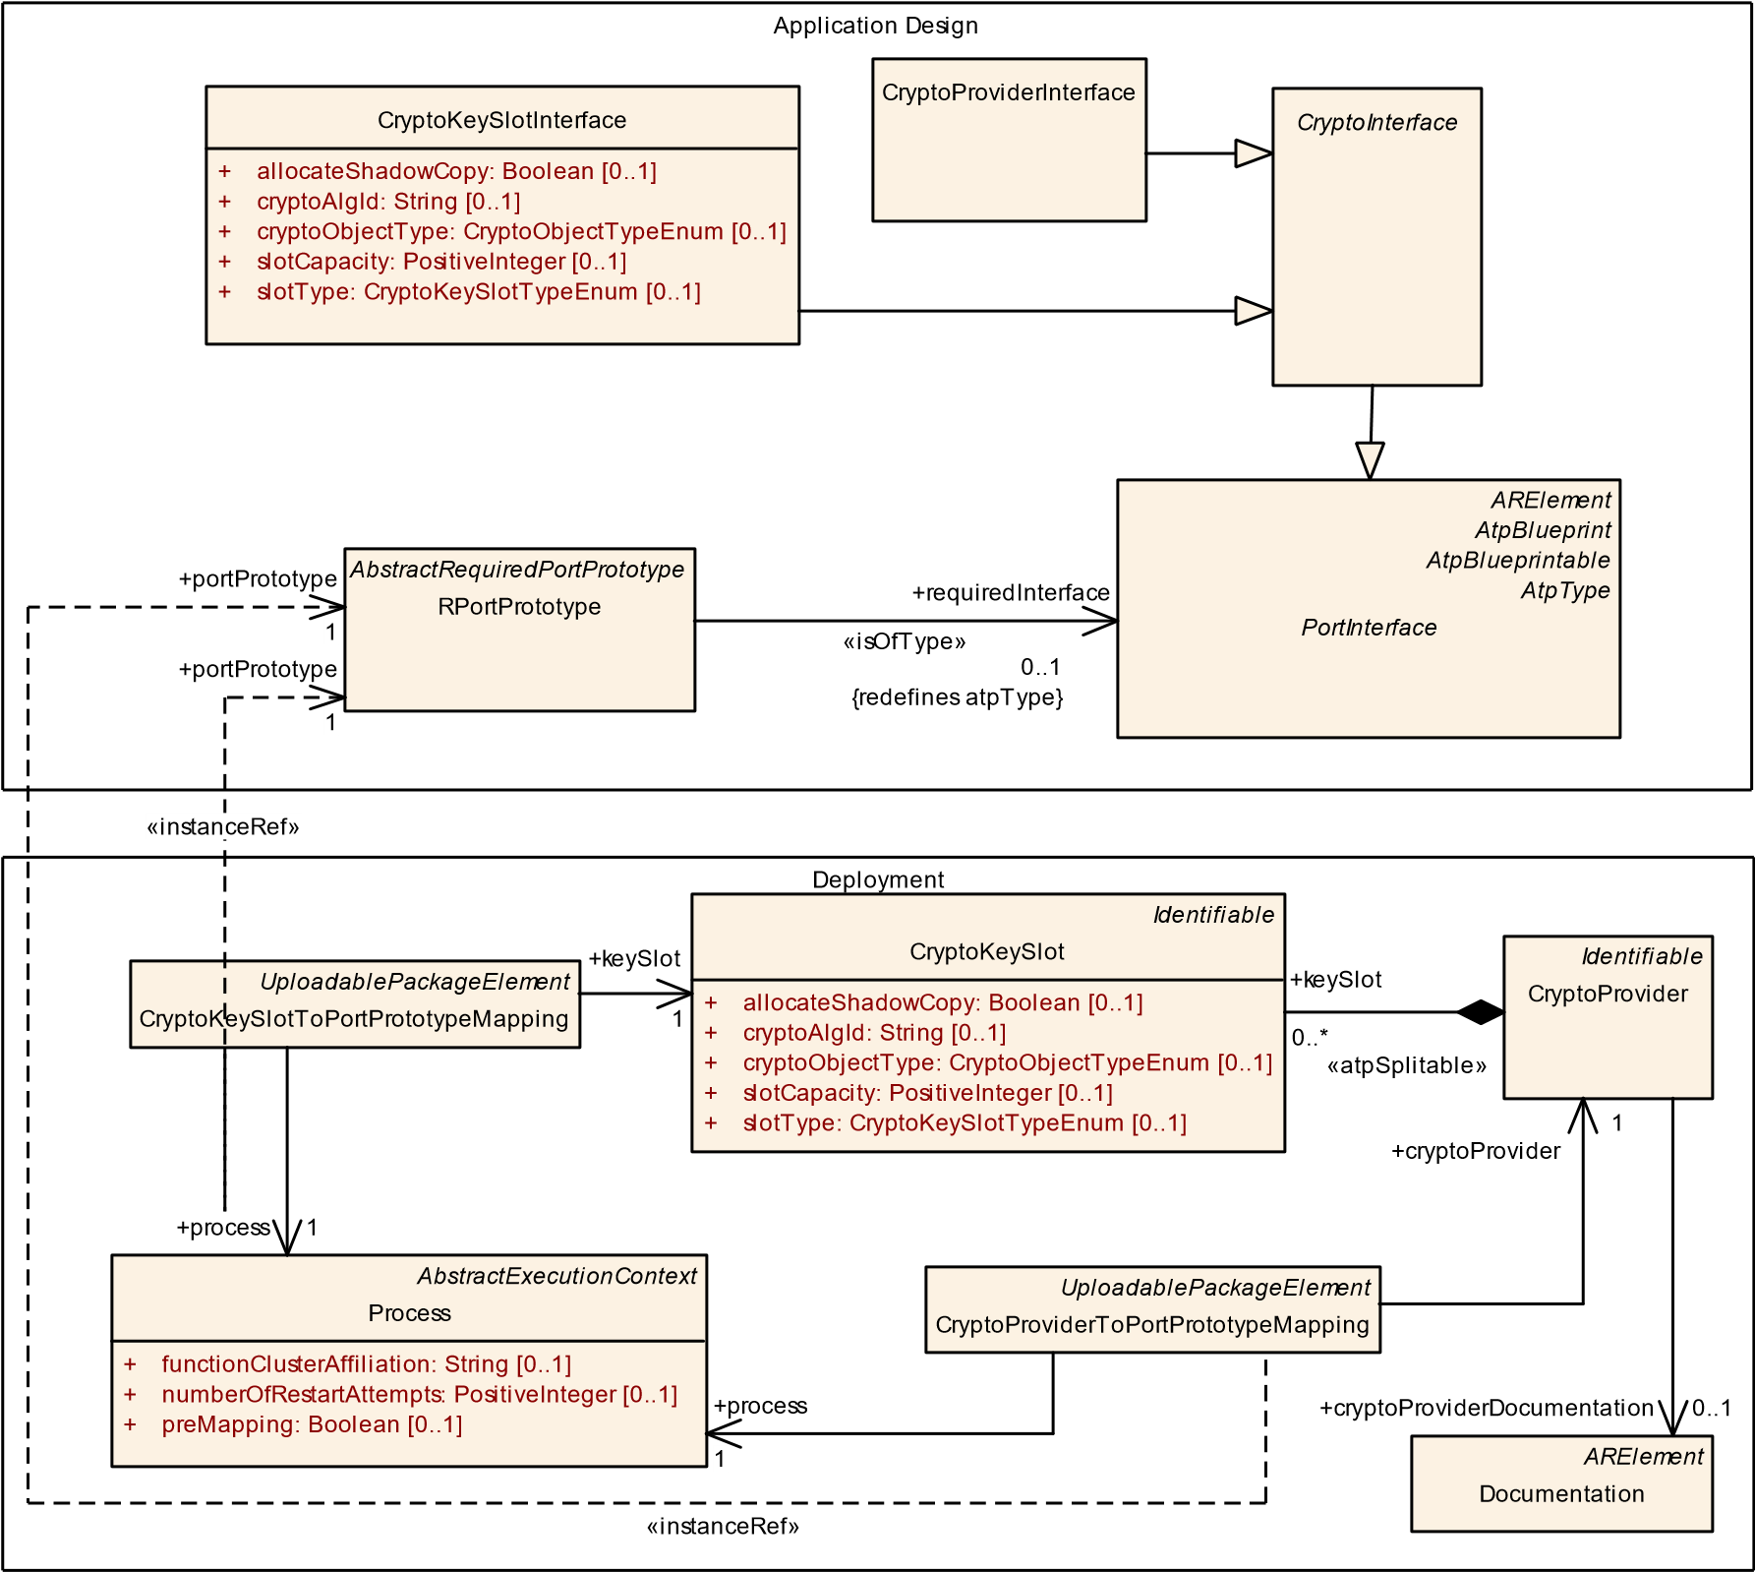

**Figure 9.38: Mapping of CryptoProviders and CryptoKeySlots to RPortPrototypes**

**9.10.2 Crypto Key Slot**

The Key Storage Provider is responsible for the storage of different type of key material. The crypto objects that are stored by the Key Storage Provider are represented as CryptoKeySlots in the model.

**[TPS_MANI_03263]**{DRAFT} **Assignment of CryptoKeySlots to CryptoProviders** dCrypto objects that are used by the CryptoProvider are described by the CryptoKeySlots that are aggregated by the CryptoProvider in the role keySlot.c*(RS_MANI_00023)*

|  |  |
| --- | --- |
| ***Class*** | **CryptoKeySlot** |
| ***Package*** | M2::AUTOSARTemplates::AdaptivePlatform::PlatformModuleDeployment::CryptoDeployment |

5

4

|  |  |  |  |  |
| --- | --- | --- | --- | --- |
| ***Class*** | **CryptoKeySlot** | | | |
| ***Note*** | This meta-class represents the ability to define a concrete key to be used for a crypto operation.  **Tags:**  atp.ManifestKind=MachineManifest atp.Status=draft | | | |
| ***Base*** | *ARObject*, *Identifiable*, *MultilanguageReferrable*, *Referrable* | | | |
| ***Attribute*** | ***Type*** | ***Mult.*** | ***Kind*** | ***Note*** |
| allocateShadow Copy | Boolean | 0..1 | attr | This attribute defines whether a shadow copy of this Key Slot shall be allocated to enable rollback of a failed Key Slot update campaign (see interface BeginTransaction).  **Tags:**atp.Status=draft |
| cryptoAlgId | String | 0..1 | attr | This attribute defines a crypto algorithm restriction (kAlgId Any means without restriction). The algorithm can be specified partially: family & length, mode, padding.  Future Crypto Providers can support some crypto algorithms that are not well known/ standardized today, therefore AUTOSAR doesn’t provide a concrete list of crypto algorithms’ identifiers and doesn’t suppose usage of numerical identifiers. Instead of this a provider supplier should provide string names of supported algorithms in accompanying documentation. The name of a crypto algorithm shall follow the rules defined in the specification of cryptography for Adaptive Platform.  **Tags:**atp.Status=draft |
| cryptoObject Type | CryptoObjectTypeEnum | 0..1 | attr | Object type that can be stored in the slot. If this field contains "Undefined" then mSlotCapacity must be provided and larger then 0.  **Tags:**atp.Status=draft |
| keySlotAllowed Modification | CryptoKeySlotAllowed  Modification | 0..1 | aggr | Restricts how this keySlot may be used  **Tags:**atp.Status=draft |
| keySlotContent AllowedUsage | CryptoKeySlotContent  AllowedUsage | * | aggr | Restriction of allowed usage of a key stored to the slot.  **Tags:**atp.Status=draft |
| slotCapacity | PositiveInteger | 0..1 | attr | Capacity of the slot in bytes to be reserved by the stack vendor. One use case is to define this value in case that the cryptoObjectType is undefined and the slot size can not be deduced from cryptoObjectType and cryptoAlgId. "0" means slot size can be deduced from cryptoObject Type and cryptoAlgId. **Tags:**atp.Status=draft |
| slotType | CryptoKeySlotType  Enum | 0..1 | attr | This attribute defines whether the keySlot is exclusively used by the Application; or whether it is used by Stack Services and managed by a Key Manager Application.  **Tags:**atp.Status=draft |

**Table 9.73: CryptoKeySlot**

**[TPS_MANI_03264]**{DRAFT} **Semantics of CryptoKeySlotToPortPrototypeMapping** dMeta-class CryptoKeySlotToPortPrototypeMapping has the ability to map a specific PortPrototype referenced in the role portPrototype to a CryptoKeySlot referenced in the role keySlot.

The mapping also comprises a reference to meta-class process in order to accommodate for the fact that identical combinations of keySlot and portPrototype may or may not apply for a given Process that represents the enclosing Executable at runtime.c*(RS_MANI_00023)*

**[constr_5241]**{DRAFT} **Restriction applicable for CryptoKeySlotToPortPrototypeMapping.portPrototype**dThe reference CryptoKeySlotToPortPrototypeMapping.portPrototype shall only be used for an RPortPrototype typed by a CryptoKeySlotInterface.c*()*

The application developer uses the ara::core::InstanceSpecifier as local identifier in the API call that represents the path to the modeled RPortPrototype. The Integrator maps the RPortPrototype in the deployment model with the CryptoKeySlotToPortPrototypeMapping to the concrete CryptoKeySlot that is stored by the Key Storage Provider. The information from the deployment model is therefore used to replace the local identifier from the Application Design by the concrete CryptoKeySlot.

**9.10.3 Crypto Certificate**

**[TPS_MANI_03265]**{DRAFT} **Support of CryptoCertificates** dCertificates stored by the Certificate Management Provider that is available in the Crypto functional cluster are modeled as CryptoCertificates.c*(RS_MANI_00023)*

|  |  |  |  |  |
| --- | --- | --- | --- | --- |
| ***Class*** | **CryptoCertificate** | | | |
| ***Package*** | M2::AUTOSARTemplates::AdaptivePlatform::PlatformModuleDeployment::CryptoDeployment | | | |
| ***Note*** | This meta-class represents the ability to model a cryptographic certificate.  **Tags:**atp.Status=draft | | | |
| ***Base*** | *ARObject*, *Identifiable*, *MultilanguageReferrable*, *Referrable* | | | |
| ***Attribute*** | ***Type*** | ***Mult.*** | ***Kind*** | ***Note*** |
| isPrivate | Boolean | 0..1 | attr | This attribute controls the possibility to access the content of the CryptoCertificateSlot by Find() interfaces of the X509 Provider.  **Tags:**atp.Status=draft |

**Table 9.74: CryptoCertificate**

**[TPS_MANI_03266]**{DRAFT} **Semantics of CryptoCertificateToCryptoKeySlotMapping** dThe CryptoCertificateToCryptoKeySlotMapping is used to assign a private key and optionally a public key to the CryptoCertificate.c *(RS_MANI_00023)*

|  |  |
| --- | --- |
| ***Class*** | **CryptoCertificateToCryptoKeySlotMapping** |
| ***Package*** | M2::AUTOSARTemplates::AdaptivePlatform::PlatformModuleDeployment::CryptoDeployment |
| ***Note*** | This meta-class represents the ability to define a mapping between a CryptoKeySlot and a Crypto  Certificate.  **Tags:**atp.Status=draft |
| ***Base*** | *ARObject* |

5

4

|  |  |  |  |  |
| --- | --- | --- | --- | --- |
| ***Class*** | **CryptoCertificateToCryptoKeySlotMapping** | | | |
| ***Attribute*** | ***Type*** | ***Mult.*** | ***Kind*** | ***Note*** |
| crypto  Certificate | CryptoCertificate | 1 | ref | This reference represents the mapped cryptoCertificate.  **Tags:**atp.Status=draft |
| cryptoKeySlot | CryptoKeySlot | 0..2 | ref | This reference represents the mapped cryptoKeySlot.  **Tags:**atp.Status=draft |

**Table 9.75: CryptoCertificateToCryptoKeySlotMapping**

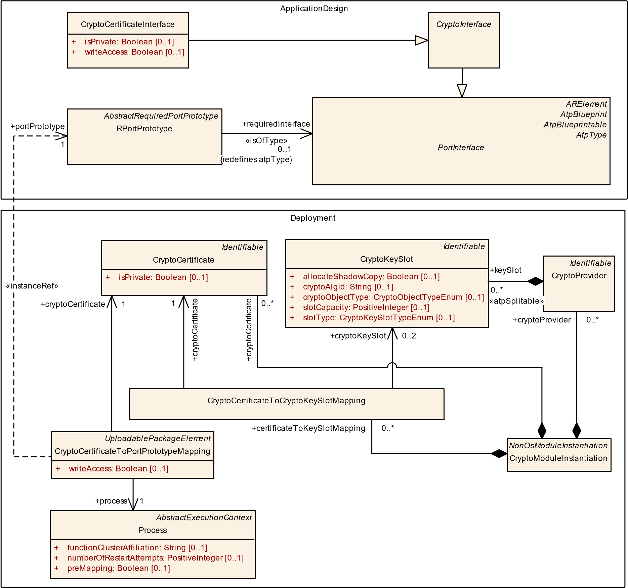

**Figure 9.39: Mapping of CryptoCertificates to RPortPrototypes**

**[TPS_MANI_03267]**{DRAFT} **Semantics of CryptoCertificateToPortPrototypeMapping** dMeta-class CryptoCertificateToPortPrototypeMapping has the ability to map a specific PortPrototype referenced in the role portPrototype to a CryptoCertificate referenced in the role cryptoCertificate.

The mapping also comprises a reference to meta-class process in order to accommodate for the fact that identical combinations of cryptoCertificate and port-

Prototype may or may not apply for a given Process that represents the enclosing Executable at runtime.c*(RS_MANI_00023)*

**[constr_5242]**{DRAFT} **Restriction applicable for CryptoCertificateToPort-**

**PrototypeMapping.portPrototype** dThe reference CryptoCertificateToPortPrototypeMapping.portPrototype shall only be used for an RPortPrototype typed by a CryptoCertificateInterface.c*()*

The application developer uses the ara::core::InstanceSpecifier as local identifier in the API call that represents the path to the modeled RPortPrototype. The Integrator maps the RPortPrototype in the deployment model with the CryptoCertificateToPortPrototypeMapping to the concrete CryptoCertificate that is stored by the Certificate Management Provider. The information from the deployment model is therefore used to replace the local identifier from the Application Design by the concrete CryptoCertificate.

## 9.11 IdsM Deployment

**9.11.1 IdsM Instantiation**

The definition of the deployment for the Intrusion Detection System Manager

(IdsM) is modeled by means of the meta-class IdsmModuleInstantiation

|  |  |  |  |  |
| --- | --- | --- | --- | --- |
| ***Class*** | **IdsmModuleInstantiation** | | | |
| ***Package*** | M2::AUTOSARTemplates::AdaptivePlatform::PlatformModuleDeployment::IntrusionDetectionSystem | | | |
| ***Note*** | This meta-class defines the attributes for the IdsM configuration on a specific machine.  **Tags:**atp.Status=draft | | | |
| ***Base*** | *ARObject*, *AdaptiveModuleInstantiation*, *Identifiable*, *IdsPlatformInstantiation*, *MultilanguageReferrable*, *NonOsModuleInstantiation*, *Referrable* | | | |
| ***Attribute*** | ***Type*** | ***Mult.*** | ***Kind*** | ***Note*** |
| reportable  SecurityEvent | SecurityEventMapping | * | ref | Collection of reportable instances of security events.  **Stereotypes:** atpSplitable **Tags:**  atp.Splitkey=reportableSecurityEvent atp.Status=draft |

**Table 9.76: IdsmModuleInstantiation**

**[constr_10021]**{DRAFT} **Existence of IdsmModuleInstantiation**dOn each Machine, only one instance of the Intrusion Detection System Manager (modeled by IdsmModuleInstantiation) shall exist.c*()*

This instance manages all the reported SEvs created by SWCLs or Function Clusters on this Adaptive Machine.

*IdsPlatformInstantiation*

*Identifiable*

*AdaptiveModuleInstantiation*

*NonOsModuleInstantiation*

IdsmModuleInstantiation

*ARElement*

*PlatformModuleEndpointConfiguration*

*IdsCommonElement*

IdsmInstance

[0..1]

idsmInstanceId: PositiveInteger

+

+

timestampFormat: String

[0..1]

PlatformModuleEthernetEndpointConfiguration

+

ipv4MulticastIpAddress: Ip4AddressString

[0..1]

ipv6MulticastIpAddress: Ip6AddressString

+

[0..1]

+

networkInterface

0..1

«atpSplitable»

+

idsmModuleInstantiation

0..1

**Figure 9.40: Specification of the IdsmModuleInstantiation**

Meta-class IdsmModuleInstantiation is derived from the abstract meta-class IdsPlatformInstantiation which acts as an abstract base class for all platform modules that contribute to the implementation of the Intrusion Detection System.

|  |  |  |  |  |
| --- | --- | --- | --- | --- |
| ***Class*** | ***IdsPlatformInstantiation*** (abstract) | | | |
| ***Package*** | M2::AUTOSARTemplates::AdaptivePlatform::PlatformModuleDeployment::IntrusionDetectionSystem | | | |
| ***Note*** | This meta-class acts as an abstract base class for platform modules that implement the intrusion detection system.  **Tags:**atp.Status=draft | | | |
| ***Base*** | *ARObject*, *AdaptiveModuleInstantiation*, *Identifiable*, *MultilanguageReferrable*, *NonOsModule Instantiation*, *Referrable* | | | |
| ***Subclasses*** | IdsmModuleInstantiation | | | |
| ***Attribute*** | ***Type*** | ***Mult.*** | ***Kind*** | ***Note*** |
| network  Interface | PlatformModule  EthernetEndpoint  Configuration | 0..1 | ref | This association contains the network configuration that shall be applied to an instance of an IDS entity.  **Tags:**atp.Status=draft |
| timeBase | TimeBaseResource | 0..1 | ref | This reference identifies the applicable time base resource.  **Stereotypes:** atpVariation **Tags:**  atp.Status=draft  vh.latestBindingTime=systemDesignTime |

**Table 9.77: IdsPlatformInstantiation**

**9.11.2 Obtaining custom Time Stamps for Security Events**

One of the tasks of an IdsM is to obtain a custom time stamp that corresponds to reported security events under certain circumstances (which are not relevant for the sake of discussing the modeling).

Time stamps can be obtained from sub-classes of the abstract base-class TimeBaseResource. Therefore, IdsmModuleInstantiation maintains a reference to TimeBaseResource.

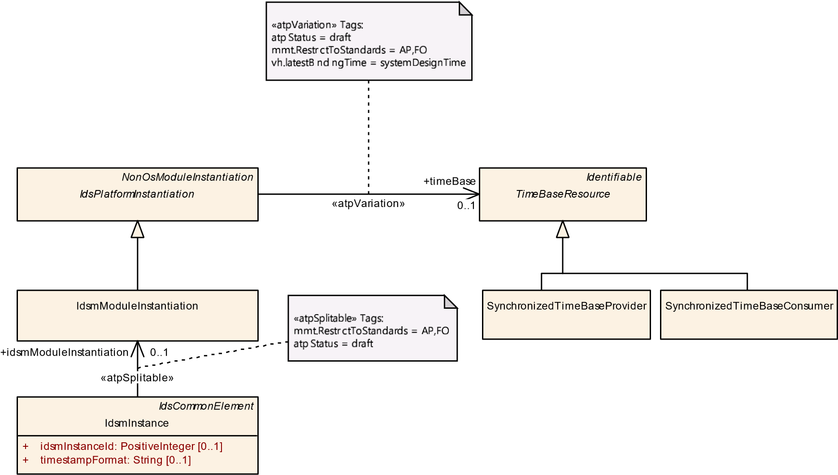

**Figure 9.41: Creating an association between a IdsmModuleInstantiation and a**

**TimeBaseResource**

**9.11.3 Deployment for Security Events**

**[TPS_MANI_01341]**{DRAFT} **Security events that are actually reported by a local IdsM** dThe security events that are actually reported by a local IdsM are represented by meta-class SecurityEventMapping, referenced by IdsmModuleInstantiation in the role reportableSecurityEvent.c*(RS_MANI_00069)*

**[TPS_MANI_01342]**{DRAFT} **Semantics of SecurityEventMapping**dThe semantics of meta-class SecurityEventMapping is to identify the

* PortPrototype in the context of an Executable from which the security event is reported
* Process that runs the Executable, and from the Process the SecurityEventDefinition from which the SecurityEventMapping.id has been derived. c*(RS_MANI_00069)*

*IdsPlatformInstantiation*

IdsmModuleInstantiation

*UploadablePackageElement*

SecurityEventMapping

[0..1]

id: PositiveInteger

+

*IdsCommonElement*

SecurityEventDefinition

[0..1]

id: PositiveInteger

+

*AbstractExecutionContext*

Process

*AbstractRequiredPortPrototype*

RPortPrototype

*AbstractPortPrototypeInExecutableInstanceRef*

RPortPrototypeInExecutableInstanceRef

*ARElement*

*AtpBlueprint*

*AtpBlueprintable*

*AtpType*

*PortInterface*

SecurityEventReportInterface

«atpUriDef»

+

targetRPortPrototype

0..1

{

redefines targetPortPrototype

}

«atpSplitable»

+

reportableSecurityEvent

0..*

+

process

0..1

«instanceRef,atpUriDef»

+

reportingPortPrototype

0..1

+

reportingPortPrototype

0..1

«atpSplitable,atpUriDef»

+

securityEvent

0..*

«isOfType»

requiredInterface

+

0..1

}

{

redefines atpType

**Figure 9.42: Modeling of between a SecurityEventMapping**

|  |  |  |  |  |
| --- | --- | --- | --- | --- |
| ***Class*** | **SecurityEventMapping** | | | |
| ***Package*** | M2::AUTOSARTemplates::AdaptivePlatform::PlatformModuleDeployment::IntrusionDetectionSystem | | | |
| ***Note*** | This meta-class represents a reportable instance of a security event.  **Tags:**  atp.Status=draft  atp.recommendedPackage=SecurityEventMappings | | | |
| ***Base*** | *ARElement*, *ARObject*, *CollectableElement*, *Identifiable*, *MultilanguageReferrable*, *Packageable*  *Element*, *Referrable*, *UploadablePackageElement* | | | |
| ***Attribute*** | ***Type*** | ***Mult.*** | ***Kind*** | ***Note*** |
| id | PositiveInteger | 0..1 | attr | This attribute defines the numerical identification of the security event subject to deployment.  **Tags:**atp.Status=draft |
| process | Process | 0..1 | ref | This reference identifies the process in which context the seurity event is reported. **Tags:**atp.Status=draft |
| reportingPort Prototype | RPortPrototype | 0..1 | iref | This instanceRef identifies the portPrototype over which the security event is reported.  **Tags:**atp.Status=draft  **InstanceRef implemented by:**RPortPrototypeIn  ExecutableInstanceRef |

**Table 9.78: SecurityEventMapping**

**[constr_10022]**{DRAFT} **Restriction for SecurityEventMapping.process.securityEvent.id w.r.t SecurityEventMapping.id** dThe value of SecurityEventMapping.id shall also occur in one of the SecurityEventDefinition. id referenced in the role SecurityEventMapping.process.securityEvent **at the time when the creation of the manifest is finished**.c*()*

Rationale for [constr_10022]: during the creation of the IdsM deployment, the value of SecurityEventMapping.id shall be copied from one of the values in SecurityEventMapping.process.securityEvent.id.

# 10 Service Instance Manifest

## 10.1 ApplicationEndpoint

**[TPS_MANI_03280]**{DRAFT} **Semantics of ApApplicationEndpoint** dThe

ApApplicationEndpoint defines a UDP or TCP Port on a EthernetCommunicationConnector and defines together with the NetworkEndpoint that is referenced by the same EthernetCommunicationConnector in the role unicastNetworkEndpoint a local endpoint of a network communication path, i.e. a Socket.c*(RS_-*

*MANI_00014)*

*CommunicationConnector*

EthernetCommunicationConnector

[0..1]

maximumTransmissionUnit: PositiveInteger

+

[0..1]

neighborCacheSize: PositiveInteger

+

[0..1]

+

pathMtuEnabled: Boolean

+

[0..1]

pathMtuTimeout: TimeValue

+

pncFilterDataMask: PositiveUnlimitedInteger

[0..1]

*Identifiable*

NetworkEndpoint

+

fullyQualifiedDomainName: String

[0..1]

+

priority: PositiveInteger

[0..1]

*Identifiable*

ApApplicationEndpoint

[0..1]

priority: PositiveInteger

+

*TransportProtocolConfiguration*

*TcpUdpConfig*

UdpTp

TcpTp

+

keepAliveInterval: TimeValue

[0..1]

+

keepAliveProbesMax: PositiveInteger

[0..1]

+

keepAlives: Boolean

[0..1]

+

keepAliveTime: TimeValue

[0..1]

+

naglesAlgorithm: Boolean

[0..1]

[0..1]

receiveWindowMin: PositiveInteger

+

[0..1]

+

tcpRetransmissionTimeout: TimeValue

TpPort

[0..1]

portNumber: PositiveInteger

+

*PhysicalChannel*

EthernetPhysicalChannel

udpTpPort

+

1

tpConfiguration

+

0..1

apApplicationEndpoint

+

0..*

+

tcpTpPort

1

+

networkEndpoint

0..*

«atpSplitable»

+

unicastNetworkEndpoint

0..1

**Figure 10.1: ApApplicationEndpoint definition**

|  |  |  |  |  |
| --- | --- | --- | --- | --- |
| ***Class*** | **ApApplicationEndpoint** | | | |
| ***Package*** | M2::AUTOSARTemplates::AdaptivePlatform::ServiceInstanceManifest::APApplicationEndpoint | | | |
| ***Note*** | An application endpoint is the endpoint on an Ecu in terms of application addressing (e.g. UDP or TCP  Port).  **Tags:**atp.Status=draft | | | |
| ***Base*** | *ARObject*, *Identifiable*, *MultilanguageReferrable*, *Referrable* | | | |
| ***Attribute*** | ***Type*** | ***Mult.*** | ***Kind*** | ***Note*** |
| priority | PositiveInteger | 0..1 | attr | This attribute defines the VLAN frame priority where values from 0 (best effort) to 7 (highest) are allowed.  **Tags:**atp.Status=draft |
| tpConfiguration | TcpUdpConfig | 0..1 | aggr | Configuration of the used transport protocol.  **Tags:**atp.Status=draft |

**Table 10.1: ApApplicationEndpoint**

|  |  |  |  |  |
| --- | --- | --- | --- | --- |
| ***Class*** | ***TcpUdpConfig*** (abstract) | | | |
| ***Package*** | M2::AUTOSARTemplates::SystemTemplate::Fibex::Fibex4Ethernet::EthernetTopology | | | |
| ***Note*** | Tcp or Udp Transport Protocol Configuration. | | | |
| ***Base*** | *ARObject*, *TransportProtocolConfiguration* | | | |
| ***Subclasses*** | TcpTp, UdpTp | | | |
| ***Attribute*** | ***Type*** | ***Mult.*** | ***Kind*** | ***Note*** |
| – | – | – | – | – |

**Table 10.2: TcpUdpConfig**

|  |  |  |  |  |
| --- | --- | --- | --- | --- |
| ***Class*** | **UdpTp** | | | |
| ***Package*** | M2::AUTOSARTemplates::SystemTemplate::Fibex::Fibex4Ethernet::EthernetTopology | | | |
| ***Note*** | Content Model for UDP configuration. | | | |
| ***Base*** | *ARObject*, *TcpUdpConfig*, *TransportProtocolConfiguration* | | | |
| ***Attribute*** | ***Type*** | ***Mult.*** | ***Kind*** | ***Note*** |
| udpTpPort | TpPort | 1 | aggr | Udp Port configuration. |

**Table 10.3: UdpTp**

|  |  |  |  |  |
| --- | --- | --- | --- | --- |
| ***Class*** | **TcpTp** | | | |
| ***Package*** | M2::AUTOSARTemplates::SystemTemplate::Fibex::Fibex4Ethernet::EthernetTopology | | | |
| ***Note*** | Content Model for TCP configuration. | | | |
| ***Base*** | *ARObject*, *TcpUdpConfig*, *TransportProtocolConfiguration* | | | |
| ***Attribute*** | ***Type*** | ***Mult.*** | ***Kind*** | ***Note*** |
| keepAlive Interval | TimeValue | 0..1 | attr | Specifies the interval in seconds between subsequent keepalive probes. |
| keepAlive  ProbesMax | PositiveInteger | 0..1 | attr | Maximum number of times that TCP retransmits an individual data segment before aborting the connection. |
| keepAlives | Boolean | 0..1 | attr | Indicates if Keep-Alive messages are sent. |
| keepAliveTime | TimeValue | 0..1 | attr | Specifies the time in seconds between the last data packet sent and the first keepalive probe. |
| naglesAlgorithm | Boolean | 0..1 | attr | Indicates if Nagle’s Algorithm is used. |
| receiveWindow Min | PositiveInteger | 0..1 | attr | Minimum size of the TCP receive window in bytes. |
| tcp  Retransmission  Timeout | TimeValue | 0..1 | attr | Defines the timeout in seconds before an  unacknowledged TCP segment is sent again. If the tcp RetransmissionTimeout is not defined or set to "INF", no TCP segments shall be re-transmitted. |
| tcpTpPort | TpPort | 1 | aggr | TCP Port configuration. |

**Table 10.4: TcpTp**

**[TPS_MANI_03281]**{DRAFT} **Port specific TCP configuration settings** dThe configuration settings in the TcpTp element of an ApApplicationEndpoint overwrite potential TCP settings that are available in TcpProps referenced by the MachineDesign that aggregates the EthernetCommunicationConnector that in

turn contains the ApApplicationEndpoint.c*(RS_MANI_00014)*

|  |  |  |  |  |
| --- | --- | --- | --- | --- |
| ***Class*** | **TpPort** | | | |
| ***Package*** | M2::AUTOSARTemplates::SystemTemplate::Fibex::Fibex4Ethernet::EthernetTopology | | | |
| ***Note*** | Dynamic or direct assignment of a PortNumber. | | | |
| ***Base*** | *ARObject* | | | |
| ***Attribute*** | ***Type*** | ***Mult.*** | ***Kind*** | ***Note*** |
| portNumber | PositiveInteger | 0..1 | attr | Port Number. |

**Table 10.5: TpPort**

**10.1.1 VLAN Priority**

The priority is a 3-bit field which refers to the IEEE 802.1Q priority. It indicates the frame priority level. Values are from 0 (best effort) to 7 (highest); These values can be used to prioritize different classes of traffic (voice, video, data, etc.). The priority is contained in the Ethernet Header together with the vlanIdentifier.

The priority can be defined on different levels and can overwrite the defaultPriority on the VLAN:

1. NetworkEndpoint (for network traffic over the IP Address)
2. ApApplicationEndpoint (for TCP Port and/or UDP Port network traffic)
3. ProvidedSomeipServiceInstance (for network traffic resulting from the Service Instance)

The following table shows an example for the usage of the priority.

Two CouplingPorts are defined and both have a reference to VLAN (EthernetPhysicalChannel) that defines two NetworkEndpoints. The CouplingPort defines the default priority. This default priority can be overwritten on the NetworkEndpoint level, and again on the ApApplicationEndpoint level.

For NetworkEndpoint NEP1.1 no priority is defined. But since on ApApplicationEndpoint AEP 1.1.2 a priority is defined, all messages on CouplingPort1 have the Priority 0 ("best effort"), except for messages that are going over AEP 1.1.2. These messages have the priority 1 (higher priority).

On CouplingPort2, the priority is overwritten on several levels. Please note that ApApplicationEndpoints AEP 2.2.1 and AEP 2.2.2 are reducing the priority that is defined on the NetworkEndpoint NEP2.2.

|  |  |  |
| --- | --- | --- |
| **Port (Default Priority)** | **NetworkEndpoint (e.g. IP Address)** | **ApApplicationEndpoint (e.g. Tcp Port)** |
|  | NEP1.1: Prio. — | AEP 1.1.1: Prio. — |
|  |
| CouplingPort1: Prio. 0 |  | AEP 1.1.2: Prio. 1 |
| NEP1.2: Prio. 0 | AEP 1.2.1: Prio. — |

5

4

|  |  |  |
| --- | --- | --- |
|  |  | AEP 1.2.2: Prio. 1 |
| CouplingPort2: Prio. 0 | NEP2.1: Prio. 1 | AEP 2.1.1: Prio. 2 |
| AEP 2.1.2: Prio. 3 |
| NEP2.2: Prio. 2 | AEP 2.2.1: Prio. 1 |
| AEP 2.2.2: Prio. 0 |

**Table 10.6: VLAN Priority Example**

Please note that the definition of the priority in the SomeipSdServerServiceInstanceConfig can be used to define priorities for SD messages like Service Offer and SubscribeEventGroupAck that are resulting from ProvidedSomeipServiceInstances that are referencing the SomeipSdServerServiceInstanceConfig in the role sdServerConfig.

To prioritize SD messages that are sent from the service consumer to the service provider like FindService or SubscribeEventGroup, the priority in the SomeipSdClientServiceInstanceConfig can be used.

The SD messages are communicated over a UDP Port that is defined in SomeipServiceDiscovery.someipServiceDiscoveryPort and over a IP Multicast Address that is defined by SomeipServiceDiscovery.multicastSdIpAddress. In other words, the priority in the SomeipSdServerServiceInstanceConfig and SomeipSdClientServiceInstanceConfig can be used to prioritize network traffic that results from specific ServiceInstances on SD level.

## 10.2 Service Interface Deployment

The different meta-class specializations of ServiceInterfaceDeployment define a binding of a ServiceInterface to a middleware transport layer.

This chapter describes the usage of the ServiceInterfaceDeployment in different bindings that are supported by AUTOSAR.

*PortInterface*

ServiceInterface

[0..1]

majorVersion: PositiveInteger

+

minorVersion: PositiveInteger

+

[0..1]

*UploadablePackageElement*

*ServiceInterfaceDeployment*

*AtpStructureElement*

*Identifiable*

ClientServerOperation

fireAndForget: Boolean

[0..1]

+

*AutosarDataPrototype*

VariableDataPrototype

*Identifiable*

*ServiceMethodDeployment*

*Identifiable*

*ServiceEventDeployment*

*Identifiable*

*ServiceFieldDeployment*

*AutosarDataPrototype*

Field

hasGetter: Boolean

+

hasNotifier: Boolean

+

hasSetter: Boolean

+

*ARElement*

ServiceInterfacePedigree

+

methodDeployment

0..*

«atpVariation»

method

+

0..*

fieldDeployment

+

0..*

«atpUriDef»

+

field

1

«atpUriDef»

+

serviceInterface

0..1

«atpVariation»

event

+

0..*

«atpUriDef»

+

event

0..1

«atpUriDef»

method

+

0..1

+

eventDeployment

0..*

«atpVariation»

field

+

0..*

+

serviceInterface

0..*

**Figure 10.2: Deployment-related modeling of ServiceInterface**

**[TPS_MANI_03036]**{DRAFT} **ServiceInterface deployment to a middleware transport layer** dThe ServiceInterfaceDeployment meta-class provides the ability to map a ServiceInterface to a middleware transport layer that is represented by a concrete class that is derived from the abstract ServiceInterfaceDeployment meta-class.c*(RS_MANI_00008)*

The association between the ServiceInterfaceDeployment and the ServiceInterface implicitly also defines the relation between the technology specific version number of the service on the ServiceInterfaceDeployment and the service version of the ServiceInterface (defined by ServiceInterface.majorVersion and ServiceInterface.minorVersion)

**[TPS_MANI_03617]**{DRAFT} **Version mapping between ServiceInterface and**

**ServiceInterfaceDeployment**dThe contract version of a ServiceInterface ( majorVersion, minorVersion) shall be mapped to a version of the ServiceInterfaceDeployment for each transport layer.

This version mapping may lead to different version numbers for different ServiceInterfaceDeployments that refer to the same ServiceInterface. This allows to define different version numbers, on the same network or on different networks (e.g. VLANs).c*(RS_MANI_00065)*

Note that transport layer specific constraints on the uniqueness of protocol credentials still have to be respected, e.g. [constr_1723].

PPortPrototype

ServiceInstanceToPort

PrototypeMapping

ServiceInstanceToPort

PrototypeMapping

ProvidedSomeip

-

ServiceInstance

ID = 4

7

ProvidedSomeip

-

ServiceInstance

ID =

11

ServiceInstanceToMachine

Mapping

)

Local Unicast Port

(

ServiceInstanceToMachine

Mapping

(

Local Unicast Port

)

EthernetCommunication

Connector

)

VLAN, Local IP

(

EthernetCommunication

Connector

)

VLAN, Local IP

(

SomeipService

InterfaceDeployment

ServiceId

I

d

=

42

MajorVersion = 2

MinorVersion = 1

SomeipService

InterfaceDeployment

ServiceId

I

d

=

17

MajorVersion = 1

MinorVersion = 7

ServiceInterface

MajorVersion=5

MinorVersion=1

ProvidedSomeipEvent

Group

)

(

Multicast IP&Port

Service Discovery

Timing Properties

ProvidedSomeipEvent

Group

(

Multicast IP&Port

)

Service Discovery

Timing Properties

Defined by OEM

Defined by Supplier

**Figure 10.3: Example of 1 PPortPrototype mapped to 2 VLANs**

In figure 10.3, the use-case of having one PPortPrototype typed by one ServiceInterface and having several ProvidedSomeipServiceInstances on several VLANs is illustrated.

It is possible to have different serviceInterfaceId, serviceInstanceId, and majorVersion values on each individual VLAN. But also the use-case of providing both service instances on the same VLAN would be supported, as long as their SOME/IP credentials are unique (see [constr_1723]).

On different VLANs the service instance may also use the same SOME/IP credentials. But only in case that all service instance specific configuration settings (e.g. IP Multicast Address, SD Timing Properties) are exactly the same on both VLANs the same

AdaptivePlatformServiceInstance can be used to model the communication on both VLANs.

If, for example, the serviceInterfaceId, serviceInstanceId, and majorVersion values of a service instance on each VLAN are the same, but different IP Multicast Addresses are used on the different VLANs for the EventGroup transmission, then an individual VLAN specific modeling of AdaptivePlatformServiceInstance is necessary as shown in figure 10.3.

|  |  |  |  |  |
| --- | --- | --- | --- | --- |
| ***Class*** | ***ServiceInterfaceDeployment*** (abstract) | | | |
| ***Package*** | M2::AUTOSARTemplates::AdaptivePlatform::ServiceInstanceManifest::ServiceInterfaceDeployment | | | |
| ***Note*** | Middleware transport layer specific configuration settings for the ServiceInterface and all contained ServiceInterface elements.  **Tags:**atp.Status=draft | | | |
| ***Base*** | *ARElement*, *ARObject*, *CollectableElement*, *Identifiable*, *MultilanguageReferrable*, *Packageable*  *Element*, *Referrable*, *UploadablePackageElement* | | | |
| ***Subclasses*** | DdsServiceInterfaceDeployment, SomeipServiceInterfaceDeployment, UserDefinedServiceInterface Deployment | | | |
| ***Attribute*** | ***Type*** | ***Mult.*** | ***Kind*** | ***Note*** |
| event  Deployment | ServiceEvent  Deployment | * | aggr | Middleware transport layer specific configuration settings for an Event that is defined in the ServiceInterface.  **Tags:**atp.Status=draft |
| fieldDeployment | ServiceField  Deployment | * | aggr | Middleware transport layer specific configuration settings for a Field that is defined in the ServiceInterface.  **Tags:**atp.Status=draft |
| method  Deployment | ServiceMethod  Deployment | * | aggr | Middleware transport layer specific configuration settings for a method that is defined in the ServiceInterface.  **Tags:**atp.Status=draft |
| serviceInterface | ServiceInterface | 0..1 | ref | Reference to a ServiceInterface that is deployed to a middleware transport layer.  **Stereotypes:** atpUriDef  **Tags:**atp.Status=draft |

**Table 10.7: ServiceInterfaceDeployment**

**[TPS_MANI_03037]**{DRAFT} **Purpose of ServiceMethodDeployment**dThe ServiceMethodDeployment meta-class provides the ability to define middleware transport layer specific configuration settings relevant for a method that is defined in the context of a ServiceInterface.c*(RS_MANI_00008)*

**[constr_3300]**{DRAFT} **Allowed ServiceMethodDeployment.method references** dThe ClientServerOperation that is referenced by ServiceMethodDeployment in the role method shall be defined in the context of a ServiceInterface that is referenced by the ServiceInterfaceDeployment in the role serviceInterface that contains the ServiceMethodDeployment.c*()*

**[TPS_MANI_03038]**{DRAFT} **Purpose of ServiceEventDeployment** dThe ServiceEventDeployment meta-class provides the ability to define middleware transport layer specific configuration settings relevant for an event or trigger that is defined in the context of a ServiceInterface.c*(RS_MANI_00008)*

**[constr_3301]**{DRAFT} **Allowed ServiceEventDeployment.event references** dThe VariableDataPrototype that is referenced by ServiceEventDeployment in the role event shall be defined in the context of a ServiceInterface that is referenced by the ServiceInterfaceDeployment in the role serviceInterface that contains the ServiceEventDeployment.c*()*

**[constr_5316]**{DRAFT} **Allowed ServiceEventDeployment.trigger references** dThe Trigger that is referenced by ServiceEventDeployment in the role trigger shall be defined in the context of a ServiceInterface that is referenced by the ServiceInterfaceDeployment in the role serviceInterface that contains the ServiceEventDeployment.c*()*

**[constr_5317]**{DRAFT}**ServiceEventDeployment not allowed to reference an event and a trigger at the same time** dThe ServiceEventDeployment element shall reference either:

* a VariableDataPrototype in the role event or
* a Trigger in the role trigger,

but not both at the same time.c*()*

**[TPS_MANI_03039]**{DRAFT} **Purpose of ServiceFieldDeployment** dThe ServiceFieldDeployment meta-class provides the ability to define middleware transport layer specific configuration settings relevant for a field that is defined in the context of a ServiceInterface.c*(RS_MANI_00008)*

**[constr_3302]**{DRAFT} **Allowed ServiceFieldDeployment.field references** dThe Field that is referenced by ServiceFieldDeployment in the role field shall be defined in the context of a ServiceInterface that is referenced by the

ServiceInterfaceDeployment in the role serviceInterface that contains the ServiceFieldDeployment.c*()*

Please note that a partial ServiceInterfaceDeployment that only covers certain parts of the corresponding ServiceInterfaceDeployment is not supported. This understanding is formalized in [constr_10029]

**[constr_10029]**{DRAFT} **ServiceInterfaceDeployment shall cover all elements of the corresponding ServiceInterfaceDeployment** dIf a ServiceInterfaceDeployment references a ServiceInterface in the role serviceInterface, then all methods, fields, triggers, and events defined in the context of the referenced ServiceInterface shall be referenced by respective methodDeployments, fieldDeployments, and eventDeployments owned by the referencing ServiceInterfaceDeployment.c*()*

|  |  |  |  |  |
| --- | --- | --- | --- | --- |
| ***Class*** | ***ServiceMethodDeployment*** (abstract) | | | |
| ***Package*** | M2::AUTOSARTemplates::AdaptivePlatform::ServiceInstanceManifest::ServiceInterfaceDeployment | | | |
| ***Note*** | This abstract meta-class represents the ability to specify a deployment of a Method to a middleware transport layer.  **Tags:**atp.Status=draft | | | |
| ***Base*** | *ARObject*, *Identifiable*, *MultilanguageReferrable*, *Referrable* | | | |
| ***Subclasses*** | SomeipMethodDeployment, UserDefinedMethodDeployment | | | |
| ***Attribute*** | ***Type*** | ***Mult.*** | ***Kind*** | ***Note*** |
| method | ClientServerOperation | 0..1 | ref | Reference to a method that is deployed to a middleware transport layer.  **Stereotypes:** atpUriDef  **Tags:**atp.Status=draft |

**Table 10.8: ServiceMethodDeployment**

|  |  |  |  |  |
| --- | --- | --- | --- | --- |
| ***Class*** | ***ServiceEventDeployment*** (abstract) | | | |
| ***Package*** | M2::AUTOSARTemplates::AdaptivePlatform::ServiceInstanceManifest::ServiceInterfaceDeployment | | | |
| ***Note*** | This abstract meta-class represents the ability to specify a deployment of an Event to a middleware transport layer.  **Tags:**atp.Status=draft | | | |
| ***Base*** | *ARObject*, *Identifiable*, *MultilanguageReferrable*, *Referrable* | | | |
| ***Subclasses*** | DdsEventDeployment, SomeipEventDeployment, UserDefinedEventDeployment | | | |
| ***Attribute*** | ***Type*** | ***Mult.*** | ***Kind*** | ***Note*** |
| event | VariableDataPrototype | 0..1 | ref | Reference to an Event that is deployed to a middleware transport layer.  **Stereotypes:** atpUriDef  **Tags:**atp.Status=draft |
| trigger | Trigger | 0..1 | ref | Reference to a Trigger that is deployed to a middleware transport layer.  **Stereotypes:** atpUriDef  **Tags:**atp.Status=draft |

**Table 10.9: ServiceEventDeployment**

|  |  |  |  |  |
| --- | --- | --- | --- | --- |
| ***Class*** | ***ServiceFieldDeployment*** (abstract) | | | |
| ***Package*** | M2::AUTOSARTemplates::AdaptivePlatform::ServiceInstanceManifest::ServiceInterfaceDeployment | | | |
| ***Note*** | This abstract meta-class represents the ability to specify a deployment of a Field to a middleware transport layer.  **Tags:**atp.Status=draft | | | |
| ***Base*** | *ARObject*, *Identifiable*, *MultilanguageReferrable*, *Referrable* | | | |
| ***Subclasses*** | DdsFieldDeployment, SomeipFieldDeployment, UserDefinedFieldDeployment | | | |
| ***Attribute*** | ***Type*** | ***Mult.*** | ***Kind*** | ***Note*** |
| field | Field | 1 | ref | Reference to a Field that is deployed to a middleware transport layer.  **Stereotypes:** atpUriDef  **Tags:**atp.Status=draft |

**Table 10.10: ServiceFieldDeployment**

**10.2.1 SOME/IP Service Interface Deployment**

This chapter describes the SOME/IP deployment of a ServiceInterface.

**[TPS_MANI_03040]**{DRAFT} **SOME/IP ServiceInterface binding** dThe

SomeipServiceInterfaceDeployment meta-class provides the ability to bind a

ServiceInterface to SOME/IP and to assign a SOME/IP Service identifier to the ServiceInterface with the serviceInterfaceId attribute.c*(RS_MANI_00024)*

The idea behind the SomeipServiceInterfaceDeployment is the definition of a common configuration set that is shared between the server that provides the ServiceInterface and all clients that are consuming the ServiceInterface. So it contains all relevant SOME/IP settings used for identification of the ServiceInterface and its content in messages on the network.

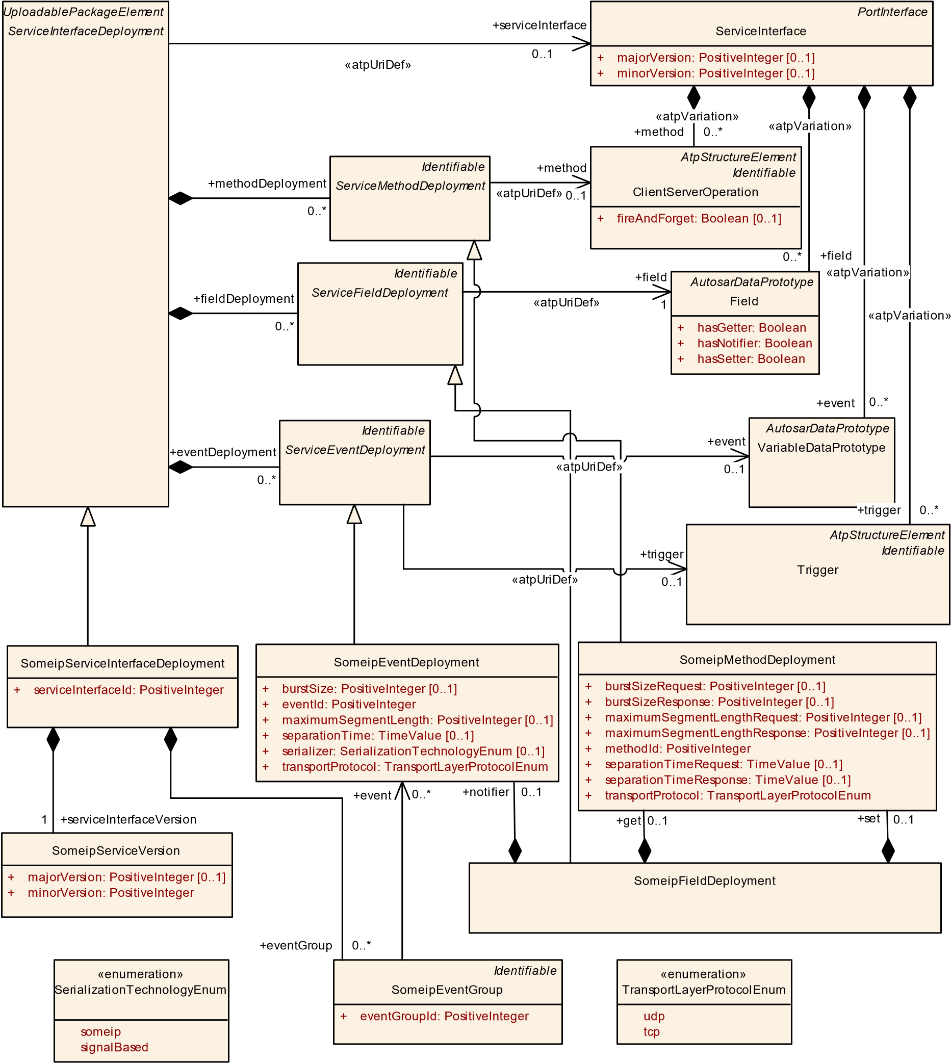

**Figure 10.4: SOME/IP deployment of ServiceInterface**

**[constr_3410]**{DRAFT} **Value range of SomeipServiceInterfaceDeployment. serviceInterfaceId** dThe value of serviceInterfaceId shall be in the range of 0..65535.c*()*

Please note that the SOME/IP MessageId that is 32 Bit long contains a 16 Bit serviceInterfaceId, a single bit that defines whether the message transports a method or an event and a 15 Bit eventId or methodId.

Please also consider [PRS_SOMEIPSD_00515] in [24] that defines special and reserved serviceInterfaceIds for SOME/IP and SOME/IP-SD. **[TPS_MANI_03041]**{DRAFT} **Definition of SOME/IP EventGroups** dThe

SomeipServiceInterfaceDeployment.eventGroup allows to define SOME/IP *EventGroups* that are included in the SOME/IP Service and provide a logical grouping of events and notification events used for publish/subscribe handling.c *(RS_MANI_00024)*

**[constr_3304]**{DRAFT} **Value of attribute SomeipEventGroup.eventGroupId shall be unique** dThe value of attribute eventGroupId shall be unique in the context of the enclosing SomeipServiceInterfaceDeployment.c*()*

**[TPS_MANI_03042]**{DRAFT} **Definition of SOME/IP Service Version** dThe

SomeipServiceInterfaceDeployment.serviceInterfaceVersion allows to define a major and a minor version for the SOME/IP Service.c*(RS_MANI_00024)*

**[constr_3557]**{DRAFT} **Mandatory majorVersion at SomeipServiceInterfaceDeployment.serviceInterfaceVersion** dIf the SomeipServiceVersion is aggregated at the SomeipServiceInterfaceDeployment in the role serviceInterfaceVersion then the attribute SomeipServiceVersion.majorVersion shall be defined.c*()*

|  |  |  |  |  |
| --- | --- | --- | --- | --- |
| ***Class*** | **SomeipServiceInterfaceDeployment** | | | |
| ***Package*** | M2::AUTOSARTemplates::AdaptivePlatform::ServiceInstanceManifest::ServiceInterfaceDeployment | | | |
| ***Note*** | SOME/IP configuration settings for a ServiceInterface.  **Tags:**  atp.Status=draft  atp.recommendedPackage=ServiceInterfaceDeployments | | | |
| ***Base*** | *ARElement*, *ARObject*, *CollectableElement*, *Identifiable*, *MultilanguageReferrable*, *Packageable*  *Element*, *Referrable*, *ServiceInterfaceDeployment*, *UploadablePackageElement* | | | |
| ***Attribute*** | ***Type*** | ***Mult.*** | ***Kind*** | ***Note*** |
| eventGroup | SomeipEventGroup | * | aggr | SOME/IP EventGroups that are defined within the SOME/ IP ServiceClass.  **Tags:**atp.Status=draft |
| serviceInterface Id | PositiveInteger | 1 | attr | Unique Identifier that identifies the ServiceInterface in SOME/IP. This Identifier is sent as Service ID in SOME/IP Service Discovery messages.  **Tags:**atp.Status=draft |
| serviceInterface Version | SomeipServiceVersion | 1 | aggr | The SOME/IP major and minor Version of the Service.  **Tags:**atp.Status=draft |

**Table 10.11: SomeipServiceInterfaceDeployment**

|  |  |  |  |  |
| --- | --- | --- | --- | --- |
| ***Class*** | **SomeipEventGroup** | | | |
| ***Package*** | M2::AUTOSARTemplates::AdaptivePlatform::ServiceInstanceManifest::ServiceInterfaceDeployment | | | |
| ***Note*** | Grouping of events and notification events inside a ServiceInterface in order to allow subscriptions.  **Tags:**atp.Status=draft | | | |
| ***Base*** | *ARObject*, *Identifiable*, *MultilanguageReferrable*, *Referrable* | | | |
| ***Attribute*** | ***Type*** | ***Mult.*** | ***Kind*** | ***Note*** |

5

4

|  |  |  |  |  |
| --- | --- | --- | --- | --- |
| ***Class*** | **SomeipEventGroup** | |  |  |
| event | SomeipEvent  Deployment | * | ref | Reference to an event that is part of the EventGroup.  **Tags:**atp.Status=draft |
| eventGroupId | PositiveInteger | 1 | attr | Unique Identifier that identifies the EventGroup in SOME/ IP. This Identifier is sent as Eventgroup ID in SOME/IP Service Discovery messages.  **Tags:**atp.Status=draft |

**Table 10.12: SomeipEventGroup**

**[TPS_MANI_03043]**{DRAFT} **SOME/IP VariableDataPrototype binding** dThe SomeipEventDeployment meta-class provides the ability to bind a VariableDataPrototype to SOME/IP and to assign a SOME/IP Event identifier to the event with the eventId attribute.c*(RS_MANI_00024)*

**[constr_3305]**{DRAFT} **Value of attribute SomeipEventDeployment.eventId shall be unique** dThe value of eventId shall be unique in the context of the enclosing SomeipServiceInterfaceDeployment.c*()*

**[constr_3408]**{DRAFT} **Value range of SomeipEventDeployment.eventId** dThe value of eventId shall be in the range of 0..32767.c*()*

Please note that [PRS_SOMEIPSD_00517] in [24] defines special and reserved EVENT-IDs for SOME/IP and SOME/IP-SD that result in the eventId values of 0 and 32767.

**[TPS_MANI_03050]**{DRAFT} **Usage of SomeipEventDeployment.transportProtocol**dThe value of SomeipEventDeployment.transportProtocol defines over which Transport Layer Protocol the SomeipEventDeployment.event is provided.c*(RS_MANI_00024)*

**[constr_5156]**{DRAFT} **SomeipEventDeployment.transportProtocol setting to udp and the impact on ProvidedSomeipServiceInstances** dIf SomeipEventDeployment.transportProtocol is set to udp then each ProvidedSomeipServiceInstance that refers the SomeipServiceInterfaceDeployment in the role serviceInterfaceDeployment shall only be mapped to a MachineDesign with a SomeipServiceInstanceToMachineMapping with a configured udpPort.c*()*

**[constr_3308]**{DRAFT} **SomeipEventDeployment.transportProtocol setting to tcp and the impact on ProvidedSomeipServiceInstances** dIf SomeipEventDeployment.transportProtocol is set to tcp then each ProvidedSomeipServiceInstance that refers the SomeipServiceInterfaceDeployment in the role serviceInterfaceDeployment shall only be mapped to a MachineDesign with a SomeipServiceInstanceToMachineMapping with a configured tcpPort.c*()*

**[TPS_MANI_03067]**{DRAFT} **SOME/IP segmentation of udp SomeipEventDeployments** dIf the maximumSegmentLength is set to a value and the data length is larger than maximumSegmentLength then SOME/IP shall segment the SomeipEventDeployment into several packets and transmit them over the network.

The sender shall wait the separationTime between the transmissions of segments. On the reception side, SOME/IP re-assembles the received SOME/IP segments to the original SomeipEventDeployment.c*(RS_MANI_00024)*

**[constr_3351]**{DRAFT} **SOME/IP segmentation allowed for udpSomeipEvent-**

**Deployments** dAttribute SomeipEventDeployment.maximumSegmentLength shall only be used if the value of attribute SomeipEventDeployment.transportProtocol is set to udp.c*()*

As the SomeipServiceInterfaceDeployment is also used for the deployment of signal-based Pdus on Ethernet the attribute SomeipEventDeployment.serializer defines whether the someip or the signalBased serialization shall be used for a specific event.

**[TPS_MANI_03615]**{DRAFT} **SomeipEventDeployment.serializer equals someip** dIf the attribute SomeipEventDeployment.serializer is not defined or is set to the value someip then the event shall be serialized/de-serialized using the SOME/IP serializer.c*(RS_MANI_00063)*

**[TPS_MANI_03591]**{DRAFT} **SomeipEventDeployment.serializer equals signalBased**dIf the attribute SomeipEventDeployment.serializer is set to the value signalBased then the event shall be serialized/de-serialized using the signalbased approach.c*(RS_MANI_00063)*

This aspect is described in chapter 12.

|  |  |  |  |  |
| --- | --- | --- | --- | --- |
| ***Class*** | **SomeipEventDeployment** | | | |
| ***Package*** | M2::AUTOSARTemplates::AdaptivePlatform::ServiceInstanceManifest::ServiceInterfaceDeployment | | | |
| ***Note*** | SOME/IP configuration settings for an Event.  **Tags:**atp.Status=draft | | | |
| ***Base*** | *ARObject*, *Identifiable*, *MultilanguageReferrable*, *Referrable*, *ServiceEventDeployment* | | | |
| ***Attribute*** | ***Type*** | ***Mult.*** | ***Kind*** | ***Note*** |
| burstSize | PositiveInteger | 0..1 | attr | Specifies the number of segments that shall be transmitted in a burst ignoring separationTime.  SeparationTime will then only be applied between bursts. If not configured, SeparationTime will be applied between all frames.  **Tags:**atp.Status=draft |
| eventId | PositiveInteger | 1 | attr | Unique Identifier within a ServiceInterface that identifies the Event in SOME/IP. This Identifier is sent as part of the Message ID in SOME/IP messages.  **Tags:**atp.Status=draft |

5

4

|  |  |  |  |  |
| --- | --- | --- | --- | --- |
| ***Class*** | **SomeipEventDeployment** | |  |  |
| maximum  SegmentLength | PositiveInteger | 0..1 | attr | This attribute describes the length in bytes of the SOME/  IP segment. This includes 8 bytes for the Request ID, Protocol Version, Interface Version, Message Type and Return Code and 4 additional SOME/IP TP bytes.  If this attribute is set to a value and the data length is larger than maximumSegmentLength then the corresponding SOME/IP message will be segmented into smaller parts that are transmitted over the network.  **Tags:**atp.Status=draft |
| separationTime | TimeValue | 0..1 | attr | Sets the duration of the minimum time in seconds SOME/ IP shall wait between the transmissions of segments.  **Tags:**atp.Status=draft |
| serializer | SerializationTechnology  Enum | 0..1 | attr | Defines which serialization technology shall be used.  **Tags:**atp.Status=draft |
| transport Protocol | TransportLayerProtocol  Enum | 1 | attr | This attribute defines over which Transport Layer Protocol this event is intended to be sent.  **Tags:**atp.Status=draft |

**Table 10.13: SomeipEventDeployment**

|  |  |
| --- | --- |
| ***Enumeration*** | **SerializationTechnologyEnum** |
| ***Package*** | M2::AUTOSARTemplates::AdaptivePlatform::ServiceInstanceManifest::ServiceInterfaceDeployment |
| ***Note*** | This enumeration allows to choose a Serialization Technology.  **Tags:**atp.Status=draft |
| ***Literal*** | ***Description*** |
| signalBased | Signal-Based serializer.  **Tags:**  atp.EnumerationLiteralIndex=1 atp.Status=draft |
| someip | SOME/IP Serializer  **Tags:**  atp.EnumerationLiteralIndex=0 atp.Status=draft |

**Table 10.14: SerializationTechnologyEnum**

**[TPS_MANI_03044]**{DRAFT} **SOME/IP ClientServerOperation binding** dThe SomeipMethodDeployment meta-class provides the ability to bind a ClientServerOperation to SOME/IP and to assign a SOME/IP Method identifier to the method with the methodId attribute.c*(RS_MANI_00024)*

**[constr_3306]**{DRAFT} **Value of attribute methodId shall be unique per**

**SomeipServiceInterfaceDeployment** dThe value of methodId shall be unique in the context of the enclosing SomeipServiceInterfaceDeployment.c*()*

**[constr_3409]**{DRAFT} **Value range of SomeipMethodDeployment.methodId** dThe value of methodId shall be in the range of 0..32767.c*()*

Please note that [PRS_SOMEIPSD_00517] in [24] defines special and reserved METHOD-IDs for SOME/IP and SOME/IP-SD that result in the methodId values of 0 and 32767.

**[TPS_MANI_03051]**{DRAFT} **Usage of SomeipMethodDeployment.transport-**

**Protocol** dThe value of SomeipMethodDeployment.transportProtocol defines over which Transport Layer Protocol this method is provided.c*(RS_MANI_00024)*

**[constr_3309]**{DRAFT} **SomeipMethodDeployment.transportProtocol setting to udp and the impact on ProvidedSomeipServiceInstances** dIf SomeipMethodDeployment.transportProtocol is set to udp then each ProvidedSomeipServiceInstance that refers the SomeipServiceInterfaceDeployment in the role serviceInterfaceDeployment shall only be mapped to a MachineDesign with a SomeipServiceInstanceToMachineMapping with a configured udpPort.c*()*

**[constr_3310]**{DRAFT} **SomeipMethodDeployment.transportProtocol setting to tcp and the impact on ProvidedSomeipServiceInstances** dIf SomeipMethodDeployment.transportProtocol is set to tcp then each ProvidedSomeipServiceInstance that refers the SomeipServiceInterfaceDeployment in the role serviceInterfaceDeployment shall only be mapped to a MachineDesign with a SomeipServiceInstanceToMachineMapping with a configured tcpPort.c*()*

**[TPS_MANI_03068]**{DRAFT} **SOME/IP segmentation of SomeipMethodDeployment Calls** dIf the maximumSegmentLengthRequest is set to a value and the data length is larger than maximumSegmentLengthRequest then SOME/IP shall segment the SomeipMethodDeployment Call-Message into several packets and transmit them over the network.

The sender shall wait the separationTimeRequest between the transmissions of segments. On the reception side, SOME/IP re-assembles the received SOME/IP segments to the original SomeipMethodDeployment Call-Message.c*(RS_MANI_00024)*

**[TPS_MANI_03069]**{DRAFT} **SOME/IP segmentation of SomeipMethodDeployment Responses** dIf the maximumSegmentLengthResponse is set to a value and the data length is larger than maximumSegmentLengthResponse then SOME/IP shall segment the SomeipMethodDeployment Response-Message into several packets and transmit them over the network.

The sender shall wait the separationTimeResponse between the transmissions of segments. On the reception side, SOME/IP re-assembles the received SOME/IP segments to the original SomeipMethodDeployment Response-Message.c*(RS_MANI_00024)*

**[constr_3352]**{DRAFT} **SOME/IP segmentation allowed for udp SomeipMethod-**

**Deployments** dSomeipMethodDeployment.maximumSegmentLengthRequest and SomeipMethodDeployment.maximumSegmentLengthResponse shall only be used if SomeipMethodDeployment.transportProtocol is set to udp.c*()*

|  |  |  |  |  |
| --- | --- | --- | --- | --- |
| ***Class*** | **SomeipMethodDeployment** | | | |
| ***Package*** | M2::AUTOSARTemplates::AdaptivePlatform::ServiceInstanceManifest::ServiceInterfaceDeployment | | | |
| ***Note*** | SOME/IP configuration settings for a Method.  **Tags:**atp.Status=draft | | | |
| ***Base*** | *ARObject*, *Identifiable*, *MultilanguageReferrable*, *Referrable*, *ServiceMethodDeployment* | | | |
| ***Attribute*** | ***Type*** | ***Mult.*** | ***Kind*** | ***Note*** |
| burstSize Request | PositiveInteger | 0..1 | attr | Specifies the number of segments for the Method Call that shall be transmitted in a burst ignoring separation Time. SeparationTime will then only be applied between bursts. If not configured, SeparationTime will be applied between all frames.  **Tags:**atp.Status=draft |
| burstSize  Response | PositiveInteger | 0..1 | attr | Specifies the number of segments for the Method Response that shall be transmitted in a burst ignoring separationTime. SeparationTime will then only be applied between bursts. If not configured, SeparationTime will be applied between all frames.  **Tags:**atp.Status=draft |
| maximum SegmentLength  Request | PositiveInteger | 0..1 | attr | This attribute describes the length in bytes of one SOME/ IP segment into which the Method Call Message will be divided. This length field includes 8 bytes for the Request ID, Protocol Version, Interface Version, Message Type and Return Code and 4 additional SOME/IP TP bytes.  If this attribute is set to a value and the data length is larger than maximumSegmentLengthRequest then the corresponding SOME/IP message will be segmented into smaller parts that are transmitted over the network.  **Tags:**atp.Status=draft |
| maximum SegmentLength  Response | PositiveInteger | 0..1 | attr | This attribute describes the length in bytes of one SOME/ IP segment into which the Method Return Message will be divided. This length field includes 8 bytes for the Request ID, Protocol Version, Interface Version, Message Type and Return Code and 4 additional SOME/IP TP bytes.  If this attribute is set to a value and the data length is larger than maximumSegmentLengthResponse then the corresponding SOME/IP message will be segmented into smaller parts that are transmitted over the network.  **Tags:**atp.Status=draft |
| methodId | PositiveInteger | 1 | attr | Unique Identifier within a ServiceInterface that identifies the Method in SOME/IP. This Identifier is sent as part of the Message ID in SOME/IP messages.  **Tags:**atp.Status=draft |
| separationTime Request | TimeValue | 0..1 | attr | Sets the duration of the minimum time in seconds SOME/ IP shall wait between the transmissions of segments into which the Method Call Message will be divided.  **Tags:**atp.Status=draft |
| separationTime Response | TimeValue | 0..1 | attr | Sets the duration of the minimum time in seconds SOME/ IP shall wait between the transmissions of segments into which the Method Return Message will be divided.  **Tags:**atp.Status=draft |
| transport Protocol | TransportLayerProtocol  Enum | 1 | attr | This attribute defines over which Transport Layer Protocol this method is intended to be sent.  **Tags:**atp.Status=draft |

**Table 10.15: SomeipMethodDeployment**

|  |  |  |  |  |
| --- | --- | --- | --- | --- |
| ***Class*** | **SomeipServiceInstanceToMachineMapping** | | | |
| ***Package*** | M2::AUTOSARTemplates::AdaptivePlatform::ServiceInstanceManifest::ServiceInstanceMapping | | | |
| ***Note*** | This meta-class allows to map SomeipServiceInstances to a CommunicationConnector of a Machine. In this step the network configuration (IP Address, Transport Protocol, Port Number) for the ServiceInstance is defined.  **Tags:**  atp.Status=draft  atp.recommendedPackage=ServiceInstanceToMachineMappings | | | |
| ***Base*** | *ARElement*, *ARObject*, *CollectableElement*, *Identifiable*, *MultilanguageReferrable*, *Packageable*  *Element*, *Referrable*, *ServiceInstanceToMachineMapping*, *UploadablePackageElement* | | | |
| ***Attribute*** | ***Type*** | ***Mult.*** | ***Kind*** | ***Note*** |
| tcpPort | ApApplicationEndpoint | 0..1 | ref | TcpPort configuration that is used for Method and Event communication in IP-Unicast case.  During SOME/IP Service Discovery: PortNumber that is sent in the SD-Offer Message to client (answer on SD-find) or clients (SD-offer).  Method: This is the destination-port where the server accepts the method call messages (from the clients). This is the source-port where the server sends the method response messages (to the client).  Event: This is the event source-port where the server sends the event messages to the subscribed clients in IP-Unicast case.  **Tags:**atp.Status=draft |
| udpCollection BufferSize  Threshold | PositiveInteger | 0..1 | attr | Specifies the amount of data in bytes that shall be buffered for data transmission over the udp connection specified by this SomeipServiceInstanceToMachine Mapping in case data collection is enabled.  **Tags:**atp.Status=draft |
| udpPort | ApApplicationEndpoint | 0..1 | ref | UdpPort configuration that is used for Method and Event communication in IP-Unicast case.  During SOME/IP Service Discovery: PortNumber that is sent in the SD-Offer Message to client (answer on SD-find) or clients (SD-offer).  Method: This is the destination-port where the server accepts the method call messages (from the clients). This is the source-port where the server sends the method response messages (to the client).  Event: This is the event source-port where the server sends the event messages to the subscribed clients in IP-Unicast case.  **Tags:**atp.Status=draft |

**Table 10.16: SomeipServiceInstanceToMachineMapping**

**[TPS_MANI_03057]**{DRAFT} **SOME/IP Field binding** dThe SomeipFieldDeployment meta-class provides the ability to bind a Field to SOME/IP.

If the Field contains a notifier (hasNotifier = true), it is possible to assign a SOME/IP notifier identifier to the field by setting the value of attribute SomeipFieldDeployment.notifier.eventId.

If the Field contains a getter method (hasGetter = true), it is possible to assign a SOME/IP method identifier to the field by setting the value of attribute SomeipFieldDeployment.get.methodId.

If the Field contains a setter method (hasSetter = true), it is possible to assign a SOME/IP method identifier to the field by setting the value of attribute SomeipFieldDeployment.set.methodIdc*(RS_MANI_00024)*

Please note that each methodId and each eventId of a SomeipFieldDeployment shall be unique in the context of a ServiceInterface as defined in [constr_3306] and [constr_3305].

|  |  |  |  |  |
| --- | --- | --- | --- | --- |
| ***Class*** | **SomeipFieldDeployment** | | | |
| ***Package*** | M2::AUTOSARTemplates::AdaptivePlatform::ServiceInstanceManifest::ServiceInterfaceDeployment | | | |
| ***Note*** | SOME/IP configuration settings for a Field.  **Tags:**atp.Status=draft | | | |
| ***Base*** | *ARObject*, *Identifiable*, *MultilanguageReferrable*, *Referrable*, *ServiceFieldDeployment* | | | |
| ***Attribute*** | ***Type*** | ***Mult.*** | ***Kind*** | ***Note*** |
| get | SomeipMethod  Deployment | 0..1 | aggr | This aggregation represents the setting of the get method.  **Tags:**atp.Status=draft |
| notifier | SomeipEvent  Deployment | 0..1 | aggr | This aggregation represents the settings of the notifier.  **Tags:**atp.Status=draft |
| set | SomeipMethod  Deployment | 0..1 | aggr | This aggregation represents the settings of the set method  **Tags:**atp.Status=draft |

**Table 10.17: SomeipFieldDeployment**

**[constr_3362]**{DRAFT} **SomeipEventDeployments aggregated by a Someip-**

**FieldDeployment**dA SomeipEventDeployment that is aggregated by a SomeipFieldDeployment in the role notifier shall not reference a VariableDataPrototype in the role event.c*()*

**[constr_3363]**{DRAFT} **SomeipMethodDeployments aggregated by a SomeipFieldDeployment** dA SomeipMethodDeployment that is aggregated by a

SomeipFieldDeployment in the role get or set shall not reference a ClientServerOperation in the role method.c*()*

**[TPS_MANI_03227]**{DRAFT} **Usage of ephemeral ports** dEphemeral ports are short-lived transport protocol ports that are allocated automatically by the communication middleware. In case the port number in the ApApplicationEndpoint (TpPort.portNumber) is configured to 0, an *ephemeral* port shall be used. If the port number is configured to a value different from 0, exactly that value shall be used.c *(RS_MANI_00024)*

**10.2.2 DDS Service Interface Deployment**

This chapter describes the DDS [25] deployment of a ServiceInterface.

**[TPS_MANI_03525]**{DRAFT} **DDS ServiceInterface binding** dThe DdsServiceInterfaceDeployment meta-class provides the ability to bind a ServiceInterface to DDS and to assign a DDS Service identifier to the ServiceInterface with the serviceInterfaceId attribute.c*(RS_MANI_00038)*

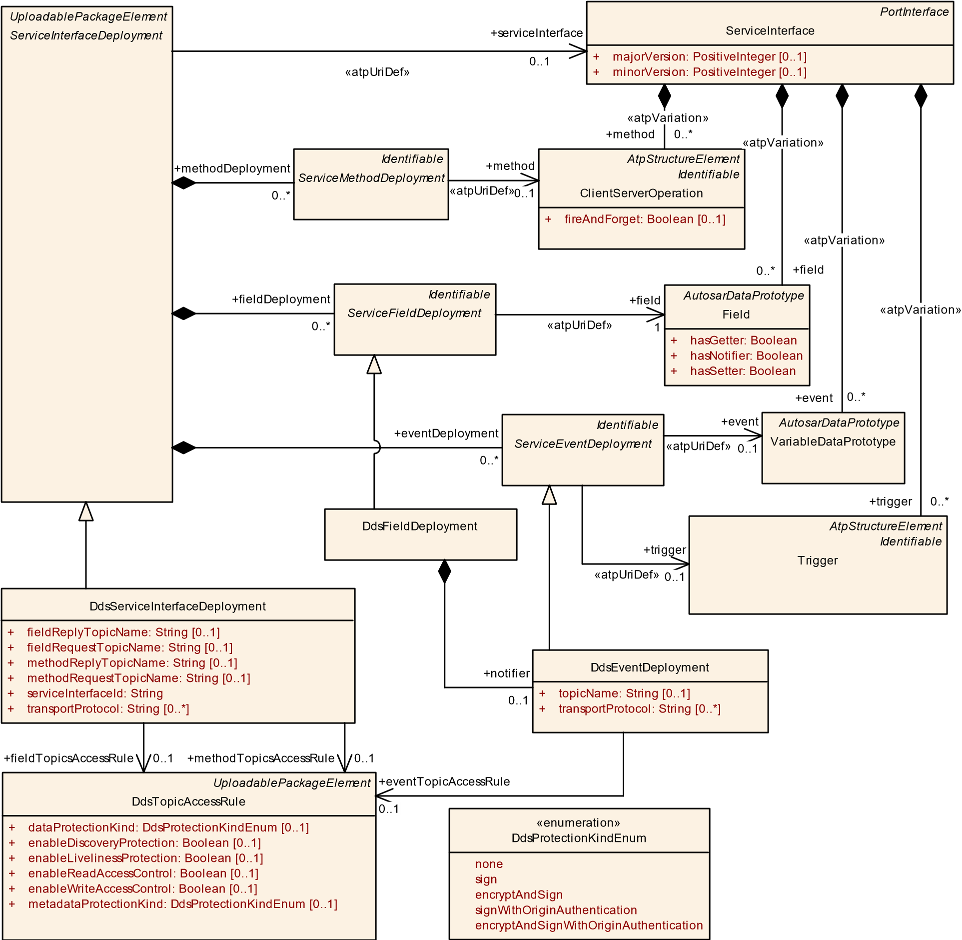

**Figure 10.5: DDS deployment of ServiceInterface**

**[TPS_MANI_03556]**{DRAFT} **DDS-RPC Service Binding** dThe DdsServiceInterfaceDeployment meta-class provides the ability to configure the name of the DDS Request and Reply Topics associated with a DDS-RPC Service with the methodRequestTopicName and methodReplyTopicName attributes, respectively. DDSRPC Services are the mechanisms specified in the OMG RPC over DDS specification (DDS-RPC [26]) to handle method calls with DDS.

The methodRequestTopicName and methodReplyTopicName attributes are optional, if unspecified they shall be configured as specified in the DDS-RPC specification.c*(RS_MANI_00038)*

**[TPS_MANI_03526]**{DRAFT} **DDS VariableDataPrototype binding** dThe DdsEventDeployment meta-class provides the ability to bind a VariableDataPrototype to DDS and to assign a DDS Topic to the event with the topicName attribute. Moreover, the meta-class provides the ability to configure the transportProtocols over which the VariableDataPrototype may be accessed.c*(RS_MANI_00038)*

|  |  |  |  |  |
| --- | --- | --- | --- | --- |
| ***Class*** | **DdsServiceInterfaceDeployment** | | | |
| ***Package*** | M2::AUTOSARTemplates::AdaptivePlatform::ServiceInstanceManifest::ServiceInterfaceDeployment | | | |
| ***Note*** | DDS configuration settings for a ServiceInterface.  **Tags:**  atp.Status=draft  atp.recommendedPackage=ServiceInterfaceDeployments | | | |
| ***Base*** | *ARElement*, *ARObject*, *CollectableElement*, *Identifiable*, *MultilanguageReferrable*, *Packageable*  *Element*, *Referrable*, *ServiceInterfaceDeployment*, *UploadablePackageElement* | | | |
| ***Attribute*** | ***Type*** | ***Mult.*** | ***Kind*** | ***Note*** |
| fieldReplyTopic  Name | String | 0..1 | attr | Name of the DDS Reply Topic associated with the Field.  **Tags:**atp.Status=draft |
| fieldRequest TopicName | String | 0..1 | attr | Name of the DDS Request Topic associated with the  Field.  **Tags:**atp.Status=draft |
| fieldTopics  AccessRule | DdsTopicAccessRule | 0..1 | ref | DDS Security access rule applicable to the DDS Topics used for service interface field access methods (Get, Set).  **Tags:**atp.Status=draft |
| methodReply TopicName | String | 0..1 | attr | Name of the DDS Reply Topic associated with the Method.  **Tags:**atp.Status=draft |
| methodRequest TopicName | String | 0..1 | attr | Name of the DDS Request Topic associated with the Method.  **Tags:**atp.Status=draft |
| methodTopics AccessRule | DdsTopicAccessRule | 0..1 | ref | DDS Security access rule applicable to the DDS Topics used for service interface methods.  **Tags:**atp.Status=draft |
| serviceInterface Id | String | 1 | attr | Unique Identifier that identifies the ServiceInterface in DDS. This Identifier is encoded in the USER_DATA QoS of the DomainParticipant associated with the Service Instance and its value is propagated by DDS Discovery messages.  **Tags:**atp.Status=draft |
| transport Protocol | String | * | attr | This attribute defines over which Transport Layer Protocol(s) this Method is intended to be sent.  **Tags:**atp.Status=draft |

**Table 10.18: DdsServiceInterfaceDeployment**

|  |  |  |  |  |
| --- | --- | --- | --- | --- |
| ***Class*** | **DdsEventDeployment** | | | |
| ***Package*** | M2::AUTOSARTemplates::AdaptivePlatform::ServiceInstanceManifest::ServiceInterfaceDeployment | | | |
| ***Note*** | DDS configuration settings for an Event.  **Tags:**atp.Status=draft | | | |
| ***Base*** | *ARObject*, *Identifiable*, *MultilanguageReferrable*, *Referrable*, *ServiceEventDeployment* | | | |
| ***Attribute*** | ***Type*** | ***Mult.*** | ***Kind*** | ***Note*** |

5

4

|  |  |  |  |  |
| --- | --- | --- | --- | --- |
| ***Class*** | **DdsEventDeployment** |  |  |  |
| eventTopic AccessRule | DdsTopicAccessRule | 0..1 | ref | DDS Security access rule applicable to the DDS Topics used for the service interface event.  **Tags:**atp.Status=draft |
| topicName | String | 0..1 | attr | Name of the DDS Topic associated with the Event.  **Tags:**atp.Status=draft |
| transport Protocol | String | * | attr | This attribute defines over which Transport Layer Protocol(s) this event is intended to be sent.  **Tags:**atp.Status=draft |

**Table 10.19: DdsEventDeployment**

**[TPS_MANI_03557]**{DRAFT} **DDS ClientServerOperation Binding** dThere exists no concrete subclass of ServiceMethodDeployment to bind a ClientServerOperation to DDS. This binding is done with the DdsServiceInterfaceDeployment (see [TPS_MANI_03556]).c*(RS_MANI_00038)*

**[TPS_MANI_03558]**{DRAFT} **DDS Field Binding** dThe DdsFieldDeployment meta-class provides the ability to bind a Field to DDS.

To bind the Field’s notification event the notifier is used to define a DDS Topic. To assign the get/set Field methods the fieldRequestTopicName and fieldReplyTopicName are used to define a DDS Topic.

The fieldRequestTopicName and fieldReplyTopicName attributes are optional, if unspecified they shall be configured as specified in the DDS-RPC specification.c*(RS_MANI_00038)*

**[TPS_MANI_03622]**{DRAFT} **DDS Transport Protocols are up to the stack implementer** dUnderlying transports below the RTPS protocol are not part of the DDS OMG standard (QoS APIs [25]) or (XML schema [27]). It is up to each DDS implementation vendor to decide which transports are supported and how those are expressed in APIs and XML.c*(RS_MANI_00038)*

|  |  |  |  |  |
| --- | --- | --- | --- | --- |
| ***Class*** | **DdsFieldDeployment** | | | |
| ***Package*** | M2::AUTOSARTemplates::AdaptivePlatform::ServiceInstanceManifest::ServiceInterfaceDeployment | | | |
| ***Note*** | DDS configuration settings for a Field.  **Tags:**atp.Status=draft | | | |
| ***Base*** | *ARObject*, *Identifiable*, *MultilanguageReferrable*, *Referrable*, *ServiceFieldDeployment* | | | |
| ***Attribute*** | ***Type*** | ***Mult.*** | ***Kind*** | ***Note*** |
| notifier | DdsEventDeployment | 0..1 | aggr | This aggregation represents the settings of the notifier.  **Tags:**atp.Status=draft |

**Table 10.20: DdsFieldDeployment**

**[constr_3563]**{DRAFT} **Mandatory topic name values** dThe attributes methodRequestTopicName, methodReplyTopicName, fieldRequestTopicName,

fieldReplyTopicName, topicName shall specify string values, each of them unique within the service interface.c*()*

**[TPS_MANI_03662]**{DRAFT} **Configuration of Topic access rules** dThe DdsTopicAccessRule meta-class defines rules generally applicable to DDS Topics defined by Service Interface deployments, determining the protection mechanisms applicable for discovery, liveliness, access control, metadata and user data.

The enableReadAccessControl and enableWriteAccessControl attributes are not meant to interfere with or duplicate ComGrant-based access rules. These are just an additional mechanisms for integrators to fully disable access control for an specific topic at Service Interface Deployment level, in case that is desirable for an specific deployment scenario.c*(RS_MANI_00038)*

|  |  |  |  |  |
| --- | --- | --- | --- | --- |
| ***Class*** | **DdsTopicAccessRule** | | | |
| ***Package*** | M2::AUTOSARTemplates::AdaptivePlatform::ServiceInstanceManifest::ServiceInterfaceDeployment | | | |
| ***Note*** | DDS Topic access rule definition.  **Tags:**  atp.Status=draft  atp.recommendedPackage=DdsTopicAccessRules | | | |
| ***Base*** | *ARElement*, *ARObject*, *CollectableElement*, *Identifiable*, *MultilanguageReferrable*, *Packageable*  *Element*, *Referrable*, *UploadablePackageElement* | | | |
| ***Attribute*** | ***Type*** | ***Mult.*** | ***Kind*** | ***Note*** |
| dataProtection Kind | DdsProtectionKind  Enum | 0..1 | attr | Defines the data protection policy applicable to metadata related to the DDS Topic(s).  **Tags:**atp.Status=draft |
| enable Discovery  Protection | Boolean | 0..1 | attr | Defines whether discovery protection mechanisms should apply to the DDS Topic(s).  **Tags:**atp.Status=draft |
| enable  Liveliness  Protection | Boolean | 0..1 | attr | Defines whether liveliness protection mechanisms should apply to the DDS Topic(s).  **Tags:**atp.Status=draft |
| enableRead  AccessControl | Boolean | 0..1 | attr | Defines whether read access control mechanisms should apply to the DDS Topic(s).  **Tags:**atp.Status=draft |
| enableWrite  AccessControl | Boolean | 0..1 | attr | Defines whether write access control mechanisms should apply to the DDS Topic(s).  **Tags:**atp.Status=draft |
| metadata  ProtectionKind | DdsProtectionKind  Enum | 0..1 | attr | Defines the data protection policy applicable to metadata related to the DDS Topic(s).  **Tags:**atp.Status=draft |

**Table 10.21: DdsTopicAccessRule**

**[constr_3680]**{DRAFT} **Existence of attributes for DdsTopicAccessRule** dThe following attributes of DdsTopicAccessRule shall exist **at the time when the manifest is complete**

* enableDiscoveryProtection
* enableLivelinessProtection
* enableReadAccessControl
* enableWriteAccessControl
* metadataProtectionKind
* dataProtectionKind

### c()

**[constr_3681]**{DRAFT} **Supported values of DdsTopicAccessRule.dataProtectionKind** dOnly values none, sign, or encryptAndSign from DdsProtectionKindEnum shall be used when setting DdsTopicAccessRule.dataProtectionKind **at the time when the manifest is complete**.c*()*

**[constr_3683]**{DRAFT} **Attributes referencing DdsTopicAccessRule** dDdsServiceInterfaceDeployment.fieldTopicsAccessRule, DdsServiceInterfaceDeployment.methodTopicsAccessRule, and DdsEventDeployment. eventTopicAccessRule shall be set if the Service Interface Deployment is to be used by Service Instances relying in DDS Security (meaning DdsServiceInstanceToMachineMapping.secureComPropsForDds is defined) **at the time when the manifest is complete**.c*()*

**10.2.3 User Defined Service Interface**

This chapter describes a user defined deployment of a ServiceInterface to a middleware technology that is not standardized by AUTOSAR. Such UserDefinedServiceInterfaceDeployment can for example also be used to describe a machine local IPC communication.

**[TPS_MANI_03045]**{DRAFT} **UserDefined ServiceInterface binding** dThe UserDefinedServiceInterfaceDeployment meta-class provides the ability to bind a ServiceInterface that is referenced in the role serviceInterface to a middleware technology that is not standardized by AUTOSAR.c*(RS_MANI_00014)*

Please note that UserDefinedServiceInterfaceDeployment is Identifiable and therefore it is able to describe special data (sdg) which is not represented by the standard model.

|  |  |  |  |  |
| --- | --- | --- | --- | --- |
| ***Class*** | **UserDefinedServiceInterfaceDeployment** | | | |
| ***Package*** | M2::AUTOSARTemplates::AdaptivePlatform::ServiceInstanceManifest::ServiceInterfaceDeployment | | | |
| ***Note*** | UserDefined configuration settings for a ServiceInterface.  **Tags:**  atp.Status=draft  atp.recommendedPackage=ServiceInterfaceDeployments | | | |
| ***Base*** | *ARElement*, *ARObject*, *CollectableElement*, *Identifiable*, *MultilanguageReferrable*, *Packageable*  *Element*, *Referrable*, *ServiceInterfaceDeployment*, *UploadablePackageElement* | | | |
| ***Attribute*** | ***Type*** | ***Mult.*** | ***Kind*** | ***Note*** |
| – | – | – | – | – |

**Table 10.22: UserDefinedServiceInterfaceDeployment**

**[TPS_MANI_01165]**{DRAFT} **Standardized value of UserDefinedServiceInterfaceDeployment.category** dThe AUTOSAR Standard reserves the following value for attribute UserDefinedServiceInterfaceDeployment.category:

• SERVICE_INTERFACE_DEPLOYMENT_IPC

It is possible to use a custom, non-standardized value for the attribute UserDefined-

ServiceInterfaceDeployment.category but this option comes with the obligation to use a value that is guaranteed to not clash with possible future extensions of the collection of standardized values.c*(RS_MANI_00014)*

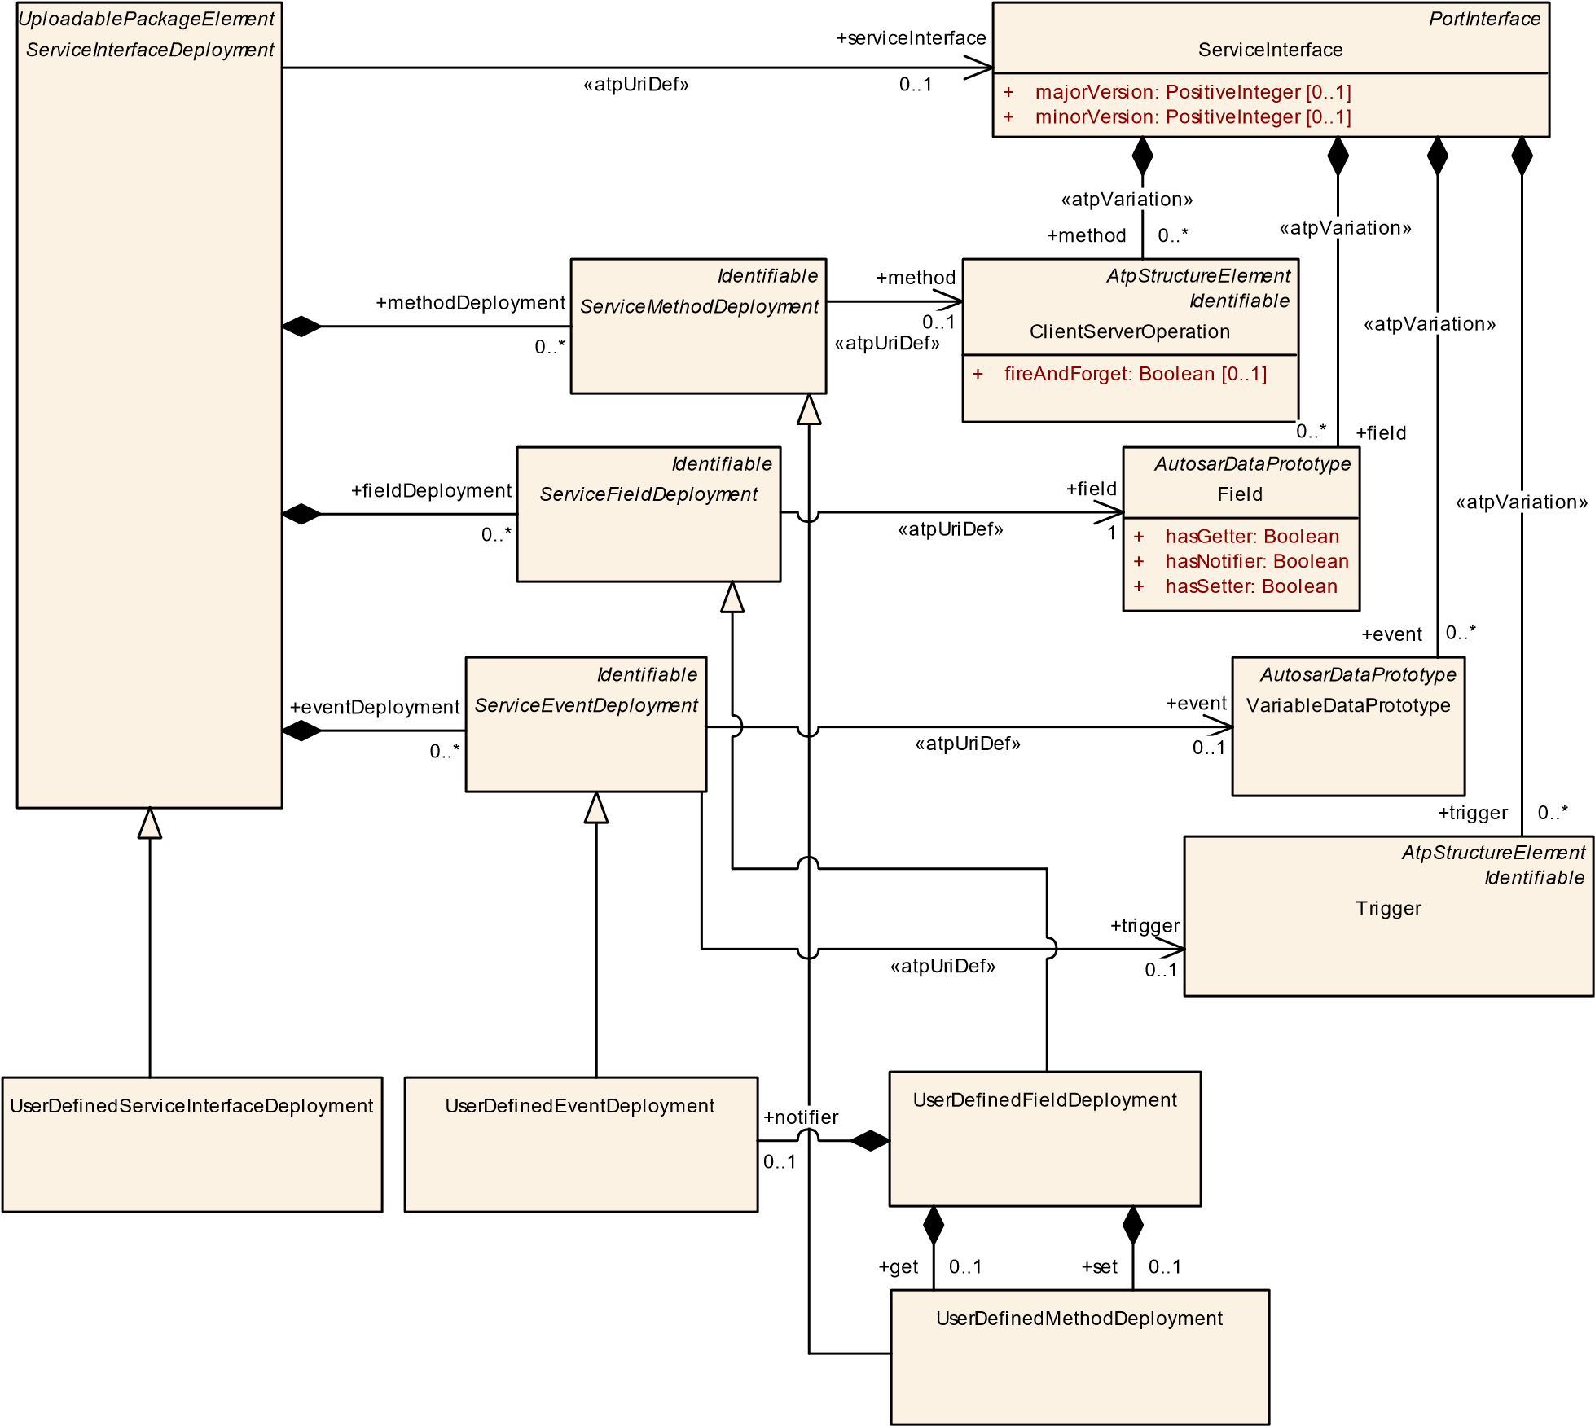

**Figure 10.6: User defined deployment of ServiceInterface**

IPC communication may or may not require configuration settings that nevertheless aren’t standardized by AUTOSAR. The best support that the AUTOSAR standard can deliver is the provision of meta-classes that can be taken as the basis to define configuration settings by means of the definition of Sdg.

**[constr_1570]**{DRAFT} **Restriction for UserDefinedServiceInterfaceDeployment of categorySERVICE_INTERFACE_DEPLOYMENT_IPC**dAn AdaptivePlatformServiceInstance that references a UserDefinedServiceInterfaceDeployment of category SERVICE_INTERFACE_DEPLOYMENT_IPC shall **only** be referenced by a UserDefinedServiceInstanceToMachineMapping in the role serviceInstance that in turn references a UserDefinedCommunicationConnector.c*()*

|  |  |  |  |  |
| --- | --- | --- | --- | --- |
| ***Class*** | **UserDefinedServiceInstanceToMachineMapping** | | | |
| ***Package*** | M2::AUTOSARTemplates::AdaptivePlatform::ServiceInstanceManifest::ServiceInstanceMapping | | | |
| ***Note*** | This meta-class allows to map UserDefinedServiceInstances to a CommunicationConnector of a Machine.  **Tags:**  atp.Status=draft  atp.recommendedPackage=ServiceInstanceToMachineMappings | | | |
| ***Base*** | *ARElement*, *ARObject*, *CollectableElement*, *Identifiable*, *MultilanguageReferrable*, *Packageable*  *Element*, *Referrable*, *ServiceInstanceToMachineMapping*, *UploadablePackageElement* | | | |
| ***Attribute*** | ***Type*** | ***Mult.*** | ***Kind*** | ***Note*** |
| – | – | – | – | – |

**Table 10.23: UserDefinedServiceInstanceToMachineMapping**

Rationale for [constr_1570]: for a local IPC binding it is sometimes necessary to define properties of the IPC system. And for this purpose the UserDefinedCommunicationConnector mapped to an AdaptivePlatformServiceInstance can be used to define global properties (e.g. for service discovery) of a given "IPC-Domain".

In other words, each defined UserDefinedCommunicationConnector may represent such an "IPC-Domain" that requires a dedicated configuration on the basis of the definition of Sdgs.

|  |  |  |  |  |
| --- | --- | --- | --- | --- |
| ***Class*** | **UserDefinedCommunicationConnector** | | | |
| ***Package*** | M2::AUTOSARTemplates::SystemTemplate::Fibex::CddSupport | | | |
| ***Note*** | This element allows the modeling of arbitrary Communication Connectors. | | | |
| ***Base*** | *ARObject*, *CommunicationConnector*, *Identifiable*, *MultilanguageReferrable*, *Referrable* | | | |
| ***Attribute*** | ***Type*** | ***Mult.*** | ***Kind*** | ***Note*** |
| – | – | – | – | – |

**Table 10.24: UserDefinedCommunicationConnector**

**[TPS_MANI_03046]**{DRAFT} **User defined VariableDataPrototype binding** dThe UserDefinedEventDeployment meta-class provides the ability to bind a VariableDataPrototype that is referenced in the role event to a middleware technology that is not standardized by AUTOSAR.c*(RS_MANI_00014)*

Please note that UserDefinedEventDeployment is Identifiable and therefore it is able to describe special data (sdg) which is not represented by the standard model.

|  |  |  |  |  |
| --- | --- | --- | --- | --- |
| ***Class*** | **UserDefinedEventDeployment** | | | |
| ***Package*** | M2::AUTOSARTemplates::AdaptivePlatform::ServiceInstanceManifest::ServiceInterfaceDeployment | | | |
| ***Note*** | UserDefined configuration settings for an Event.  **Tags:**atp.Status=draft | | | |
| ***Base*** | *ARObject*, *Identifiable*, *MultilanguageReferrable*, *Referrable*, *ServiceEventDeployment* | | | |
| ***Attribute*** | ***Type*** | ***Mult.*** | ***Kind*** | ***Note*** |
| – | – | – | – | – |

**Table 10.25: UserDefinedEventDeployment**

**[TPS_MANI_03047]**{DRAFT} **User defined ClientServerOperation binding** dThe UserDefinedMethodDeployment meta-class provides the ability to bind a ClientServerOperation that is referenced in the role method to a middleware technology that is not standardized by AUTOSAR.c*(RS_MANI_00014)*

Please note that UserDefinedMethodDeployment is Identifiable and therefore it is able to describe special data (sdg) which is not represented by the standard model.

|  |  |  |  |  |
| --- | --- | --- | --- | --- |
| ***Class*** | **UserDefinedMethodDeployment** | | | |
| ***Package*** | M2::AUTOSARTemplates::AdaptivePlatform::ServiceInstanceManifest::ServiceInterfaceDeployment | | | |
| ***Note*** | UserDefined configuration settings for a Method.  **Tags:**atp.Status=draft | | | |
| ***Base*** | *ARObject*, *Identifiable*, *MultilanguageReferrable*, *Referrable*, *ServiceMethodDeployment* | | | |
| ***Attribute*** | ***Type*** | ***Mult.*** | ***Kind*** | ***Note*** |
| – | – | – | – | – |

**Table 10.26: UserDefinedMethodDeployment**

**[TPS_MANI_03048]**{DRAFT} **User defined Field binding** dThe UserDefinedFieldDeployment meta-class provides the ability to bind a Field that is referenced in the role field to a middleware technology that is not standardized by AUTOSAR.c *(RS_MANI_00014)*

Please note that UserDefinedFieldDeployment is Identifiable and therefore it is able to describe special data (sdg) which is not represented by the standard model.

|  |  |  |  |  |
| --- | --- | --- | --- | --- |
| ***Class*** | **UserDefinedFieldDeployment** | | | |
| ***Package*** | M2::AUTOSARTemplates::AdaptivePlatform::ServiceInstanceManifest::ServiceInterfaceDeployment | | | |
| ***Note*** | UserDefined configuration settings for a Field.  **Tags:**atp.Status=draft | | | |
| ***Base*** | *ARObject*, *Identifiable*, *MultilanguageReferrable*, *Referrable*, *ServiceFieldDeployment* | | | |
| ***Attribute*** | ***Type*** | ***Mult.*** | ***Kind*** | ***Note*** |
| get | UserDefinedMethod  Deployment | 0..1 | aggr | This aggregation represents the settings of the get method  **Tags:**atp.Status=draft |

5

4

|  |  |  |  |  |
| --- | --- | --- | --- | --- |
| ***Class*** | **UserDefinedFieldDeployment** | |  |  |
| notifier | UserDefinedEvent  Deployment | 0..1 | aggr | This aggregation represents the settings of the notifier.  **Tags:**atp.Status=draft |
| set | UserDefinedMethod  Deployment | 0..1 | aggr | This aggregation represents the settings of the set method  **Tags:**atp.Status=draft |

**Table 10.27: UserDefinedFieldDeployment**

**[constr_3417]**{DRAFT} **UserDefinedEventDeployments aggregated by a UserDefinedFieldDeployment** dA UserDefinedEventDeployment that is aggregated by a UserDefinedFieldDeployment in the role notifier shall not reference a VariableDataPrototype in the role event.c*()*

**[constr_3418]**{DRAFT} **UserDefinedMethodDeployments aggregated by a UserDefinedFieldDeployment**dA UserDefinedMethodDeployment that is aggregated by a UserDefinedFieldDeployment in the role get or set shall not reference a ClientServerOperation in the role method.c*()*

## 10.3 Service Instance Deployment

An AdaptivePlatformServiceInstance makes the functionality of a ServiceInterface available on the *AUTOSAR adaptive platform*. Several Adaptive-

PlatformServiceInstances may be set up for the same ServiceInterface.

They deliver the same functionality, but for different purposes and/or to different users.

The ProvidedApServiceInstance represents a provider that offers the functionality of a ServiceInterface with particular properties. Clients that are represented by the RequiredApServiceInstance observe offers and choose a provider with respect to service properties.

*UploadablePackageElement*

*AdaptivePlatformServiceInstance*

*ProvidedApServiceInstance*

*RequiredApServiceInstance*

*UploadablePackageElement*

*ServiceInterfaceDeployment*

+

serviceInterfaceDeployment

0..1

**Figure 10.7: Modeling of the AdaptivePlatformServiceInstance**

Note that the abstract meta-class AdaptivePlatformServiceInstance is derived from ARElement. This means that all meta-classes derived from AdaptivePlatformServiceInstance can be declared on the M1 level as part of an ARPackage and thus can be used in several Manifest descriptions.

|  |  |  |  |  |
| --- | --- | --- | --- | --- |
| ***Class*** | ***AdaptivePlatformServiceInstance*** (abstract) | | | |
| ***Package*** | M2::AUTOSARTemplates::AdaptivePlatform::ServiceInstanceManifest::ServiceInstanceDeployment | | | |
| ***Note*** | This meta-class represents the ability to describe the existence and configuration of a service instance in an abstract way.  **Tags:**atp.Status=draft | | | |
| ***Base*** | *ARElement*, *ARObject*, *CollectableElement*, *Identifiable*, *MultilanguageReferrable*, *Packageable*  *Element*, *Referrable*, *UploadablePackageElement* | | | |
| ***Subclasses*** | *ProvidedApServiceInstance*, *RequiredApServiceInstance* | | | |
| ***Attribute*** | ***Type*** | ***Mult.*** | ***Kind*** | ***Note*** |
| e2eEvent  ProtectionProps | End2EndEvent  ProtectionProps | * | aggr | This aggregation allows to protect an event or a field notifier that is defined inside of the ServiceInterface that is referenced by the ServiceInstance in the role service Interface.  **Tags:**atp.Status=draft |
| e2eMethod  ProtectionProps | End2EndMethod  ProtectionProps | * | aggr | This aggregation allows to protect a method or a field getter or a field setter that is defined inside of the Service Interface that is referenced by the ServiceInstance in the role serviceInterface  **Tags:**atp.Status=draft |
| secureCom Config | ServiceInterface  ElementSecureCom  Config | * | aggr | Configuration settings to secure the communication of ServiceInterface elements.  **Tags:**atp.Status=draft |
| serviceInterface Deployment | ServiceInterface  Deployment | 0..1 | ref | Reference to a ServiceInterfaceDeployment that identifies the ServiceInterface that is represented by the Service Instance.  **Tags:**atp.Status=draft |

**Table 10.28: AdaptivePlatformServiceInstance**

|  |  |  |  |  |
| --- | --- | --- | --- | --- |
| ***Class*** | ***RequiredApServiceInstance*** (abstract) | | | |
| ***Package*** | M2::AUTOSARTemplates::AdaptivePlatform::ServiceInstanceManifest::ServiceInstanceDeployment | | | |
| ***Note*** | This meta-class represents the ability to describe the existence and configuration of a required service instance in an abstract way.  **Tags:**atp.Status=draft | | | |
| ***Base*** | *ARElement*, *ARObject*, *AdaptivePlatformServiceInstance*, *CollectableElement*, *Identifiable*,  *MultilanguageReferrable*, *PackageableElement*, *Referrable*, *UploadablePackageElement* | | | |
| ***Subclasses*** | DdsRequiredServiceInstance, RequiredSomeipServiceInstance, RequiredUserDefinedServiceInstance | | | |
| ***Attribute*** | ***Type*** | ***Mult.*** | ***Kind*** | ***Note*** |
| – | – | – | – | – |

**Table 10.29: RequiredApServiceInstance**

|  |  |
| --- | --- |
| ***Class*** | ***ProvidedApServiceInstance*** (abstract) |
| ***Package*** | M2::AUTOSARTemplates::AdaptivePlatform::ServiceInstanceManifest::ServiceInstanceDeployment |
| ***Note*** | This meta-class represents the ability to describe the existence and configuration of a provided service instance in an abstract way.  **Tags:**atp.Status=draft |
| ***Base*** | *ARElement*, *ARObject*, *AdaptivePlatformServiceInstance*, *CollectableElement*, *Identifiable*,  *MultilanguageReferrable*, *PackageableElement*, *Referrable*, *UploadablePackageElement* |
| ***Subclasses*** | DdsProvidedServiceInstance, ProvidedSomeipServiceInstance, ProvidedUserDefinedServiceInstance |

5

4

|  |  |  |  |  |
| --- | --- | --- | --- | --- |
| ***Class*** | ***ProvidedApServiceInstance*** (abstract) | | |  |
| ***Attribute*** | ***Type*** | ***Mult.*** | ***Kind*** | ***Note*** |
| – | – | – | – | – |

**Table 10.30: ProvidedApServiceInstance**

There are two alternative ways to relate an AdaptivePlatformServiceInstance with a MachineDesign as described in [TPS_MANI_03000] and [TPS_MANI_03001]. Figure Figure 10.8 shows both approaches in an example.

**Machine**

**Machine**

SOME/IP Service Discovery

**Provided Service Instance**

•

wheelSpeedFrontLeft

wheelSpeedFrontRight

•

**Required Service Instance**

vehicleState

•

**Required Service Instance**

wheelSpeedFrontLeft

•

wheelSpeedFrontRight

•

•

wheelSpeedRearLeft

wheelSpeedRearRight

•

**Required Service Instance**

•

vehicleState

Application

Component A

R

Application

Component B

R

**Figure 10.8: Different approaches for ServiceInstanceMapping**

*Identifiable*

*CommunicationConnector*

[0..1]

createEcuWakeupSource: Boolean

+

}

pncFilterArrayMask: PositiveInteger [0..*] {ordered

+

*ARElement*

*AtpStructureElement*

Machine

:

trustedPlatformExecutableLaunchBehavior

+

TrustedPlatformExecutableLaunchBehaviorEnum

*UploadablePackageElement*

*ServiceInstanceToMachineMapping*

*UploadablePackageElement*

*AdaptivePlatformServiceInstance*

*UploadablePackageElement*

*ServiceInterfaceDeployment*

*AtpStructureElement*

*FibexElement*

MachineDesign

[0..1]

accessControl: AccessControlEnum

+

+

pncPrepareSleepTimer: TimeValue

[0..1]

+

pnResetTimer: TimeValue

[0..1]

machineDesign

+

1

«atpSplitable»

+

communicationConnector

0..*

+

serviceInterfaceDeployment

0..1

+

communicationConnector

0..1

+

serviceInstance

0..*

**Figure 10.9: ServiceInstanceToMachineMapping**

**[TPS_MANI_03001]**{DRAFT} **Mapping of AdaptivePlatformServiceInstance to a MachineDesign** dServiceInstanceToMachineMapping is used to assign one or several AdaptivePlatformServiceInstances to (via a CommunicationConnector) a MachineDesign. This allows to define a “black box” machine view without any assumption on the application software but with all necessary information to configure the communication (e.g. SOME/IP).c*(RS_MANI_00009)*

|  |  |  |  |  |
| --- | --- | --- | --- | --- |
| ***Class*** | ***ServiceInstanceToMachineMapping*** (abstract) | | | |
| ***Package*** | M2::AUTOSARTemplates::AdaptivePlatform::ServiceInstanceManifest::ServiceInstanceMapping | | | |
| ***Note*** | This meta-class represents the ability to map one or several AdaptivePlatformServiceInstances to a CommunicationConnector of a Machine.  **Tags:**atp.Status=draft | | | |
| ***Base*** | *ARElement*, *ARObject*, *CollectableElement*, *Identifiable*, *MultilanguageReferrable*, *Packageable*  *Element*, *Referrable*, *UploadablePackageElement* | | | |
| ***Subclasses*** | DdsServiceInstanceToMachineMapping, SomeipServiceInstanceToMachineMapping, UserDefined ServiceInstanceToMachineMapping | | | |
| ***Attribute*** | ***Type*** | ***Mult.*** | ***Kind*** | ***Note*** |
| communication Connector | Communication  Connector | 0..1 | ref | Reference to the Machine to which the ServiceInstance is mapped.  **Tags:**atp.Status=draft |
| secOcCom  PropsFor  Multicast | SecOcSecureCom  Props | * | ref | Reference to communication security configuration settings that are valid for the udp multicast endpoint (Port + Multicast IP Address) defined by the ServiceInstanceTo MachineMapping.  **Tags:**atp.Status=draft |
| secureCom PropsForTcp | SecureComProps | 0..1 | ref | Reference to communication security configuration settings that are valid for the tcp unicast endpoint (Tcp Port + Unicast IP Address) defined by the Service InstanceToMachineMapping.  **Tags:**atp.Status=draft |
| secureCom  PropsForUdp | SecureComProps | 0..1 | ref | Reference to communication security configuration settings that are valid for the udp unicast endpoint (Udp Port + Unicast IP Address) defined by the Service InstanceToMachineMapping.  **Tags:**atp.Status=draft |
| serviceInstance | AdaptivePlatform  ServiceInstance | * | ref | Reference to a ServiceInstance that is mapped to the Machine.  **Tags:**atp.Status=draft |

**Table 10.31: ServiceInstanceToMachineMapping**

**[constr_5155]**{DRAFT}**SomeipServiceInstanceToMachineMapping only supports a single Address Family** dA SomeipServiceInstanceToMachineMapping shall only support a single Address Family, i.e. either IPv4 or IPv6. If IPv4 is defined for IP unicast communication according to [constr_3288] then the Someip-

ProvidedEventGroups in ProvidedSomeipServiceInstances that are referenced by the SomeipServiceInstanceToMachineMapping shall only define an ipv4MulticastIpAddress.

If IPv6 is defined for IP unicast communication according to [constr_3288] then the

SomeipProvidedEventGroups in ProvidedSomeipServiceInstances that are referenced by the SomeipServiceInstanceToMachineMapping shall only define an ipv6MulticastIpAddress.c*()*

**[constr_3487]**{DRAFT} **TCP endpoint can only serve provided or required service instances exclusively** dServiceInstanceToMachineMapping is not allowed to refer to a ProvidedApServiceInstance and at the same time a RequiredApServiceInstance in the role serviceInstance if

* the ServiceInterfaceDeployment that is referenced by the ProvidedApServiceInstance in the role serviceInterfaceDeployment and
* the ServiceInterfaceDeployment that is referenced by the RequiredApServiceInstance in the role serviceInterfaceDeployment

both contain defined tcp content that is described by the transportProtocol attribute in the deployment elements of SOME/IP or DDS.

In other words a TCP endpoint can only serve provided or required service instances exclusively.c*()*

The reason for [constr_3487] is that the POSIX Socket API does not support the binding of several TCP sockets onto the same tuple <local IP address, local port>. But this would be necessary if a service is provided and consumed over the same TCP

Endpoint.

**[TPS_MANI_03000]**{DRAFT} **Mapping of AdaptivePlatformServiceInstance to PortPrototypes** dServiceInstanceToPortPrototypeMapping is used to assign an AdaptivePlatformServiceInstance to a PortPrototype of a SwComponentType. This allows to define how specific PortPrototypes of a Software Component are represented in the middleware in terms of the service configuration.c*(RS_MANI_00011)*

In other words, the “outside” appearance of a PortPrototype from the middleware point of view is the AdaptivePlatformServiceInstance, or the concrete subclasses RequiredApServiceInstance and ProvidedApServiceInstance.

Meta-classes ProvidedApServiceInstance and RequiredApServiceInstance are abstract and this allows for using specific derived classes that fit the underlying middleware (e.g. SOME/IP). The following sub-chapters will detail the supported specializations.

**[TPS_MANI_01316]**{DRAFT} **Existence of ServiceInstanceToPortPrototypeMapping.processDesign** dThe reference ServiceInstanceToPortPrototypeMapping.processDesign shall only be used in a design-level modeling scenario where a pre-assignment of a given ServiceInstanceToPortPrototypeMapping to a specific ProcessDesign is intended.

By this means it is possible to express that one Executable is foreseen to be executed in multiple instances and it is also possible to assign service instances to each of the foreseen ProcessDesigns that represent instances of Executable at design time.c*(RS_MANI_00009)*

*UploadablePackageElement*

*AdaptivePlatformServiceInstance*

*UploadablePackageElement*

ServiceInstanceToPortPrototypeMapping

*UploadablePackageElement*

*ServiceInterfaceDeployment*

*AtpBlueprintable*

*AtpPrototype*

*PortPrototype*

*ARElement*

ProcessDesign

*AbstractExecutionContext*

Process

+

functionClusterAffiliation: String

[0..1]

+

numberOfRestartAttempts: PositiveInteger

[0..1]

+

preMapping: Boolean

[0..1]

+

serviceInterfaceDeployment

0..1

«instanceRef,atpUriDef»

+

portPrototype

0..1

«atpUriDef»

+

processDesign

0..1

+

serviceInstance

0..1

design

+

0..1

«atpSplitable»

process

+

0..1

**Figure 10.10: ServiceInstanceToPortPrototypeMapping**

|  |  |  |  |  |
| --- | --- | --- | --- | --- |
| ***Class*** | **ServiceInstanceToPortPrototypeMapping** | | | |
| ***Package*** | M2::AUTOSARTemplates::AdaptivePlatform::ServiceInstanceManifest::ServiceInstanceMapping | | | |
| ***Note*** | This meta-class represents the ability to assign a transport layer dependent ServiceInstance to a Port Prototype.  With this mapping it is possible to define how specific PortPrototypes are represented in the middleware in terms of service configuration.  **Tags:**  atp.Status=draft  atp.recommendedPackage=ServiceInstanceToPortPrototypeMappings | | | |
| ***Base*** | *ARElement*, *ARObject*, *CollectableElement*, *Identifiable*, *MultilanguageReferrable*, *Packageable*  *Element*, *Referrable*, *UploadablePackageElement* | | | |
| ***Attribute*** | ***Type*** | ***Mult.*** | ***Kind*** | ***Note*** |
| portPrototype | PortPrototype | 0..1 | iref | Reference to a specific PortPrototype that represents the ServiceInstance.  **Tags:**atp.Status=draft  **InstanceRef implemented by:**PortPrototypeIn  ExecutableInstanceRef |
| process | Process | 0..1 | ref | Reference to the Process in which the enclosing Service InstanceToPortPrototypeMapping is executed.  **Stereotypes:** atpSplitable **Tags:**  atp.Splitkey=process atp.Status=draft |

5

4

|  |  |  |  |  |
| --- | --- | --- | --- | --- |
| ***Class*** | **ServiceInstanceToPortPrototypeMapping** | | |  |
| processDesign | ProcessDesign | 0..1 | ref | Reference to the ProcessDesign in which the Executable that contains the SoftwareComponent and the referenced PortPrototype is executed.  **Stereotypes:** atpUriDef  **Tags:**atp.Status=draft |
| serviceInstance | AdaptivePlatform  ServiceInstance | 0..1 | ref | Reference to a ServiceInstance that is represented in the  Software Component by the mapped group of Port  Prototypes.  **Tags:**atp.Status=draft |

**Table 10.32: ServiceInstanceToPortPrototypeMapping**

**[TPS_MANI_01317]**{DRAFT} **Existence of ServiceInstanceToPortPrototypeMapping.process** dThe reference ServiceInstanceToPortPrototypeMapping.process shall be only used in a deployment-level modeling where the integration of a SoftwareCluster is created. The reference has the role to identify the actual Process used in the execution manifest.

This reference overwrites a potentially existing reference to a ProcessDesign in the context of the enclosing ServiceInstanceToPortPrototypeMappingc*(RS_MANI_00009)*

Please note that if both ServiceInstanceToPortPrototypeMapping.processDesign and process exist, the latter gets the higher significance because it is created by an integrator who may overrule design decisions on the basis of superior knowledge about the context.

In such a case it is acceptable that the Process references a different ProcessDesign than the one referenced in the role ServiceInstanceToPortPrototypeMapping.processDesign. This is just the result of superior knowledge of the integrator over the designer.

**10.3.1 SOME/IP Service Instance Deployment**

In the case of SOME/IP used as the middleware the derived meta-classes are ProvidedSomeipServiceInstance or RequiredSomeipServiceInstance. These meta-classes also carry attributes that apply for the service discovery on SOME/IP.

|  |  |
| --- | --- |
| ***Primitive*** | **AnyServiceInstanceId** |
| ***Package*** | M2::AUTOSARTemplates::GenericStructure::GeneralTemplateClasses::PrimitiveTypes |

5

4

|  |  |
| --- | --- |
| ***Primitive*** | **AnyServiceInstanceId** |
| ***Note*** | This is a positive integer or the literal ALL (the value ANY is technically supported but deprecated) which can be denoted in decimal, octal and hexadecimal. The value is between 0 and 65535.  **Tags:**  xml.xsd.customType=ANY-SERVICE-INSTANCE-ID  xml.xsd.pattern=[1-9][0-9]*|0[xX][0-9a-fA-F]+|0[0-7]*|0[bB][0-1]+|ANY|ALL xml.xsd.type=string |

**Table 10.33: AnyServiceInstanceId**

ProvidedSomeipServiceInstance

[0..1]

loadBalancingPriority: PositiveInteger

+

[0..1]

loadBalancingWeight: PositiveInteger

+

[0..1]

priority: PositiveInteger

+

serviceInstanceId: PositiveInteger

+

RequiredSomeipServiceInstance

[0..1]

requiredMinorVersion: AnyVersionString

+

requiredServiceInstanceId: AnyServiceInstanceId

[0..1]

+

[0..1]

versionDrivenFindBehavior: ServiceVersionAcceptanceKindEnum

+

*ProvidedApServiceInstance*

*RequiredApServiceInstance*

*UploadablePackageElement*

*AdaptivePlatformServiceInstance*

*UploadablePackageElement*

*ServiceInterfaceDeployment*

*Identifiable*

SomeipProvidedEventGroup

eventMulticastUdpPort: PositiveInteger

+

[0..1]

[0..1]

ipv4MulticastIpAddress: Ip4AddressString

+

[0..1]

ipv6MulticastIpAddress: Ip6AddressString

+

multicastThreshold: PositiveInteger

+

*ARElement*

SomeipSdServerServiceInstanceConfig

[0..1]

+

offerCyclicDelay: TimeValue

+

priority: PositiveInteger

[0..1]

serviceOfferTimeToLive: PositiveInteger

+

*Referrable*

SomeipRequiredEventGroup

*ARElement*

SomeipSdClientServiceInstanceConfig

+

[0..1]

priority: PositiveInteger

+

serviceFindTimeToLive: PositiveInteger

+

sdServerConfig

1

requiredEventGroup

+

0..*

+

providedEventGroup

0..*

+

sdClientConfig

1

+

serviceInterfaceDeployment

0..1

**Figure 10.11: SOME/IP Service Instances**

**10.3.1.1 Provided Service Instance**

The ProvidedSomeipServiceInstance defines the serviceInstanceId for the Service Instance of the SomeipServiceInterfaceDeployment that is referenced with the serviceInterfaceDeployment reference.

It means that the Server on which the ProvidedSomeipServiceInstance is deployed offers the Service Instance over SOME/IP with the serviceInstanceId and serviceInterfaceId.

|  |  |  |  |  |
| --- | --- | --- | --- | --- |
| ***Class*** | **ProvidedSomeipServiceInstance** | | | |
| ***Package*** | M2::AUTOSARTemplates::AdaptivePlatform::ServiceInstanceManifest::ServiceInstanceDeployment | | | |
| ***Note*** | This meta-class represents the ability to describe the existence and configuration of a provided service instance in a concrete implementation on top of SOME/IP.  **Tags:**  atp.Status=draft  atp.recommendedPackage=ServiceInstances | | | |
| ***Base*** | *ARElement*, *ARObject*, *AdaptivePlatformServiceInstance*, *CollectableElement*, *Identifiable*,  *MultilanguageReferrable*, *PackageableElement*, *ProvidedApServiceInstance*, *Referrable*, *Uploadable PackageElement* | | | |
| ***Attribute*** | ***Type*** | ***Mult.*** | ***Kind*** | ***Note*** |
| capability  Record  (ordered) | TagWithOptionalValue | * | aggr | A sequence of records to store arbitrary name/value pairs conveying additional information about the named service.  **Tags:**atp.Status=draft |
| eventProps | SomeipEventProps | * | aggr | Configuration settings for individual events that are provided by the ServiceInstance.  **Tags:**atp.Status=draft |
| loadBalancing Priority | PositiveInteger | 0..1 | attr | This attribute is used to specify the priority in the load balancing option of SOME/IP that is added to the Offer Service.  When a client searches for all service instances of a service, the client shall choose the service instance with highest priority if one is defined.  **Tags:**atp.Status=draft |
| loadBalancing Weight | PositiveInteger | 0..1 | attr | This attribute is used to specify the weight in the load balancing option of SOME/IP that is added to the Offer Service.  When a client searches for all service instances of a service, the client shall choose the service instance with highest priority if one is defined. If several service instances exist with the highest priority the service instance shall be chosen based on the weights of the service instances.  **Tags:**atp.Status=draft |
| method  ResponseProps | SomeipMethodProps | * | aggr | Configuration settings for individual methods that are provided by the ServiceInstance.  **Tags:**atp.Status=draft |
| priority | PositiveInteger | 0..1 | attr | This attribute defines the VLAN frame priority for SOME/ IP messages that are resulting from this ProvidedSomeip ServiceInstance (Method and Event communication).  Values from 0 (best effort) to 7 (highest) are allowed.  **Tags:**atp.Status=draft |
| providedEvent Group | SomeipProvidedEvent  Group | * | aggr | List of EventGroups that are provided by the Service Instance.  **Tags:**atp.Status=draft |
| sdServerConfig | SomeipSdServer  ServiceInstanceConfig | 1 | ref | Server specific configuration settings relevant for the SOME/IP service discovery.  **Tags:**atp.Status=draft |

5 4

|  |  |  |  |  |
| --- | --- | --- | --- | --- |
| ***Class*** | **ProvidedSomeipServiceInstance** | |  |  |
| serviceInstance Id | PositiveInteger | 1 | attr | Identification number that is used by SOME/IP service discovery to identify the instance of the service.  The value 65535 for service instance id is reserved and should not be used.  **Tags:**atp.Status=draft |

**Table 10.34: ProvidedSomeipServiceInstance**

**[constr_3287]**{DRAFT} **Mandatory information of a ProvidedSomeipServiceInstance**dThe ProvidedSomeipServiceInstance shall always define the serviceInstanceId.c*()*

**[constr_1770]**{DRAFT} **Value of ProvidedSomeipServiceInstance.serviceInstanceId** dFor each ProvidedSomeipServiceInstance.serviceInstanceId, the value shall be in the range 0..65534.c*()*

Rationale for [constr_1770]: on protocol level, the value 65535 represents the "ALL" semantics that can only be used in find messages.

In addition to the service identification properties a SOME/IP offer message contains so called endpoint options that define how the service instance is reachable by clients.

**[TPS_MANI_03168]**{DRAFT} **Configuration of the SOME/IP load balancing option** dThe SOME/IP load balancing option is configurable per ProvidedSomeipService-

Instance with the two attributes loadBalancingPriority and loadBalancingWeight.c*(RS_MANI_00024)*

The SOME/IP load balancing option is used to prioritize different ProvidedSomeipServiceInstances that point to the same SomeipServiceInterfaceDeployment, so that a client chooses the service instance based on these settings. This option is attached to SOME/IP Offer Service entries.

**[constr_3415]**{DRAFT} **Value range of loadBalancingPriority** dThe value of loadBalancingPriority shall be in the range of 0..65535.c*()*

Please note that according to SOME/IP a lower value means higher priority.

**[constr_3416]**{DRAFT} **Value range of loadBalancingWeight** dThe value of loadBalancingWeight shall be in the range of 0..65535.c*()*

Please note that according to SOME/IP a higher value means higher probability to be chosen.

**[constr_1723]**{DRAFT} **ProvidedSomeipServiceInstance shall be unique in respect of serviceInstanceId, serviceInterfaceId and majorVersion on a VLAN** dOn a VLAN, each ProvidedSomeipServiceInstance shall have a different serviceInstanceId, serviceInterfaceId and majorVersion value combination.

In other words, no two ProvidedSomeipServiceInstances shall have the same serviceInstanceId, serviceInterfaceId and majorVersion value combination during runtime on the same VLAN.c*()*

The following figure shows that different SOME/IP ServiceInstances with the same serviceInstanceId, serviceInterfaceId and majorVersion are provided on different VLANs. This is a valid setup according to [constr_1723].

PPortPrototype

PPortPrototype

ServiceInstanceToPort

PrototypeMapping

ServiceInstanceToPort

PrototypeMapping

ProvidedSomeip

-

ServiceInstance

ID

=

42

ProvidedSomeip

-

ServiceInstance

ID

=

42

ServiceInstanceTo

MachineMapping

ServiceInstanceTo

MachineMapping

EthernetCommunication

Connector

EthernetCommunication

Connector

**Figure 10.12: Scenario in which two ProvidedSomeipServiceInstances with the same credentials are provided on two VLANs**

In the following example where the same ProvidedSomeipServiceInstance is mapped to different PPortPrototypes and is provided on different VLANs the specification item [TPS_MANI_03236] applies. This means that only one of the PPortPrototypes is active at runtime at the same time and offers the ServiceInstance on two different VLANs.

PPortPrototype

PPortPrototype

ServiceInstanceToPort

PrototypeMapping

ServiceInstanceToPort

PrototypeMapping

ProvidedSomeip

-

ServiceInstance

ID

=

42

ServiceInstanceTo

MachineMapping

ServiceInstanceTo

MachineMapping

EthernetCommunication

Connector

EthernetCommunication

Connector

**Figure 10.13: Scenario in which a ProvidedSomeipServiceInstance is provided on two VLANs and is mapped to different PPortPrototypes from which latest at runtime only one is operational**

**[TPS_MANI_03236]**{DRAFT} **Mapping of ProvidedSomeipServiceInstance to different PPortPrototypes** dIn case that the same ProvidedSomeipServiceInstance is mapped by several ServiceInstanceToPortPrototypeMappings to different PPortPrototypes it shall be ensured (latest at runtime) that only one of these mapped PPortPrototypes is actually operational at any given point in time.c *(RS_MANI_00009)*

PPortPrototype

PPortPrototype

ServiceInstanceToPort

PrototypeMapping

ServiceInstanceToPort

PrototypeMapping

ProvidedSomeip

ServiceInstance

ID

=

42

**Figure 10.14: Static setup in which a ProvidedSomeipServiceInstance is mapped to two PPortPrototypes from which latest at runtime only one is operational**

Please note that two ProvidedSomeipServiceInstance elements with the same credentials according to [constr_1723] may exist that both are mapped to different

PPortPrototypes and the ProvidedSomeipServiceInstances are mapped by ServiceInstanceToMachineMappings to the same VLAN. At runtime only one of these PPortPrototypes shall be operational at any given point in time.

PPortPrototype

PPortPrototype

ServiceInstanceToPort

PrototypeMapping

ServiceInstanceToPort

PrototypeMapping

ProvidedSomeip

-

ServiceInstance

ID

=

42

ProvidedSomeip

-

ServiceInstance

ID

=

42

ServiceInstanceTo

MachineMapping

ServiceInstanceTo

MachineMapping

EthernetCommunication

Connector

**Figure 10.15: Static setup in which ProvidedSomeipServiceInstances with the same credentials provided on the same VLAN are mapped to two different PPortPrototypes from which latest at runtime only one is operational**

PPortPrototype

PPortPrototype

ServiceInstanceToPort

PrototypeMapping

ServiceInstanceToPort

PrototypeMapping

ProvidedSomeip

-

ServiceInstance

ID

=

42

ProvidedSomeip

-

ServiceInstance

ID

=

42

ServiceInstanceTo

MachineMapping

ServiceInstanceTo

MachineMapping

EthernetCommunication

Connector

SWCL A

SWCL B

Machine

**Figure 10.16: SoftwareCluster scenario in which ProvidedSomeipServiceInstances with the same credentials provided on the same VLAN exist**

Such a scenario may be created by the installation of two separate SoftwareClusters as shown in the following figure. It is not possible to check such a setup since the SoftwareClusters may be developed, integrated, and deployed independent from each other.

**10.3.1.1.1 IP Configuration**

In SOME/IP the Offer service entry references IPv4 or IPv6 Endpoint options to indicate to the client where the server accepts the method calls and where the server sends the event messages.

Such an Endpoint contains the IP address of the sender. The IP address configuration is described in this chapter.

**[TPS_MANI_03002]**{DRAFT} **IP configuration for a ProvidedSomeipServiceInstance** dA ProvidedSomeipServiceInstance can be mapped to a CommunicationConnector of a MachineDesign with the SomeipServiceInstanceToMachineMapping.

With this mapping an assignment of the ProvidedSomeipServiceInstance to a unicast IP Address is established since the EthernetCommunicationConnector refers to a NetworkEndpoint in the role unicastNetworkEndpoint.c*(RS_MANI_00009, RS_MANI_00024)*

**[TPS_MANI_03003]**{DRAFT} **ProvidedSomeipServiceInstance Fanout** dIt is allowed to map the same ProvidedSomeipServiceInstance to different CommunicationConnectors of a MachineDesign. In such a case, several SomeipServiceInstanceToMachineMappings shall be defined.

This allows for offering the same ProvidedSomeipServiceInstance on different VLANs or even on different CommunicationClusters.c*(RS_MANI_00009, RS_MANI_00024)*

**[constr_3538]**{DRAFT} **Only one ServiceInstanceToMachineMapping per technology and CommunicationConnector** dEach AdaptivePlatformServiceInstance shall only be referenced up to once by a specific ServiceInstanceToMachineMapping subclass in the role serviceInstance where the ServiceInstanceToMachineMapping refer to the same CommunicationConnector.c*()*

In other words, it is not allowed to define for the same service instance two Service-

InstanceToMachineMapping of the same kind (e.g. SomeipServiceInstanceToMachineMapping) which refer to the same CommunicationConnector.

**[TPS_MANI_03554]**{DRAFT} **Several SomeipServiceInstanceToMachineMappings with equal settings** dIf

* one SomeipServiceInstanceToMachineMapping refers to several service instances in the role serviceInstance
* several SomeipServiceInstanceToMachineMappings with equal settings refer to several service instances in the role serviceInstance
* the combination of the two above applies

then for all the referenced service instances the same network connection (i.e. Ethernet socket) will be used.c*(RS_MANI_00009, RS_MANI_00024)*

**[constr_5052]**{DRAFT}**ProvidedSomeipServiceInstances of the same serviceInterface on one Machine** dProvidedSomeipServiceInstances that are referring to the same SomeipServiceInterfaceDeployment shall not be mapped to the same combination of:

* IP address that is assigned by the SomeipServiceInstanceToMachineMapping with the reference to the EthernetCommunicationConnector that in turn references the NetworkEndpoint and
* UDP Port or TCP Port number that are defined by the SomeipServiceInstanceToMachineMapping.udpPort and SomeipServiceInstanceToMachineMapping.tcpPort references to the ApApplicationEndpoint.

### c()

SomeipServiceInstanceToMachineMapping

[0..1]

udpCollectionBufferSizeThreshold: PositiveInteger

+

*Identifiable*

*CommunicationConnector*

+

createEcuWakeupSource: Boolean

[0..1]

pncFilterArrayMask: PositiveInteger [0..*] {ordered

}

+

EthernetCommunicationConnector

[0..1]

maximumTransmissionUnit: PositiveInteger

+

[0..1]

neighborCacheSize: PositiveInteger

+

[0..1]

pathMtuEnabled: Boolean

+

+

pathMtuTimeout: TimeValue

[0..1]

+

[0..1]

pncFilterDataMask: PositiveUnlimitedInteger

*UploadablePackageElement*

*ServiceInstanceToMachineMapping*

*UploadablePackageElement*

*AdaptivePlatformServiceInstance*

*AtpStructureElement*

*FibexElement*

MachineDesign

+

accessControl: AccessControlEnum

[0..1]

+

pncPrepareSleepTimer: TimeValue

[0..1]

pnResetTimer: TimeValue

[0..1]

+

*Identifiable*

ApApplicationEndpoint

[0..1]

+

priority: PositiveInteger

apApplicationEndpoint

+

0..*

+

udpPort

0..1

«atpSplitable»

communicationConnector

+

0..*

communicationConnector

+

0..1

+

tcpPort

0..1

+

serviceInstance

0..*

**Figure 10.17: SomeipServiceInstanceToMachineMapping with TP and IP configura-**

**tion**

The reason for this restriction is that the Instance IDs are only used for Service Discovery but are not contained in the SOME/IP header. So if for example two ProvidedSomeipServiceInstances of the same ServiceInterface are provided on the same machine and a client wants to call a method of one of these ProvidedSomeipServiceInstances the only possibility for the client to distinguish the ProvidedSomeipServiceInstances is the port number over which the individual ProvidedSomeipServiceInstances are provided.

**[TPS_MANI_03555]**{DRAFT} **Mix of SomeipServiceInstanceToMachineMapping and signal-based communication** dSomeipServiceInstanceToMachineMapping defines service instance communication on a specific Ethernet socket and the same socket may also be used for signal-based communication at the same time.c*(RS_MANI_00009, RS_MANI_00024)*

Please note that the signal-based communication is described in section 12.

Via the definition of respective ISignalTriggering, PduTriggering, and SocketConnection for signal-based communication, the same values for Ethernet address and port may be defined as used at the SomeipServiceInstanceToMachineMapping.

|  |  |  |  |  |
| --- | --- | --- | --- | --- |
| ***Class*** | <<atpVariation>> ***CommunicationCluster*** (abstract) | | | |
| ***Package*** | M2::AUTOSARTemplates::SystemTemplate::Fibex::FibexCore::CoreTopology | | | |
| ***Note*** | The CommunicationCluster is the main element to describe the topological connection of communicating ECUs.  A cluster describes the ensemble of ECUs, which are linked by a communication medium of arbitrary topology (bus, star, ring, ...). The nodes within the cluster share the same communication protocol, which may be event-triggered, time-triggered or a combination of both.  A CommunicationCluster aggregates one or more physical channels.  **Tags:**vh.latestBindingTime=postBuild | | | |
| ***Base*** | *ARObject*, *CollectableElement*, *FibexElement*, *Identifiable*, *MultilanguageReferrable*, *Packageable Element*, *Referrable* | | | |
| ***Subclasses*** | *AbstractCanCluster*, EthernetCluster, FlexrayCluster, LinCluster, UserDefinedCluster | | | |
| ***Attribute*** | ***Type*** | ***Mult.*** | ***Kind*** | ***Note*** |
| baudrate | PositiveUnlimitedInteger | 0..1 | attr | Channels speed in bits/s. |
| physical  Channel | PhysicalChannel | 1..* | aggr | This relationship defines which channel element belongs to which cluster. A channel shall be assigned to exactly one cluster, whereas a cluster may have one or more channels.  Note: This atpSplitable property has no atp.Splitkey due to atpVariation (PropertySetPattern).  **Stereotypes:** atpSplitable; atpVariation  **Tags:**vh.latestBindingTime=systemDesignTime |
| protocolName | String | 0..1 | attr | The name of the protocol used. |
| protocolVersion | String | 0..1 | attr | The version of the protocol used. |

**Table 10.35: CommunicationCluster**

|  |  |
| --- | --- |
| ***Class*** | ***CommunicationConnector*** (abstract) |
| ***Package*** | M2::AUTOSARTemplates::SystemTemplate::Fibex::FibexCore::CoreTopology |
| ***Note*** | The connection between the referencing ECU and the referenced channel via the referenced controller.  Connectors are used to describe the bus interfaces of the ECUs and to specify the sending/receiving behavior. Each CommunicationConnector has a reference to exactly one communicationController.  Note: Several CommunicationConnectors can be assigned to one PhysicalChannel in the scope of one ECU Instance. |
| ***Base*** | *ARObject*, *Identifiable*, *MultilanguageReferrable*, *Referrable* |
| ***Subclasses*** | *AbstractCanCommunicationConnector*, EthernetCommunicationConnector, FlexrayCommunication Connector, UserDefinedCommunicationConnector |

5

4

|  |  |  |  |  |
| --- | --- | --- | --- | --- |
| ***Class*** | ***CommunicationConnector*** (abstract) | | |  |
| ***Attribute*** | ***Type*** | ***Mult.*** | ***Kind*** | ***Note*** |
| createEcu  WakeupSource | Boolean | 0..1 | attr | If this parameter is available and set to true then a channel wakeup source shall be created for the Physical Channel referencing this CommunicationConnector. |
| pncFilterArray  Mask (ordered) | PositiveInteger | * | attr | Bit mask for NM-Pdu Payload used to configure the NM filter mask for the Network Management.  **Tags:**atp.Status=draft |

**Table 10.36: CommunicationConnector**

|  |  |  |  |  |
| --- | --- | --- | --- | --- |
| ***Class*** | **EthernetCommunicationConnector** | | | |
| ***Package*** | M2::AUTOSARTemplates::SystemTemplate::Fibex::Fibex4Ethernet::EthernetTopology | | | |
| ***Note*** | Ethernet specific attributes to the CommunicationConnector. | | | |
| ***Base*** | *ARObject*, *CommunicationConnector*, *Identifiable*, *MultilanguageReferrable*, *Referrable* | | | |
| ***Attribute*** | ***Type*** | ***Mult.*** | ***Kind*** | ***Note*** |
| apApplication Endpoint | ApApplicationEndpoint | * | aggr | Collection of Application Addresses that are used on the CommunicationConnector.  **Tags:**atp.Status=draft |
| maximum  Transmission  Unit | PositiveInteger | 0..1 | attr | This attribute specifies the maximum transmission unit in bytes. |
| neighborCache Size | PositiveInteger | 0..1 | attr | This attribute specifies the size of neighbor cache or ARP table in units of entries. |
| pathMtu  Enabled | Boolean | 0..1 | attr | If enabled the IPv4/IPv6 processes incoming ICMP "Packet Too Big" messages and stores a MTU value for each destination address. |
| pathMtuTimeout | TimeValue | 0..1 | attr | If this value is >0 the IPv4/IPv6 will reset the MTU value stored for each destination after n seconds. |
| pncFilterData Mask | PositiveUnlimitedInteger | 0..1 | attr | Bit mask for Ethernet Payload used to configure the NM filter mask for the Network Management.  **Tags:**atp.Status=obsolete |
| unicastNetwork Endpoint | NetworkEndpoint | 0..1 | ref | Network Endpoint that defines the IPAddress of the machine.  **Tags:**atp.Status=draft |

**Table 10.37: EthernetCommunicationConnector**

**[constr_3288]**{DRAFT} **IP configuration restriction for unicastNetworkEndpoints** dA NetworkEndpoint that is referenced by a EthernetCommunication-

Connector in the role unicastNetworkEndpoint shall have either

* one Ipv4Configuration or
* one Ipv6Configuration

as networkEndpointAddress that is defined in the unicast IP range according to the rules defined in [TPS_MANI_03005] and [TPS_MANI_03006].c*()*

In SOME/IP, a server that offers a ProvidedSomeipServiceInstance is able to send events and notification events to an IP-Multicast address.

As the server needs to inform the client to which Multicast IP address the event messages will be sent, the *Subscribe Eventgroup Acknowledgement Entry* contains a reference to an IPv4 Multicast Option and/or an IPv6 Multicast Option.

**[TPS_MANI_03004]**{DRAFT} **IPv4 Multicast event destination address** dMetaclass SomeipProvidedEventGroup defines the multicast IPv4 address to which the events and notification events of the SomeipProvidedEventGroup are sent to with the attribute ipv4MulticastIpAddress.c*(RS_MANI_00009, RS_MANI_00024)*

**[TPS_MANI_03061]**{DRAFT} **IPv6 Multicast event destination address** dMetaclass SomeipProvidedEventGroup defines the multicast IPv6 address to which the events and notification events of the SomeipProvidedEventGroup are sent to with the attribute ipv6MulticastIpAddress.c*(RS_MANI_00009, RS_MANI_00024)*

**[TPS_MANI_03005]**{DRAFT} **IPv4 Multicast address range** dThe IPv4 addresses reserved for multicast communication are in the range 224.0.0.0 through 239.255.255.255. Addresses between 0.0.0.0 and 223.255.255.255 are reserved for unicast communication.c*(RS_MANI_00009, RS_MANI_00024)*

**[TPS_MANI_03006]**{DRAFT} **IPv6 Multicast address range** dIPv6 multicast addresses are distinguished from unicast addresses by the value of the high-order octet of the addresses: a value of 0xFF (binary 11111111) identifies an address as an address reserved for multicast communication; any other value identifies an address as a unicast address.c*(RS_MANI_00009, RS_MANI_00024)*

|  |  |  |  |  |
| --- | --- | --- | --- | --- |
| ***Class*** | ***NetworkEndpointAddress*** (abstract) | | | |
| ***Package*** | M2::AUTOSARTemplates::SystemTemplate::Fibex::Fibex4Ethernet::EthernetTopology | | | |
| ***Note*** | To build a valid network endpoint address there has to be either one MAC multicast group reference or an ipv4 configuration or an ipv6 configuration. | | | |
| ***Base*** | *ARObject* | | | |
| ***Subclasses*** | Ipv4Configuration, Ipv6Configuration, MacMulticastConfiguration | | | |
| ***Attribute*** | ***Type*** | ***Mult.*** | ***Kind*** | ***Note*** |
| – | – | – | – | – |

**Table 10.38: NetworkEndpointAddress**

**10.3.1.1.2 TP Configuration**

The IPv4 or IPv6 Endpoint option that is referenced in the SOME/IP Offer message contains besides the IP address the transport layer protocol (e.g. UDP or TCP), and the port number of the sender.

With the SomeipServiceInstanceToMachineMapping the Transport Layer configuration attributes are assigned to the ProvidedSomeipServiceInstance.

The same element contains the Transport Layer configuration attributes for the IPv4/IPv6 Multicast Option that may be used in the SOME/IP SubscribeEventGroupAck message.

**[TPS_MANI_03007]**{DRAFT} **Udp Transport Protocol Configuration for ProvidedSomeipServiceInstance** dThe reference SomeipServiceInstanceToMachineMapping.udpPort to the ApApplicationEndpoint defines the Transport Protocol for a UDP communication.

This setting is used in an IPv4 or IPv6 Endpoint Option that is referenced by an OfferService entry.c*(RS_MANI_00009, RS_MANI_00024)*

**[TPS_MANI_03008]**{DRAFT} **Tcp Transport Protocol Configuration for ProvidedSomeipServiceInstance** dThe reference SomeipServiceInstanceToMachineMapping.tcpPort to the ApApplicationEndpoint defines the Transport Protocol for a TCP communication.

This setting is used in an IPv4 or IPv6 Endpoint Option that is referenced by an OfferService entry.c*(RS_MANI_00009, RS_MANI_00024)*

**[TPS_MANI_03009]**{DRAFT} **Tcp and Udp Transport Protocol Configuration for**

**ProvidedSomeipServiceInstance**dIt is allowed to set tcpPort and udpPort in the same SomeipServiceInstanceToMachineMapping.

Such a setting shall be used to indicate that one UDP endpoint and one TCP endpoint are referenced in the OfferService entry. It means that the Server provides the ProvidedSomeipServiceInstance over both Transport Protocols.c*(RS_MANI_00009, RS_MANI_00024)*

If a Tcp and Udp Transport Protocol Configuration is defined for a ProvidedSomeipServiceInstance as described in [TPS_MANI_03009] then the SOME/IP ServiceInterfaceDeployment settings decide which content of the ProvidedSomeipServiceInstance is transported over udp and which content is transported over tcp.

This is described in [TPS_MANI_03050] and [TPS_MANI_03051].

**[TPS_MANI_03010]**{DRAFT} **Udp Transport Protocol Configuration in case of**

**IP-Multicast** dThe SomeipProvidedEventGroup.eventMulticastUdpPort defines the Transport Protocol Port Number for a UDP event communication in case IP-Multicast is used.

This setting is used in an IPv4 or IPv6 Multicast Option that is referenced by a SubscribeEventGroupAck Service entry.c*(RS_MANI_00009, RS_MANI_00024)*

**[constr_3290]**{DRAFT} **Transport Protocol attributes defined for a ProvidedSomeipServiceInstance** dEach SomeipServiceInstanceToMachineMapping that is defined for a ProvidedSomeipServiceInstance shall define either

* a udpPort or
* a tcpPort or
* a udpPort and a tcpPort. c*()*

**[TPS_MANI_03157]**{DRAFT} **Enabling of data collection for UDP data transmission** dThe setting of the attribute SomeipServiceInstanceToMachineMapping. udpCollectionBufferSizeThreshold to a value enables the data collection for data transmission over the udpPort and unicastNetworkEndpoint defined on the

EthernetCommunicationConnector that is referenced by the SomeipServiceInstanceToMachineMapping. In this case all event and method messages that are configured for data collection will be collected in the buffer until a transmission trigger arrives and the data transmission starts.c*(RS_MANI_00024)*

For configuration of transmission triggers please see [TPS_MANI_03158] and [TPS_MANI_03159].

**10.3.1.1.3 Service Discovery Server Configuration**

The multicast messages of the SOME/IP Service Discovery come with the risk of overflowing Machines with too many messages. Therefore, the Service Discovery can be configured with a suitable message sending behavior.

*ProvidedApServiceInstance*

ProvidedSomeipServiceInstance

+

loadBalancingPriority: PositiveInteger

[0..1]

+

loadBalancingWeight: PositiveInteger

[0..1]

+

priority: PositiveInteger

[0..1]

+

serviceInstanceId: PositiveInteger

*Identifiable*

SomeipProvidedEventGroup

+

eventMulticastUdpPort: PositiveInteger

[0..1]

[0..1]

+

ipv4MulticastIpAddress: Ip4AddressString

[0..1]

ipv6MulticastIpAddress: Ip6AddressString

+

+

multicastThreshold: PositiveInteger

*ARElement*

SomeipSdServerServiceInstanceConfig

[0..1]

offerCyclicDelay: TimeValue

+

priority: PositiveInteger

[0..1]

+

+

serviceOfferTimeToLive: PositiveInteger

InitialSdDelayConfig

+

initialDelayMaxValue: TimeValue

initialDelayMinValue: TimeValue

+

[0..1]

initialRepetitionsBaseDelay: TimeValue

+

initialRepetitionsMax: PositiveInteger

[0..1]

+

RequestResponseDelay

maxValue: TimeValue

+

+

minValue: TimeValue

*ARElement*

SomeipSdServerEventGroupTimingConfig

*Identifiable*

SomeipEventGroup

+

eventGroupId: PositiveInteger

TagWithOptionalValue

+

key: String

[0..1]

+

sequenceOffset: Integer

[0..1]

+

value: String

+

requestResponseDelay

0..1

eventGroup

+

0..1

providedEventGroup

+

0..*

+

initialOfferBehavior

0..1

+

capabilityRecord

0..*

{

ordered

}

+

requestResponseDelay

0..1

+

sdServerConfig

1

sdServerEventGroupTimingConfig

+

0..1

**Figure 10.18: SOME/IP Service Discovery Server configuration settings**

For every ProvidedSomeipServiceInstance on a Server different phases are existing:

* Down
* Available
  + Initial Wait Phase
  + Repetition Phase
  + Main Phase

**[TPS_MANI_03011]**{DRAFT} **Server Timing configuration for a Provided-**

**SomeipServiceInstance**dThe Server Timing is configurable with SomeipSdServerServiceInstanceConfig that is referenced in the role sdServerConfig by the ProvidedSomeipServiceInstance for which the Timing is valid.c*(RS_MANI_00024)*

The number of SomeipSdServerServiceInstanceConfig elements determine how many timers shall actually be used by the middleware to keep the randomized times. Via the reference ProvidedSomeipServiceInstance.sdServerConfig each ProvidedSomeipServiceInstance defines to which timer it is assigned.

If several ProvidedSomeipServiceInstances share the same timer then the expiration of that timer will lead a combined sending of service discovery messages.

Note that it is possible to define several SomeipSdServerServiceInstanceConfig elements with identical timing specification values in order to request several timer handling in the middleware.

**[TPS_MANI_03230]**{DRAFT} **Sharing timers for ProvidedSomeipServiceInstance** dIf several ProvidedSomeipServiceInstances point to the same SomeipSdServerServiceInstanceConfig in the role sdServerConfig then all of these ProvidedSomeipServiceInstances will share the same timers for their timing behavior. This will lead to combining several service discovery entries in one service discovery message.c*(RS_MANI_00024)*

|  |  |  |  |  |
| --- | --- | --- | --- | --- |
| ***Class*** | **SomeipSdServerServiceInstanceConfig** | | | |
| ***Package*** | M2::AUTOSARTemplates::SystemTemplate::Fibex::Fibex4Ethernet::ServiceInstances | | | |
| ***Note*** | Server specific settings that are relevant for the configuration of SOME/IP Service-Discovery.  **Tags:**atp.recommendedPackage=SomeipSdTimingConfigs | | | |
| ***Base*** | *ARElement*, *ARObject*, *CollectableElement*, *Identifiable*, *MultilanguageReferrable*, *Packageable Element*, *Referrable* | | | |
| ***Attribute*** | ***Type*** | ***Mult.*** | ***Kind*** | ***Note*** |
| initialOffer Behavior | InitialSdDelayConfig | 0..1 | aggr | Controls offer behavior of the server. |
| offerCyclicDelay | TimeValue | 0..1 | attr | Optional attribute to define cyclic offers. Cyclic offer is active, if the delay is set (in seconds). |
| priority | PositiveInteger | 0..1 | attr | This attribute defines the VLAN frame priority for Service  Discovery messages that result from ProvidedSomeip ServiceInstances that are referencing the SomeipSd  ServerServiceInstanceConfig (OfferService, StopOffer Service, SubscribeEventGroupAck). Values from 0 (best effort) to 7 (highest) are allowed. |
| request  ResponseDelay | RequestResponseDelay | 0..1 | aggr | Maximum/Minimum allowable response delay to entries received by multicast in seconds. The Service Discovery shall delay answers to entries that were transported in a multicast SOME/IP-SD message (e.g. FindService). |

5

4

|  |  |  |  |  |
| --- | --- | --- | --- | --- |
| ***Class*** | **SomeipSdServerServiceInstanceConfig** | | |  |
| serviceOffer TimeToLive | PositiveInteger | 1 | attr | Defines the time in seconds the service offer is valid. |

**Table 10.39: SomeipSdServerServiceInstanceConfig**

**[TPS_MANI_03012]**{DRAFT} **Initial Wait Phase configuration for a Provided-**

**SomeipServiceInstance** dThe Initial Wait Phase for a ProvidedSomeipServiceInstance is configured with the initialOfferBehavior and the two attributes initialDelayMinValue and initialDelayMaxValue.

When a calculated random timer based on these min and max values expires the first

OfferService entry will be sent out.c*(RS_MANI_00024)*

When the calculated random timer expires, the Repetition Phase will be entered.

**[TPS_MANI_03013]**{DRAFT} **Repetition Wait Phase configuration for a ProvidedSomeipServiceInstance** dThe Repetition Wait Phase for a ProvidedSomeipServiceInstance is configured with the initialOfferBehavior and the two attributes initialRepetitionsMax and initialRepetitionsBaseDelay.c *(RS_MANI_00024)*

If the Repetition Phase is entered the Service Discovery waits for the initialRepetitionsBaseDelay and then sends an OfferService entry. If the amount of sent OfferService entries reaches initialRepetitionsMax, the Main Phase will be entered.

**[TPS_MANI_03014]**{DRAFT} **Main Phase configuration for a Provided-**

**SomeipServiceInstance** dThe Main Phase for a ProvidedSomeipServiceInstance is configured with the offerCyclicDelay attribute of SomeipSdServerServiceInstanceConfig.

The OfferService entry will be sent cyclically with an interval that is defined by the value of attribute offerCyclicDelay.c*(RS_MANI_00024)*

|  |  |  |  |  |
| --- | --- | --- | --- | --- |
| ***Class*** | **InitialSdDelayConfig** | | | |
| ***Package*** | M2::AUTOSARTemplates::SystemTemplate::Fibex::Fibex4Ethernet::ServiceInstances | | | |
| ***Note*** | This element is used to configure the offer behavior of the server and the find behavior on the client. | | | |
| ***Base*** | *ARObject* | | | |
| ***Attribute*** | ***Type*** | ***Mult.*** | ***Kind*** | ***Note*** |
| initialDelayMax Value | TimeValue | 1 | attr | Max Value in seconds to delay randomly the first offer (if aggregated in role initialOfferBehavior by SomeipSd ServerServiceInstanceConfig) or the transmission of a find message (if aggregated in role initialFindBehavior by SomeipSdClientServiceInstanceConfig). |
| initialDelayMin Value | TimeValue | 1 | attr | Min Value in seconds to delay randomly the first offer (if aggregated in role initialOfferBehavior by SomeipSd ServerServiceInstanceConfig) or the transmission of a find message (if aggregated in role initialFindBehavior by SomeipSdClientServiceInstanceConfig). |

5

4

|  |  |  |  |  |
| --- | --- | --- | --- | --- |
| ***Class*** | **InitialSdDelayConfig** | |  |  |
| initial  Repetitions  BaseDelay | TimeValue | 0..1 | attr | The base delay for offer repetitions (if aggregated in role initialOfferBehavior by SomeipSdServerServiceInstance Config) or find repetitions (if aggregated in role initialFind Behavior by SomeipSdClientServiceInstanceConfig). Successive find messages have an exponential back off delay. |
| initial  RepetitionsMax | PositiveInteger | 0..1 | attr | Describes the maximum amount of offer repetitions (if aggregated in role initialOfferBehavior by SomeipSd ServerServiceInstanceConfig) or the maximum amount of find repetitions (if aggregated in role initialFindBehavior by SomeipSdClientServiceInstanceConfig). |

**Table 10.40: InitialSdDelayConfig**

**[TPS_MANI_03015]**{DRAFT} **TTL for Offer Service Entries** dThe lifetime of a ProvidedSomeipServiceInstance is configurable with the serviceOfferTimeToLive attribute of SomeipSdServerServiceInstanceConfig.

If the time that is configured by serviceOfferTimeToLive expires, the ProvidedSomeipServiceInstance is no longer offered.c*(RS_MANI_00024)*

**[TPS_MANI_03016]**{DRAFT} **Servers RequestResponseDelay for received FindService entries** dThe Server will delay the OfferService answer to a received multicast FindService entry by the configured SomeipSdServerServiceInstanceConfig.requestResponseDelay.

The actual delay will be randomly chosen between the maxValue and minValue.c

*(RS_MANI_00024)*

|  |  |  |  |  |
| --- | --- | --- | --- | --- |
| ***Class*** | **RequestResponseDelay** | | | |
| ***Package*** | M2::AUTOSARTemplates::SystemTemplate::Fibex::Fibex4Ethernet::ServiceInstances | | | |
| ***Note*** | Time to wait before answering the query. | | | |
| ***Base*** | *ARObject* | | | |
| ***Attribute*** | ***Type*** | ***Mult.*** | ***Kind*** | ***Note*** |
| maxValue | TimeValue | 1 | attr | Maximum allowable response delay to entries received by multicast in seconds. |
| minValue | TimeValue | 1 | attr | Minimum allowable response delay to entries received by multicast in seconds. |

**Table 10.41: RequestResponseDelay**

Figure 10.19 shows an example of the different SOME/IP phases on the Server side.

SOME/IP allows for the specification of additional information about the ProvidedSomeipServiceInstance with the Capability Record that allows to transport arbitrary configuration strings (key/value pairs). This allows to encode additional information like the name of a service or its configuration.

**[TPS_MANI_03017]**{DRAFT} **Server Capability Records** dA Capability Record

(key/value pair) on the Server side is configurable with the capabilityRecord and the two attributes key and value.c*(RS_MANI_00024)*

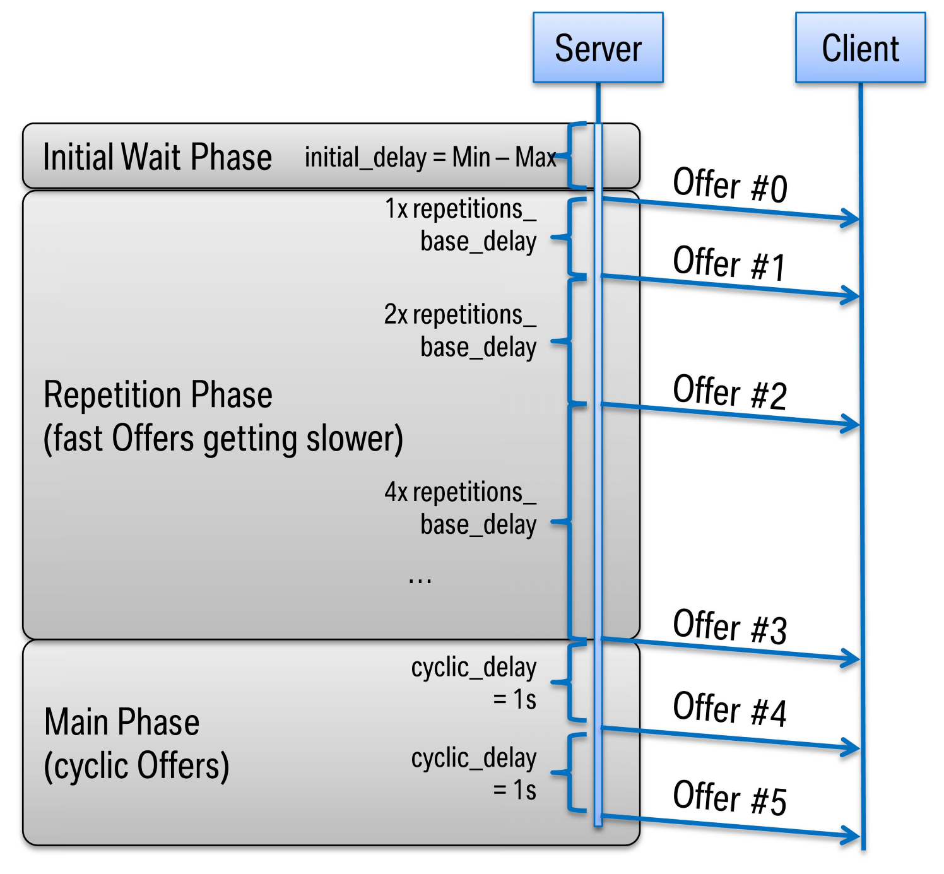

**Figure 10.19: SOME/IP Server Timing example**

|  |  |  |  |  |
| --- | --- | --- | --- | --- |
| ***Class*** | **TagWithOptionalValue** | | | |
| ***Package*** | M2::AUTOSARTemplates::GenericStructure::GeneralTemplateClasses::TagWithOptionalValue | | | |
| ***Note*** | A tagged value is a combination of a tag (key) and a value that gives supplementary information that is attached to a model element. Please note that keys without a value are allowed. | | | |
| ***Base*** | *ARObject* | | | |
| ***Attribute*** | ***Type*** | ***Mult.*** | ***Kind*** | ***Note*** |
| key | String | 1 | attr | Defines a key. |
| sequenceOffset | Integer | 0..1 | attr | The sequenceOffset attribute supports the use case where TagWithOptionalValue is aggregated as splitable. If multiple aggregations define the same value of attribute key then the order in which the value collection is merged might be significant. As an example consider the modeling of the $PATH environment variable by means of a meta class TagWithOptionalValue. The sequenceOffset describes the relative position of each contribution in the concatenated value. The contributions are sorted in increasing integer order. |
| value | String | 0..1 | attr | Defines the corresponding value. |

**Table 10.42: TagWithOptionalValue**

**[constr_10037]**{DRAFT} **Existence of attribute TagWithOptionalValue.sequenceOffset in the context of attribute capabilityRecord owned by ProvidedSomeipServiceInstance, RequiredSomeipServiceInstance, SdServerConfig, SdClientConfig, or AbstractServiceInstance** dFor all capabilityRecord modeled in the context of ProvidedSomeipServiceInstance, RequiredSomeipServiceInstance, SdServerConfig, SdClientConfig, or

AbstractServiceInstance, attribute TagWithOptionalValue.sequenceOff-

set shall not exist.c*()*

**10.3.1.1.4 Provided Event Group**

The ProvidedSomeipServiceInstance aggregates a SomeipProvidedEventGroup in the role providedEventGroup that allows to define service instance specific configuration settings for a SomeipEventGroup.

|  |  |  |  |  |
| --- | --- | --- | --- | --- |
| ***Class*** | **SomeipProvidedEventGroup** | | | |
| ***Package*** | M2::AUTOSARTemplates::AdaptivePlatform::ServiceInstanceManifest::ServiceInstanceDeployment | | | |
| ***Note*** | The meta-class represents the ability to configure ServiceInstance related communication settings on the provided side for each EventGroup separately.  **Tags:**atp.Status=draft | | | |
| ***Base*** | *ARObject*, *Identifiable*, *MultilanguageReferrable*, *Referrable* | | | |
| ***Attribute*** | ***Type*** | ***Mult.*** | ***Kind*** | ***Note*** |
| eventGroup | SomeipEventGroup | 0..1 | ref | Reference to the SomeipEventGroup in the System Manifest for which the ServiceInstance related Event Group settings are valid.  **Tags:**atp.Status=draft |
| eventMulticast UdpPort | PositiveInteger | 0..1 | attr | UdpPort configuration that is used for Event communication in the IP-Multicast case.  During SOME/IP Service Discovery: Send in the SD-SubscribeEventGroupAck Message to client (answer to SD-SubscribeEventGroup).  Event: This is the destination-port where the server sends the multicast event messages if the multicastThreshold is exceeded.  **Tags:**atp.Status=draft |
| ipv4MulticastIp Address | Ip4AddressString | 0..1 | attr | Multicast IPv4 Address that is transmitted in the Event GroupSubscribeAck message.  **Tags:**atp.Status=draft |
| ipv6MulticastIp Address | Ip6AddressString | 0..1 | attr | Multicast IPv6 Address that is transmitted in the Event GroupSubscribeAck message.  **Tags:**atp.Status=draft |

5

4

|  |  |  |  |  |
| --- | --- | --- | --- | --- |
| ***Class*** | **SomeipProvidedEventGroup** | |  |  |
| multicast  Threshold | PositiveInteger | 1 | attr | Specifies the number of subscribed clients that trigger the server to change the transmission of events to multicast.  Example: If configured to 0 only unicast will be used. If configured to 1 the first client will be already served by multicast. If configured to 2 the first client will be served with unicast and as soon as the 2nd client arrives both will be served by multicast.  This does not influence the handling of initial events, which are served using unicast only.  **Tags:**atp.Status=draft |
| sdServerEvent  GroupTiming  Config | SomeipSdServerEvent  GroupTimingConfig | 0..1 | ref | Server Timing configuration settings that are EventGroup specific.  **Tags:**atp.Status=draft |

**Table 10.43: SomeipProvidedEventGroup**

**[TPS_MANI_03018]**{DRAFT} **Usage of SomeipProvidedEventGroup.multicastThreshold** dThe switching between IP-Unicast and IP-Multicast is guided by the server with the SomeipProvidedEventGroup.multicastThreshold attribute and by the number of subscribed clients to the SomeipProvidedEventGroup.

The Server will change the transmission of events to Multicast if the multicast-

Threshold of the corresponding SomeipProvidedEventGroup is reached by the number of subscribed clients. If the number of subscribed clients is smaller than the configured multicastThreshold, the transmission of events takes place via unicast communication.c*(RS_MANI_00024)*

The following example shows the effect of the multicastThreshold in relation to the number of subscribed clients to the transmission of the SOME/IP event to the unicast or multicast destination address:

* If multicastThreshold is configured to 0, only the unicast IP address and the port will be used as destination address.
* If multicastThreshold is configured to 1, the first client will be served by multicast.
* If multicastThreshold is configured to 2, the first client will be served with unicast and as soon as the second client arrives both will be served by multicast, etc.

**[TPS_MANI_03020]**{DRAFT} **Servers RequestResponseDelay for received SubscribeEventGroup entries** dThe Server will delay the SubscribeEventGroupAck answer to a received SubscribeEventGroup message that was triggered by a multicast ServiceOffer by the configured SomeipSdClientEventGroupTimingConfig.requestResponseDelay.

The actual delay will be randomly chosen between the maxValue and minValue.c *(RS_MANI_00024)*

|  |  |  |  |  |
| --- | --- | --- | --- | --- |
| ***Class*** | **SomeipSdServerEventGroupTimingConfig** | | | |
| ***Package*** | M2::AUTOSARTemplates::SystemTemplate::Fibex::Fibex4Ethernet::ServiceInstances | | | |
| ***Note*** | EventGroup specific timing configuration settings.  **Tags:**atp.recommendedPackage=SomeipSdTimingConfigs | | | |
| ***Base*** | *ARElement*, *ARObject*, *CollectableElement*, *Identifiable*, *MultilanguageReferrable*, *Packageable Element*, *Referrable* | | | |
| ***Attribute*** | ***Type*** | ***Mult.*** | ***Kind*** | ***Note*** |
| request  ResponseDelay | RequestResponseDelay | 0..1 | aggr | The Service Discovery shall delay answers to unicast messages triggered by multicast messages (e.g.  Subscribe Eventgroup after Offer Service). |

**Table 10.44: SomeipSdServerEventGroupTimingConfig**

**10.3.1.1.5 ProvidedSomeipServiceInstance related event and method properties**

**[TPS_MANI_03154]**{DRAFT} **ProvidedSomeipServiceInstance related configuration settings for events** dThe class SomeipEventProps that is aggregated by the ProvidedSomeipServiceInstance in the role eventProps allows for specifying ProvidedSomeipServiceInstance related configuration settings for events that are defined in the SomeipServiceInterfaceDeployment referenced by the ProvidedSomeipServiceInstance in the role serviceInterfaceDeployment.c*(RS_MANI_00024)*

|  |  |  |  |  |
| --- | --- | --- | --- | --- |
| ***Class*** | **SomeipEventProps** | | | |
| ***Package*** | M2::AUTOSARTemplates::AdaptivePlatform::ServiceInstanceManifest::ServiceInstanceDeployment | | | |
| ***Note*** | This meta-class allows to set configuration options for an event in the provided service instance.  **Tags:**atp.Status=draft | | | |
| ***Base*** | *ARObject* | | | |
| ***Attribute*** | ***Type*** | ***Mult.*** | ***Kind*** | ***Note*** |
| collectionProps | SomeipCollectionProps | 0..1 | aggr | Collection of timing attributes configurable for an event that is provided by a Service Instance.  **Tags:**atp.Status=draft |
| event | SomeipEvent  Deployment | 0..1 | ref | Reference to the event for which the SomeipEventProps are applicable.  **Tags:**atp.Status=draft |

**Table 10.45: SomeipEventProps**

**[TPS_MANI_03155]**{DRAFT} **ProvidedSomeipServiceInstance related configuration settings for methods** dThe class SomeipMethodProps that is aggregated by the ProvidedSomeipServiceInstance in the role methodResponseProps allows for specifying ProvidedSomeipServiceInstance related configuration settings for a method response message. The method is defined in the SomeipServiceInterfaceDeployment referenced by the ProvidedSomeipServiceInstance in the role serviceInterfaceDeployment.c*(RS_MANI_00024)*

*ProvidedApServiceInstance*

ProvidedSomeipServiceInstance

+

loadBalancingPriority: PositiveInteger

[0..1]

+

loadBalancingWeight: PositiveInteger

[0..1]

priority: PositiveInteger

[0..1]

+

+

serviceInstanceId: PositiveInteger

SomeipEventProps

SomeipMethodProps

*ServiceEventDeployment*

SomeipEventDeployment

burstSize: PositiveInteger

[0..1]

+

+

eventId: PositiveInteger

[0..1]

+

maximumSegmentLength: PositiveInteger

[0..1]

separationTime: TimeValue

+

[0..1]

serializer: SerializationTechnologyEnum

+

+

transportProtocol: TransportLayerProtocolEnum

*ServiceMethodDeployment*

SomeipMethodDeployment

[0..1]

burstSizeRequest: PositiveInteger

+

+

[0..1]

burstSizeResponse: PositiveInteger

[0..1]

maximumSegmentLengthRequest: PositiveInteger

+

[0..1]

maximumSegmentLengthResponse: PositiveInteger

+

methodId: PositiveInteger

+

separationTimeRequest: TimeValue

+

[0..1]

+

separationTimeResponse: TimeValue

[0..1]

+

transportProtocol: TransportLayerProtocolEnum

*RequiredApServiceInstance*

RequiredSomeipServiceInstance

+

requiredMinorVersion: AnyVersionString

[0..1]

[0..1]

requiredServiceInstanceId: AnyServiceInstanceId

+

[0..1]

versionDrivenFindBehavior: ServiceVersionAcceptanceKindEnum

+

SomeipCollectionProps

[0..1]

udpCollectionBufferTimeout: TimeValue

+

[0..1]

+

udpCollectionTrigger: UdpCollectionTriggerEnum

«enumeration»

UdpCollectionTriggerEnum

always

never

+

methodRequestProps

0..*

collectionProps

+

0..1

methodResponseProps

+

0..*

+

event

0..1

+

collectionProps

0..1

+

method

0..1

+

eventProps

0..*

**Figure 10.20: ProvidedSomeipServiceInstance related event and method properties**

|  |  |  |  |  |
| --- | --- | --- | --- | --- |
| ***Class*** | **SomeipMethodProps** | | | |
| ***Package*** | M2::AUTOSARTemplates::AdaptivePlatform::ServiceInstanceManifest::ServiceInstanceDeployment | | | |
| ***Note*** | This meta-class allows to set configuration options for a method in the service instance.  **Tags:**atp.Status=draft | | | |
| ***Base*** | *ARObject* | | | |
| ***Attribute*** | ***Type*** | ***Mult.*** | ***Kind*** | ***Note*** |
| collectionProps | SomeipCollectionProps | 0..1 | aggr | Collection of timing attributes configurable for a method that is provided or requested by a Service Instance.  **Tags:**atp.Status=draft |
| method | SomeipMethod  Deployment | 0..1 | ref | Reference to the method for which the SomeipMethod Props are applicable.  **Tags:**atp.Status=draft |

**Table 10.46: SomeipMethodProps**

|  |  |  |  |  |
| --- | --- | --- | --- | --- |
| ***Class*** | **SomeipCollectionProps** | | | |
| ***Package*** | M2::AUTOSARTemplates::AdaptivePlatform::ServiceInstanceManifest::ServiceInstanceDeployment | | | |
| ***Note*** | Collection of attributes that are configurable for an event that is provided by a ServiceInstance or for a method that is provided or requested by a ServiceInstance.  **Tags:**atp.Status=draft | | | |
| ***Base*** | *ARObject* | | | |
| ***Attribute*** | ***Type*** | ***Mult.*** | ***Kind*** | ***Note*** |
| udpCollection BufferTimeout | TimeValue | 0..1 | attr | Maximum time, an outgoing message (event, method call or method response) may be delayed, due to data collection.  **Tags:**atp.Status=draft |
| udpCollection Trigger | UdpCollectionTrigger  Enum | 0..1 | attr | Defines whether the ServiceInterface element (event or method) contributes to the triggering of the udp data transmission if data collection is enabled.  **Tags:**atp.Status=draft |

**Table 10.47: SomeipCollectionProps**

|  |  |
| --- | --- |
| ***Enumeration*** | **UdpCollectionTriggerEnum** |
| ***Package*** | M2::AUTOSARTemplates::AdaptivePlatform::ServiceInstanceManifest::ServiceInstanceDeployment |
| ***Note*** | Defines whether the ServiceInterface element (event or method) contributes to the triggering of the udp data transmission if data collection is enabled.  **Tags:**atp.Status=draft |
| ***Literal*** | ***Description*** |
| always | ServiceInterface element will trigger the transmission of the data.  **Tags:**  atp.EnumerationLiteralIndex=0 atp.Status=draft |
| never | ServiceInterface element will be buffered and will not trigger the transmission of the data.  **Tags:**  atp.EnumerationLiteralIndex=1 atp.Status=draft |

**Table 10.48: UdpCollectionTriggerEnum**

**[TPS_MANI_03158]**{DRAFT} **Configuration of a data collection on a Provided-**

**ServiceInstance for transmission over udp** dThe attributes udpCollectionBufferTimeout and udpCollectionTrigger support the configuration of a data collection of several messages for transmission over Udp.

In the ProvidedServiceInstance all method responses and events for which the udpCollectionTrigger is set to never will be collected in a buffer until a trigger arrives that starts the data transmission.

The following trigger options are supported:

* a message needs to be transmitted for which the udpCollectionTrigger is set to always.
* the udpCollectionBufferTimeout is reached for a message.
* the buffer size defined by the attribute udpCollectionBufferSizeThreshold is reached.

c*(RS_MANI_00024)*

**10.3.1.2 Required Service Instance**

**[TPS_MANI_03059]**{DRAFT} **RequiredSomeipServiceInstance.requiredServiceInstanceId** dThe RequiredSomeipServiceInstance defines the requiredServiceInstanceId of a SomeipServiceInterfaceDeployment that the client searches.

The client may search for a specific requiredServiceInstanceId or for ALL requiredServiceInstanceId of the serviceInterfaceDeployment.c*(RS_MANI_00024)*

**[constr_10070]**{DRAFT} **Value of RequiredSomeipServiceInstance.requiredServiceInstanceId** dFor each RequiredSomeipServiceInstance. requiredServiceInstanceId, the value shall be in the range 0..65534 or ALL.c*()*

|  |  |  |  |  |
| --- | --- | --- | --- | --- |
| ***Class*** | **RequiredSomeipServiceInstance** | | | |
| ***Package*** | M2::AUTOSARTemplates::AdaptivePlatform::ServiceInstanceManifest::ServiceInstanceDeployment | | | |
| ***Note*** | This meta-class represents the ability to describe the existence and configuration of a required service instance in a concrete implementation on top of SOME/IP.  **Tags:**  atp.Status=draft  atp.recommendedPackage=ServiceInstances | | | |
| ***Base*** | *ARElement*, *ARObject*, *AdaptivePlatformServiceInstance*, *CollectableElement*, *Identifiable*,  *MultilanguageReferrable*, *PackageableElement*, *Referrable*, *RequiredApServiceInstance*, *Uploadable PackageElement* | | | |
| ***Attribute*** | ***Type*** | ***Mult.*** | ***Kind*** | ***Note*** |
| blacklisted Version | SomeipServiceVersion | * | aggr | Collection of blacklisted versions.  **Tags:**atp.Status=draft |
| capability  Record  (ordered) | TagWithOptionalValue | * | aggr | A sequence of records to store arbitrary name/value pairs conveying additional information about the named service.  **Tags:**atp.Status=draft |
| methodRequest Props | SomeipMethodProps | * | aggr | Configuration settings for individual methods that are requested by the ServiceInstance.  **Tags:**atp.Status=draft |
| requiredEvent Group | SomeipRequiredEvent  Group | * | aggr | List of EventGroups that are used by the RequiredService Instance.  **Tags:**atp.Status=draft |
| requiredMinor Version | AnyVersionString | 0..1 | attr | This attribute is used to configure for which minor version of the SomeIp ServiceInterface the Service Discovery will search. Value can be set to a number that represents the Minor Version of the searched service or to ANY.  **Tags:**atp.Status=draft |

5

4

|  |  |  |  |  |
| --- | --- | --- | --- | --- |
| ***Class*** | **RequiredSomeipServiceInstance** | |  |  |
| requiredService InstanceId | AnyServiceInstanceId | 0..1 | attr | This attribute represents the ability to describe the required service instance ID.  **Tags:**atp.Status=draft |
| sdClientConfig | SomeipSdClientService  InstanceConfig | 1 | ref | Client specific configuration settings relevant for the SOME/IP service discovery.  **Tags:**atp.Status=draft |
| versionDriven FindBehavior | ServiceVersion  AcceptanceKindEnum | 0..1 | attr | Defines the service discovery find behavior.  **Tags:**atp.Status=draft |

**Table 10.49: RequiredSomeipServiceInstance**

|  |  |  |  |  |
| --- | --- | --- | --- | --- |
| ***Class*** | **SomeipServiceVersion** | | | |
| ***Package*** | M2::AUTOSARTemplates::SystemTemplate::Fibex::Fibex4Ethernet::ServiceInstances | | | |
| ***Note*** | This meta-class represents the ability to describe a version of a SOME/IP Service.  **Tags:**atp.Status=draft | | | |
| ***Base*** | *ARObject* | | | |
| ***Attribute*** | ***Type*** | ***Mult.*** | ***Kind*** | ***Note*** |
| majorVersion | PositiveInteger | 0..1 | attr | Major Version of the ServiceInterface.  **Tags:**  atp.Status=draft xml.sequenceOffset=10 |
| minorVersion | PositiveInteger | 1 | attr | Minor Version of the ServiceInterface.  **Tags:**  atp.Status=draft xml.sequenceOffset=20 |

**Table 10.50: SomeipServiceVersion**

|  |  |
| --- | --- |
| ***Enumeration*** | **ServiceVersionAcceptanceKindEnum** |
| ***Package*** | M2::AUTOSARTemplates::SystemTemplate::Fibex::Fibex4Ethernet::ServiceInstances |
| ***Note*** | Defined the possible acceptance kinds for required service instances.  **Tags:**atp.Status=draft |
| ***Literal*** | ***Description*** |
| exactOrAnyMinor Version | Search for ANY or specific minor version service instance and select either ALL returned service instances (in case of ANY) or exactly the specific minor version service instances defined in required MinorVersion.  **Tags:**  atp.EnumerationLiteralIndex=0 atp.Status=draft |
| minimumMinor Version | Search for ANY minor version service instance and select only those service instances which have an equal or greater minor version than given in requiredMinorVersion.  **Tags:**  atp.EnumerationLiteralIndex=1 atp.Status=draft |

**Table 10.51: ServiceVersionAcceptanceKindEnum**

**[TPS_MANI_03021]**{DRAFT} **Requirements on the searched minor version from the client’s point of view** dThe meta-class RequiredSomeipServiceInstance is able to make further specifications regarding the version of the service from the client’s point of view.

For this purpose, the attribute RequiredSomeipServiceInstance.requiredMinorVersion exists and provides the ability to define the required minor version ( SomeipServiceVersion.minorVersion).c*(RS_MANI_00024)*

Please note that the major version that the client searches for is already defined by the SomeipServiceVersion.majorVersion in the SomeipServiceInterfaceDeployment. It is therefore not possible to search for ANY major version, so the client looks always for a specific major version.

The minor version that may be defined by SomeipServiceVersion.minorVersion in the SomeipServiceInterfaceDeployment is irrelevant for the client and the service search and shall be ignored.

**[TPS_MANI_03619]**{DRAFT} **SOME/IP Service search for requiredMinorVersion** dA RequiredSomeipServiceInstance is searching for a SOME/IP Service Instance requiredMinorVersion:

* in case versionDrivenFindBehavior = exactOrAnyMinorVersion: Service minor version that matches the value set in requiredMinorVersion or *ANY* minor version of the Service Instance in case the requiredMinorVersion is set to *ANY*
* in case versionDrivenFindBehavior = minimumMinorVersion: Service minor version that matches at least the value set in requiredMinorVersion or is higher c*(RS_MANI_00009)*

**[constr_3561]**{DRAFT} **minimumMinorVersion and RequiredSomeipServiceInstance.requiredMinorVersion value** dThe RequiredSomeipServiceInstance.requiredMinorVersion shall not have the value *ANY* if versionDrivenFindBehavior = minimumMinorVersion.c*()*

**[TPS_MANI_03618]**{DRAFT} **Usage of RequiredSomeipServiceInstance. blacklistedVersion** dA service connection of a RequiredSomeipServiceInstance to a ProvidedSomeipServiceInstance is not considered for service discovery if the SomeipServiceVersion.minorVersion of the enclosing SomeipServiceInterfaceDeployment that is referenced by the ProvidedSomeipServiceInstance exists in the collection of SomeipServiceVersions aggregated at the RequiredSomeipServiceInstance in the role blacklistedVersion.c*(RS_MANI_00066)*

A typical scenario for using a blacklist may be: For a certain RequiredSomeipServiceInstance a certain compatible provider service version inside a system may not work which may have been identified after the design phase.

In order to keep the system running this certain provider version won’t be considered in the service search if it has been blacklisted. Therefore, the RequiredSomeipServiceInstance may connect only to ProvidedSomeipServiceInstances that fulfill the search criteria and are not blacklisted.

**[constr_3558]**{DRAFT} **RequiredSomeipServiceInstance.blacklistedVersion is restricted to the usage of minorVersion** dThe majorVersion attribute shall not be used in the SomeipServiceVersion that is aggregated by the RequiredSomeipServiceInstance in the role blacklistedVersion.c*()*

**[constr_5115]**{DRAFT} **Search for a specific SOME/IP ServiceInstance and for all SOME/IP ServiceInstances over the same RPortPrototype** dA RequiredSomeipServiceInstance that configures the search for a specific ServiceInstance on SOME/IP (with concrete requiredServiceInstanceId) and a RequiredSomeipServiceInstance that configures the search for ALL ServiceInstances on SOME/IP (with requiredServiceInstanceId = ALL) that are mapped using ServiceInstanceToMachineMapping to the same EthernetCommunicationConnector (and therefore are searching for SOME/IP ServiceInstances on the same VLAN) are not allowed to be mapped by ServiceInstanceToPortPrototypeMappings to the same RPortPrototype.c*()*

RPortPrototype

ServiceInstanceToPort

-

PrototypeMapping

ServiceInstanceToPort

-

PrototypeMapping

RequiredSomeip

-

ServiceInstance

ID=42

RequiredSomeip

-

ServiceInstance

ID=ALL

ServiceInstanceTo

-

MachineMapping

ServiceInstanceTo

-

MachineMapping

EthernetCommuni

-

cationConnector

**Figure 10.21: Depiction of not-allowed scenario**

Please note that the depicted scenario in Figure 10.21 is covered by [constr_5115].

In other words the middleware is allowed to search for a concrete SOME/IP ServiceInstance on one VLAN and for ALL SOME/IP ServiceInstances on a different VLAN via a single RPortPrototype. But the middleware is only able to search for either ALL SOME/IP ServiceInstances or for one concrete SOME/IP ServiceInstance on the same VLAN via a single RPortPrototype.

RPortPrototype

ServiceInstanceToPort

-

PrototypeMapping

ServiceInstanceToPort

-

PrototypeMapping

RequiredSomeip

-

ServiceInstance

ID=42

RequiredSomeip

-

ServiceInstance

ID=ALL

ServiceInstanceTo

-

MachineMapping

ServiceInstanceTo

-

MachineMapping

EthernetCommuni

-

cationConnector

EthernetCommuni

-

cationConnector

**Figure 10.22: Depiction of allowed scenario**

Please note that the depicted scenario in Figure 10.22 is covered by [constr_5115].

**10.3.1.2.1 IP Configuration**

In SOME/IP, the SubscribeEventGroup entry references IPv4 or IPv6 Endpoint options to indicate to the server where the client wants to receive the events of the SomeipEventGroup. Such an Endpoint contains the IP address of the client.

**[TPS_MANI_03022]**{DRAFT} **Context of RequiredSomeipServiceInstance**dA RequiredSomeipServiceInstance can be mapped to a CommunicationConnector of a MachineDesign with the SomeipServiceInstanceToMachineMapping.

With this mapping an assignment of the RequiredSomeipServiceInstance to a unicast IP Address is established since the EthernetCommunicationConnector refers to a NetworkEndpoint in the role unicastNetworkEndpoint. The unicastNetworkEndpoint defines the local IP address of the client.c*(RS_MANI_00009, RS_MANI_00024)*

**10.3.1.2.2 TP Configuration**

The IPv4 or IPv6 Endpoint option that is referenced in the SOME/IP SubscribeEventGroup message contains besides the IP address the transport layer protocol (e.g. UDP or TCP), and the port number of the client.

With the SomeipServiceInstanceToMachineMapping the Transport Layer configuration attributes are assigned to the RequiredSomeipServiceInstance.

The Transport Layer (TCP/UDP) configuration attributes for the SubscribeEvent-

Group entry are directly available in the SomeipServiceInstanceToMachineMapping element.

The SomeipServiceInstanceToMachineMapping defines also the source-port where the client sends the method call messages to the server and the destinationport where the client receives the method responses from the server.

The modeling of the SomeipServiceInstanceToMachineMapping with TP and IP configuration is depicted in Figure C.1.

**[TPS_MANI_03023]**{DRAFT} **Udp Transport Protocol Configuration for**

**RequiredSomeipServiceInstance** dThe SomeipServiceInstanceToMachineMapping.udpPort defines the Transport Protocol for a UDP communication in case that the server provides ServiceInterface content over UDP and the client wants to use it.c*(RS_MANI_00009, RS_MANI_00024)*

**[TPS_MANI_03024]**{DRAFT} **Tcp Transport Protocol Configuration for**

**RequiredSomeipServiceInstance** dThe SomeipServiceInstanceToMachineMapping.tcpPort defines the Transport Protocol for a TCP communication in case that the server provides ServiceInterface content over TCP and the client wants to use it.c*(RS_MANI_00009, RS_MANI_00024)*

**[TPS_MANI_03049]**{DRAFT} **Tcp and Udp Transport Protocol Configuration for**

**RequiredSomeipServiceInstance**dIt is allowed to set tcpPort and udpPort in the same SomeipServiceInstanceToMachineMapping. Such a setting shall be used in case that the server provides ServiceInterface content over Udp and Tcp and the client wants to use it.c*(RS_MANI_00009, RS_MANI_00024)*

**[TPS_MANI_03237]**{DRAFT} **Transport Protocol attributes defined for a**

**RequiredSomeipServiceInstance** dEach SomeipServiceInstanceToMachineMapping that is defined for a RequiredSomeipServiceInstance is allowed to have:

* a configured udpPort or
* a configured tcpPort or
* a configured udpPort and a tcpPort or
* no configured udpPort and tcpPort.

c*(RS_MANI_00009, RS_MANI_00024)*

A RequiredSomeipServiceInstance that is mapped by a SomeipServiceInstanceToMachineMapping that does not contain a udpPort and tcpPort is allowed to receive events over IP Multicast only.

In this case, it is not required for a client to have a unicast socket prepared if the server will always use the multicast transport. In such a case, the SubscribeEventGroup SOME/IP SD message that is sent from the ServiceConsumer to the ServiceProvider will not contain any Unicast Endpoint options.

In addition, the corresponding ServiceInterface is not allowed to have any Methods defined since the Request/Response communication pattern is restricted to IP Unicast only.

An additional prerequisite for such a setup is that the ProvidedSomeipServiceInstance is configured for IP multicast transmission only. In other words, the value of attribute multicastThreshold for all SomeipProvidedEventGroups needs to be set to 1.

**[constr_5161]**{DRAFT} **RequiredSomeipServiceInstance that is mapped by a SomeipServiceInstanceToMachineMapping without a configured tcpPort and udpPort**dA RequiredSomeipServiceInstance that is mapped to a EthernetCommunicationConnector by a SomeipServiceInstanceToMachineMapping that does not have neither a udpPort nor a tcpPort is not allowed to reference a SomeipServiceInterfaceDeployment that includes SomeipMethodDeployments (directly or indirectly via ServiceFieldDeployment).c*()*

If a Tcp and Udp Transport Protocol Configuration is defined for a RequiredSomeipServiceInstance as described in [TPS_MANI_03049] then the SOME/IP ServiceInterfaceDeployment settings decide which content of the ProvidedSomeipServiceInstance is transported over udp and which content is transported over tcp. This is described in [TPS_MANI_03050] and [TPS_MANI_03051].

**10.3.1.2.3 Service Discovery Client Configuration**

Service Discovery phases on the Client side allow minimizing the number of Service Discovery messages and allow a fast synchronization upon ECU start.

For every RequiredSomeipServiceInstance on a Client different phases are existing:

* Down
* Requested
  + Initial Wait Phase
  + Repetition Phase
  + Main Phase

**[TPS_MANI_03025]**{DRAFT} **Client Timing configuration for a RequiredSomeipServiceInstance** dThe Client Timing is configurable with SomeipSdClientServiceInstanceConfig that is referenced in the role sdClientConfig by the RequiredSomeipServiceInstance for which the Timing is valid.c*(RS_MANI_00024)*

The number of SomeipSdClientServiceInstanceConfig elements determine how many timers shall actually be used by the middleware to keep the randomized times. Via the reference RequiredSomeipServiceInstance.sdClientConfig each RequiredSomeipServiceInstance defines to which timer it is assigned.

Note that it is possible to define several SomeipSdClientServiceInstanceConfig elements with identical timing specification values in order to request several timer handling in the middleware.

If several RequiredSomeipServiceInstance share the same timer then the expiration of that timer will lead a combined sending of service discovery messages.

**[TPS_MANI_03231]**{DRAFT} **Sharing timers for RequiredSomeipServiceInstance** dIf several RequiredSomeipServiceInstances point to the same SomeipSdClientServiceInstanceConfig in the role sdClientConfig then all of these RequiredSomeipServiceInstances will share the same timers for their timing behavior. This will lead to combining several service discovery entries in one service discovery message.c*(RS_MANI_00024)*

|  |  |  |  |  |
| --- | --- | --- | --- | --- |
| ***Class*** | **SomeipSdClientServiceInstanceConfig** | | | |
| ***Package*** | M2::AUTOSARTemplates::SystemTemplate::Fibex::Fibex4Ethernet::ServiceInstances | | | |
| ***Note*** | Client specific settings that are relevant for the configuration of SOME/IP Service-Discovery.  **Tags:**atp.recommendedPackage=SomeipSdTimingConfigs | | | |
| ***Base*** | *ARElement*, *ARObject*, *CollectableElement*, *Identifiable*, *MultilanguageReferrable*, *Packageable Element*, *Referrable* | | | |
| ***Attribute*** | ***Type*** | ***Mult.*** | ***Kind*** | ***Note*** |
| initialFind Behavior | InitialSdDelayConfig | 0..1 | aggr | Controls initial find behavior of clients. |
| priority | PositiveInteger | 0..1 | attr | This attribute defines the VLAN frame priority for Service  Discovery messages that result from RequiredSomeip  ServiceInstances that are referncing this SomeipSdClient  ServiceInstanceConfig (Find, SubscribeEventGroup, Stop SubscribeEventgroup). Values from 0 (best effort) to 7 (highest) are allowed. |
| serviceFind TimeToLive | PositiveInteger | 1 | attr | This attribute represents the ability to define the time in seconds the service find is valid. |

**Table 10.52: SomeipSdClientServiceInstanceConfig**

**[TPS_MANI_03026]**{DRAFT} **Initial Wait Phase configuration for a Required-**

**SomeipServiceInstance** dThe Initial Wait Phase for a RequiredSomeipServiceInstance is configured with the initialFindBehavior and the two attributes initialDelayMinValue and initialDelayMaxValue.

If a calculated random timer based on these min and max values expires the first

FindService entry will be sent out.c*(RS_MANI_00024)*

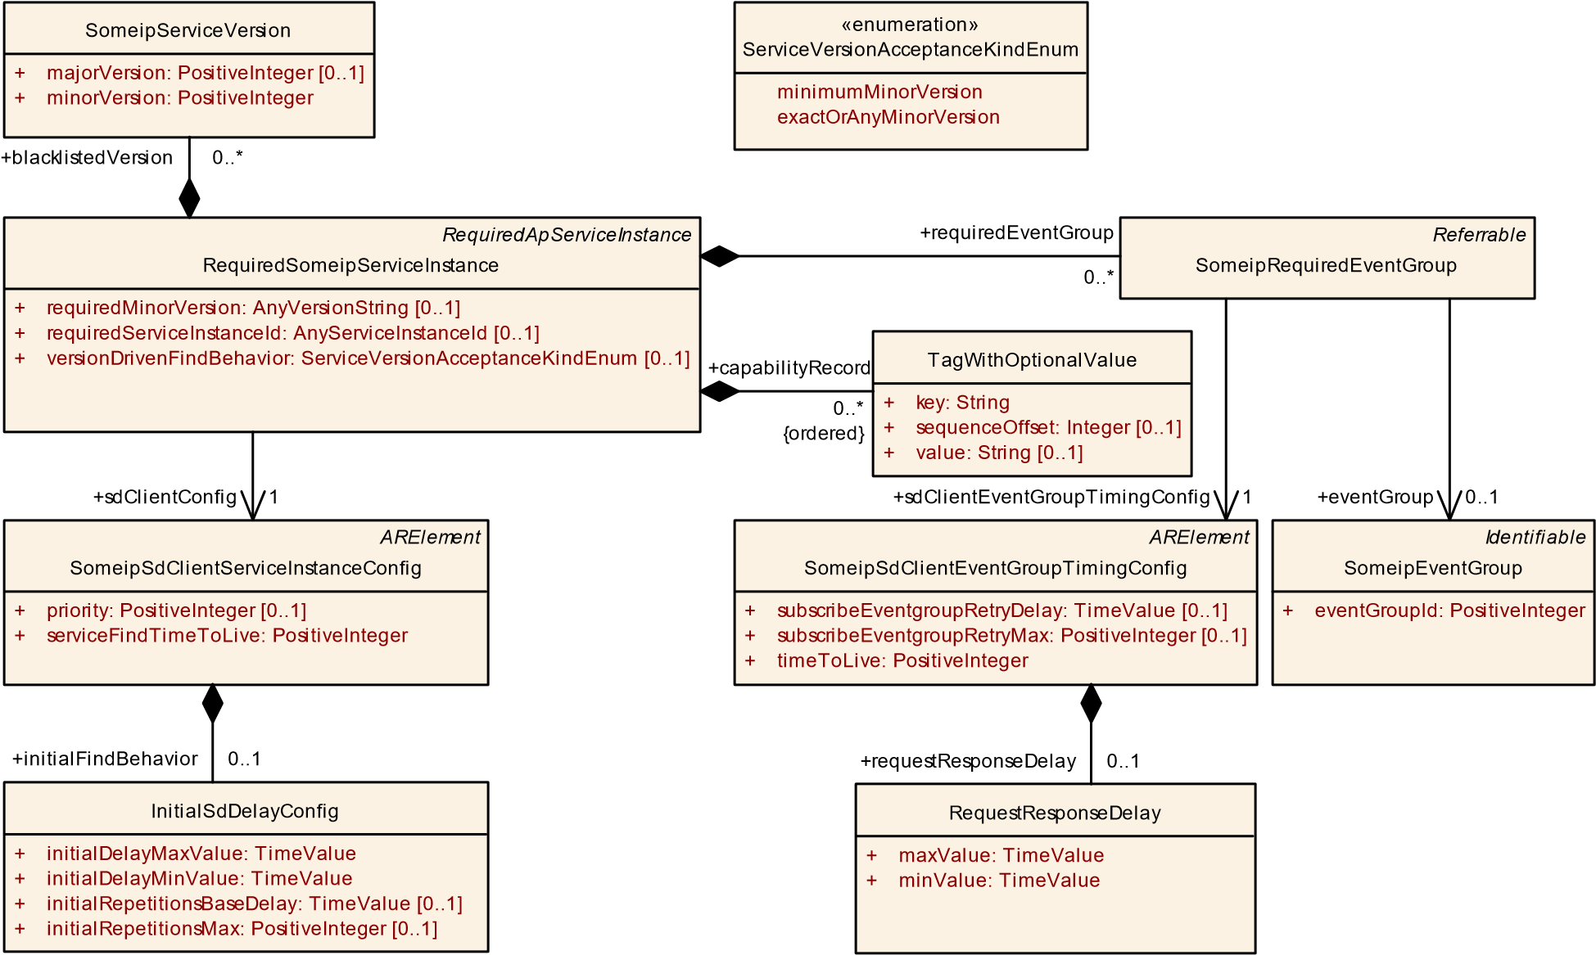

**Figure 10.23: SOME/IP Service Discovery Client configuration settings**

When the calculated random timer expires and no OfferService is received the Repetition Phase will be entered.

**[TPS_MANI_03027]**{DRAFT} **Repetition Wait Phase configuration for a RequiredSomeipServiceInstance** dThe Repetition Wait Phase for a RequiredSomeipServiceInstance is configured with the initialFindBehavior and the two attributes initialRepetitionsMax and initialRepetitionsBaseDelay.c *(RS_MANI_00024)*

If the Repetition Phase is entered, the Service Discovery waits the initialRepetitionsBaseDelay and sends an FindService entry.

If the amount of sent FindService entries reaches initialRepetitionsMax and no OfferService is received the Main Phase will be entered. In the Main Phase no further FindService entries are sent by the client.

**[TPS_MANI_03028]**{DRAFT} **TTL for Find Service Entries** dThe lifetime of a RequiredSomeipServiceInstance is configurable with the serviceFindTimeToLive attribute of SomeipSdClientServiceInstanceConfig.

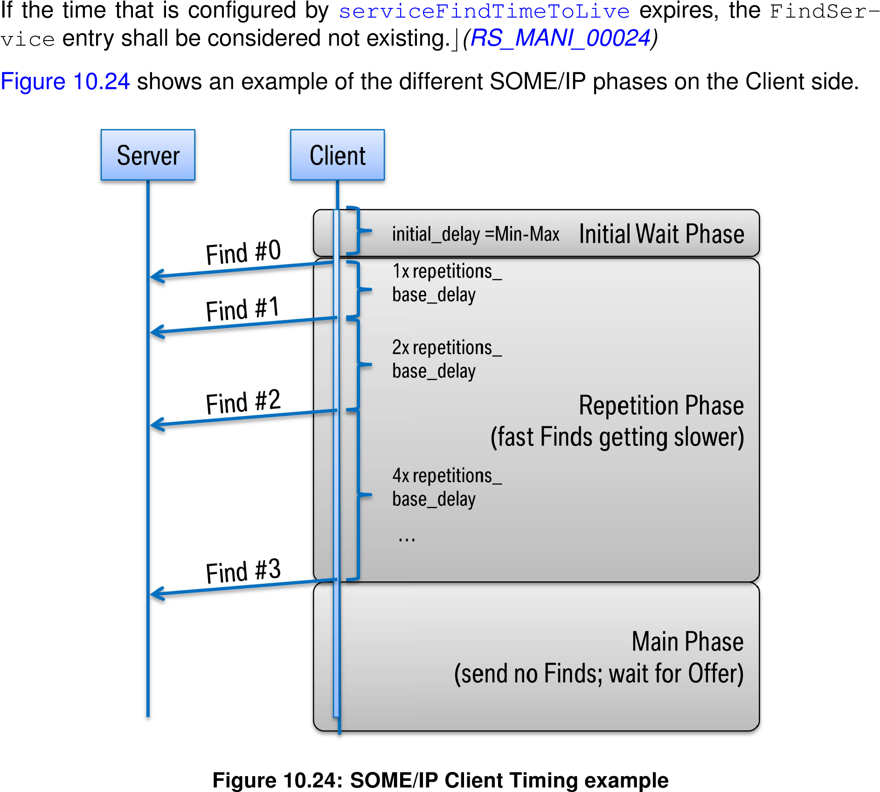

SOME/IP allows for specifying additional information about the RequiredSomeipServiceInstance with the Capability Record that allows to transport arbitrary configuration strings (key/value pairs).

This allows to encode additional information like the name of a service or its configuration.

**[TPS_MANI_03029]**{DRAFT} **Client Capability Records** dA Capability Record (key/value pair) on the Client side is configurable with the capabilityRecord and the two attributes key and value.c*(RS_MANI_00024)*

**10.3.1.2.4 Required Event Group**

The RequiredSomeipServiceInstance aggregates a SomeipRequiredEventGroup in the role requiredEventGroup that allows to define service instance specific configuration settings for a SomeipEventGroup.

|  |  |  |  |  |
| --- | --- | --- | --- | --- |
| ***Class*** | **SomeipRequiredEventGroup** | | | |
| ***Package*** | M2::AUTOSARTemplates::AdaptivePlatform::ServiceInstanceManifest::ServiceInstanceDeployment | | | |
| ***Note*** | The meta-class represents the ability to configure ServiceInstance related communication settings on the required side for each EventGroup separately.  **Tags:**atp.Status=draft | | | |
| ***Base*** | *ARObject*, *Referrable* | | | |
| ***Attribute*** | ***Type*** | ***Mult.*** | ***Kind*** | ***Note*** |
| eventGroup | SomeipEventGroup | 0..1 | ref | Reference to the SomeipEventGroup in the System Manifest for which the ServiceInstance related Event Group settings are valid.  **Tags:**atp.Status=draft |
| sdClientEvent  GroupTiming  Config | SomeipSdClientEvent  GroupTimingConfig | 1 | ref | Client Timing configuration settings that are EventGroup specific.  **Tags:**atp.Status=draft |

**Table 10.53: SomeipRequiredEventGroup**

|  |  |  |  |  |
| --- | --- | --- | --- | --- |
| ***Class*** | **SomeipSdClientEventGroupTimingConfig** | | | |
| ***Package*** | M2::AUTOSARTemplates::SystemTemplate::Fibex::Fibex4Ethernet::ServiceInstances | | | |
| ***Note*** | This meta-class is used to specify configuration related to service discovery in the context of an event group on SOME/IP.  **Tags:**atp.recommendedPackage=SomeipSdTimingConfigs | | | |
| ***Base*** | *ARElement*, *ARObject*, *CollectableElement*, *Identifiable*, *MultilanguageReferrable*, *Packageable Element*, *Referrable* | | | |
| ***Attribute*** | ***Type*** | ***Mult.*** | ***Kind*** | ***Note*** |
| request  ResponseDelay | RequestResponseDelay | 0..1 | aggr | The Service Discovery shall delay answers to unicast messages triggered by multicast messages (e.g.  Subscribe Eventgroup after Offer Service). |
| subscribe Eventgroup RetryDelay | TimeValue | 0..1 | attr | This attribute defines the interval in seconds to re-trigger a subscription to a Eventgroup, if a retry to subscribe to a Eventgroup is configured (subscribeEventgroupRetryMax  > 0). |

5

4

|  |  |  |  |  |
| --- | --- | --- | --- | --- |
| ***Class*** | **SomeipSdClientEventGroupTimingConfig** | | | |
| subscribe Eventgroup  RetryMax | PositiveInteger | 0..1 | attr | This attribute define the maximum counts of retries to subscribe to an Eventgroup. If the value is set to 0 no retry shall be done. If the value is set to 255 the retry shall be done as along as the Eventgroup is requested and no SubscribeEventGroupAck was received. |
| timeToLive | PositiveInteger | 1 | attr | Defines the time in seconds the subscription of this event is expected by the client. this value is sent from the client to the server in the SD-subscribeEvent message. |

**Table 10.54: SomeipSdClientEventGroupTimingConfig**

**[TPS_MANI_03030]**{DRAFT} **SomeipSdClientEventGroupTimingConfig. timeToLive for SubscribeEventGroup Entries** dThe lifetime of an event subscription is configurable with the timeToLive attribute of SomeipSdClientEventGroupTimingConfig.

If the time that is configured by timeToLive expires, the event subscription is canceled.c*(RS_MANI_00024)*

**[TPS_MANI_03031]**{DRAFT} **Clients RequestResponseDelay for received ServiceOffer entries** dThe Client will delay the SubscribeEventGroup answer to a received ServiceOffer message by the configured SomeipSdClientEventGroupTimingConfig.requestResponseDelay.

The actual delay will be randomly chosen between the maxValue and minValue.c *(RS_MANI_00024)*

**10.3.1.2.5 RequiredSomeipServiceInstance related method call properties**

**[TPS_MANI_03156]**{DRAFT} **RequiredSomeipServiceInstance related configuration settings for methods** dThe class SomeipMethodProps that is aggregated by the RequiredSomeipServiceInstance in the role methodRequestProps allows specifying RequiredSomeipServiceInstance related configuration settings for a method request message. The method is defined in the SomeipServiceInterfaceDeployment referenced by the RequiredSomeipServiceInstance in the role serviceInterfaceDeployment.c*(RS_MANI_00024)*

**[TPS_MANI_03159]**{DRAFT} **Configuration of a data collection on a RequiredSomeipServiceInstance for transmission over udp** dThe attributes udpCollectionBufferTimeout and udpCollectionTrigger support the configuration of a data collection of several messages for transmission over udp. In the Required-

SomeipServiceInstance all method requests for which the udpCollectionTrigger is set to never will be collected in a buffer until a trigger arrives that starts the data transmission.

The following trigger options are supported:

* a message needs to be transmitted for which the udpCollectionTrigger is set to always.
* the udpCollectionBufferTimeout is reached for a message.
* the buffer size defined by the attribute udpCollectionBufferSizeThreshold is reached.

c*(RS_MANI_00024)*

The modeling of the RequiredSomeipServiceInstance-related event-properties and method-properties is depicted in Figure 10.20.

**10.3.2 DDS Service Instance Deployment**

In the case of DDS used as the transport layer the derived meta-classes are

DdsProvidedServiceInstance or DdsRequiredServiceInstance. These meta-classes also carry attributes that apply for the service discovery on DDS.

Two discovery protocols are supported by the DDS Network binding:

* Service Instance announcement via purpose-specific formatting of the Domain Participant USER_DATA QoS policy
* Service Instance announcement through a purpose-specific discovery Topic.

For details on these two protocols and their implications, please refer to section 7.7.3 "DDS Network Binding" in [8].

*UploadablePackageElement*

*AdaptivePlatformServiceInstance*

*ProvidedApServiceInstance*

DdsProvidedServiceInstance

[0..1]

discoveryType: DdsServiceInstanceDiscoveryTypeEnum

+

:

resourceIdentifierType

+

DdsServiceInstanceResourceIdentifierTypeEnum [0..1]

serviceInstanceId: PositiveInteger

+

[0..1]

*RequiredApServiceInstance*

DdsRequiredServiceInstance

[0..1]

discoveryType: DdsServiceInstanceDiscoveryTypeEnum

+

requiredServiceInstanceId: AnyServiceInstanceId

+

[0..1]

*DdsQosProps*

[0..1]

+

qosProfile: String

*DdsServiceInstanceProps*

domainId: Integer

+

**Figure 10.25: Dds Service Instances**

|  |  |  |  |  |
| --- | --- | --- | --- | --- |
| ***Class*** | ***DdsQosProps*** (abstract) | | | |
| ***Package*** | M2::AUTOSARTemplates::AdaptivePlatform::ServiceInstanceManifest::ServiceInstanceDeployment | | | |
| ***Note*** | QoS configuration properties for the DDS entities associated with an event, method, or field provided by or requested from a Service Instance using DDS as the underlying network binding.  **Tags:**atp.Status=draft | | | |
| ***Base*** | *ARObject* | | | |
| ***Subclasses*** | DdsEventQosProps, DdsFieldQosProps, *DdsServiceInstanceProps* | | | |
| ***Attribute*** | ***Type*** | ***Mult.*** | ***Kind*** | ***Note*** |
| qosProfile | String | 0..1 | attr | Identifies a group of QoS Policies that apply to the DDS entities associated with the event, method, field, or the service instance.  **Tags:**atp.Status=draft |

**Table 10.55: DdsQosProps**

|  |  |  |  |  |
| --- | --- | --- | --- | --- |
| ***Class*** | ***DdsServiceInstanceProps*** (abstract) | | | |
| ***Package*** | M2::AUTOSARTemplates::AdaptivePlatform::ServiceInstanceManifest::ServiceInstanceDeployment | | | |
| ***Note*** | Common configuration properties for the DDS entities provided by or requested from a Service Instance using DDS as the underlying network binding.  **Tags:**atp.Status=draft | | | |
| ***Base*** | *ARObject*, *DdsQosProps* | | | |
| ***Subclasses*** | DdsProvidedServiceInstance, DdsRequiredServiceInstance | | | |
| ***Attribute*** | ***Type*** | ***Mult.*** | ***Kind*** | ***Note*** |
| domainId | Integer | 1 | attr | This attribute identifies the DDS Domain the Service Instance shall join.  **Tags:**atp.Status=draft |

**Table 10.56: DdsServiceInstanceProps**

**10.3.2.1 Provided DDS Service Instance**

**[TPS_MANI_03527]**{DRAFT} **Definition of DdsProvidedServiceInstance**dThe DdsProvidedServiceInstance configures the Service to join a DDS Domain with the domainId attribute, and to instantiate the underlying DDS entities according to a QoS profile with the qosProfile attribute, using the discovery protocol defined by discoveryType and resource identification scheme defined by the resourceIdentifierType attribute. Moreover, it assigns an Instance ID to the Service for deployment with the serviceInstanceId attribute.c*(RS_MANI_00038)*

**[TPS_MANI_03650]**{DRAFT} **Definition of DdsServiceInstanceResourceIdentifierTypeEnum** dThe resource identification schemes enumerated by

DdsServiceInstanceResourceIdentifierTypeEnum in DdsProvidedServiceInstance.resourceIdentifierType attribute define the various combinations of DDS features through which Provided Service Interface Instances can advertise, be bound, and communicate on a given DDS domain, as defined by section 7.7.3 "DDS Network Binding" of [8].c*(RS_MANI_00038)*

**[constr_3528]**{DRAFT} **Value range of domainId** dThe value of domainId at

DdsProvidedServiceInstance and domainId at DdsRequiredServiceIn-

stance shall be in the range of a signed 32-bit integer.c*()*

**[constr_3529]**{DRAFT} **Value range of serviceInstanceId** dThe value of serviceInstanceId shall be in the range of 0..65535.c*()*

**[constr_3541]**{DRAFT} **qosProfile mandatory for DdsProvidedServiceInstance** dThe attribute qosProfile shall be defined for every DdsProvidedServiceInstance **at the time when manifest creation is finished**.c*()*

**[constr_3645]**{DRAFT} **discoveryType mandatory for DdsProvidedService-**

**Instance**dThe attribute discoveryType shall be defined for every DdsProvidedServiceInstance **at the time when manifest creation is finished**.c*()*

**[constr_3646]**{DRAFT} **resourceIdentifierType mandatory for DdsProvidedServiceInstance** dThe attribute resourceIdentifierType shall be defined for every DdsProvidedServiceInstance **at the time when manifest creation is finished**.c*()*

**[constr_3647]**{DRAFT} **resourceIdentifierType value for USER_DATA QoSbased discovery** dIf the value of discoveryType is domainParticipantUserDataQos, for a given DdsProvidedServiceInstance, the only valid value for attribute resourceIdentifierType is partition.c*()*

*UploadablePackageElement*

*AdaptivePlatformServiceInstance*

*ProvidedApServiceInstance*

*UploadablePackageElement*

*ServiceInterfaceDeployment*

*Identifiable*

*ServiceEventDeployment*

*DdsServiceInstanceProps*

DdsProvidedServiceInstance

discoveryType: DdsServiceInstanceDiscoveryTypeEnum

[0..1]

+

resourceIdentifierType: DdsServiceInstanceResourceIdentifierTypeEnum

[0..1]

+

serviceInstanceId: PositiveInteger

[0..1]

+

*DdsQosProps*

DdsEventQosProps

*Identifiable*

*ServiceMethodDeployment*

*Identifiable*

*ServiceFieldDeployment*

*DdsQosProps*

DdsFieldQosProps

«enumeration»

DdsServiceInstanceResourceIdentifierTypeEnum

partition

topicPrefix

instanceId

«enumeration»

DdsServiceInstanceDiscoveryTypeEnum

domainParticipantUserDataQos

topic

+

fieldDeployment

0..*

eventDeployment

+

0..*

+

methodDeployment

0..*

+

field

1

+

fieldNotifierQosProps

0..*

+

event

1

+

serviceInterfaceDeployment

0..1

eventQosProps

+

0..*

**Figure 10.26: Provided Dds Service Instances**

**[constr_3564]**{DRAFT} **Consistency between DDS Service Interface Deployment and Provided DDS Service Instance** dTransport attributes DdsServiceInterfaceDeployment.transportProtocol and DdsEventDeployment.transportProtocol shall be consistent with DDS profiles generated and selected by the DdsQosProps component of DdsProvidedServiceInstance, DdsField-

QosProps, and DdsEventQosProps.c*()*

|  |  |  |  |  |
| --- | --- | --- | --- | --- |
| ***Class*** | **DdsProvidedServiceInstance** | | | |
| ***Package*** | M2::AUTOSARTemplates::AdaptivePlatform::ServiceInstanceManifest::ServiceInstanceDeployment | | | |
| ***Note*** | This meta-class represents the ability to describe the existence and configuration of a provided service instance in a concrete implementation on top of DDS.  **Tags:**  atp.Status=draft  atp.recommendedPackage=ServiceInstances | | | |
| ***Base*** | *ARElement*, *ARObject*, *AdaptivePlatformServiceInstance*, *CollectableElement*, *DdsQosProps*, *Dds*  *ServiceInstanceProps*, *Identifiable*, *MultilanguageReferrable*, *PackageableElement*, *ProvidedApService Instance*, *Referrable*, *UploadablePackageElement* | | | |
| ***Attribute*** | ***Type*** | ***Mult.*** | ***Kind*** | ***Note*** |
| discoveryType | DdsServiceInstance  DiscoveryTypeEnum | 0..1 | attr | Discovery protocol.  **Tags:**atp.Status=draft |
| eventQosProps | DdsEventQosProps | * | aggr | List of configuration properties for the Events that are provided by the Service Instance.  **Tags:**atp.Status=draft |
| fieldNotifierQos Props | DdsFieldQosProps | * | aggr | List of configuration properties for Field notifiers that are provided by the Service Instance.  **Tags:**atp.Status=draft |
| resource  IdentifierType | DdsServiceInstance  ResourceIdentifierType  Enum | 0..1 | attr | Type of resource identification scheme.  **Tags:**atp.Status=draft |
| serviceInstance Id | PositiveInteger | 0..1 | attr | Identification number that is used by DDS to identify DomainParticipants associated with an instance of the service.  **Tags:**atp.Status=draft |

**Table 10.57: DdsProvidedServiceInstance**

|  |  |
| --- | --- |
| ***Enumeration*** | **DdsServiceInstanceDiscoveryTypeEnum** |
| ***Package*** | M2::AUTOSARTemplates::AdaptivePlatform::ServiceInstanceManifest::ServiceInstanceDeployment |
| ***Note*** | Supported discovery schemes for DDS Service Instances.  **Tags:**atp.Status=draft |
| ***Literal*** | ***Description*** |
| domainParticipant UserDataQos | The USER_DATA QoS policy is used to advertise and discover available Service Instances hosted by each Domain Participant.  **Tags:**  atp.EnumerationLiteralIndex=0 atp.Status=draft |
| topic | A purpose-specific Topic is used to convey availability of Service Instances and how to bind against them.  **Tags:**  atp.EnumerationLiteralIndex=1 atp.Status=draft |

**Table 10.58: DdsServiceInstanceDiscoveryTypeEnum**

|  |  |
| --- | --- |
| ***Enumeration*** | **DdsServiceInstanceResourceIdentifierTypeEnum** |
| ***Package*** | M2::AUTOSARTemplates::AdaptivePlatform::ServiceInstanceManifest::ServiceInstanceDeployment |
| ***Note*** | Supported Resource Identification schemes for DDS Service Instances.  **Tags:**atp.Status=draft |
| ***Literal*** | ***Description*** |
| instanceId | In-band instance identification fields are used to discriminate samples related to specific Service Instances sharing the same DDS Topics   * Partitions: - * Topics: ara.com://services/<InterfaceId>/<Major>.<<Minor>/<TopicName>   **Tags:**  atp.EnumerationLiteralIndex=2 atp.Status=draft |
| partition | The DDS PARTITION QoS policy is used to isolate DDS Topics related to specific Service Instances   * Partitions: ara.com://services/<InterfaceId>/<InstanceId> * Topics: ara.com://services/<InterfaceId>/<Major>.<Minor>/<TopicName>   **Tags:**  atp.EnumerationLiteralIndex=0 atp.Status=draft |
| topicPrefix | Unique prefixes are assigned to DDS Topics related to specific Service Instances   * Partitions: - * Topics: ara.com://services/<InterfaceId>/<InstanceId>/<TopicName>   **Tags:**  atp.EnumerationLiteralIndex=1 atp.Status=draft |

**Table 10.59: DdsServiceInstanceResourceIdentifierTypeEnum**

**[TPS_MANI_03528]**{DRAFT} **Definition of DdsProvidedServiceInstance. eventQosProps** dThe DdsProvidedServiceInstance.eventQosProps configures the DDS entities associated with the event according to a QoS Profile specified with the qosProfile attribute.c*(RS_MANI_00038)*

**[TPS_MANI_03531]**{DRAFT} **qosProfile of DdsProvidedServiceInstance. eventQosProps is optional** dThe attribute qosProfile of DdsProvidedServiceInstance.eventQosProps is optional; if qosProfile is not defined, the underlying DDS entities shall be configured according to the qosProfile attribute of the parent DdsProvidedServiceInstance.c*(RS_MANI_00038)*

|  |  |  |  |  |
| --- | --- | --- | --- | --- |
| ***Class*** | **DdsEventQosProps** | | | |
| ***Package*** | M2::AUTOSARTemplates::AdaptivePlatform::ServiceInstanceManifest::ServiceInstanceDeployment | | | |
| ***Note*** | Configuration properties of the Event using DDS as the underlying network binding.  **Tags:**atp.Status=draft | | | |
| ***Base*** | *ARObject*, *DdsQosProps* | | | |
| ***Attribute*** | ***Type*** | ***Mult.*** | ***Kind*** | ***Note*** |
| event | ServiceEvent  Deployment | 1 | ref | Reference to an event that is provided.  **Tags:**atp.Status=draft |

**Table 10.60: DdsEventQosProps**

**[TPS_MANI_03561]**{DRAFT} **Definition of DdsProvidedServiceInstance. fieldNotifierQosProps** dThe DdsProvidedServiceInstance.fieldNotifierQosProps configures the DDS entities associated with the field according to a QoS Profile specified with the qosProfile attribute.c*(RS_MANI_00038)*

**[TPS_MANI_03562]**{DRAFT} **qosProfile of DdsProvidedServiceInstance. fieldNotifierQosProps is optional** dThe attribute qosProfile of DdsProvidedServiceInstance.fieldNotifierQosProps is optional; if qosProfile is not defined, the underlying DDS entities shall be configured according to the qosProfile attribute of the parent DdsProvidedServiceInstance.c*(RS_MANI_00038)*

|  |  |  |  |  |
| --- | --- | --- | --- | --- |
| ***Class*** | **DdsFieldQosProps** | | | |
| ***Package*** | M2::AUTOSARTemplates::AdaptivePlatform::ServiceInstanceManifest::ServiceInstanceDeployment | | | |
| ***Note*** | Configuration properties of the Field interaction when using DDS as the underlying network binding.  **Tags:**atp.Status=draft | | | |
| ***Base*** | *ARObject*, *DdsQosProps* | | | |
| ***Attribute*** | ***Type*** | ***Mult.*** | ***Kind*** | ***Note*** |
| field | ServiceField  Deployment | 1 | ref | Reference to the field.  **Tags:**atp.Status=draft |

**Table 10.61: DdsFieldQosProps**

**10.3.2.2 Required DDS Service Instance**

**[TPS_MANI_03529]**{DRAFT} **Definition of DdsRequiredServiceInstance**dThe DdsRequiredServiceInstance configures the Client to join a DDS Domain with the domainId attribute, and to instantiate the underlying DDS entities according to a QoS Profile with the qosProfile attribute, using the discovery protocol defined by discoveryType. Optionally, the requiredServiceInstanceId attribute allows a Client to search for a specific Instance ID of the serviceInterface.c*(RS_MANI_00038)*

**[constr_3542]**{DRAFT} **qosProfile mandatory for DdsRequiredServiceInstance** dThe attribute qosProfile shall be defined for every DdsRequiredServiceInstance **at the time when manifest creation is finished**.c*()*

**[constr_3648]**{DRAFT} **discoveryType mandatory for DdsRequiredServiceInstance**dThe attribute discoveryType shall be defined for every DdsRequiredServiceInstance **at the time when manifest creation is finished**.c*()*

**[constr_3565]**{DRAFT} **Consistency between DDS Service Interface Deployment and Required DDS Service Instance** dTransport attributes DdsServiceInterfaceDeployment.transportProtocol and DdsEventDeployment.transportProtocol shall be consistent with DDS profiles generated and selected by the DdsQosProps component of DdsRequiredServiceInstance, DdsFieldQosProps, and DdsEventQosProps.c*()*

*UploadablePackageElement*

*AdaptivePlatformServiceInstance*

*RequiredApServiceInstance*

*UploadablePackageElement*

*ServiceInterfaceDeployment*

*Identifiable*

*ServiceEventDeployment*

*DdsServiceInstanceProps*

DdsRequiredServiceInstance

[0..1]

discoveryType: DdsServiceInstanceDiscoveryTypeEnum

+

+

requiredServiceInstanceId: AnyServiceInstanceId

[0..1]

*Identifiable*

*ServiceMethodDeployment*

*Identifiable*

*ServiceFieldDeployment*

*DdsQosProps*

DdsEventQosProps

*DdsQosProps*

DdsFieldQosProps

DdsServiceVersion

majorVersion: PositiveInteger

+

minorVersion: PositiveInteger

+

«enumeration»

DdsServiceInstanceDiscoveryTypeEnum

domainParticipantUserDataQos

topic

+

eventQosProps

0..*

+

fieldNotifierQosProps

0..*

+

fieldDeployment

0..*

event

+

1

+

eventDeployment

0..*

+

methodDeployment

0..*

+

field

1

serviceInterfaceDeployment

+

0..1

+

blacklistedVersion

0..*

**Figure 10.27: Required Dds Service Instances**

|  |  |  |  |  |
| --- | --- | --- | --- | --- |
| ***Class*** | **DdsRequiredServiceInstance** | | | |
| ***Package*** | M2::AUTOSARTemplates::AdaptivePlatform::ServiceInstanceManifest::ServiceInstanceDeployment | | | |
| ***Note*** | This meta-class represents the ability to describe the existence and configuration of a required service instance in a concrete implementation on top of DDS.  **Tags:**  atp.Status=draft  atp.recommendedPackage=ServiceInstances | | | |
| ***Base*** | *ARElement*, *ARObject*, *AdaptivePlatformServiceInstance*, *CollectableElement*, *DdsQosProps*, *Dds ServiceInstanceProps*, *Identifiable*, *MultilanguageReferrable*, *PackageableElement*, *Referrable*,  *RequiredApServiceInstance*, *UploadablePackageElement* | | | |
| ***Attribute*** | ***Type*** | ***Mult.*** | ***Kind*** | ***Note*** |
| blacklisted Version | DdsServiceVersion | * | aggr | Collection of blacklisted versions.  **Tags:**atp.Status=draft |
| discoveryType | DdsServiceInstance  DiscoveryTypeEnum | 0..1 | attr | Discovery protocol.  **Tags:**atp.Status=draft |
| eventQosProps | DdsEventQosProps | * | aggr | List of configuration properties for the Events that are required by the Service Instance.  **Tags:**atp.Status=draft |
| fieldNotifierQos Props | DdsFieldQosProps | * | aggr | List of configuration properties for Field notifiers that are required by the Service Instance.  **Tags:**atp.Status=draft |

5

4

|  |  |  |  |  |
| --- | --- | --- | --- | --- |
| ***Class*** | **DdsRequiredServiceInstance** | |  |  |
| requiredService InstanceId | AnyServiceInstanceId | 0..1 | attr | This attribute represents the ability to describe the required service instance ID.  **Tags:**atp.Status=draft |

**Table 10.62: DdsRequiredServiceInstance**

**[TPS_MANI_03530]**{DRAFT} **Definition of DdsRequiredServiceInstance. eventQosProps** dThe DdsRequiredServiceInstance.eventQosProps configures the DDS entities responsible for subscribing to an event according to a QoS Profile specified with the qosProfile attribute.c*(RS_MANI_00038)*

**[TPS_MANI_03532]**{DRAFT} **qosProfile of DdsRequiredServiceInstance. eventQosProps is optional** dThe attribute qosProfile of DdsRequiredServiceInstance.eventQosProps is optional; if qosProfile is not defined, the underlying DDS entities shall be configured according to the qosProfile attribute of the parent DdsRequiredServiceInstance.c*(RS_MANI_00038)*

**[TPS_MANI_03567]**{DRAFT} **Definition of DdsRequiredServiceInstance. fieldNotifierQosProps** dThe DdsRequiredServiceInstance.fieldNotifierQosProps configures the DDS entities associated with the field according to a QoS Profile specified with the qosProfile attribute.c*(RS_MANI_00038)*

**[TPS_MANI_03568]**{DRAFT} **qosProfile of DdsRequiredServiceInstance. fieldNotifierQosProps is optional** dThe attribute qosProfile of DdsRequiredServiceInstance.fieldNotifierQosProps is optional; if qosProfile is not defined, the underlying DDS entities shall be configured according to the qosProfile attribute of the parent DdsRequiredServiceInstance.c*(RS_MANI_00038)*

**10.3.2.3 DDS Service Instance to Machine mapping**

The DdsServiceInstanceToMachineMapping defines on which network / VLAN the DDS communication shall be deployed.

**[TPS_MANI_03533]**{DRAFT} **DdsServiceInstanceToMachineMapping** dThe DdsServiceInstanceToMachineMapping defines for a specific serviceInstance (either DdsProvidedServiceInstance or DdsRequiredServiceInstance) on which network the communication shall be done using the reference communicationConnector to CommunicationConnector.c*(RS_MANI_00038)*

**[constr_3684]**{DRAFT} **Mutual exclusivity of Secure Communication Properties** dThe attributes ServiceInstanceToMachineMapping.secOcComPropsFor-

Multicast and DdsServiceInstanceToMachineMapping.secureComPropsForDds are mutually exclusive, meaning zero or just one of them shall be set depending on whether no security, SecOC, or DDS Security is chosen as data-level security (optionally) above transport-level security **at the time when the manifest is com-**

**plete**.c*()*

DdsServiceInstanceToMachineMapping

*Identifiable*

*CommunicationConnector*

+

[0..1]

createEcuWakeupSource: Boolean

}

pncFilterArrayMask: PositiveInteger [0..*] {ordered

+

*UploadablePackageElement*

*ServiceInstanceToMachineMapping*

*UploadablePackageElement*

*AdaptivePlatformServiceInstance*

*AtpStructureElement*

*FibexElement*

MachineDesign

[0..1]

accessControl: AccessControlEnum

+

[0..1]

pncPrepareSleepTimer: TimeValue

+

[0..1]

pnResetTimer: TimeValue

+

*ARElement*

*SecureComProps*

DdsSecureComProps

+

communicationConnector

0..1

+

secureComPropsForTcp

0..1

secureComPropsForUdp

+

0..1

+

secureComPropsForDds

0..1

serviceInstance

+

0..*

«atpSplitable»

+

communicationConnector

0..*

**Figure 10.28: Dds Service Instance to Machine mapping**

|  |  |  |  |  |
| --- | --- | --- | --- | --- |
| ***Class*** | **DdsServiceInstanceToMachineMapping** | | | |
| ***Package*** | M2::AUTOSARTemplates::AdaptivePlatform::ServiceInstanceManifest::ServiceInstanceMapping | | | |
| ***Note*** | This meta-class allows to map DdsServiceInstances to a CommunicationConnector of a Machine.  **Tags:**  atp.Status=draft  atp.recommendedPackage=ServiceInstanceToMachineMappings | | | |
| ***Base*** | *ARElement*, *ARObject*, *CollectableElement*, *Identifiable*, *MultilanguageReferrable*, *Packageable*  *Element*, *Referrable*, *ServiceInstanceToMachineMapping*, *UploadablePackageElement* | | | |
| ***Attribute*** | ***Type*** | ***Mult.*** | ***Kind*** | ***Note*** |
| secureCom  PropsForDds | DdsSecureComProps | 0..1 | ref | Reference to SecureComProps applicable to the service instance.  **Tags:**atp.Status=draft |

**Table 10.63: DdsServiceInstanceToMachineMapping**

**10.3.3 User Defined Service Instance Deployment**

**[TPS_MANI_03032]**{DRAFT} **Description of middleware technologies not standardized by AUTOSAR** dThe elements ProvidedUserDefinedServiceInstance and RequiredUserDefinedServiceInstance can be used to describe alternative middleware technologies that are not standardized by AUTOSAR.c*(RS_MANI_00014)*

*ProvidedApServiceInstance*

*RequiredApServiceInstance*

*UploadablePackageElement*

*AdaptivePlatformServiceInstance*

ProvidedUserDefinedServiceInstance

RequiredUserDefinedServiceInstance

**Figure 10.29: User Defined Service Instance Deployment**

|  |  |  |  |  |
| --- | --- | --- | --- | --- |
| ***Class*** | **ProvidedUserDefinedServiceInstance** | | | |
| ***Package*** | M2::AUTOSARTemplates::AdaptivePlatform::ServiceInstanceManifest::ServiceInstanceDeployment | | | |
| ***Note*** | This meta-class represents the ability to describe the existence and configuration of a provided service instance in a concrete implementation that is not standardized by AUTOSAR.  **Tags:**  atp.Status=draft  atp.recommendedPackage=ServiceInstances | | | |
| ***Base*** | *ARElement*, *ARObject*, *AdaptivePlatformServiceInstance*, *CollectableElement*, *Identifiable*,  *MultilanguageReferrable*, *PackageableElement*, *ProvidedApServiceInstance*, *Referrable*, *Uploadable PackageElement* | | | |
| ***Attribute*** | ***Type*** | ***Mult.*** | ***Kind*** | ***Note*** |
| – | – | – | – | – |

**Table 10.64: ProvidedUserDefinedServiceInstance**

|  |  |  |  |  |
| --- | --- | --- | --- | --- |
| ***Class*** | **RequiredUserDefinedServiceInstance** | | | |
| ***Package*** | M2::AUTOSARTemplates::AdaptivePlatform::ServiceInstanceManifest::ServiceInstanceDeployment | | | |
| ***Note*** | This meta-class represents the ability to describe the existence and configuration of a required service instance in a concrete implementation that is not standardized by AUTOSAR.  **Tags:**  atp.Status=draft  atp.recommendedPackage=ServiceInstances | | | |
| ***Base*** | *ARElement*, *ARObject*, *AdaptivePlatformServiceInstance*, *CollectableElement*, *Identifiable*,  *MultilanguageReferrable*, *PackageableElement*, *Referrable*, *RequiredApServiceInstance*, *Uploadable PackageElement* | | | |
| ***Attribute*** | ***Type*** | ***Mult.*** | ***Kind*** | ***Note*** |
| – | – | – | – | – |

**Table 10.65: RequiredUserDefinedServiceInstance**

Please note that both elements ProvidedUserDefinedServiceInstance and

RequiredUserDefinedServiceInstance are Identifiable and therefore are able to describe special data (sdg) which is not represented by the standard model.

**10.3.4 Service Deployment Relations**

The meta-model is set up in a way that it is in general possible to create a relation between different sub-classes of

* ServiceInterfaceDeployment
* AdaptivePlatformServiceInstance
* ServiceInstanceToMachineMapping

For example, from the formal point of view, it would be possible to let a UserDefinedServiceInstanceToMachineMapping reference a DdsProvidedServiceInstance that in turn references a SomeipServiceInterfaceDeployment. But it is obviously questionable whether such a combination makes sense in a realworld model.

The consequence of the modeling is therefore that the possible combinations of the three mentioned meta-classes need to be regulated by a constraint.

|  |  |  |  |  |  |  |
| --- | --- | --- | --- | --- | --- | --- |
|  | **DdsProvidedServiceInstance** | **ProvidedSomeipServiceInstance** | **ProvidedUserDefinedServiceInstance** | **DdsRequiredServiceInstance** | **RequiredSomeipServiceInstance** | **RequiredUserDefinedServiceInstance** |
| **DdsServiceInterfaceDeployment** | Yes | No | Yes | Yes | No | Yes |
| **SomeipServiceInterfaceDeployment** | No | Yes | Yes | No | Yes | Yes |
| **UserDefinedServiceInterfaceDeployment** | No | No | Yes | No | No | Yes |
|  |  |  |  |  |  |  |
| **DdsServiceInstanceToMachineMapping** | Yes | No | No | Yes | No | No |
| **SomeipServiceInstanceToMachineMapping** | No | Yes | No | No | Yes | No |
| **UserDefinedServiceInstanceToMachineMapping** | No | Yes | Yes | No | Yes | Yes |

**Table 10.66: Relation of ServiceInterfaceDeployment, AdaptivePlatformServiceInstance, and ServiceInstanceToMachineMapping**

**[constr_3641]**{DRAFT} **Allowed combinations of ServiceInterfaceDeployment, AdaptivePlatformServiceInstance, ServiceInstanceToMachineMapping**dThe possible combinations of

* ServiceInterfaceDeployment
* AdaptivePlatformServiceInstance
* ServiceInstanceToMachineMapping

are documented in Table 10.66.c*()*

## 10.4 EndToEndProtection

AUTOSAR supports the protection of events, methods, Field notifiers, Field get methods and Field set methods with E2E Profiles that are defined in the E2E Communication Protection Library [28].

*UploadablePackageElement*

*AdaptivePlatformServiceInstance*

*UploadablePackageElement*

*ServiceInterfaceDeployment*

*Identifiable*

*ServiceEventDeployment*

*ARElement*

E2EProfileConfigurationSet

*Identifiable*

E2EProfileConfiguration

clearFromValidToInvalid: Boolean

+

[0..1]

[0..1]

+

dataIdMode: DataIdModeEnum

[0..1]

maxDeltaCounter: PositiveInteger

+

[0..1]

maxErrorStateInit: PositiveInteger

+

+

maxErrorStateInvalid: PositiveInteger

[0..1]

[0..1]

maxErrorStateValid: PositiveInteger

+

[0..1]

minOkStateInit: PositiveInteger

+

[0..1]

minOkStateInvalid: PositiveInteger

+

minOkStateValid: PositiveInteger

[0..1]

+

profileName: NameToken

+

[0..1]

+

windowSizeInit: PositiveInteger

[0..1]

windowSizeInvalid: PositiveInteger

+

[0..1]

windowSizeValid: PositiveInteger

+

*Identifiable*

End2EndEventProtectionProps

}

dataId: PositiveInteger [0..*] {ordered

+

[0..1]

dataLength: PositiveInteger

+

dataUpdatePeriod: TimeValue

+

[0..1]

+

maxDataLength: PositiveInteger

[0..1]

+

minDataLength: PositiveInteger

[0..1]

*ProvidedApServiceInstance*

*RequiredApServiceInstance*

«enumeration»

DataIdModeEnum

all16Bit

lower12Bit

+

e2eProfileConfiguration

0..*

+

serviceInterfaceDeployment

0..1

+

e2eProfileConfiguration

0..1

eventDeployment

+

0..*

+

event

0..1

+

e2eEventProtectionProps

0..*

**Figure 10.30: E2E EventProtection**

**[TPS_MANI_03127]**{DRAFT} **Usage of End2EndEventProtectionProps** dThe End2EndEventProtectionProps element is used to define event specific E2E configuration settings in the context of an AdaptivePlatformServiceInstance.c *(RS_MANI_00028)*

Please note that the E2E protection of a field notifier is possible with the

End2EndEventProtectionProps.event reference since each specific ServiceFieldDeployment element aggregates a ServiceEventDeployment in the role notifier. If such an aggregated ServiceEventDeployment is referenced with the End2EndEventProtectionProps.event reference the E2E protection settings are valid for the notifier that is embedded by the ServiceFieldDeployment.

Since the End2EndEventProtectionProps element is aggregated by the abstract AdaptivePlatformServiceInstance it can be used to describe the End-to-End protection on specific derived classes like ProvidedSomeipServiceInstance or RequiredSomeipServiceInstance that fit the underlying middleware.

With this approach it is possible to define different End-to-End protection settings for different used transport layer mechanisms in case of Multi-Binding.

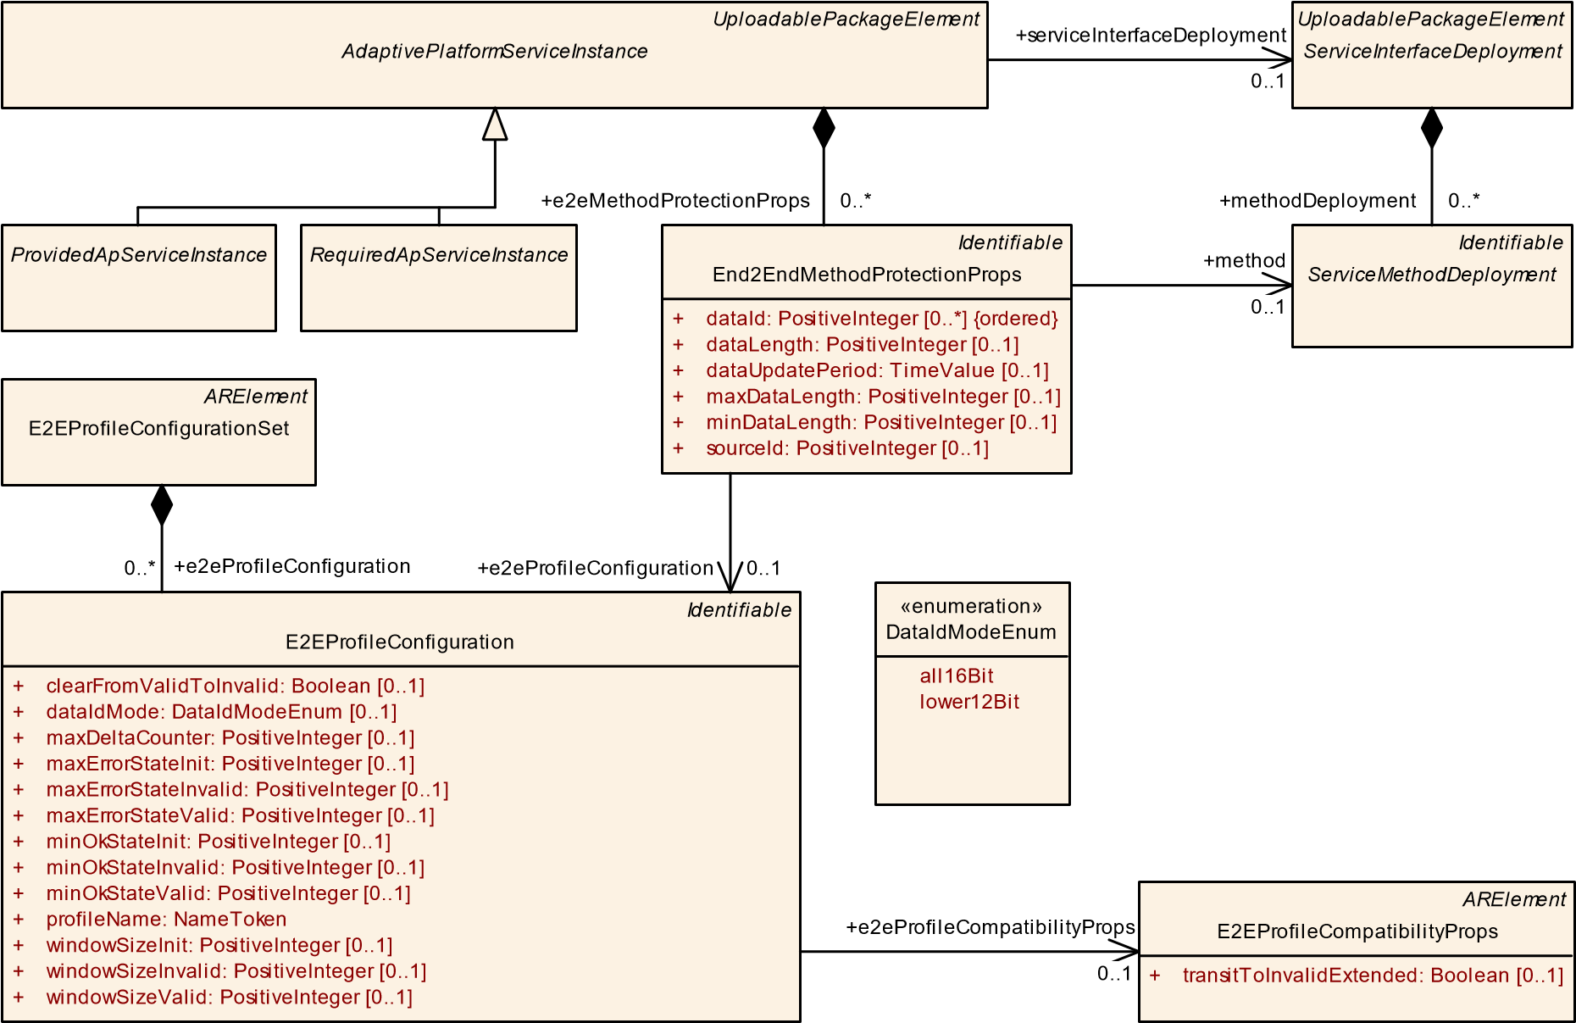

**Figure 10.31: E2E MethodProtection**

**[TPS_MANI_03228]**{DRAFT} **Usage of End2EndMethodProtectionProps** dThe End2EndMethodProtectionProps element is used to define method specific E2E configuration settings in the context of an AdaptivePlatformServiceInstance.c *(RS_MANI_00028)*

Please note that the E2E protection of field get and set methods is possible with the End2EndMethodProtectionProps.method reference since each specific ServiceFieldDeployment element is allowed to aggregate a ServiceMethodDeployment in the role get and/or set.

If such an aggregated ServiceMethodDeployment is referenced with the End2EndMethodProtectionProps.method reference the E2E protection settings are valid for the get or set method that is embedded by the ServiceFieldDeployment.

**[TPS_MANI_03129]**{DRAFT} **E2E profile** dThe E2E profile is defined by E2EProfileConfiguration.profileName.c*(RS_MANI_00028)*

**[TPS_MANI_03130]**{DRAFT} **Standardized values of the attribute**

**E2EProfileConfiguration.profileName** dThe E2EProfileConfiguration. profileName that is referenced by an End2EndEventProtectionProps or by an End2EndMethodProtectionProps can have the following values that are standardized by AUTOSAR: PROFILE_04, PROFILE_05, PROFILE_06, PROFILE_-

07, PROFILE_08, PROFILE_11, PROFILE_22, PROFILE_04m, PROFILE_07m, PROFILE_44, PROFILE_08m, and PROFILE_44m.c*(RS_MANI_00028)*

**[TPS_MANI_03131]**{DRAFT} **Non-Standardized values of attribute**

**E2EProfileConfiguration.profileName** dThe values for the profileName of E2EProfileConfiguration mentioned in [TPS_MANI_03130] are standardized and reserved for being used in the way the AUTOSAR standard foresees.

PROFILE_01 and PROFILE_02 are also reserved by AUTOSAR but excluded for usage on the *AUTOSAR adaptive Platform*. In addition, it is positively possible to use other than the standardized values for the profileName.c*(RS_MANI_00028)*

**[TPS_MANI_03128]**{DRAFT} **Usage of same End2EndEventProtectionProps. dataId in case of Multi-Binding** dIn case of Multi-Binding, i.e. if different AdaptivePlatformServiceInstances exist that are mapped by ServiceInstanceToPortPrototypeMapping to the same PortPrototype, the different Adaptive-

PlatformServiceInstances may contain the same dataId for the same event.c *(RS_MANI_00028)*

In other words, if a PortPrototype contains two transport layer bindings, e.g. a

ProvidedSomeipServiceInstance and a ProvidedUserDefinedServiceInstance representing an IPC communication, then an event is allowed to be protected with the same dataId in both AdaptivePlatformServiceInstances because the two AdaptivePlatformServiceInstances effectively represent the identical piece of data.

**[TPS_MANI_03229]**{DRAFT} **Usage of same End2EndMethodProtectionProps. dataId in case of Multi-Binding** dIn case of Multi-Binding, i.e. if different AdaptivePlatformServiceInstances exist that are mapped by ServiceInstanceToPortPrototypeMapping to the same PortPrototype, the different AdaptivePlatformServiceInstances may contain the same dataId for the same method.c*(RS_MANI_00028)*

In other words if a PortPrototype contains two transport layer bindings, e.g. a

ProvidedSomeipServiceInstance and a ProvidedUserDefinedServiceInstance representing an IPC communication then a method is allowed to be protected with the same dataId in both AdaptivePlatformServiceInstances.

**[TPS_MANI_03252]**{DRAFT} **Usage of same End2EndMethodProtectionProps. sourceId in case of Multi-Binding** dIn case of Multi-Binding, i.e. if different AdaptivePlatformServiceInstances exist that are mapped by ServiceInstanceToPortPrototypeMapping to the same PortPrototype, the different AdaptivePlatformServiceInstances may contain the same sourceId (for the same and even for a different method).c*(RS_MANI_00028)*

In other words if a PortPrototype contains two transport layer bindings, e.g. a

ProvidedSomeipServiceInstance and a ProvidedUserDefinedServiceInstance representing an IPC communication then a single as well as different methods are allowed to be protected with the same sourceId in both AdaptivePlatformServiceInstances.

|  |  |  |  |  |
| --- | --- | --- | --- | --- |
| ***Class*** | **End2EndEventProtectionProps** | | | |
| ***Package*** | M2::AUTOSARTemplates::AdaptivePlatform::ServiceInstanceManifest::E2E | | | |
| ***Note*** | This element allows to protect an event or a field notifier with an E2E profile.  **Tags:**atp.Status=draft | | | |
| ***Base*** | *ARObject*, *Identifiable*, *MultilanguageReferrable*, *Referrable* | | | |
| ***Attribute*** | ***Type*** | ***Mult.*** | ***Kind*** | ***Note*** |
| dataId (ordered) | PositiveInteger | * | attr | This represents a unique numerical identifier for the referenced event or field notifier that is included in the CRC calculation.  Note: ID is used for protection against masquerading.  The details concerning the maximum number of values (this information is specific for each E2E profile) applicable for this attribute are controlled by a semantic constraint that depends on the category of the EndToEnd Protection.  **Tags:**atp.Status=draft |
| dataLength | PositiveInteger | 0..1 | attr | Length of payload including E2E header in bits.  **Tags:**atp.Status=draft |
| dataUpdate Period | TimeValue | 0..1 | attr | This attribute describes the period in which the applications are assumed to process E2E-protected messages. The middleware does not use this attribute at all.  **Tags:**atp.Status=draft |
| e2eProfile  Configuration | E2EProfileConfiguration | 0..1 | ref | Reference to E2E profile configuration settings that are valid to protect the referenced event or field notifier.  **Tags:**atp.Status=draft |
| event | ServiceEvent  Deployment | 0..1 | ref | Reference to an event that is protected by the E2E profile.  **Tags:**atp.Status=draft |
| maxDataLength | PositiveInteger | 0..1 | attr | Maximum length of payload including E2E header in bits.  **Tags:**atp.Status=draft |
| minDataLength | PositiveInteger | 0..1 | attr | Minimum length of payload including E2E header in bits.  **Tags:**atp.Status=draft |

**Table 10.67: End2EndEventProtectionProps**

|  |  |  |  |  |
| --- | --- | --- | --- | --- |
| ***Class*** | **End2EndMethodProtectionProps** | | | |
| ***Package*** | M2::AUTOSARTemplates::AdaptivePlatform::ServiceInstanceManifest::E2E | | | |
| ***Note*** | This element allows to protect a method, a field setter or a field getter with an E2E profile.  **Tags:**atp.Status=draft | | | |
| ***Base*** | *ARObject*, *Identifiable*, *MultilanguageReferrable*, *Referrable* | | | |
| ***Attribute*** | ***Type*** | ***Mult.*** | ***Kind*** | ***Note*** |

5

|  |  |  |  |  |
| --- | --- | --- | --- | --- |
| ***Class*** | **End2EndMethodProtectionProps** | | | |
| dataId (ordered) | PositiveInteger | * | attr | This represents a numerical identifier that is included in the CRC calculation. This dataId is used for call and response.  Note: ID is used for protection against masquerading.  The details concerning the maximum number of values (this information is specific for each E2E profile) applicable for this attribute are controlled by a semantic constraint that depends on the category of the EndToEnd Protection.  **Tags:**atp.Status=draft |
| dataLength | PositiveInteger | 0..1 | attr | Length of payload including E2E header in bits.  **Tags:**atp.Status=draft |
| dataUpdate Period | TimeValue | 0..1 | attr | This attribute describes the period in which the applications are assumed to process E2E-protected messages. The middleware does not use this attribute at all.  **Tags:**atp.Status=draft |
| e2eProfile  Configuration | E2EProfileConfiguration | 0..1 | ref | Reference to E2E profile configuration settings that are valid to protect the referenced method, field getter or field setter.  **Tags:**atp.Status=draft |
| maxDataLength | PositiveInteger | 0..1 | attr | Maximum length of payload including E2E header in bits.  **Tags:**atp.Status=draft |
| method | ServiceMethod  Deployment | 0..1 | ref | Reference to a method, a field getter or a field setter that is protected by the E2E profile.  **Tags:**atp.Status=draft |
| minDataLength | PositiveInteger | 0..1 | attr | Minimum length of payload including E2E header in bits.  **Tags:**atp.Status=draft |
| sourceId | PositiveInteger | 0..1 | attr | This represents a unique numerical identifier identifying the source of a certain transmission. In case of C/S communication, this ID uniquely identifies the client.  Note: ID is used for protection against masquerading.  The details concerning the maximum number of values (this information is specific for each E2E profile) applicable for this attribute are controlled by a semantic constraint that depends on the category of the EndToEnd Protection.  **Tags:**atp.Status=draft |

**Table 10.68: End2EndMethodProtectionProps**

|  |  |  |  |  |
| --- | --- | --- | --- | --- |
| ***Class*** | **E2EProfileConfigurationSet** | | | |
| ***Package*** | M2::AUTOSARTemplates::AdaptivePlatform::ServiceInstanceManifest::E2E | | | |
| ***Note*** | This meta-class represents the ability to aggregate a collection of E2EProfileConfigurations.  **Tags:**  atp.Status=draft  atp.recommendedPackage=E2EProfileConfigurationSets | | | |
| ***Base*** | *ARElement*, *ARObject*, *CollectableElement*, *Identifiable*, *MultilanguageReferrable*, *Packageable Element*, *Referrable* | | | |
| ***Attribute*** | ***Type*** | ***Mult.*** | ***Kind*** | ***Note*** |

5

|  |  |  |  |  |
| --- | --- | --- | --- | --- |
| ***Class*** | **E2EProfileConfigurationSet** | |  |  |
| e2eProfile  Configuration | E2EProfileConfiguration | * | aggr | This represents the collection of E2EProfileConfigurations aggregated at the E2EProfileConfigurationSet.  **Tags:**atp.Status=draft |

**Table 10.69: E2EProfileConfigurationSet**

|  |  |  |  |  |
| --- | --- | --- | --- | --- |
| ***Class*** | **E2EProfileConfiguration** | | | |
| ***Package*** | M2::AUTOSARTemplates::AdaptivePlatform::ServiceInstanceManifest::E2E | | | |
| ***Note*** | This element holds E2E profile specific configuration settings.  **Tags:**atp.Status=draft | | | |
| ***Base*** | *ARObject*, *Identifiable*, *MultilanguageReferrable*, *Referrable* | | | |
| ***Attribute*** | ***Type*** | ***Mult.*** | ***Kind*** | ***Note*** |
| clearFromValid ToInvalid | Boolean | 0..1 | attr | Clear monitoring window on transition from state Valid to state Invalid.  **Tags:**atp.Status=draft |
| dataIdMode | DataIdModeEnum | 0..1 | attr | This attribute describes the inclusion mode that is used to include the implicit Data ID in the one-byte CRC.  **Tags:**atp.Status=draft |
| e2eProfile  Compatibility  Props | E2EProfileCompatibility  Props | 0..1 | ref | Reference to additional settings for the E2E state machine.  **Tags:**atp.Status=draft |
| maxDelta Counter | PositiveInteger | 0..1 | attr | Maximum allowed difference between two counter values of two consecutively received valid messages. For example, if the receiver gets data with counter 1 and Max DeltaCounter is 3, then at the next reception the receiver can accept Counters with values 2, 3 or 4.  **Tags:**atp.Status=draft |
| maxErrorState  Init | PositiveInteger | 0..1 | attr | Maximal number of checks in which ProfileStatus equal to E2E_P_ERROR was determined, within the last Window Size checks, for the state E2E_SM_INIT.  **Tags:**atp.Status=draft |
| maxErrorState Invalid | PositiveInteger | 0..1 | attr | Maximal number of checks in which ProfileStatus equal to E2E_P_ERROR was determined, within the last Window Size checks, for the state E2E_SM_INVALID.  **Tags:**atp.Status=draft |
| maxErrorState Valid | PositiveInteger | 0..1 | attr | Maximal number of checks in which ProfileStatus equal to E2E_P_ERROR was determined, within the last Window Size checks, for the state E2E_SM_VALID.  **Tags:**atp.Status=draft |
| minOkStateInit | PositiveInteger | 0..1 | attr | Minimal number of checks in which ProfileStatus equal to E2E_P_OK was determined, within the last WindowSize checks, for the state E2E_SM_INIT.  **Tags:**atp.Status=draft |
| minOkState  Invalid | PositiveInteger | 0..1 | attr | Minimal number of checks in which ProfileStatus equal to E2E_P_OK was determined, within the last WindowSize checks, for the state E2E_SM_INVALID.  **Tags:**atp.Status=draft |

5

|  |  |  |  |  |
| --- | --- | --- | --- | --- |
| ***Class*** | **E2EProfileConfiguration** | | | |
| minOkState Valid | PositiveInteger | 0..1 | attr | Minimal number of checks in which ProfileStatus equal to E2E_P_OK was determined, within the last WindowSize checks, for the state E2E_SM_VALID.  **Tags:**atp.Status=draft |
| profileName | NameToken | 1 | attr | Definition of the E2E profile.  **Tags:**atp.Status=draft |
| windowSizeInit | PositiveInteger | 0..1 | attr | Size of the monitoring window of state Init for the E2E state machine.  **Tags:**atp.Status=draft |
| windowSize  Invalid | PositiveInteger | 0..1 | attr | Size of the monitoring window of state Invalid for the E2E state machine.  **Tags:**atp.Status=draft |
| windowSize Valid | PositiveInteger | 0..1 | attr | Size of the monitoring window of state Valid for the E2E state machine.  **Tags:**atp.Status=draft |

**Table 10.70: E2EProfileConfiguration**

|  |  |
| --- | --- |
| ***Enumeration*** | **DataIdModeEnum** |
| ***Package*** | M2::AUTOSARTemplates::SystemTemplate::Transformer |
| ***Note*** | Supported inclusion modes to include the implicit two-byte Data ID in the one-byte CRC. |
| ***Literal*** | ***Description*** |
| all16Bit | Two bytes are included in the CRC (double ID configuration).  **Tags:**atp.EnumerationLiteralIndex=0 |
| lower12Bit | The low byte is included in the implicit CRC calculation, the low nibble of the high byte is transmitted along with the data (i.e. it is explicitly included), the high nibble of the high byte is not used. This is applicable for the IDs up to 12 bits.  **Tags:**atp.EnumerationLiteralIndex=2 |

**Table 10.71: DataIdModeEnum**

|  |  |  |  |  |
| --- | --- | --- | --- | --- |
| ***Class*** | **E2EProfileCompatibilityProps** | | | |
| ***Package*** | M2::AUTOSARTemplates::SystemTemplate::Transformer | | | |
| ***Note*** | This meta-class collects settings for configuration of the E2E state machine.  **Tags:**atp.recommendedPackage=E2EProfileCompatibilityPropsCollection | | | |
| ***Base*** | *ARElement*, *ARObject*, *CollectableElement*, *Identifiable*, *MultilanguageReferrable*, *Packageable Element*, *Referrable* | | | |
| ***Attribute*** | ***Type*** | ***Mult.*** | ***Kind*** | ***Note*** |
| transitToInvalid Extended | Boolean | 0..1 | attr | E2E State machine behavior concerning transition from NODATA/INIT to INVALID  value=0 (false): no direct transition from NODATA to INVALID, no transition from INIT to INVALID due to counter-related faults (Autosar R19-11 or former behavior)  value=1 (true): direct transition from NODATA to INVALID covered, transition from INIT to INVALID due to counter-related faults covered (state machine extended) |

**Table 10.72: E2EProfileCompatibilityProps**

Please note that the configuration of the E2E state machines with the configuration attributes available in E2EProfileConfiguration is restricted by [constr_3176], [constr_3177], [constr_3178], [constr_3179], [constr_3180], [constr_3181] defined in the E2E Protocol specification [29].

It is possible to overwrite the E2E state machine configuration settings that are defined in E2EProfileConfiguration at the RPortPrototype of a SwComponentType with settings available in the ReceiverComSpec as described in [TPS_MANI_03132]. With this approach it is possible to define individual E2E settings for different receivers of the event, or field notifiers.

Likewise, it is possible to overwrite the E2E state machine configuration settings that are defined in E2EProfileConfiguration at the RPortPrototype of a SwComponentType with settings available in the ClientComSpec as described in [TPS_MANI_01324].

With this approach it is possible to define individual E2E settings for different callers of a method.

Finally, it is possible to overwrite the E2E state machine configuration settings that are defined in E2EProfileConfiguration at the PPortPrototype of a SwComponentType with settings available in the ServerComSpec as described in [TPS_MANI_01325].

**[constr_3493]**{DRAFT} **Applicable attributes for standardized E2E Profiles** d Table 10.73 defines the applicable attributes for the standardized E2E Profiles of AUTOSAR.c*()*

In PROFILE_22, the dataId is defined as a list of 16 dataId values, where a different value is transmitted depending on the counter value.

Please also note that the Classic Platform attributes counterOffset, crcOffset and dataIdNibbleOffset are not configurable on the *AUTOSAR adaptive Platform* and are set to fixed values by the AUTOSAR Standard.

**[constr_5230]**{DRAFT} **Attribute E2EProfileCompatibilityProps.transitToInvalidExtended shall exist for each E2EProfileConfiguration**dFor each E2EProfileConfiguration, a reference to E2EProfileCompatibilityProps in the role e2eProfileCompatibilityProps shall exist and the referenced E2EProfileCompatibilityProps shall define a value for the attribute transitToInvalidExtended.c*()*

**[constr_5250]**{DRAFT} **Protection of AdaptivePlatformServiceInstances of the same ServiceInterfaceDeployment** dIf several AdaptivePlatformServiceInstances exist that are referencing the same ServiceInterfaceDeployment and these AdaptivePlatformServiceInstances contain aggregated

End2EndMethodProtectionProps and/or End2EndEventProtectionProps then the E2EProfileConfigurations that are referenced by the

End2EndMethodProtectionProps and End2EndEventProtectionProps shall have the same profileName defined.c*()*

|  |  |  |  |  |  |  |  |  |  |  |  |  |  |  |  |
| --- | --- | --- | --- | --- | --- | --- | --- | --- | --- | --- | --- | --- | --- | --- | --- |
| **E2E Attributes** | **Root Element** | | | **Attribute Existence per Profile** | | | | | | | | | | | |
|  | **End2EndEventProtectionProps** | **End2EndMethodProtectionProps** | **E2EProfileConfiguration** | **PROFILE_04** | **PROFILE_05** | **PROFILE_06** | **PROFILE_07** | **PROFILE_08** | **PROFILE_11** | **PROFILE_22** | **PROFILE_04m** | **PROFILE_07m** | **PROFILE_44** | **PROFILE_08m** | **PROFILE_44m** |
| **dataId** | x | x |  | 1 | 1 | 1 | 1 | 1 | 1 | n | 1 | 1 | 1 | 1 | 1 |
| **dataLength** | x | x |  |  | x |  |  |  | x | x |  |  |  |  |  |
| **minDataLength** | x | x |  | x |  | x | x | x |  |  | x | x | x | x | x |
| **maxDataLength** | x | x |  | x |  | x | x | x |  |  | x | x | x | x | x |
| **dataUpdatePeriod** | x | x |  | x | x | x | x | x | x | x | x | x | x | x | x |
| **sourceId** |  | x |  |  |  |  |  |  |  |  | x | x |  | x | x |
| **dataIdMode** |  |  | x |  |  |  |  |  | x |  |  |  |  |  |  |
| **maxDeltaCounter** |  |  | x | x | x | x | x | x | x | x | x | x | x | x | x |
| **maxErrorStateInit** |  |  | x | x | x | x | x | x | x | x | x | x | x | x | x |
| **maxErrorStateInvalid** |  |  | x | x | x | x | x | x | x | x | x | x | x | x | x |
| **maxErrorStateValid** |  |  | x | x | x | x | x | x | x | x | x | x | x | x | x |
| **minOkStateInit** |  |  | x | x | x | x | x | x | x | x | x | x | x | x | x |
| **minOkStateInvalid** |  |  | x | x | x | x | x | x | x | x | x | x | x | x | x |
| **minOkStateValid** |  |  | x | x | x | x | x | x | x | x | x | x | x | x | x |
| **windowSizeValid** |  |  | x | x | x | x | x | x | x | x | x | x | x | x | x |
| **windowSizeInvalid** |  |  | x | x | x | x | x | x | x | x | x | x | x | x | x |
| **windowSizeInit** |  |  | x | x | x | x | x | x | x | x | x | x | x | x | x |
| **clearFromValidToInvalid** |  |  | x | x | x | x | x | x | x | x | x | x | x | x | x |

**Table 10.73: Allowed Attributes for standardized E2E Profiles**

In other words it is not allowed to protect different AdaptivePlatformServiceInstances of the same ServiceInterfaceDeployment with different E2E Profiles. Please note that the End2EndMethodProtectionProps and/or

End2EndEventProtectionProps in the different AdaptivePlatformServiceInstances are allowed to reference different E2EProfileConfigurations since the same E2E Profile may be configured with different E2E settings.

## 10.5 Secure Communication

AUTOSAR supports different protocols that provide communication security over a network. To configure the secured communication of ServiceInterface elements between a ProvidedApServiceInstance and a RequiredApServiceInstance the ServiceInterfaceElementSecureComConfig meta-class is defined. **[TPS_MANI_03133]**{DRAFT} **Usage of ServiceInterfaceElementSecureComConfig** dThe ServiceInterfaceElementSecureComConfig element is used to define ServiceInterface element specific secure communication configuration settings in the context of an AdaptivePlatformServiceInstance.c*(RS_MANI_00036)*

The modeling allows protecting selected elements of a ServiceInterface, like particular events or methods.

*UploadablePackageElement*

*AdaptivePlatformServiceInstance*

*UploadablePackageElement*

*ServiceInterfaceDeployment*

*Identifiable*

*ServiceEventDeployment*

*Identifiable*

*ServiceFieldDeployment*

*ProvidedApServiceInstance*

*RequiredApServiceInstance*

*Identifiable*

*ServiceMethodDeployment*

*Identifiable*

ServiceInterfaceElementSecureComConfig

[0..1]

dataId: PositiveInteger

+

freshnessValueId: PositiveInteger

+

[0..1]

+

getterCall

0..1

eventDeployment

+

0..*

+

getterReturn

0..1

+

serviceInterfaceDeployment

0..1

+

methodCall

0..1

+

fieldDeployment

0..*

+

setterReturn

0..1

+

setterCall

0..1

+

event

0..1

+

methodDeployment

0..*

+

methodReturn

0..1

secureComConfig

+

0..*

+

fieldNotifier

0..1

**Figure 10.32: Secure Communication**

Since the ServiceInterfaceElementSecureComConfig meta-class is aggregated by the abstract AdaptivePlatformServiceInstance it can be used to configure the secure communication on specific derived classes like Provided-

SomeipServiceInstance or RequiredSomeipServiceInstance that fit the underlying middleware. With this approach it is possible to define different communication security protections for different used transport layer mechanisms in case of Multi-Binding.

|  |  |  |  |  |
| --- | --- | --- | --- | --- |
| ***Class*** | **ServiceInterfaceElementSecureComConfig** | | | |
| ***Package*** | M2::AUTOSARTemplates::AdaptivePlatform::ServiceInstanceManifest::SecureCommunication | | | |
| ***Note*** | This element allows to secure the communication of the referenced ServiceInterface element.  **Tags:**atp.Status=draft | | | |
| ***Base*** | *ARObject*, *Identifiable*, *MultilanguageReferrable*, *Referrable* | | | |
| ***Attribute*** | ***Type*** | ***Mult.*** | ***Kind*** | ***Note*** |
| dataId | PositiveInteger | 0..1 | attr | This attribute defines a unique numerical identifier for the referenced ServiceInterface element.  **Tags:**atp.Status=draft |
| event | ServiceEvent  Deployment | 0..1 | ref | Reference to an event that is protected by a security protocol.  **Tags:**atp.Status=draft |
| fieldNotifier | ServiceField  Deployment | 0..1 | ref | Reference to a field notifier that is protected by a security protocol.  **Tags:**atp.Status=draft |
| freshnessValue Id | PositiveInteger | 0..1 | attr | This attribute defines the Id of the Freshness Value.  **Tags:**atp.Status=draft |
| getterCall | ServiceField  Deployment | 0..1 | ref | Reference to a field getter call message that is protected by a security protocol. **Tags:**atp.Status=draft |
| getterReturn | ServiceField  Deployment | 0..1 | ref | Reference to a field getter return message that is protected by a security protocol.  **Tags:**atp.Status=draft |
| methodCall | ServiceMethod  Deployment | 0..1 | ref | Reference to a method call message that is protected by a security protocol.  **Tags:**atp.Status=draft |
| methodReturn | ServiceMethod  Deployment | 0..1 | ref | Reference to a method return message that is protected by a security protocol. **Tags:**atp.Status=draft |
| setterCall | ServiceField  Deployment | 0..1 | ref | Reference to a field setter call message that is protected by a security protocol. **Tags:**atp.Status=draft |
| setterReturn | ServiceField  Deployment | 0..1 | ref | Reference to a field setter return message that is protected by a security protocol.  **Tags:**atp.Status=draft |

**Table 10.74: ServiceInterfaceElementSecureComConfig**

**[constr_3391]**{DRAFT} **ServiceInterfaceElementSecureComConfig references to ServiceInterfaceDeployment elements** dServiceInterfaceElementSecureComConfig element shall be defined for exactly one ServiceInterface element and shall therefore contain only one single reference to an element defined in the scope of a ServiceInterfaceDeployment.c*()*

The attributes in the ServiceInterfaceElementSecureComConfig meta-class are defining security configuration settings that are specific for the referenced ServiceInterface element in the context of an AdaptivePlatformServiceInstance. The used security protocol is defined in the ServiceInstanceToMachineMapping. **[TPS_MANI_03199]**{DRAFT} **Endpoint protection by SecureComProps** dThe ServiceInstanceToMachineMapping allows to assign a security protocol configuration settings that are defined in the referenced SecureComProps meta-class to protect endpoints that are defined by the Transport Protocol, Port and IP Address on which one or several AdaptivePlatformServiceInstances are provided or consumed.c*(RS_MANI_00036)*

*ARElement*

*SecureComProps*

*Identifiable*

*CommunicationConnector*

[0..1]

+

createEcuWakeupSource: Boolean

pncFilterArrayMask: PositiveInteger [0..*] {ordered

+

}

*UploadablePackageElement*

*ServiceInstanceToMachineMapping*

*UploadablePackageElement*

*AdaptivePlatformServiceInstance*

TlsSecureComProps

SecOcSecureComProps

[0..1]

+

authAlgorithm: String

[0..1]

authInfoTxLength: PositiveInteger

+

[0..1]

freshnessValueLength: PositiveInteger

+

+

freshnessValueTxLength: PositiveInteger

[0..1]

+

communicationConnector

0..1

serviceInstance

+

0..*

secureComPropsForUdp

+

0..1

+

secOcComPropsForMulticast

0..*

secureComPropsForTcp

+

0..1

**Figure 10.33: Security protocol configuration**

**[TPS_MANI_03200]**{DRAFT} **SecureComProps for udp, tcp and multicast communication** dThe ServiceInstanceToMachineMapping allows to assign a security protocol configuration settings for:

* udp communication if the ServiceInstanceToMachineMapping refers to the SecureComProps in the role secureComPropsForUdp
* tcp communication in case the ServiceInstanceToMachineMapping refers to the SecureComProps in the role secureComPropsForTcp
* multicast communication in case the ServiceInstanceToMachineMapping refers to the SecOcSecureComProps in the role secOcComPropsForMulticast

c*(RS_MANI_00036)*

With this modeling approach it is possible to configure different security protocol settings for the communication over TCP, UDP and multicast. For example it is allowed to use different settings to protect the TCP communication of a AdaptivePlatformServiceInstance via TLS and UDP communication via DTLS.

Please note that protection of IP multicast traffic is only supported by SecOC and therefore the ServiceInstanceToMachineMapping refers directly the SecOcSecureComProps in the secOcComPropsForMulticast role.

|  |  |  |  |  |
| --- | --- | --- | --- | --- |
| ***Class*** | ***SecureComProps*** (abstract) | | | |
| ***Package*** | M2::AUTOSARTemplates::AdaptivePlatform::ServiceInstanceManifest::SecureCommunication | | | |
| ***Note*** | This meta-class defines a communication security protocol and its configuration settings.  **Tags:**atp.Status=draft | | | |
| ***Base*** | *ARElement*, *ARObject*, *CollectableElement*, *Identifiable*, *MultilanguageReferrable*, *Packageable Element*, *Referrable* | | | |
| ***Subclasses*** | DdsSecureComProps, SecOcSecureComProps, TlsSecureComProps | | | |
| ***Attribute*** | ***Type*** | ***Mult.*** | ***Kind*** | ***Note*** |
| – | – | – | – | – |

**Table 10.75: SecureComProps**

**10.5.1 Secure Communication over TLS**

The configuration of the Transport Layer Security (TLS) and Datagram Transport Layer Security (DTLS) protocols is supported with the TlsSecureComProps meta-class, which is a specialization of SecureComProps.

It is a common use case that only one end of a TLS-based connection is actually modeled in an AUTOSAR model. It is therefore important that the modeling does not rely on or imply knowledge about both ends of such a TLS-based connection.

An AUTOSAR model that only describes one end of the communication is positively required to work, independently of the availability of a formal modeling of the other end.

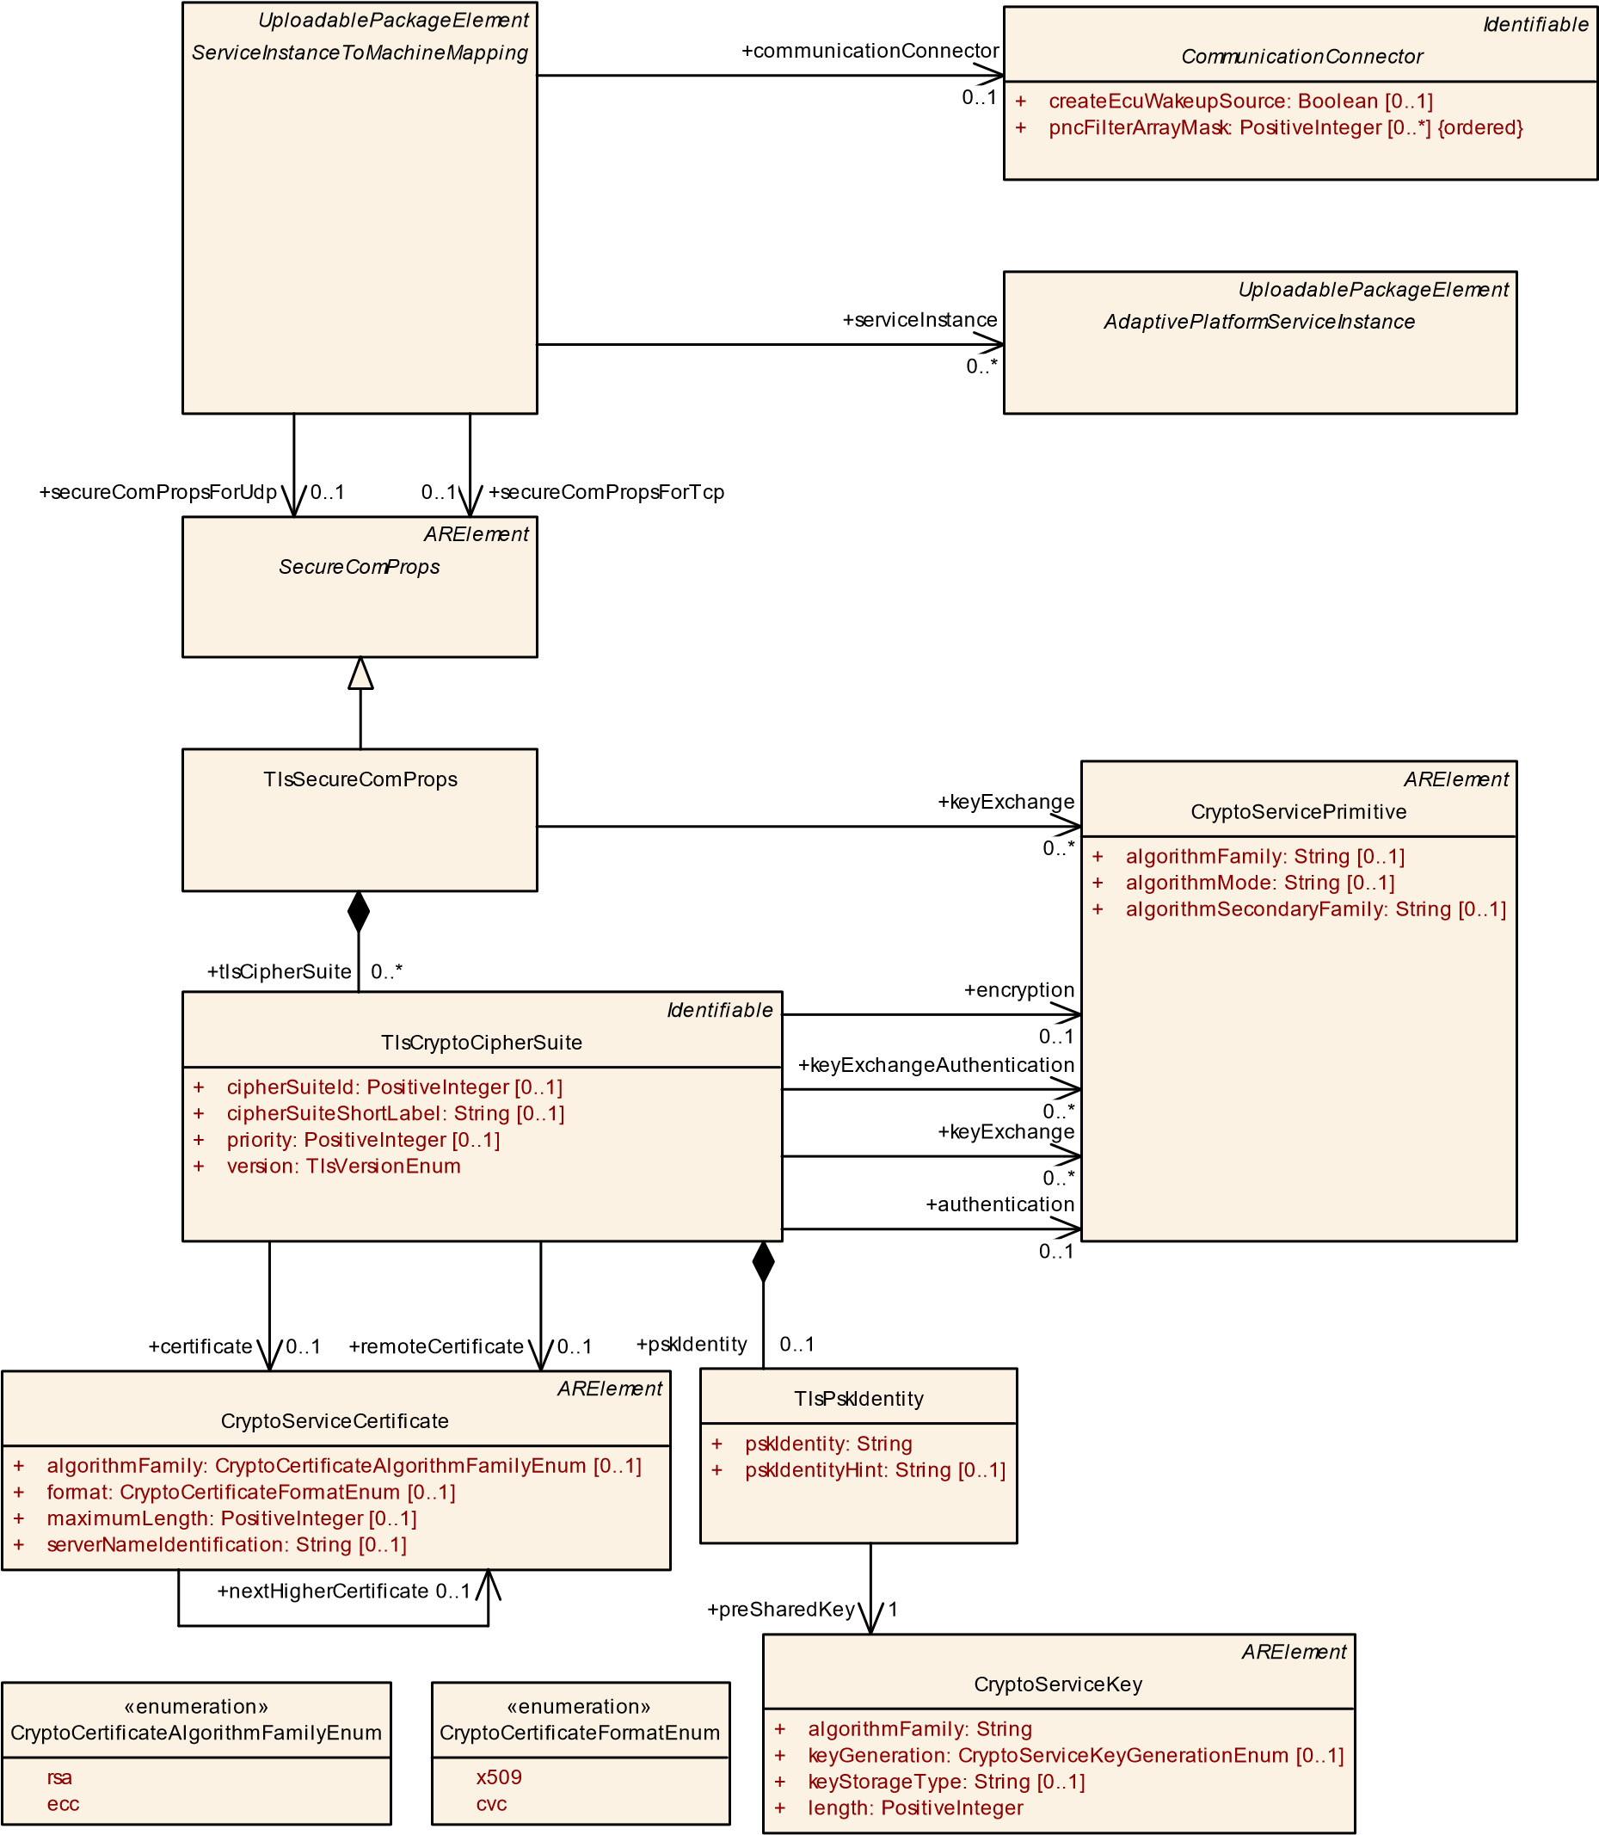

|  |
| --- |
| «enumerati... TlsVersionEnum |
| tls12 tls13 |

**Figure 10.34: Secure Communication over TLS**

|  |  |  |  |  |
| --- | --- | --- | --- | --- |
| ***Class*** | **TlsSecureComProps** | | | |
| ***Package*** | M2::AUTOSARTemplates::AdaptivePlatform::ServiceInstanceManifest::SecureCommunication | | | |
| ***Note*** | Configuration of the Transport Layer Security protocol (TLS).  **Tags:**  atp.Status=draft  atp.recommendedPackage=SecureComProps | | | |
| ***Base*** | *ARElement*, *ARObject*, *CollectableElement*, *Identifiable*, *MultilanguageReferrable*, *Packageable Element*, *Referrable*, *SecureComProps* | | | |
| ***Attribute*** | ***Type*** | ***Mult.*** | ***Kind*** | ***Note*** |
| keyExchange | CryptoServicePrimitive | * | ref | This reference identifies the shared (i.e. applicable for each of the aggregated cipher suites) crypto service primitive for the execution of key exchange during the handshake phase.  **Tags:**atp.Status=draft |
| tlsCipherSuite | TlsCryptoCipherSuite | * | aggr | Collection of supported cipher suites that are used to negotiate the security settings for a network connection defined by the ServiceInstanceToMachineMapping.  **Tags:**atp.Status=draft |

**Table 10.76: TlsSecureComProps**

|  |  |
| --- | --- |
| ***Enumeration*** | **CryptoServiceKeyGenerationEnum** |
| ***Package*** | M2::AUTOSARTemplates::SystemTemplate::SecureCommunication |
| ***Note*** | This enumeration shall be taken to express the handling of a crypto key in terms of whether it is obtained from e.g. a diagnostic tester or whether it is created by derivation from a master key. |
| ***Literal*** | ***Description*** |
| keyDerivation | This means that the crypto key is created by derivation from a master key.  **Tags:**atp.EnumerationLiteralIndex=0 |
| keyStorage | This means that the crypto key is obtained from an external entity, e.g. a diagnostic tester.  **Tags:**atp.EnumerationLiteralIndex=1 |

**Table 10.77: CryptoServiceKeyGenerationEnum**

TLS is composed of the TLS Record Protocol and the TLS Handshake Protocol. The Record Protocol provides connection security and encrypts and authenticate packets. The record layer functions can be called at any time after the handshake process is finished, when there is need to receive or send data.

The Handshake Protocol allows the server and client to authenticate each other and to negotiate encryption algorithms and cryptographic keys before any data is exchanged.

In order to establish a cryptographically secure data channel, the communication partners in form of ServiceInstanceToMachineMappings shall agree on ciphersuites and on keys that will be used to encrypt the data.

The client sends a list of supported ciphersuites to the server. The server decides on a ciphersuite from the list provided by the client, and continues with the handshake. Please note that the server and client roles cannot be swapped while the connection exists, i.e. a *server* remains the *server* for the full amount of time the connection exists. **[TPS_MANI_03213]**{DRAFT} **Semantics of meta-class TlsSecureComProps** dAs a sub-class of SecureComProps, meta-class TlsSecureComProps has the ability to collect the TLS-related configuration aspects from either the perspective of the client or the server.

In the case of TLS, the collection boils down to the aggregation of meta-class

TlsCryptoCipherSuite in the role tlsCipherSuite plus the ability (by means of the role keyExchange) to define handshake properties that are shared for each of the aggregated tlsCipherSuite.c*(RS_MANI_00036)*

**[constr_5047]**{DRAFT} **Supported values of TlsSecureComProps.category** dThe only supported values of attribute TlsSecureComProps.category are:

* **TLS_SERVER**: the TlsSecureComProps assumes the role of the *server* in the TLS connection.
* **TLS_CLIENT**: the TlsSecureComProps assumes the role of the *client* in the TLS connection.

### c()

**[TPS_MANI_03134]**{DRAFT} **Configuration of supported TLS ciphersuites** dThe creation of a TLS connection requires the usage of a suite of cryptographic operations in specific roles, also known as a *cipher suite*.

Meta-class TlsCryptoCipherSuite represents a given cipher suite for a TLS connection. TlsCryptoCipherSuite references meta-class CryptoServicePrimitive in three dedicated roles that represent the steps of the creation of a TLS connection.

More specifically, the cryptographic operations for setting up a TLS connection involve the following steps:

* **Key exchange**: these CryptoServicePrimitives may be used for the handshake phase of the TLS connection. Different alternatives exist for executing this phase and therefore the multiplicity of this reference is 0..*.
* **Authentication** of communication partners during the operational phase of the TLS connection. For this purpose a single CryptoServicePrimitive is used on each end of the communication.
* **Encryption** of content exchanged between the communication partners that have established the TLS connection. For this purpose a single CryptoServicePrimitive is used on each end of the communication.

c*(RS_MANI_00036)*

|  |  |
| --- | --- |
| ***Class*** | **TlsCryptoCipherSuite** |
| ***Package*** | M2::AUTOSARTemplates::SystemTemplate::SecureCommunication |

5

4

|  |  |  |  |  |
| --- | --- | --- | --- | --- |
| ***Class*** | **TlsCryptoCipherSuite** | | | |
| ***Note*** | This meta-class represents a cipher suite for describing cryptographic operations in the context of establishing a connection of ApplicationEndpoints that is protected by TLS. | | | |
| ***Base*** | *ARObject*, *Identifiable*, *MultilanguageReferrable*, *Referrable* | | | |
| ***Attribute*** | ***Type*** | ***Mult.*** | ***Kind*** | ***Note*** |
| authentication | CryptoServicePrimitive | 0..1 | ref | This reference identifies the crypto service primitive for the generation and verification of MACs. |
| certificate | CryptoService  Certificate | 0..1 | ref | This reference identifies the applicable local certificate. |
| cipherSuiteId | PositiveInteger | 0..1 | attr | Identification of the CipherSuite according to the IANA assignments list. |
| cipherSuite ShortLabel | String | 0..1 | attr | Name of the CipherSuite according to the IANA assignments list. |
| ellipticCurve | CryptoEllipticCurve  Props | * | ref | This references point to the properties of elliptic curves. |
| encryption | CryptoServicePrimitive | 0..1 | ref | This reference identifies the crypto service primitive for the execution of encryption. |
| keyExchange | CryptoServicePrimitive | * | ref | This reference identifies the individual (i.e. per cipher suite) crypto service primitive for the execution of key exchange during the handshake phase. |
| keyExchange  Authentication | CryptoServicePrimitive | * | ref | This reference identifies the crypto service primitives for the generation and verification of signatures during the key exchange algorithm. |
| priority | PositiveInteger | 0..1 | attr | This attribute identifies the priority of the cipher suite. Range: 1..65535. Lower values represent higher priorities. |
| props | TlsCryptoCipherSuite  Props | 0..1 | aggr | The aggregated TlsCryptoCipherSuiteProps provide details for the TLS Cipher Suite. |
| pskIdentity | TlsPskIdentity | 0..1 | aggr | Pre-shared key identity shared during the handshake among the communication parties, to establish a TLS connection if the handshake is based on the existence of a pre-shared key. |
| remote  Certificate | CryptoService  Certificate | 0..1 | ref | This reference identifies the applicable remote certificate. |
| signature  Scheme | CryptoSignature  Scheme | * | ref | This reference points to the properties of a TLS Signature Scheme. |
| version | TlsVersionEnum | 1 | attr | This attribute supports the definition of the applicable version of TLS. |

**Table 10.78: TlsCryptoCipherSuite**

|  |  |  |  |  |
| --- | --- | --- | --- | --- |
| ***Class*** | **CryptoServicePrimitive** | | | |
| ***Package*** | M2::AUTOSARTemplates::SystemTemplate::SecureCommunication | | | |
| ***Note*** | This meta-class has the ability to represent a crypto primitive.  **Tags:**atp.recommendedPackage=CryptoPrimitives | | | |
| ***Base*** | *ARElement*, *ARObject*, *CollectableElement*, *Identifiable*, *MultilanguageReferrable*, *Packageable Element*, *Referrable* | | | |
| ***Attribute*** | ***Type*** | ***Mult.*** | ***Kind*** | ***Note*** |
| algorithmFamily | String | 0..1 | attr | This attribute represents a description of the family (e.g. AES) of crypto algorithm implemented by the crypto primitive. |
| algorithmMode | String | 0..1 | attr | This attribute represents a description of the mode of the crypto algorithm implemented by the crypto primitive. |

5

4

|  |  |  |  |  |
| --- | --- | --- | --- | --- |
| ***Class*** | **CryptoServicePrimitive** | |  |  |
| algorithm Secondary  Family | String | 0..1 | attr | This attribute represents a further description of the secondary family of crypto algorithm implemented by the crypto primitive.  The secondary family is needed for the specification of the hash algorithm for a signature check, e.g. using RSA. |

**Table 10.79: CryptoServicePrimitive**

|  |  |  |  |  |
| --- | --- | --- | --- | --- |
| ***Class*** | **CryptoServiceKey** | | | |
| ***Package*** | M2::AUTOSARTemplates::SystemTemplate::SecureCommunication | | | |
| ***Note*** | This meta-class has the ability to represent a crypto key  **Tags:**atp.recommendedPackage=CryptoDevelopmentKeys | | | |
| ***Base*** | *ARElement*, *ARObject*, *CollectableElement*, *Identifiable*, *MultilanguageReferrable*, *Packageable Element*, *Referrable* | | | |
| ***Attribute*** | ***Type*** | ***Mult.*** | ***Kind*** | ***Note*** |
| algorithmFamily | String | 1 | attr | This attribute represent the description of the family of the applicable crypto algorithm. |
| development Value | ValueSpecification | 0..1 | aggr | This aggregation represents the ability to assign a specific value to the crypto key as part of the system description. This value can then be taken for the development of the respective ECU. |
| keyGeneration | CryptoServiceKey  GenerationEnum | 0..1 | attr | This attribute describes how a the specific cryptographic key is created. |
| keyStorageType | String | 0..1 | attr | This attribute describes where the enclosing cryptographic key shall be stored. AUTOSAR reserves specific values for this attributes but it is possible to insert custom values as well. |
| length | PositiveInteger | 1 | attr | This attribute describes the length of the cryptographic key. |

**Table 10.80: CryptoServiceKey**

**[TPS_MANI_03214]**{DRAFT} **Existence of TlsCryptoCipherSuite.keyExchange vs. TlsSecureComProps.keyExchange**dThe role TlsSecureComProps. keyExchange has been introduced as an optimization.

It is assumed that the references for key exchange look pretty similar if not identical for many concrete TlsCryptoCipherSuites.

Adding these references in an identical form to a bunch of TlsCryptoCipherSuites does not really make sense. Therefore, TlsSecureComProps allows to define these references as well with the intention to make them valid for all TlsSecureComProps. tlsCipherSuites.

A mixture of references in the role TlsCryptoCipherSuite.keyExchange and TlsSecureComProps.keyExchange is supported.c*(RS_MANI_00036)*

**[TPS_MANI_03215]**{DRAFT} **Semantics of CryptoServiceCertificate**dMetaclass CryptoServiceCertificate represents a cryptographic certificate needed for the creation of a TLS connection between *server* and *client*.c*(RS_MANI_00036)*

|  |  |  |  |  |
| --- | --- | --- | --- | --- |
| ***Class*** | **CryptoServiceCertificate** | | | |
| ***Package*** | M2::AUTOSARTemplates::SystemTemplate::SecureCommunication | | | |
| ***Note*** | This meta-class represents the ability to model a cryptographic certificate.  **Tags:**atp.recommendedPackage=CryptoServiceCertificates | | | |
| ***Base*** | *ARElement*, *ARObject*, *CollectableElement*, *Identifiable*, *MultilanguageReferrable*, *Packageable Element*, *Referrable* | | | |
| ***Attribute*** | ***Type*** | ***Mult.*** | ***Kind*** | ***Note*** |
| algorithmFamily | CryptoCertificate  AlgorithmFamilyEnum | 0..1 | attr | This attribute represents a description of the family of crypto algorithm used to generate public key and signature of the cryptographic certificate. |
| format | CryptoCertificateFormat  Enum | 0..1 | attr | This attribute can be used to provide information about the format used to create the certificate |
| maximum Length | PositiveInteger | 0..1 | attr | This attribute represents the ability to define the maximum length of the certificate. |
| nextHigher Certificate | CryptoService  Certificate | 0..1 | ref | The reference identifies the next higher certificate in the certificate chain. |
| serverName  Identification | String | 0..1 | attr | Server Name Indication (SNI) is needed if the IP address hosts multiple servers (on the same port), each of them using a different certificate.  If the client sends the SNI to the Server in the client hello, the server looks the SNI up in its certificate list and uses the certificate identified by the SNI. |

**Table 10.81: CryptoServiceCertificate**

|  |  |
| --- | --- |
| ***Enumeration*** | **CryptoCertificateAlgorithmFamilyEnum** |
| ***Package*** | M2::AUTOSARTemplates::SystemTemplate::SecureCommunication |
| ***Note*** | This meta-class defies possible cryptographic algorithm families used to create public keys and signatures within the certificate. |
| ***Literal*** | ***Description*** |
| ecc | The cryptographic operations in the certificate are executed using elliptic curves (ecc)  **Tags:**atp.EnumerationLiteralIndex=2 |
| rsa | The cryptographic operations in the certificate are executed using the RSA approach.  **Tags:**atp.EnumerationLiteralIndex=1 |

**Table 10.82: CryptoCertificateAlgorithmFamilyEnum**

|  |  |
| --- | --- |
| ***Enumeration*** | **CryptoCertificateFormatEnum** |
| ***Package*** | M2::AUTOSARTemplates::SystemTemplate::SecureCommunication |
| ***Note*** | This meta-class defines possible formats of cryptographic certificates. |
| ***Literal*** | ***Description*** |
| cvc | The certificate has been created in Card Verifiable Certificate (CVC) format  **Tags:**atp.EnumerationLiteralIndex=2 |
| x509 | The certificate is created in X.509 format.  **Tags:**atp.EnumerationLiteralIndex=1 |

**Table 10.83: CryptoCertificateFormatEnum**

**[constr_5048]**{DRAFT} **Existence of TlsCryptoCipherSuite.certificate and TlsCryptoCipherSuite.pskIdentity in the *server* role** d**Either**

* the reference to CryptoServiceCertificate in the role TlsCryptoCipherSuite.certificate
* the aggregation of TlsPskIdentity in the role TlsCryptoCipherSuite. pskIdentity

**shall** exist if the TlsCryptoCipherSuite is aggregated by TlsSecureComProps that has the attribute category set to the value TLS_SERVER.c*()*

In other words two different approaches are supported by TLS for the handling of key compromise: Pre-shared secret and certificate.

The server may optionally request a certificate from the *client*. If this option is not used then other documented approaches for completing the handshake phase is foreseen for the specific case.

**[TPS_MANI_03216]**{DRAFT} **Existence of TlsCryptoCipherSuite.certificate and TlsCryptoCipherSuite.pskIdentity in the *client* role** dThe client (TlsSecureComProps has set the value of attribute category to TLS_CLIENT) has the following authentication options:

* the reference to CryptoServiceCertificate in the role TlsCryptoCipherSuite.certificate exists,
* the aggregation of TlsPskIdentity in the role TlsCryptoCipherSuite. pskIdentity exists,
* neither one nor the other exists. In this case the handshake is provided on the basis of the server certificate only.

c*(RS_MANI_00036)*

In the pre-shared Key approach the client indicates which key to use by including a pskIdentity in the ClientKeyExchange message. To help the client in selecting which identity to use, the server can provide a pskIdentityHint in the ServerKeyExchange message. Please note that the usage of pskIdentityHints is restricted for usage with TLS 1.2.

**[TPS_MANI_03137]**{DRAFT} **ServiceInterfaceElementSecureComConfig is not relevant in case of TLS communication** dThe element ServiceInterfaceElementSecureComConfig is not relevant in case of TLS communication.c *(RS_MANI_00036)*

**[constr_3485]**{DRAFT} **UDP endpoint using DTLS SERVER role can only serve provided service instances** dA ServiceInstanceToMachineMapping that refers to TlsSecureComProps in the role secureComPropsForUdp is only allowed to reference ProvidedApServiceInstances in the role serviceInstance if the TlsSecureComProps has the category TLS_SERVER.c*()*

**[constr_3486]**{DRAFT} **TCP endpoint using TLS SERVER role can only serve provided service instances** dA ServiceInstanceToMachineMapping that refers to TlsSecureComProps in the role secureComPropsForTcp is only allowed to reference ProvidedApServiceInstances in the role serviceInstance if the TlsSecureComProps has the category TLS_SERVER.c*()*

**[constr_5260]**{DRAFT} **UDP endpoint using DTLS CLIENT role can only serve required service instances** dA ServiceInstanceToMachineMapping that refers to TlsSecureComProps in the role secureComPropsForUdp is only allowed to reference RequiredApServiceInstances in the role serviceInstance if the TlsSecureComProps has the category TLS_CLIENT.c*()*

**[constr_5261]**{DRAFT} **TCP endpoint using TLS CLIENT role can only serve required service instances** dA ServiceInstanceToMachineMapping that refers to TlsSecureComProps in the role secureComPropsForTcp is only allowed to reference RequiredApServiceInstances in the role serviceInstance if the TlsSecureComProps has the category TLS_CLIENT.c*()*

The reason for [constr_3485], [constr_3486], [constr_5260], [constr_5261] is that the (D)TLS client needs to establish the (D)TLS connection and a TCP/UDP endpoint that is described by the ServiceInstanceToMachineMapping can only take one role: (D)TLS client or (D)TLS server. If a ServiceInstanceToMachineMapping would act as (D)TLS client and would refer to a ProvidedApServiceInstance then this (D)TLS client would need to establish the (D)TLS connection. But in this case the (D)TLS client would not know to which remote service client a connection needs to be established since different RequiredApServiceInstances may directly call methods of the ProvidedApServiceInstance without any registration.

The same issue exists if the ServiceInstanceToMachineMapping acts as (D)TLS server and refers to RequiredApServiceInstances. The (D)TLS client needs to establish the (D)TLS connection before any messages are exchanged. But the remote service provider has no knowledge that this service consumer wants to call methods over a (D)TLS connection.

**10.5.2 Secure Communication over SecOC**

AUTOSAR Secure Onboard Communication (SecOC) supports symmetric and asymmetric authentication approaches. To configure the SecOC secure protection of a message by a MAC or Signature the ServiceInterfaceElementSecureComConfig needs to be defined. This element contains the configuration settings for the individual ServiceInterface elements. In addition, the ServiceInstanceToMachineMapping needs to point to SecOcSecureComProps to configure the endpoint protection that is defined by the Transport Protocol, Port and IP Address.

**[constr_3392]**{DRAFT} **ServiceInterfaceElementSecureComConfig.dataId and ServiceInterfaceElementSecureComConfig.freshnessValueId are mandatory in case of SecOC communication** dThe attributes ServiceInterfaceElementSecureComConfig.dataId and ServiceInterfaceElementSecureComConfig.freshnessValueId are mandatory in case of SecOC communi-

cation.c*()*

|  |  |  |  |
| --- | --- | --- | --- |
| *ARElement*  *SecureComProps*  SecOcSecureComProps  +  authAlgorithm: String  [0..1]  +  authInfoTxLength: PositiveInteger  [0..1]  +  freshnessValueLength: PositiveInteger  [0..1]  +  freshnessValueTxLength: PositiveInteger  [0..1]  *Identifiable*  SecOcJobRequirement  +  secOcJobSemantic: SecOcJobSemanticEnum  +  jobRequirement  0..* | |  | | --- | | «enumeration»  SecOcJobSemanticEnum | | authenticate verify | |

**Figure 10.35: Secure Communication over SecOC**

**[TPS_MANI_03138]**{DRAFT} **SecOC Security Profile** dThe SecOC security profile is defined by SecOcSecureComProps.category.c*(RS_MANI_00036)*

|  |  |  |  |  |
| --- | --- | --- | --- | --- |
| ***Class*** | **SecOcSecureComProps** | | | |
| ***Package*** | M2::AUTOSARTemplates::AdaptivePlatform::ServiceInstanceManifest::SecureCommunication | | | |
| ***Note*** | Configuration of AUTOSAR SecOC.  **Tags:**  atp.Status=draft  atp.recommendedPackage=SecureComProps | | | |
| ***Base*** | *ARElement*, *ARObject*, *CollectableElement*, *Identifiable*, *MultilanguageReferrable*, *Packageable Element*, *Referrable*, *SecureComProps* | | | |
| ***Attribute*** | ***Type*** | ***Mult.*** | ***Kind*** | ***Note*** |
| authAlgorithm | String | 0..1 | attr | This attribute defines the authentication algorithm used for MAC generation and verification.  **Tags:**atp.Status=draft |
| authInfoTx Length | PositiveInteger | 0..1 | attr | This attribute defines the length in bits of the authentication code to be included in the payload of the authenticated Message. **Tags:**atp.Status=draft |
| freshnessValue Length | PositiveInteger | 0..1 | attr | This attribute defines the complete length in bits of the Freshness Value.  **Tags:**atp.Status=draft |
| freshnessValue TxLength | PositiveInteger | 0..1 | attr | This attribute defines the length in bits of the Freshness Value to be included in the payload of the secured message. In other words this attribute defines the length of the authenticated Message.  **Tags:**atp.Status=draft |

5

4

|  |  |  |  |  |
| --- | --- | --- | --- | --- |
| ***Class*** | **SecOcSecureComProps** |  |  |  |
| jobRequirement | SecOcJobRequirement | * | aggr | Collection of cryptographic job requirements.  **Tags:**atp.Status=draft |

**Table 10.84: SecOcSecureComProps**

**[TPS_MANI_03139]**{DRAFT} **Standardized SecOC Security Profiles** dThe SecOC security profile that is defined by SecOcSecureComProps.category can have the following values that are standardized by AUTOSAR: PROFILE_01, PROFILE_02, PROFILE_03.c*(RS_MANI_00036)*

The attribute values for the predefined categories mentioned in [TPS_MANI_03139] are defined in [constr_3325] in [17].

**[TPS_MANI_03140]**{DRAFT} **Non-Standardized SecOC Security Profiles** dThe values for the SecOcSecureComProps.category mentioned in [TPS_MANI_03139] are standardized and reserved for being used in the way the AUTOSAR standard foresees.

In addition, it is positively possible to use other than the standardized values for the SecOcSecureComProps.category.c*(RS_MANI_00036)*

With the SecOcJobRequirement the cryptographic routines can be selected that need to be supported. In case of SecOC it can be selected whether the symmetric and/or asymmetric authentication approach is needed.

|  |  |  |  |  |
| --- | --- | --- | --- | --- |
| ***Class*** | **SecOcJobRequirement** | | | |
| ***Package*** | M2::AUTOSARTemplates::AdaptivePlatform::ServiceInstanceManifest::SecureCommunication | | | |
| ***Note*** | Requirements for the cryptographic job that need to be executed.  **Tags:**atp.Status=draft | | | |
| ***Base*** | *ARObject*, *Identifiable*, *MultilanguageReferrable*, *Referrable* | | | |
| ***Attribute*** | ***Type*** | ***Mult.*** | ***Kind*** | ***Note*** |
| secOcJob Semantic | SecOcJobSemantic  Enum | 1 | attr | This attribute defines the cryptographic algorithm that needs to be supported.  **Tags:**atp.Status=draft |

**Table 10.85: SecOcJobRequirement**

|  |  |
| --- | --- |
| ***Enumeration*** | **SecOcJobSemanticEnum** |
| ***Package*** | M2::AUTOSARTemplates::AdaptivePlatform::ServiceInstanceManifest::SecureCommunication |
| ***Note*** | List of cryptographic routines supported by SecOC.  **Tags:**atp.Status=draft |
| ***Literal*** | ***Description*** |
| authenticate | Authentication algorithm for Authenticator generation/verification.  **Tags:**  atp.EnumerationLiteralIndex=0 atp.Status=draft |

5

4

|  |  |
| --- | --- |
| ***Enumeration*** | **SecOcJobSemanticEnum** |
| verify | Asymmetric cryptographic algorithm to generate/verify a signature  **Tags:**  atp.EnumerationLiteralIndex=1 atp.Status=draft |

**Table 10.86: SecOcJobSemanticEnum**

**10.5.3 Secure Communication over DDS**

The configuration of participant identities for the DDS Security [30] plugins is supported by the DdsSecureComProps meta-class, which is a specialization of SecureComProps.

Please note the following classes and constraints depict a structural specification of

DDS Security deployment configuration. For functional details please refer to section "Secure Communication" of SWS_CommunicationManagement [8].

These modeling elements affect only DDS Security (as defined by [30]) deployments via DdsServiceInstanceToMachineMapping.secureComPropsForDds. For DDS Transport Security over TCP (TLS) and UDP (DTLS) configuration please refer to ServiceInstanceToMachineMapping.secureComPropsForTcp and ServiceInstanceToMachineMapping.secureComPropsForUdp, respectively.

DdsServiceInstanceToMachineMapping

*Identifiable*

*CommunicationConnector*

*UploadablePackageElement*

*ServiceInstanceToMachineMapping*

*UploadablePackageElement*

*AdaptivePlatformServiceInstance*

*ARElement*

*SecureComProps*

DdsSecureComProps

*UploadablePackageElement*

DdsSecureGovernance

[0..1]

allowUnauthenticatedParticipants: Boolean

+

[0..1]

discoveryProtectionKind: DdsProtectionKindEnum

+

[0..1]

enableJoinAccessControl: Boolean

+

+

[0..1]

livelinessProtectionKind: DdsProtectionKindEnum

[0..1]

rtpsProtectionKind: DdsProtectionKindEnum

+

*Identifiable*

CryptoCertificate

[0..1]

isPrivate: Boolean

+

*Identifiable*

DdsDomainRange

+

max: PositiveInteger

[0..1]

[0..1]

+

min: PositiveInteger

«enumeration»

DdsProtectionKindEnum

none

sign

encryptAndSign

signWithOriginAuthentication

encryptAndSignWithOriginAuthentication

secureComPropsForTcp

+

0..1

+

secureComPropsForDds

0..1

+

communicationConnector

0..1

+

identity

0..1

secureComPropsForUdp

+

0..1

+

serviceInstance

0..*

+

governance

0..1

+

domainId

0..*

+

permissionCertificateAuthority

0..1

+

identityCertificateAuthority

0..1

**Figure 10.36: DdsSecureComProps at the DdsServiceInstanceToMachineMapping**

|  |  |  |  |  |
| --- | --- | --- | --- | --- |
| ***Class*** | **DdsSecureComProps** | | | |
| ***Package*** | M2::AUTOSARTemplates::AdaptivePlatform::ServiceInstanceManifest::ServiceInstanceMapping | | | |
| ***Note*** | Identity and governance information of participants in case of DDS Security.  **Tags:**  atp.Status=draft  atp.recommendedPackage=SecureComProps | | | |
| ***Base*** | *ARElement*, *ARObject*, *CollectableElement*, *Identifiable*, *MultilanguageReferrable*, *Packageable Element*, *Referrable*, *SecureComProps* | | | |
| ***Attribute*** | ***Type*** | ***Mult.*** | ***Kind*** | ***Note*** |
| governance | DdsSecureGovernance | 0..1 | ref | This attribute defines general DDS Security communication properties applicable to the DDS domain(s) in which the subject operates.  **Tags:**atp.Status=draft |
| identity | CryptoCertificate | 0..1 | ref | This attribute defines the cryptographic identity of the subject.  **Tags:**atp.Status=draft |

**Table 10.87: DdsSecureComProps**

**[constr_3678]**{DRAFT} **Existence of attributes for DdsSecureComProps**dThe following attributes of DdsSecureComProps shall exist **at the time when the manifest is complete**

* identity
* governance

### c()

**[TPS_MANI_03661]**{DRAFT} **Configuration of Governance in DDS Security** dThe DdsSecureGovernance meta-class defines domain-wide rules determining relevant certificate authorities (for participant identities and permission manifests), constraints related to how participants may join such domain(s) and protection levels associated to each kind of communication (none, sign, encrypt+sign, with or without origin authentication).c*(RS_MANI_00036)*

|  |  |  |  |  |
| --- | --- | --- | --- | --- |
| ***Class*** | **DdsSecureGovernance** | | | |
| ***Package*** | M2::AUTOSARTemplates::AdaptivePlatform::ServiceInstanceManifest::SecureCommunication | | | |
| ***Note*** | Configuration of DDS Security for all applications joining a specific set of DDS Domains.  **Tags:**  atp.Status=draft  atp.recommendedPackage=DdsSecureGovernances | | | |
| ***Base*** | *ARElement*, *ARObject*, *CollectableElement*, *Identifiable*, *MultilanguageReferrable*, *Packageable*  *Element*, *Referrable*, *UploadablePackageElement* | | | |
| ***Attribute*** | ***Type*** | ***Mult.*** | ***Kind*** | ***Note*** |
| allowUnauthenticated Participants | Boolean | 0..1 | attr | Defines whether unauthenticated participants can join this domain.  **Tags:**atp.Status=draft |

5

4

|  |  |  |  |  |
| --- | --- | --- | --- | --- |
| ***Class*** | **DdsSecureGovernance** | | | |
| discovery  ProtectionKind | DdsProtectionKind  Enum | 0..1 | attr | Defines the kind of cryptographic transformation to apply in DDS discovery communication.  **Tags:**atp.Status=draft |
| domainId | DdsDomainRange | * | aggr | Set of domains to be covered by this property set.  **Tags:**atp.Status=draft |
| enableJoin  AccessControl | Boolean | 0..1 | attr | Defines whether access control is to be enforced upon joining this domain.  **Tags:**atp.Status=draft |
| identity Certificate  Authority | CryptoCertificate | 0..1 | ref | Certificate representing the identity certificate authority applicable to the domain(s) specified by domainsIds.  **Tags:**atp.Status=draft |
| liveliness  ProtectionKind | DdsProtectionKind  Enum | 0..1 | attr | Defines the kind of cryptographic transformation to apply in DDS liveliness communication.  **Tags:**atp.Status=draft |
| permission  Certificate  Authority | CryptoCertificate | 0..1 | ref | Certificate representing the permissions certificate authority applicable to the domain(s) specified by domainsIds.  **Tags:**atp.Status=draft |
| rtpsProtection Kind | DdsProtectionKind  Enum | 0..1 | attr | Defines the kind of cryptographic transformation to apply to whole DDS RTPS.  **Tags:**atp.Status=draft |

**Table 10.88: DdsSecureGovernance**

|  |  |  |  |  |
| --- | --- | --- | --- | --- |
| ***Class*** | **DdsDomainRange** | | | |
| ***Package*** | M2::AUTOSARTemplates::AdaptivePlatform::ServiceInstanceManifest::SecureCommunication | | | |
| ***Note*** | DDS Domain ID range.  **Tags:**atp.Status=draft | | | |
| ***Base*** | *ARObject*, *Identifiable*, *MultilanguageReferrable*, *Referrable* | | | |
| ***Attribute*** | ***Type*** | ***Mult.*** | ***Kind*** | ***Note*** |
| max | PositiveInteger | 0..1 | attr | Upper bound of the DdsDomainRange.  **Tags:**atp.Status=draft |
| min | PositiveInteger | 0..1 | attr | Lower bound of the DdsDomainRange.  **Tags:**atp.Status=draft |

**Table 10.89: DdsDomainRange**

|  |  |
| --- | --- |
| ***Enumeration*** | **DdsProtectionKindEnum** |
| ***Package*** | M2::AUTOSARTemplates::AdaptivePlatform::ServiceInstanceManifest::SecureCommunication |
| ***Note*** | Supported cryptographic transformations (extended).  **Tags:**atp.Status=draft |
| ***Literal*** | ***Description*** |
| encryptAndSign | encryption and MAC transformations (in that precise order) are applied  **Tags:**  atp.EnumerationLiteralIndex=2 atp.Status=draft |

5

4

|  |  |
| --- | --- |
| ***Enumeration*** | **DdsProtectionKindEnum** |
| encryptAndSign WithOrigin  Authentication | similar to "EncryptAndSign" but with additional authentication codes produced under different secret keys, which prevents receiving peers from impersonating a specific sender  **Tags:**  atp.EnumerationLiteralIndex=4 atp.Status=draft |
| none | no transformation is applied  **Tags:**  atp.EnumerationLiteralIndex=0 atp.Status=draft |
| sign | Message Authentication Code (MAC) is applied, no encryption  **Tags:**  atp.EnumerationLiteralIndex=1 atp.Status=draft |
| signWithOrigin Authentication | similar to "sign" but with additional authentication codes produced under different secret keys, which prevents receiving peers from impersonating a specific sender  **Tags:**  atp.EnumerationLiteralIndex=3 atp.Status=draft |

**Table 10.90: DdsProtectionKindEnum**

**[constr_3679]**{DRAFT} **Existence of attributes for DdsSecureGovernance** dThe following attributes of DdsSecureGovernance shall exist **at the time when the manifest is complete**

* at least one domainId
* identityCertificateAuthority
* permissionCertificateAuthority
* allowUnauthenticatedParticipants
* enableJoinAccessControl
* discoveryProtectionKind
* livelinessProtectionKind
* rtpsProtectionKind

### c()

**[constr_3682]**{DRAFT} **Values of DdsDomainRange.min and DdsDomainRange. max**dThe value of DdsDomainRange.min shall be less than or equal to the value of

DdsDomainRange.max **at the time when the manifest is complete**.c*()*

# 11 Raw Data Stream Manifest

## 11.1 Raw Data Stream Deployment

**[TPS_MANI_01285]**{DRAFT} **Purpose of meta-class RawDataStreamDeployment** dMeta-class RawDataStreamDeployment has the ability to further qualify an existing AbstractRawDataStreamInterface on deployment level.c*(RS_MANI_-*

*00067)*

RawDataStreamClientInterface

*UploadablePackageElement*

RawDataStreamDeployment

*PortInterface*

*AbstractRawDataStreamInterface*

RawDataStreamServerInterface

+

rawDataStreamInterface

0..1

**Figure 11.1: Modeling of the RawDataStreamDeployment**

|  |  |  |  |  |
| --- | --- | --- | --- | --- |
| ***Class*** | **RawDataStreamDeployment** | | | |
| ***Package*** | M2::AUTOSARTemplates::AdaptivePlatform::RawDataStreamMapping | | | |
| ***Note*** | This meta-class represents the ability to model deployment-level information for a raw data stream  **Tags:**  atp.Status=draft  atp.recommendedPackage=RawDataStreamDeployments | | | |
| ***Base*** | *ARElement*, *ARObject*, *CollectableElement*, *Identifiable*, *MultilanguageReferrable*, *Packageable*  *Element*, *Referrable*, *UploadablePackageElement* | | | |
| ***Attribute*** | ***Type*** | ***Mult.*** | ***Kind*** | ***Note*** |
| rawDataStream Interface | AbstractRawData  StreamInterface | 0..1 | ref | This reference identifies the corresponding RawData StreamInterface,  **Tags:**atp.Status=draft |

**Table 11.1: RawDataStreamDeployment**

## 11.2 Raw Data Stream Mapping

**[TPS_MANI_01287]**{DRAFT} **Semantics of RawDataStreamMapping** dOn the deployment side, the access to a raw data stream requires the provision of actual transport for the raw data.

In principle, it would be possible to implement the transport on top of various technologies.

Therefore, abstract meta-class RawDataStreamMapping exists to provide the principle ability to map to an RPortPrototype and to a Process.

The mapping to a concrete transport technology is left to sub-classes of RawDataStreamMapping.c*(RS_MANI_00067)*

*UploadablePackageElement*

*RawDataStreamMapping*

*AbstractRequiredPortPrototype*

Components::RPortPrototype

*AbstractExecutionContext*

ExecutionManifest::Process

functionClusterAffiliation: String

+

[0..1]

+

numberOfRestartAttempts

:

PositiveInteger [0..1]

[0..1]

preMapping: Boolean

+

*UploadablePackageElement*

RawDataStreamDeployment

+

process

0..1

«instanceRef,atpUriDef»

+

portPrototype

0..1

+

deployment

0..1

**Figure 11.2: Modeling of the RawDataStreamMapping**

|  |  |  |  |  |
| --- | --- | --- | --- | --- |
| ***Class*** | ***RawDataStreamMapping*** (abstract) | | | |
| ***Package*** | M2::AUTOSARTemplates::AdaptivePlatform::RawDataStreamMapping | | | |
| ***Note*** | This meta-class acts as an abstract base class for mapping raw data streams to the application software.  **Tags:**atp.Status=draft | | | |
| ***Base*** | *ARElement*, *ARObject*, *CollectableElement*, *Identifiable*, *MultilanguageReferrable*, *Packageable*  *Element*, *Referrable*, *UploadablePackageElement* | | | |
| ***Subclasses*** | *EthernetRawDataStreamMapping* | | | |
| ***Attribute*** | ***Type*** | ***Mult.*** | ***Kind*** | ***Note*** |
| deployment | RawDataStream  Deployment | 0..1 | ref | This reference identifies the applicable RawDataStream Deployment.  **Tags:**atp.Status=draft |
| portPrototype | RPortPrototype | 0..1 | iref | Reference to a specific PortPrototype that represents the raw data stream to the application.  **Tags:**atp.Status=draft  **InstanceRef implemented by:**RPortPrototypeIn  ExecutableInstanceRef |
| process | Process | 0..1 | ref | Reference to the Process in which the Executable that contains the SoftwareComponent and the referenced Port Prototype is executed.  **Tags:**atp.Status=draft |

**Table 11.2: RawDataStreamMapping**

## 11.3 Raw Data Streams over Ethernet

The configuration of raw data streams over Ethernet is done by means of the subclasses of meta-class AbstractRawDataStreamEthernetCredentials as well as meta-class EthernetRawDataStreamMapping.

The obvious requirement to the configuration of the Ethernet credentials is that both ends of the communication have to be configured sufficiently, such that a connection between the two ends can be established.

The modeling of the configuration of Ethernet credentials uses different concepts for the description of the **local** end vs. the description of the **remote** end, see [TPS_MANI_01354].

**[TPS_MANI_01354]**{DRAFT} **Rationale for the existence of meta-class AbstractRawDataStreamEthernetCredentials** dOn the *AUTOSAR adaptive platform*, the configuration of Ethernet credentials is typically modeled by means of the combination of NetworkEndpoint and ApApplicationEndpoint.

This approach is also used for the unicast raw data stream communication, but only for the **local** configuration of unicast Ethernet credentials.

The credentials of the **remote** end (unicast and multicast) are configured in a simplified way by means of sub-classes of meta-class AbstractRawDataStreamEthernetCredentials.

This approach also supports the configuration of credentials for a remote end that is not running an AUTOSAR stack and that is therefore not contributing it’s credentials inside an AUTOSAR model in a more approachable way.c*(RS_MANI_00067)*

Please note that, from the point of view of the application software and in the case of raw data stream communication both communication ends, i.e. the client side **and** the server side are implemented using an RPortPrototype.

This (from an AUTOSAR perspective) seemingly counter-intuitive aspect is also depicted in Figure 11.4, i.e. RawDataStreamMapping does only define a reference to an RPortPrototype.

Meta-class AbstractRawDataStreamEthernetCredentials and its subclasses (see Figure 11.3) have the ability to define IP addresses (either V4 or V6) and transport protocol (UDP and/or TCP).

*Describable*

*AbstractRawDataStreamEthernetCredentials*

+

ipV4Address: Ip4AddressString

[0..1]

+

ipV6Address: Ip6AddressString

[0..1]

+

udpPort: PositiveInteger

[0..1]

RawDataStreamEthernetUdpCredentials

RawDataStreamEthernetTcpUdpCredentials

+

tcpPort: PositiveInteger

[0..1]

**Figure 11.3: Modeling of the AbstractRawDataStreamEthernetCredentials**

**[constr_10076]**{DRAFT} **Existence of RawDataStreamEthernetUdpCredentials.udpPort** dIn the context of RawDataStreamEthernetUdpCredentials, the attribute udpPort shall exists **at the time when the manifest is complete**.c*()*

|  |  |  |  |  |
| --- | --- | --- | --- | --- |
| ***Class*** | ***AbstractRawDataStreamEthernetCredentials*** (abstract) | | | |
| ***Package*** | M2::AUTOSARTemplates::AdaptivePlatform::RawDataStreamMapping | | | |
| ***Note*** | This meta-class serves as an abstract base class for the configuration of network credentials.  **Tags:**atp.Status=draft | | | |
| ***Base*** | *ARObject*, *Describable* | | | |
| ***Subclasses*** | RawDataStreamEthernetTcpUdpCredentials, RawDataStreamEthernetUdpCredentials | | | |
| ***Attribute*** | ***Type*** | ***Mult.*** | ***Kind*** | ***Note*** |
| ipV4Address | Ip4AddressString | 0..1 | attr | This attribute describes the IP V4 address of the remote server.  **Tags:**atp.Status=draft |
| ipV6Address | Ip6AddressString | 0..1 | attr | This attribute describes the IP V6 address of the remote server.  **Tags:**atp.Status=draft |
| udpPort | PositiveInteger | 0..1 | attr | This attribute represents the configuration of a UDP port number.  **Tags:**atp.Status=draft |

**Table 11.3: AbstractRawDataStreamEthernetCredentials**

|  |  |  |  |  |
| --- | --- | --- | --- | --- |
| ***Class*** | **RawDataStreamEthernetUdpCredentials** | | | |
| ***Package*** | M2::AUTOSARTemplates::AdaptivePlatform::RawDataStreamMapping | | | |
| ***Note*** | This-meta-class represents the ability to create a configuration of network credentials for a raw data stream connection over UDP.  **Tags:**atp.Status=draft | | | |
| ***Base*** | *ARObject*, *AbstractRawDataStreamEthernetCredentials*, *Describable* | | | |
| ***Attribute*** | ***Type*** | ***Mult.*** | ***Kind*** | ***Note*** |
| – | – | – | – | – |

**Table 11.4: RawDataStreamEthernetUdpCredentials**

|  |  |  |  |  |
| --- | --- | --- | --- | --- |
| ***Class*** | **RawDataStreamEthernetTcpUdpCredentials** | | | |
| ***Package*** | M2::AUTOSARTemplates::AdaptivePlatform::RawDataStreamMapping | | | |
| ***Note*** | This-meta-class represents the ability to create a configuration of network credentials for a raw data stream connection over TCP and UDP (inherited from base class).  **Tags:**atp.Status=draft | | | |
| ***Base*** | *ARObject*, *AbstractRawDataStreamEthernetCredentials*, *Describable* | | | |
| ***Attribute*** | ***Type*** | ***Mult.*** | ***Kind*** | ***Note*** |
| tcpPort | PositiveInteger | 0..1 | attr | This attribute represents the configuration of a TCP port number.  **Tags:**atp.Status=draft |

**Table 11.5: RawDataStreamEthernetTcpUdpCredentials**

**[constr_10077]**{DRAFT} **Existence of ipV4Address and ipV6Address within AbstractRawDataStreamEthernetCredentials** dWithin the context of a AbstractRawDataStreamEthernetCredentials, either the attribute ipV4Address or the attribute ipV6Address shall exist **at the time when the manifest is complete**.c*()*

**[constr_10078]**{DRAFT} **Existence of RawDataStreamEthernetTcpUdpCredentials.tcpPort and udpPort** dIn the context of a RawDataStreamEthernetTcpUdpCredentials, either the attribute tcpPort **or** udpPort shall exist **at the time when the manifest is complete**.c*()*

**[TPS_MANI_01355]**{DRAFT} **Definition of local Ethernet credentials** dThe definition of the **local** Ethernet credentials is done by means of the aggregation of meta-class

EthernetRawDataStreamLocalEndpointConfig in the role localEndpointConfig.

EthernetRawDataStreamLocalEndpointConfig, in turn, defines the following aggregations for the configuration of local Ethernet credentials:

* a reference to EthernetCommunicationConnector in the role localCommConnector, that in turn refers to NetworkEndpoint.
* references to ApApplicationEndpoint in the roles
  + EthernetRawDataStreamLocalEndpointConfig.localUdpPort
  + EthernetRawDataStreamLocalEndpointConfig.localTcpPort

c*(RS_MANI_00067)*

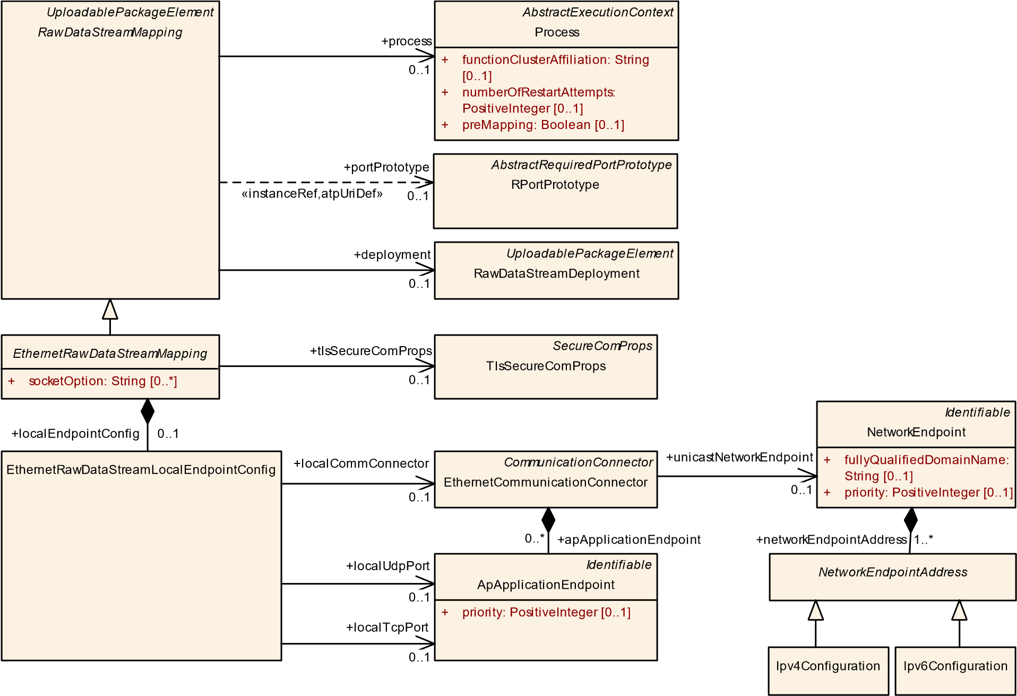

**Figure 11.4: Modeling of the EthernetRawDataStreamMapping**

Please note that the configuration of the corresponding remote end depends on the question whether the remote end represents a server (see [TPS_MANI_01356] in section 11.3.1) or a client (see [TPS_MANI_01357] in section 11.3.2).

|  |  |  |  |  |
| --- | --- | --- | --- | --- |
| ***Class*** | ***EthernetRawDataStreamMapping*** (abstract) | | | |
| ***Package*** | M2::AUTOSARTemplates::AdaptivePlatform::RawDataStreamMapping | | | |
| ***Note*** | This meta-class serves as the abstract bases class for the ability to map a PortPrototype to a Ethernet-based communication channel.  **Tags:**atp.Status=draft | | | |
| ***Base*** | *ARElement*, *ARObject*, *CollectableElement*, *Identifiable*, *MultilanguageReferrable*, *Packageable*  *Element*, *RawDataStreamMapping*, *Referrable*, *UploadablePackageElement* | | | |
| ***Subclasses*** | EthernetRawDataStreamClientMapping, EthernetRawDataStreamServerMapping | | | |
| ***Attribute*** | ***Type*** | ***Mult.*** | ***Kind*** | ***Note*** |
| localEndpoint Config | EthernetRawData  StreamLocalEndpoint  Config | 0..1 | aggr | This aggregation is used to configure the credentials of the endpoint.  **Tags:**atp.Status=draft |
| socketOption | String | * | attr | This attribute represents the ability to specify non-formal socket options that might only be valid for specific platforms. AUTOSAR does not define a standardized meaning for the possible values of this attribute.  **Tags:**atp.Status=draft |
| tlsSecureCom Props | TlsSecureComProps | 0..1 | ref | This reference provides the ability to define TLS-related properties for the enclosing SocketRawDataStream Mapping.  **Tags:**atp.Status=draft |

**Table 11.6: EthernetRawDataStreamMapping**

|  |  |  |  |  |
| --- | --- | --- | --- | --- |
| ***Class*** | **EthernetRawDataStreamLocalEndpointConfig** | | | |
| ***Package*** | M2::AUTOSARTemplates::AdaptivePlatform::RawDataStreamMapping | | | |
| ***Note*** | This meta-class has the ability to act as a wrapper for the configuration of the remote endpoint in the context of a raw data stream mapping.  **Tags:**atp.Status=draft | | | |
| ***Base*** | *ARObject* | | | |
| ***Attribute*** | ***Type*** | ***Mult.*** | ***Kind*** | ***Note*** |
| localComm Connector | EthernetCommunication  Connector | 0..1 | ref | This attribute represents the CommunicationConnector taken for socket-based data communication.  **Tags:**atp.Status=draft |
| localTcpPort | ApApplicationEndpoint | 0..1 | ref | This aggregation represents the configuration of a local TCP port number.  **Tags:**atp.Status=draft |
| localUdpPort | ApApplicationEndpoint | 0..1 | ref | This aggregation represents the configuration of a local unicast UDP port number.  **Tags:**atp.Status=draft |

**Table 11.7: EthernetRawDataStreamLocalEndpointConfig**

**[constr_10079]**{DRAFT} **Existence of EthernetRawDataStreamMapping.localTcpPort and localUdpPort** dIn the context of a EthernetRawDataStreamMapping.localCommConnector, only **one** attribute out of

* localTcpPort
* localUdpPort shall exist **at the time when the manifest is complete**.c*()*

**11.3.1 Ethernet Raw Data Stream Client Mapping**

A raw data stream client may be prepared to receive data via unicast or multicast communication, but it shall only send requests via unicast to exactly one server.

**[TPS_MANI_01356]**{DRAFT} **Definition of remote server’s Ethernet credentials** dThe definition of the **remote** server’s Ethernet credentials is done by means of attributes of meta-class EthernetRawDataStreamRemoteServerConfig:

**multicast** If multicast configuration shall be supported, then the aggregation EthernetRawDataStreamRemoteServerConfig.multicastCredentials shall exist and the attribute udpPort shall be configured.

**unicast** If unicast configuration shall be supported, then the aggregation EthernetRawDataStreamRemoteServerConfig.unicastUdpCredentials shall exist and either the attribute udpPort **or** attribute tcpPort shall be configured. c*(RS_MANI_00067)*

The mutual existence of attributes udpPort and tcpPort is also addressed by [constr_10078].

Note that it is also possible for the client to use ephemeral ports for the communication. In this case, the EthernetRawDataStreamLocalEndpointConfig.localTcpPort – by convention – would be configured to value 0.

*UploadablePackageElement*

*RawDataStreamMapping*

*EthernetRawDataStreamMapping*

socketOption: String

+

[0..*]

*UploadablePackageElement*

RawDataStreamDeployment

*Describable*

*AbstractRawDataStreamEthernetCredentials*

[0..1]

ipV4Address: Ip4AddressString

+

[0..1]

ipV6Address: Ip6AddressString

+

udpPort: PositiveInteger

+

[0..1]

RawDataStreamEthernetUdpCredentials

RawDataStreamEthernetTcpUdpCredentials

+

tcpPort: PositiveInteger

[0..1]

EthernetRawDataStreamClientMapping

*PortInterface*

*AbstractRawDataStreamInterface*

RawDataStreamClientInterface

EthernetRawDataStreamRemoteServerConfig

EthernetRawDataStreamLocalEndpointConfig

+

localEndpointConfig

0..1

+

unicastCredentials

0..1

+

remoteServerConfig

0..1

+

rawDataStreamInterface

0..1

+

multicastCredentials

0..1

deployment

+

0..1

**Figure 11.5: Modeling of the EthernetRawDataStreamClientMapping**

|  |  |  |  |  |
| --- | --- | --- | --- | --- |
| ***Class*** | **EthernetRawDataStreamClientMapping** | | | |
| ***Package*** | M2::AUTOSARTemplates::AdaptivePlatform::RawDataStreamMapping | | | |
| ***Note*** | This meta-class represents the ability to map a client PortPrototype to a Ethernet-based communication channel.  **Tags:**  atp.Status=draft  atp.recommendedPackage=RawDataStreamingMappings | | | |
| ***Base*** | *ARElement*, *ARObject*, *CollectableElement*, *EthernetRawDataStreamMapping*, *Identifiable*,  *MultilanguageReferrable*, *PackageableElement*, *RawDataStreamMapping*, *Referrable*, *Uploadable PackageElement* | | | |
| ***Attribute*** | ***Type*** | ***Mult.*** | ***Kind*** | ***Note*** |
| remoteServer Config | EthernetRawData  StreamRemoteServer  Config | 0..1 | aggr | This aggregation is used to configure the credentials of the remote server.  **Tags:**atp.Status=draft |

**Table 11.8: EthernetRawDataStreamClientMapping**

|  |  |  |  |  |
| --- | --- | --- | --- | --- |
| ***Class*** | **EthernetRawDataStreamRemoteServerConfig** | | | |
| ***Package*** | M2::AUTOSARTemplates::AdaptivePlatform::RawDataStreamMapping | | | |
| ***Note*** | This meta-class has the ability to act as a wrapper for the configuration of the remote server in the context of a raw data stream client mapping.  **Tags:**atp.Status=draft | | | |
| ***Base*** | *ARObject* | | | |
| ***Attribute*** | ***Type*** | ***Mult.*** | ***Kind*** | ***Note*** |
| multicast  Credentials | RawDataStream  EthernetUdpCredentials | 0..1 | aggr | This aggregation represents the configuration of multicast credentials for communication with a remote raw data stream server.  **Tags:**atp.Status=draft |
| unicast  Credentials | RawDataStream  EthernetTcpUdp  Credentials | 0..1 | aggr | This meta-class represents the ability to map a server PortPrototype to a Ethernet-based communication channel.  **Tags:**atp.Status=draft |

**Table 11.9: EthernetRawDataStreamRemoteServerConfig**

**11.3.2 Ethernet Raw Data Stream Server Mapping**

A raw data stream server shall *either* communicate via unicast *or* via multicast, as expressed in [constr_10086]. A switch between the two approaches depending on the evaluation of conditions at runtime, as possible in the SOME/IP communication, is not supported for raw data streams.

**[TPS_MANI_01357]**{DRAFT} **Definition of remote client’s Ethernet credentials** dThe definition of the **remote** client’s Ethernet credentials is done by means of attributes of meta-class EthernetRawDataStreamRemoteClientConfig:

**multicast** If multicast configuration shall be supported, then the aggregation EthernetRawDataStreamRemoteClientConfig.multicastCredentials shall exist and the attribute udpPort shall be configured.

**unicast** If unicast configuration shall be supported, then the aggregation EthernetRawDataStreamRemoteClientConfig.unicastUdpCredentials shall exist and attribute udpPort shall be configured.

c*(RS_MANI_00067)*

Please note that a raw data stream server does not need to configure a TCP port of the client because the information about the TCP port of the client is conveyed as part of the TCP protocol.

**[constr_10086]**{DRAFT} **Existence of unicastUdpCredentials and multicastCredentials in the context of a EthernetRawDataStreamServerMapping**dIn the context of a EthernetRawDataStreamServerMapping, only one aggregation out of

* remoteClientConfig.multicastCredentials
* remoteClientConfig.unicastUdpCredentials shall exist **at the time when the manifest is complete**.c*()*

*UploadablePackageElement*

*RawDataStreamMapping*

*EthernetRawDataStreamMapping*

socketOption: String

+

[0..*]

*UploadablePackageElement*

RawDataStreamDeployment

*PortInterface*

*AbstractRawDataStreamInterface*

RawDataStreamServerInterface

EthernetRawDataStreamServerMapping

RawDataStreamEthernetUdpCredentials

*Describable*

*AbstractRawDataStreamEthernetCredentials*

+

ipV4Address: Ip4AddressString

[0..1]

+

[0..1]

ipV6Address: Ip6AddressString

+

udpPort: PositiveInteger

[0..1]

EthernetRawDataStreamRemoteClientConfig

EthernetRawDataStreamLocalEndpointConfig

remoteClientConfig

+

0..1

multicastCredentials

+

0..1

deployment

+

0..1

rawDataStreamInterface

+

0..1

+

unicastUdpCredentials

0..1

localEndpointConfig

+

0..1

**Figure 11.6: Modeling of the EthernetRawDataStreamServerMapping**

|  |  |  |  |  |
| --- | --- | --- | --- | --- |
| ***Class*** | **EthernetRawDataStreamServerMapping** | | | |
| ***Package*** | M2::AUTOSARTemplates::AdaptivePlatform::RawDataStreamMapping | | | |
| ***Note*** | This meta-class represents the ability to map a server PortPrototype to a Ethernet-based communication channel.  **Tags:**  atp.Status=draft  atp.recommendedPackage=RawDataStreamingMappings | | | |
| ***Base*** | *ARElement*, *ARObject*, *CollectableElement*, *EthernetRawDataStreamMapping*, *Identifiable*,  *MultilanguageReferrable*, *PackageableElement*, *RawDataStreamMapping*, *Referrable*, *Uploadable PackageElement* | | | |
| ***Attribute*** | ***Type*** | ***Mult.*** | ***Kind*** | ***Note*** |

5

4

|  |  |  |  |  |
| --- | --- | --- | --- | --- |
| ***Class*** | **EthernetRawDataStreamServerMapping** | | |  |
| remoteClient Config | EthernetRawData  StreamRemoteClient  Config | 0..1 | aggr | This aggregation is used to configure the credentials of the remote client.  **Tags:**atp.Status=draft |

**Table 11.10: EthernetRawDataStreamServerMapping**

|  |  |  |  |  |
| --- | --- | --- | --- | --- |
| ***Class*** | **EthernetRawDataStreamRemoteClientConfig** | | | |
| ***Package*** | M2::AUTOSARTemplates::AdaptivePlatform::RawDataStreamMapping | | | |
| ***Note*** | This meta-class has the ability to act as a wrapper for the configuration of the remote server in the context of a raw data stream client mapping.  **Tags:**atp.Status=draft | | | |
| ***Base*** | *ARObject* | | | |
| ***Attribute*** | ***Type*** | ***Mult.*** | ***Kind*** | ***Note*** |
| multicast  Credentials | RawDataStream  EthernetUdpCredentials | 0..1 | aggr | This aggregation represents the configuration of multicast credentials for communication with a remote raw data stream client.  **Tags:**atp.Status=draft |
| unicastUdp Credentials | RawDataStream  EthernetUdpCredentials | 0..1 | aggr | This aggregation represents the configuration of a remote raw data stream client that communicates via unicast over UDP.  **Tags:**atp.Status=draft |

**Table 11.11: EthernetRawDataStreamRemoteClientConfig**

**11.3.3 Ethernet Raw Data Stream Configuration Examples**

**11.3.3.1 Preamble**

The examples discussed in this section of the document are based on the modeling of two EthernetCommunicationConnectors, one for the client (see Listing 11.1) and one for the server (see Listing 11.2)

**<ETHERNET-COMMUNICATION-CONNECTOR>**

**<SHORT-NAME>**ClientConn**</SHORT-NAME>**

**<AP-APPLICATION-ENDPOINTS>**

**<AP-APPLICATION-ENDPOINT>**

**<SHORT-NAME>**ClientUnicastAEP**</SHORT-NAME>**

**<TP-CONFIGURATION>**

**<UDP-TP>**

**<UDP-TP-PORT>**

**<PORT-NUMBER>**3333**</PORT-NUMBER>**

**</UDP-TP-PORT>**

**</UDP-TP>**

**</TP-CONFIGURATION>**

**</AP-APPLICATION-ENDPOINT>**

**<AP-APPLICATION-ENDPOINT>**

**<SHORT-NAME>**ClientMulticastAEP**</SHORT-NAME>**

**<TP-CONFIGURATION>**

**<UDP-TP>**

**<UDP-TP-PORT>**

**<PORT-NUMBER>**7654**</PORT-NUMBER>**

**</UDP-TP-PORT>**

**</UDP-TP>**

**</TP-CONFIGURATION>**

**</AP-APPLICATION-ENDPOINT>**

**</AP-APPLICATION-ENDPOINTS>**

**<UNICAST-NETWORK-ENDPOINT-REF DEST=**"NETWORK-ENDPOINT"**>**/

CommunicationClusters/Ether/VLAN1/ClientEP**</UNICAST-NETWORK-ENDPOINT-REF >**

**</ETHERNET-COMMUNICATION-CONNECTOR>**

**Listing 11.1: Definition of EthernetCommunicationConnector for the client**

**<ETHERNET-COMMUNICATION-CONNECTOR>**

**<SHORT-NAME>**ServerConn**</SHORT-NAME>**

**<AP-APPLICATION-ENDPOINTS>**

**<AP-APPLICATION-ENDPOINT>**

**<SHORT-NAME>**ServerUnicastAEP**</SHORT-NAME>**

**<TP-CONFIGURATION>**

**<UDP-TP>**

**<UDP-TP-PORT>**

**<PORT-NUMBER>**7777**</PORT-NUMBER>**

**</UDP-TP-PORT>**

**</UDP-TP>**

**</TP-CONFIGURATION>**

**</AP-APPLICATION-ENDPOINT>**

**<AP-APPLICATION-ENDPOINT>**

**<SHORT-NAME>**ServerMulticastAEP**</SHORT-NAME>**

**<TP-CONFIGURATION>**

**<UDP-TP>**

**<UDP-TP-PORT>**

**<PORT-NUMBER>**7654**</PORT-NUMBER>**

**</UDP-TP-PORT>**

**</UDP-TP>**

**</TP-CONFIGURATION>**

**</AP-APPLICATION-ENDPOINT>**

**</AP-APPLICATION-ENDPOINTS>**

**<UNICAST-NETWORK-ENDPOINT-REF DEST=**"NETWORK-ENDPOINT"**>**/

CommunicationClusters/Ether/VLAN1/ServerEP**</UNICAST-NETWORK-ENDPOINT-REF >**

**</ETHERNET-COMMUNICATION-CONNECTOR>**

**Listing 11.2: Definition of EthernetCommunicationConnector for the server**

On top of that, the definition of a EthernetPhysicalChannel is also considered, see Listing 11.3.

**<ETHERNET-PHYSICAL-CHANNEL>**

**<SHORT-NAME>**VLAN1**</SHORT-NAME>**

**<NETWORK-ENDPOINTS>**

**<NETWORK-ENDPOINT>**

**<SHORT-NAME>**ClientEP**</SHORT-NAME>**

**<NETWORK-ENDPOINT-ADDRESSES>**

**<IPV-4-CONFIGURATION>**

**<IPV-4-ADDRESS>**192.168.2.240**</IPV-4-ADDRESS> </IPV-4-CONFIGURATION> </NETWORK-ENDPOINT-ADDRESSES>**

**</NETWORK-ENDPOINT>**

**<NETWORK-ENDPOINT>**

**<SHORT-NAME>**ServerEP**</SHORT-NAME>**

**<NETWORK-ENDPOINT-ADDRESSES>**

**<IPV-4-CONFIGURATION>**

**<IPV-4-ADDRESS>**192.168.2.223**</IPV-4-ADDRESS>**

**</IPV-4-CONFIGURATION>**

**</NETWORK-ENDPOINT-ADDRESSES>**

**</NETWORK-ENDPOINT>**

**</NETWORK-ENDPOINTS>**

**</ETHERNET-PHYSICAL-CHANNEL>**

**Listing 11.3: Definition of EthernetPhysicalChannel for connection between client and server**

**11.3.3.2 Fully formalized Model Example**

A scenario where both the raw data stream client and raw data stream server are fully formalized inside an AUTOSAR model is depicted in Figure 11.7.

In the case of a fully formalized model it may be possible to derive the client configuration (that also consists of the credentials of the remote server) from the server’s model if the server model is accessible.

remoteClientConfig

remoteServerConfig

**Legend**

RawDataStreamClient

)

AUTOSAR, static ports

(

Connect()

Read()

Write()

Shutdown()

RawDataStreamServer

)

AUTOSAR

(

WaitForConnection()

Read()

Write()

Shutdown()

VLAN

Communication

Connector

Communication

Connector

local Network

Endpoint

local Network

Endpoint

EthernetRawDataStream

ClientMapping

EthernetRawDataStream

Mapping

IPV4Configuration

ipV4Address=192.168.2.223

Remote Server Credentials

udpPort=7777

ipV4Address=192.168.2.223

Multicast Credentials

multicastIpV4Address=224.224.1.2

multcastUdpPort=7654

Multicast Credentials

multicastIpV4Address=224.224.1.2

multcastUdpPort=7654

IPV4Configuration

ipV4Address=192.168.2.240

ApApplicationEndpoint

udpPort=3333

ApApplicationEndpoint

udpPort=7777

Remote Client Credentials

udpPort=3333

ipV4Address=192.168.2.240

Server Configuration

Client Configuration

**Figure 11.7: Scenario where both the raw data stream client and raw data stream server are fully formalized inside an AUTOSAR model**

The AUTOSAR meta-model foresees the specification of the server credentials in the client’s configuration by means of the aggregation EthernetRawDataStreamClientMapping.remoteServerConfig.

If multicast communication from server to client is foreseen, then the aggregation in the role EthernetRawDataStreamClientMapping.remoteServerConfig.multicastCredentials also needs to exist.

For the sake of simplicity, this example has been created to communicate the general idea of the configuration approach rather than to demonstrate a true-to-the-meta-model representation.

Please note that this example utilizes UDP communication only. If the unicast communication were based on TCP, the server’s configuration would (as mentioned in section 11.3.2) not need the client’s TCP credentials, i.e. EthernetRawDataStreamServerMapping.remoteClientConfig (the “Remote Client Credentials” in Figure 11.7) would not exist.

In a fully formalized model, the configuration of the multicast credentials shall be identical for all affected communication ends.

The simplified (the focus is on the Ethernet configuration, based on the modeling described in section 11.3.3.1) modeling of the client mapping is sketched in Listing 11.4.

**<ETHERNET-RAW-DATA-STREAM-CLIENT-MAPPING>**

**<SHORT-NAME>**ClientMap**</SHORT-NAME>**

**<LOCAL-ENDPOINT-CONFIG>**

**<LOCAL-COMM-CONNECTOR-REF DEST=**"ETHERNET-COMMUNICATION-CONNECTOR"**>**/

MachineDesigns/Mach/ClientConn**</LOCAL-COMM-CONNECTOR-REF>**

**<LOCAL-UDP-PORT-REF DEST=**"AP-APPLICATION-ENDPOINT"**>**/MachineDesigns/Mach

/ClientConn/ClientUnicastAEP**</LOCAL-UDP-PORT-REF>**

**</LOCAL-ENDPOINT-CONFIG>**

**<REMOTE-SERVER-CONFIG>**

**<MULTICAST-CREDENTIALS>**

**<IP-V-4-ADDRESS>**224.224.1.2**</IP-V-4-ADDRESS>**

**<UDP-PORT>**7654**</UDP-PORT>**

**</MULTICAST-CREDENTIALS>**

**<UNICAST-CREDENTIALS>**

**<IP-V-4-ADDRESS>**192.168.2.223**</IP-V-4-ADDRESS>**

**<UDP-PORT>**7777**</UDP-PORT>**

**</UNICAST-CREDENTIALS>**

**</REMOTE-SERVER-CONFIG>**

**</ETHERNET-RAW-DATA-STREAM-CLIENT-MAPPING>**

**Listing 11.4: Modeling of the client mapping**

The simplified (the focus is on the Ethernet configuration, based on the modeling described in section 11.3.3.1) modeling of the server mapping is sketched in Listing 11.5.

**<ETHERNET-RAW-DATA-STREAM-SERVER-MAPPING>**

**<SHORT-NAME>**ServerMap**</SHORT-NAME>**

**<LOCAL-ENDPOINT-CONFIG>**

**<LOCAL-COMM-CONNECTOR-REF DEST=**"ETHERNET-COMMUNICATION-CONNECTOR"**>**/

MachineDesigns/Mach/ServerConn**</LOCAL-COMM-CONNECTOR-REF>**

**<LOCAL-UDP-PORT-REF DEST=**"AP-APPLICATION-ENDPOINT"**>**/MachineDesigns/Mach

/ServerConn/ServerUnicastAEP**</LOCAL-UDP-PORT-REF>**

**</LOCAL-ENDPOINT-CONFIG>**

**<REMOTE-CLIENT-CONFIG>**

**<UNICAST-UDP-CREDENTIALS>**

**<IP-V-4-ADDRESS>**192.168.2.240**</IP-V-4-ADDRESS>**

**<UDP-PORT>**3333**</UDP-PORT>**

**</UNICAST-UDP-CREDENTIALS>**

**</REMOTE-CLIENT-CONFIG>**

**</ETHERNET-RAW-DATA-STREAM-SERVER-MAPPING>**

**Listing 11.5: Modeling of the server mapping**

**11.3.3.3 Only Client is formalized**

The case that **only** the client is formalized (and the server does not appear in the form of an EthernetRawDataStreamServerMapping) can be represented by a subset of the modeling described in section 11.3.3.2 as well as the model sketched in Listing 11.4.

**Legend**

RawDataStreamClient

)

(

AUTOSAR, static ports

Connect()

Read()

Write()

Shutdown()

VLAN

Communication

Connector

local Network

Endpoint

EthernetRawDataStream

ClientMapping

IPV4Configuration

ipV4Address=192.168.2.240

ApApplicationEndpoint

udpPort=3333

Server Configuration

Client Configuration

remoteServerConfig

Remote Server Credentials

udpPort=7777

ipV4Address=192.168.2.223

Multicast Credentials

multicastIpV4Address=224.224.1.2

multcastUdpPort=7654

**Figure 11.8: Scenario where only the raw data stream client is fully formalized inside an**

**AUTOSAR model**

**11.3.3.4 Only Server is formalized**

The case that **only** the server is formalized (and the client does not appear in the form of an EthernetRawDataStreamClientMapping) can be represented by a subset of the modeling described in section 11.3.3.2 as well as the model sketched in Listing 11.5.

RawDataStreamServer

(

AUTOSAR

)

WaitForConnection()

Read()

Write()

Shutdown()

VLAN

Communication

Connector

local Network

Endpoint

EthernetRawDataStream

Mapping

IPV4Configuration

ipV4Address=192.168.2.223

ApApplicationEndpoint

udpPort=7777

**Legend**

Server Configuration

Client Configuration

remoteClientConfig

Multicast Credentials

multicastIpV4Address=224.224.1.2

multcastUdpPort=7654

Remote Client Credentials

udpPort=3333

ipV4Address=192.168.2.240

**Figure 11.9: Scenario where only the raw data stream server is fully formalized inside an**

**AUTOSAR model**

# 12 Signal-based communication

## 12.1 Overview

The applications on the adaptive platform communicate with each other in a serviceoriented manner. But there is also a use case where applications on the *AUTOSAR adaptive platform* need to communicate with software-components running on the *AUTOSAR classic platform*.

If the remote ECU on the *AUTOSAR classic platform* communicates via SOME/IP in a service-oriented manner and uses the SOME/IP transformer to serialize its data, then the communication with the Machine on the *AUTOSAR adaptive platform* can be established directly without any adaptations of neither the ECU nor the Machine.

If the counterpart on the *AUTOSAR classic platform* ECU communicates using signalbased communication over, e.g., CAN or FlexRay, the translation of the signal-based content into ServiceInterfaces needs to be established. The preconditions for this use-case are defined in section 12.2.

Such a signal/service translation may happen in a Gateway that is implemented on an ECU on the *AUTOSAR classic platform*. Such a solution is out of scope of this document since it is handled using the *AUTOSAR classic platform* configuration means. This approach is defined in the System Template specification for the Classic platform [17]. It is up to the vehicle architecture design to choose whether the signal/service translation shall be implemented on a Classic platform ECU or on an Adaptive platform Machine.

Another alternative for this translation is to happen directly on the Machine on the *AUTOSAR adaptive platform* by an Application that is running in the Process, as sketched in Figure 12.1.

This Application communicates with other applications on the *AUTOSAR adaptive platform* in the service-oriented way over ara::com; but it is also able to transmit and receive ISignals as well as communicate signal-based with remote ECUs on the *AUTOSAR classic platform*.

In order to make this possible, software that conforms to the specification of the COM stack on the *AUTOSAR classic platform* needs to be executed on the Machine on the *AUTOSAR adaptive platform*.

For the configuration of this software, the System Description based on the System Template on the *AUTOSAR classic platform* is used that contains a communication matrix description with Pdus and ISignals.

This chapter introduces a modeling that creates a bridge between the service-oriented communication based on ServiceInterfaces of the *AUTOSAR adaptive platform* and the signal-based communication involving the definition of Pdus and ISignals that are used on the *AUTOSAR classic platform*.

The signal/service translation mapping, together with the *AUTOSAR classic platform* System Description, allows to configure the communication between a Machine on the *AUTOSAR adaptive platform* and an ECU on the *AUTOSAR classic platform*. Please note that in a setup like the one sketched in Figure 12.1, the *AUTOSAR classic platform* System Description would also contain a Pdu or Signal Gateway configuration between the Ethernet and the CAN network to forward the PDUs between the networks.

Process

Adaptive Application

Classic SWC

Adaptive Machine

Classic ECU

Ethernet

CAN

Gateway ECU

(

Classic AUTOSAR

)

Service oriented communication

Signal based communication

Communication Management

Signal / Service

Translation

PDU

Communication

Matrix

+

signal-service

Mapping

PDU

PDU

translated service instance

**Figure 12.1: Signal-service-translation in Application on Adaptive Machine**

The *translated service instance* is accessed from the application software using the ara::com API. The translation is designed as a network binding similar to the binding of SOME/IP. So the communication direction is

* if the signal-based payload is received by the Machine then the application software has a RPortPrototype
* if the signal-based payload is sent by the Machine then the application software has a PPortPrototype.

Another approach for the usage of signal/service translation is the interaction of a Classic AUTOSAR Instance and an Adaptive AUTOSAR Instance running on the same virtualization technology.

In such a setup, the IPC technology is able to transport ISignalIPdus between the two platform instances. It is not defined whether the IPC technology requires any Message Header (according to section 12.2.1) being part of the payload. Thus, no dedicated configuration for this Message Header (specifically the configuration of the Header ID) is required in case this information can already be derived from the protocol information of the underlying IPC technology (e.g. dedicated IPC channels for different messages).

Figure 12.2 sketches an example setup where a virtualization technology enables the transport of messages between a Classic and an Adaptive Platform instance.

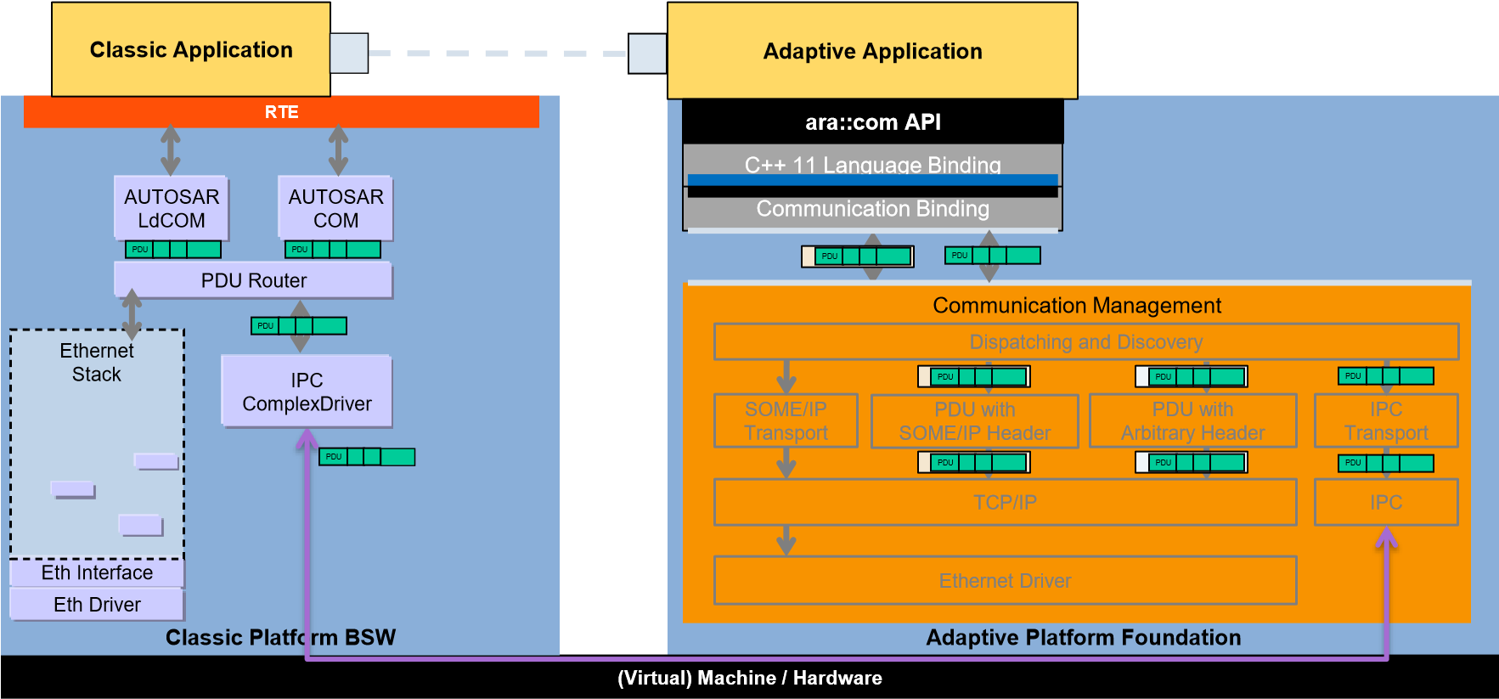

**Figure 12.2: Signal/service translation using IPC technology**

Based on the signal/service translation network binding there are several approaches for further processing the translated information (illustrated in figure 12.3):

* The application software on the *AUTOSAR adaptive platform* directly consumes/produces[2] the translated service (1)

This is the typical approach if there is only one piece of application software on the *AUTOSAR adaptive platform* interested in the translated data.

* The application software on the *AUTOSAR adaptive platform* manages and performs a functional routing (2)

This is the approach if the translated data shall be available as a service again for further processing. Here it is up to the implementation of the application software on the *AUTOSAR adaptive platform* how the translated data is routed to the secondary service, especially whether data combination and data conversion are applied.

* Pass Through Connectors: The translated service is passed through to be available to further application software on the *AUTOSAR adaptive platform*. This is the approach if there exist several further application software on the *AUTOSAR adaptive platform* which are using the translated service. In this case the translation only has be performed once. Two cases can be distinguished:
  + The translated service and the secondary service use the same ServiceInterface (3)
  + The translated service and the secondary service use different (but compatible) ServiceInterfaces (4)

Translation

Executable

Functional

(1)

Adaptive Application

R

Signal / Service

Translation

Service Interface X

-

event x

PassThrough

(4)

Composition

Service Interface X

-

event x

R

P

Pass Through

Connector

Functional

(2)

Routing Component

Service Interface Y

-

event y

R

P

Service Interface Z

-

event z

(3)

PassThrough

Composition

Service Interface Y

-

event y

R

P

Service Interface Z

-

event z

**Figure 12.3: Signal/service translation and PassThroughConnector**

The methodological approach is that out of the signal/service translation mapping descriptions it is possible to automatically generate the network binding code for the signal/service translation.

If there is a CompositionSwComponentType defined with PassThroughSwConnectors then also the AdaptiveApplicationSwComponentType implementing the pass through behavior can be generated (see section 12.7).

Please note that the configuration of such signal-based communication on an adaptive machine may be solved in two different ways:

1. The communication matrix definition (ARXML System Description) and the signal/service translation mapping is available on the target machine and is interpreted at run-time (like the manifest approach).
2. The communication matrix definition (ARXML System Description) and the signal/service translation mapping is built off-board and the application executable gets uploaded to the target Machine in response to changes in the communication matrix.

The Executable utilizing the signal/service translation and/or implementing the PassThroughSwConnectors is considered to belong to the APPLICATION_LEVEL domain as defined in [constr_1605]. This also applies to cases where the code implementing the PassThroughSwConnectors has been generated automatically by some tooling.

**[TPS_MANI_03643]**{DRAFT} **Translation-Executablecategory**dThe category value of the Executable utilizing the signal/service translation and/or implementing the PassThroughSwConnectors shall be set to APPLICATION_LEVEL.c *(RS_MANI_00063)*

The following terminology is used in the context of signal/service translation:

*Signal/service translation* defines the feature this chapter is concerned with. It does not prescribe a specific translation direction.

*Signal-service-translation* defines the translation direction from a signal-based to a service oriented representation.

*Service-signal-translation* defines the translation direction from a service oriented to a signal-based representation.

## 12.2 Signal-based prerequisites

The identification of the received and sent messages and their actual length needs to be determined for each individual Pdu. Depending on the transport technology and configuration, a Message Header might be required. If the transport technology can determine the kind of Pdu and the length out of its protocol information, then the Message Header may be omitted.

If a custom transport technology is used (e.g. IPC between a Classic Platform instance and an Adaptive Platform instance), it depends on that specific transport technology whether a Message Header and length information is required or not.

As the sole communication network currently supported is Ethernet, the Pdus have to be transported on that network.

Although there is in theory the possibility to directly put the Pdu on the Ethernet, this approach would require an individual Socket per Pdu. This is an approach where especially Classic platform ECUs do not have enough resources available to allow individual Sockets per Pdu. Nevertheless, there is also support by the signal/service translation to have no Message Header defined for Ethernet transport.

In case of Ethernet transport and the approach of several Pdus sharing a Socket, there is a need to use a dedicated Message Header per Pdu. This is illustrated in figure 12.4. The Classic Platform ECU routes the Pdus from a CAN network to the Ethernet.

PDU collection

H

Process

Adaptive Application

Classic SWC

Adaptive Machine

Classic ECU

Ethernet

CAN

Gateway ECU

)

Classic AUTOSAR

(

Service oriented communication

Signal based communication

PDU 1

PDU 3

PDU 2

PDU 3

PDU 4

PDU 4

PDU 1

PDU 2

PDU 1

PDU 2

ms

10

10

ms

10

ms

10

ms

Signal / Service

Translation

H

H

H

H

H

**Figure 12.4: Network architecture for signal-service-translation**

In order to have efficient transport of many Pdus on Ethernet additionally the SOME/IP collection mechanism may be used (i.e. definition of pduCollectionTrigger, pduCollectionSemantics, pduCollectionPduTimeout).

**12.2.1 Message Header**

In case of Ethernet transport and the approach of several Pdus sharing a Socket, the identification of the received and sent messages is done using a 64 bit wide Message Header. This Message Header is composed of a 32 bit wide Message ID and a 32 bit wide Message Length field.

**[TPS_MANI_03652]**{DRAFT} **Signal/service translation header format** dIf a Message Header is used then the message-transporting signal-based Pdus shall have a 32 bit wide Message ID field and a 32 bit wide Message Length field.c*(RS_MANI_00063)*

**[TPS_MANI_03653]**{DRAFT} **Signal/service translation header endianness** dThe header of a message-transporting signal-based Pdus shall be encoded in big endian.c *(RS_MANI_00063)*

There are three variants supported by the signal/service translation approach how the Message Header is interpreted:

**Partial SOME/IP Header** : 32 bit wide Message ID field and 32 bit wide Length field (just Message ID and Length, then signal-based payload. Message ID according to the rules of SOME/IP: ServiceId and EventId)

**Arbitrary Message Header** : 32 bit wide Message ID field and 32 bit wide

Length field (e.g. CAN-Id taken as Message Id) with signal-based payload

**No Message Header** : No standardized Message Header is defined.

In figure 12.5, the *Full SOME/IP Header* is shown for illustration purposes. In the context of signal/service translation the *Full SOME/IP Header* is not used. The *Signal-Based Header* can either be configured according to the Partial SOME/-

IP Header, the Arbitrary Message Header, or the No Message Header approach.

|  |
| --- |
| SOME/IP Message ID (Service ID / Method ID) or Arbitrary Message ID [32 bit] |
| Length [32 bit] |
| Payload [variable size] |

Full SOME/IP Header Signal-Based Header

Message ID (Service ID / Method ID) [32 bit]

Length [32 bit]

Request ID (Client ID / Session ID) [32 bit]

Protocol Version [8 bit]

Interface Version [8 bit]

Message Type [8 bit]

Return Code [8 bit]

Payload [variable size]

No Header

Payload [variable size]

**Figure 12.5: SOME/IP Message Header Format**

Which Message Header variant is used for a dedicated message is defined according to the input configuration:

**[TPS_MANI_03654]**{DRAFT} **Definition of Partial SOME/IP Header ID** dIf there is a RequiredSomeipServiceInstance of category SIGNALBASED_WITH_HEADER defined for the signal-service-translation (resp. ProvidedSomeipServiceInstance for the service-signal-translation), then the Message ID shall be interpreted according to the SOME/IP Message ID rules. Namely the Message ID is composed of the SomeipServiceInterfaceDeployment.serviceInterfaceId and the SomeipEventDeployment.eventId.c *(RS_MANI_00063)*

**[TPS_MANI_03577]**{DRAFT} **Definition of Arbitrary Message Header ID** dIf there is a RequiredUserDefinedServiceInstance of category SIGNALBASED_WITH_HEADER defined for the signal-service-translation (resp.

ProvidedUserDefinedServiceInstance for the service-signal-translation), then the Message ID shall be taken from the SocketConnectionIpduIdentifier.headerId attribute.c*(RS_MANI_00063)*

**[constr_3650]**{DRAFT}**headerId required in case of Arbitrary Message Header** dIf [TPS_MANI_03577] applies, then the respective SocketConnectionIpduIdentifier.headerId shall be defined.c*()*

There is also the possibility to define the No Message Header option:

**[TPS_MANI_03655]**{DRAFT} **Definition of No Message Header - implicit SOME/IP Message Identification** dIf there is a RequiredSomeipServiceInstance of category SIGNALBASED_NO_HEADER defined for the signal-service-translation (resp. ProvidedSomeipServiceInstance for the service-signal-translation), then no Message Header shall be used.

In this case it is either possible to derive the Message identification from the assignment to unambiguous communication channels or the Message identification is derived from protocol information of the underlying IPC technology.c*(RS_MANI_00063)*

**[TPS_MANI_03656]**{DRAFT} **Definition of No Message Header - implicit Arbitrary Message Identification** dIf there is a RequiredUserDefinedServiceInstance of category SIGNALBASED_NO_HEADER defined for the signal-service-translation (resp. ProvidedUserDefinedServiceInstance for the service-signal-translation), then no Message Header shall be used.

In this case it is either possible to derive the Message identification from the assignment to unambiguous communication channels or the Message identification is derived from protocol information of the underlying IPC technology.c*(RS_MANI_00063)*

## 12.3 Signal-based Deployment

The signal-service-translation is embedded in the SOME/IP deployment using

SomeipServiceInterfaceDeployment. The attribute SomeipEventDeployment.serializer defines whether the someip or the signalBased serialization shall be used for a specific event (see also figure 10.4).

**[TPS_MANI_03578]**{DRAFT} **Signal-based ServiceInterface binding over Ethernet**dIn case of signal-based communication over Ethernet the SomeipServiceInterfaceDeployment is used to define the Pdu transport over the network.c *(RS_MANI_00063)*

This aspect is described in section 12.2.

R

PortPrototype

ServiceInstanceToPort

PrototypeMapping

ServiceInstanceToPort

PrototypeMapping

Required

Someip

-

ServiceInstance

ID = 4

7

requiredMinorVersion = 1

ProvidedSomeip

-

ServiceInstance

ID =

11

ServiceInstanceTo

MachineMapping

ServiceInstanceTo

MachineMapping

EthernetCommunication

Connector

SomeipService

InterfaceDeployment

ServiceId

=

42

MajorVersion = 2

signalBased

SomeipService

InterfaceDeployment

ServiceId

=

42

MajorVersion = 1

MinorVersion = 0

someIpSerializer

ServiceInterface

MajorVersion=5

MinorVersion=1

PPortPrototype

**Figure 12.6: Example of 1 PPortPrototype mapped to one VLAN**

**[TPS_MANI_03579]**{DRAFT} **Signal-based ServiceEventDeployment over Ethernet** dIf the attribute SomeipEventDeployment.serializer equals signalBased then the event referenced by ServiceEventDeployment.event shall be handled using signal-service-translation.c*(RS_MANI_00063)*

Figure 12.6 illustrates a use-case where a ServiceInterface has two SomeipServiceInterfaceDeployments, one with signalBased serializer technology and one with someip.

The translation use-case is defined by having one RPortPrototype receiving the signalBased serialized messages and one PPortPrototype providing the someip serialized service.

**12.4 Signal/Service Translation Mapping**

This chapter describes the mapping of ServiceInterface elements of a specific AdaptivePlatformServiceInstance to ISignalTriggerings.

Note that according to [TPS_MANI_03555] the same Ethernet socket (via ISignal-

Triggering, PduTriggering, and SocketConnection) may be used for signalbased and service-oriented communication at the same time.

This allows to define one service instance which consists of events with different serialization technologies (i.e. someip and signalBased).

**[TPS_MANI_03627]**{DRAFT} **No signal/service translation for methods** dAs Methods and Field getter/setter are already serialized using the someip serialization there is no need for signal/service translation for them.c*(RS_MANI_00029)*

Therefore, Methods and Field getter/setter are directly accessible using ara::com via the *Signal Based Network Binding* as defined in Communication Management [8]. For passing methods through refer to section 12.7.

### **12.4.1 Direction of Signal/Service Translation Mapping**

The definition of the translation mappings has no explicitly modeled direction (has no source or target point of view). Each individual mapping (AbstractSignalBasedToISignalTriggeringMapping) takes one element from a ServiceInterface and one ISignalTriggering.

**[TPS_MANI_03635]**{DRAFT} **Determination of translation direction** dThe translation direction is determined by

* the communicationDirection of the referenced ISignalPort which is referenced by the ISignalTriggering
* the kind of service instance which is referenced from the ServiceInstanceToSignalMapping in the role serviceInstance. It can be either a ProvidedApServiceInstance or a RequiredApServiceInstance.

c*(RS_MANI_00029)*

**[constr_3636]**{DRAFT} **Consistent ISignal communication direction in and**

**RequiredApServiceInstance** dIf the ServiceInstanceToSignalMapping. serviceInstance refers to a RequiredApServiceInstance then any ServiceInstanceToSignalMapping.eventElementMapping (respectively ServiceInstanceToSignalMapping.fieldMapping) shall refer to an ISignalTriggering which in turn refers to an ISignalPort with communicationDirection equal to in.c*()*

**[constr_3637]**{DRAFT} **Consistent ISignal communication direction out and**

**ProvidedApServiceInstance** dIf the ServiceInstanceToSignalMapping. serviceInstance refers to a ProvidedApServiceInstance then any ServiceInstanceToSignalMapping.eventElementMapping (respectively ServiceInstanceToSignalMapping.fieldMapping) shall refer to an ISignalTriggering which in turn refers to an ISignalPort with communicationDirection equal to out.c*()*

|  |  |  |  |  |
| --- | --- | --- | --- | --- |
| ***Class*** | **ServiceInstanceToSignalMapping** | | | |
| ***Package*** | M2::AUTOSARTemplates::AdaptivePlatform::SignalBasedCommunication | | | |
| ***Note*** | This meta-class is defined for a specific ServiceInstance and contains the mappings of elements of a ServiceInterface for which the ServiceInstance is defined to individual ISignalTriggerings.  **Tags:**  atp.Status=draft  atp.recommendedPackage=ServiceInstanceToSignalMapping | | | |
| ***Base*** | *ARElement*, *ARObject*, *CollectableElement*, *Identifiable*, *MultilanguageReferrable*, *Packageable Element*, *Referrable* | | | |
| ***Attribute*** | ***Type*** | ***Mult.*** | ***Kind*** | ***Note*** |
| eventElement Mapping | SignalBasedEvent  ElementToISignal  TriggeringMapping | * | aggr | Mapping of an event or an element inside of the event to an ISignalTriggering.  **Tags:**atp.Status=draft |
| fieldMapping | SignalBasedFieldToI  SignalTriggering  Mapping | * | aggr | Mapping of a field to ISignalTriggerings.  **Tags:**atp.Status=draft |
| methodMapping | SignalBasedMethodToI  SignalTriggering  Mapping | 0..1 | aggr | Mapping of a method to ISignalTriggerings.  **Tags:**atp.Status=draft |
| serviceInstance | AdaptivePlatform  ServiceInstance | 0..1 | ref | Reference to a ServiceInstance from which the corresponding ServiceInterface elements will be transported in the signal-based way over a communication medium.  **Tags:**atp.Status=draft |
| triggerMapping | SignalBasedTriggerToI  SignalTriggering  Mapping | * | aggr | Mapping of a trigger to an ISignalTriggering.  **Tags:**atp.Status=draft |

**Table 12.1: ServiceInstanceToSignalMapping**

The ServiceInstanceToSignalMapping refers to an AdaptivePlatformServiceInstance and thereby defines which serviceInterfaceDeployment elements will be mapped by the aggregated eventElementMapping, methodMapping and/or fieldMapping to ISignalTriggerings. This is described in detail in the following chapters.

The ServiceInstanceToMachineMapping which refers to the AdaptivePlatformServiceInstance (which in turn is referenced by the ServiceInstanceToSignalMapping) defines on which CommunicationConnector (i.e. network / VLAN) the signal based communication shall be performed.

**[TPS_MANI_03629]**{DRAFT} **Relation of ServiceInstanceToSignalMapping and CommunicationConnector**dThe ServiceInstanceToMachineMapping referring to the AdaptivePlatformServiceInstance defines on which CommunicationConnector the AdaptivePlatformServiceInstance shall be communicated. If a ServiceInstanceToSignalMapping refers to the same AdaptivePlatformServiceInstance then the signal based communication shall be performed on the referenced CommunicationConnector.c*(RS_MANI_00029)*

*ARElement*

ServiceInstanceToSignalMapping

*AbstractSignalBasedToISignalTriggeringMapping*

SignalBasedEventElementToISignalTriggeringMapping

[0..1]

transmissionTrigger: Boolean

+

*UploadablePackageElement*

*AdaptivePlatformServiceInstance*

*UploadablePackageElement*

*ServiceInstanceToMachineMapping*

*Identifiable*

*CommunicationConnector*

[0..1]

createEcuWakeupSource: Boolean

+

pncFilterArrayMask: PositiveInteger [0..*] {ordered

}

+

EthernetCommunicationConnector

[0..1]

maximumTransmissionUnit: PositiveInteger

+

+

neighborCacheSize: PositiveInteger

[0..1]

[0..1]

pathMtuEnabled: Boolean

+

[0..1]

pathMtuTimeout: TimeValue

+

[0..1]

pncFilterDataMask: PositiveUnlimitedInteger

+

SomeipServiceInstanceToMachineMapping

+

[0..1]

udpCollectionBufferSizeThreshold: PositiveInteger

+

serviceInstance

0..1

serviceInstance

+

0..*

+

communicationConnector

0..1

eventElementMapping

+

0..*

**Figure 12.7: Relation of ServiceInstanceToSignalMapping and CommunicationConnector**

**12.4.2 SignalBasedEvent Mapping**

It is required that every event with signalBased serialization has a ServiceInstanceToSignalMapping defined.

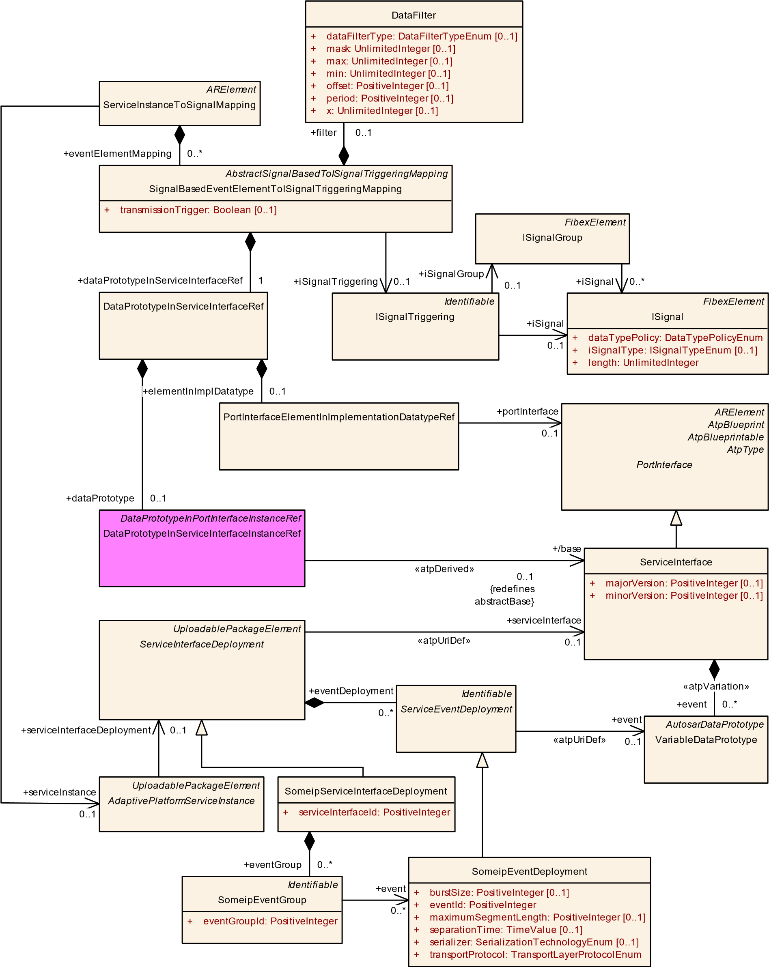

**Figure 12.8: Mapping of Event elements to ISignals**

**[constr_3550]**{DRAFT} **Existence of ServiceInstanceToSignalMapping for an event with signalBased serialization** dIf an event is referenced by a SomeipEventDeployment in the role event and the attribute SomeipEventDeployment.serializer is set to signalBased then a ServiceInstanceToSignalMapping shall exist with eventElementMapping referring to the event in the role dataPrototypeInServiceInterfaceRef.c*()*

In case of composite payload it is important that the mapping definition is complete from the target point of view:

**[constr_3551]**{DRAFT} **Full mapping of target ISignalGroup** dIf an ISignal-

Triggering is part of a ServiceInstanceToSignalMapping and the ISignalTriggering refers to an ISignalPort with communicationDirection equals out and the ISignalTriggering refers to an ISignalGroup in the role iSignalGroup then a SignalBasedEventElementToISignalTriggeringMapping shall exist for every ISignal referenced by the ISignalGroup in the role iSignal.c*()*

**[constr_3552]**{DRAFT} **Full mapping of target event**dIf the ServiceInstanceToSignalMapping refers to a ProvidedSomeipServiceInstance and the dataPrototypeInServiceInterfaceRef refers to a DataPrototype which is part of a composite data type then a SignalBasedEventElementToISignalTriggeringMapping shall exist for every DataPrototype that is part of the composite data type.c*()*

**[TPS_MANI_03124]**{DRAFT} **ServiceInterface.event to ISignalTriggering mapping** dThe SignalBasedEventElementToISignalTriggeringMapping meta-class provides the ability to map a DataPrototype defined in the context of a ServiceInterface to one ISignalTriggering of the ISignal or ISignalGroup.c*(RS_MANI_00029)*

|  |  |  |  |  |
| --- | --- | --- | --- | --- |
| ***Class*** | **SignalBasedEventElementToISignalTriggeringMapping** | | | |
| ***Package*** | M2::AUTOSARTemplates::AdaptivePlatform::SignalBasedCommunication | | | |
| ***Note*** | This meta-class defines the mapping of a ServiceInterface event or an element that is defined inside of the event in case that the datatype is composite to an ISignalTriggering.  **Tags:**atp.Status=draft | | | |
| ***Base*** | *ARObject*, *AbstractSignalBasedToISignalTriggeringMapping*, *Identifiable*, *MultilanguageReferrable*,  *Referrable* | | | |
| ***Attribute*** | ***Type*** | ***Mult.*** | ***Kind*** | ***Note*** |
| dataPrototypeIn ServiceInterface  Ref | DataPrototypeInService  InterfaceRef | 1 | aggr | Reference to a DataPrototype or to an internal structure of a DataPrototype in the context of a ServiceInterface.  **Tags:**atp.Status=draft |
| filter | DataFilter | 0..1 | aggr | Defines an optional filter to be applied during translation.  **Tags:**atp.Status=draft |
| iSignal  Triggering | ISignalTriggering | 0..1 | ref | Reference to the ISignalTriggering that is used to transport a piece of data of an event that is defined in a ServiceInterface in a signal-based way over a communication channel. **Tags:**atp.Status=draft |

5

4

|  |  |  |  |  |
| --- | --- | --- | --- | --- |
| ***Class*** | **SignalBasedEventElementToISignalTriggeringMapping** | | | |
| transmission Trigger | Boolean | 0..1 | attr | Defines whether the source element triggers the sending of the respective payload.  **Tags:**atp.Status=draft |

**Table 12.2: SignalBasedEventElementToISignalTriggeringMapping**

In the example sketched in Figure 12.9 the *TestEvent* in the *TestServiceInterface* is of type *struct1* that consists of a primitive element *a* and struct *b*. The struct *b* consists of the primitive elements *x*, *y* and *z*.

One ServiceInstanceToSignalMapping with several SignalBasedEventElementToISignalTriggeringMappings is necessary to map the *TestEvent* to the corresponding ISignalTriggerings.

One SignalBasedEventElementToISignalTriggeringMapping maps the

DataPrototype that represents the *TestEvent* to an ISignalTriggering of an

ISignalGroup. Here the dataPrototype role of DataPrototypeInServiceInterfaceRef is used to refer to the targetDataPrototype according to the rules defined in [TPS_MANI_01136] and [TPS_MANI_01137].

Additional SignalBasedEventElementToISignalTriggeringMappings are necessary to map the primitive DataPrototypes *a*, *x*, *y* and *z* to ISignalTriggerings of ISignals located in the ISignalGroup.

The example shows the mapping of *z* to the ISignalTriggering. Here the elementInImplDatatype role of DataPrototypeInServiceInterfaceRef is used to refer to the targetDataPrototype since it refers to the internal structure of an AutosarDataPrototype which is typed by a CppImplementationDataType. The context of this reference is defined by the *TestEvent* and struct *b*.

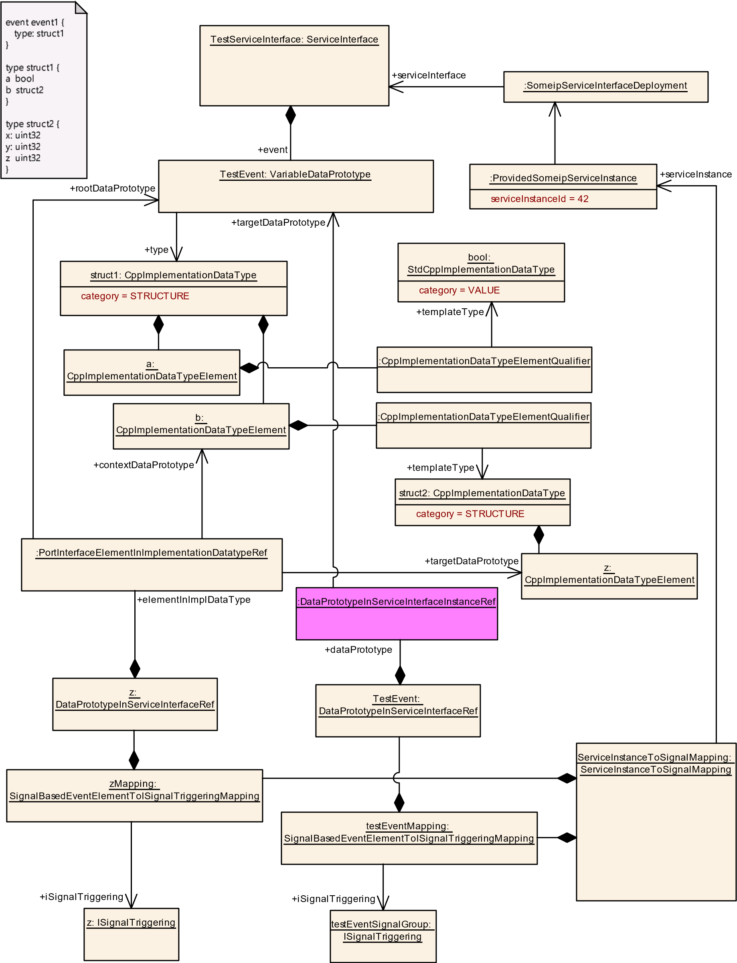

**Figure 12.9: Example for a mapping of event content to a Signal**

**12.4.3 SignalBasedTrigger Mapping**

It is required that every trigger with signalBased serialization has a ServiceInstanceToSignalMapping defined:

**[constr_5318]**{DRAFT} **Existence of ServiceInstanceToSignalMapping for an trigger with signalBased serialization** dIf a trigger is referenced by a SomeipEventDeployment in the role trigger and the attribute SomeipEventDeployment.serializer is set to signalBased then a ServiceInstanceToSignalMapping shall exist with triggerMapping referring to the trigger in the role trigger.c*()*

**[TPS_MANI_03287]**{DRAFT} **ServiceInterface.trigger to ISignalTriggering mapping** dThe SignalBasedTriggerToISignalTriggeringMapping meta-class provides the ability to map a trigger defined in the context of a ServiceInterface to one ISignalTriggering of the ISignal.c*(RS_MANI_00063)*

*FibexElement*

ISignalGroup

*FibexElement*

ISignal

+

dataTypePolicy: DataTypePolicyEnum

+

[0..1]

iSignalType: ISignalTypeEnum

length: UnlimitedInteger

+

*PortInterface*

ServiceInterface

+

[0..1]

majorVersion: PositiveInteger

minorVersion: PositiveInteger

+

[0..1]

*ARElement*

ServiceInstanceToSignalMapping

*Identifiable*

ISignalTriggering

*UploadablePackageElement*

*ServiceInterfaceDeployment*

*UploadablePackageElement*

*AdaptivePlatformServiceInstance*

SomeipServiceInterfaceDeployment

+

serviceInterfaceId: PositiveInteger

*AbstractSignalBasedToISignalTriggeringMapping*

SignalBasedTriggerToISignalTriggeringMapping

*AtpStructureElement*

*Identifiable*

Trigger

+

trigger

0..1

«atpUriDef»

serviceInterface

+

0..1

+

iSignal

0..1

triggerMapping

+

0..*

+

serviceInstance

0..1

«atpVariation»

trigger

+

0..*

+

serviceInterfaceDeployment

0..1

+

iSignal

0..*

iSignalGroup

+

0..1

iSignalTriggering

+

0..1

**Figure 12.10: Mapping of a Trigger to an ISignal**

Please note that [constr_1198] and [constr_1199] that are defined in the System Template specification [17] apply for the ISignal to which the trigger is mapped via the ISignalTriggering by the SignalBasedTriggerToISignalTriggeringMapping. This means that the length of the ISignal shall be 0 and an update bit shall be defined for the ISignal in case that no DataTransformation is used.

|  |  |  |  |  |
| --- | --- | --- | --- | --- |
| ***Class*** | **SignalBasedTriggerToISignalTriggeringMapping** | | | |
| ***Package*** | M2::AUTOSARTemplates::AdaptivePlatform::SignalBasedCommunication | | | |
| ***Note*** | This meta-class defines the mapping of a ServiceInterface trigger to an ISignalTriggering.  **Tags:**atp.Status=draft | | | |
| ***Base*** | *ARObject*, *AbstractSignalBasedToISignalTriggeringMapping*, *Identifiable*, *MultilanguageReferrable*,  *Referrable* | | | |
| ***Attribute*** | ***Type*** | ***Mult.*** | ***Kind*** | ***Note*** |
| iSignal  Triggering | ISignalTriggering | 0..1 | ref | Reference to the ISignalTriggering that is used to transport the trigger that is defined in a ServiceInterface in a signal-based way over a communication channel.  **Tags:**atp.Status=draft |
| trigger | Trigger | 0..1 | ref | Reference to a trigger defined in the context of a Service  Interface.  **Tags:**atp.Status=draft |

**Table 12.3: SignalBasedTriggerToISignalTriggeringMapping**

**12.4.4 SignalBasedField Mapping**

**[TPS_MANI_03126]**{DRAFT} **ServiceInterface.field mapping to ISignalTriggerings** dThe SignalBasedFieldToISignalTriggeringMapping metaclass provides the ability to map a field

* to one ISignalTriggering for the ISignalGroup representing the Notifier or
* to one ISignalTriggering for the ISignal representing the primitive Notifier element or
* to one ISignalTriggering for the ISignal representing the Getter-Call and one ISignalTriggering for the ISignal representing the Getter-Return or
* to one ISignalTriggering for the ISignal representing the Setter-Call and one ISignalTriggering for the ISignal representing the Setter-Return. c*(RS_MANI_00029)*

It means that several SignalBasedFieldToISignalTriggeringMappings may be necessary to map a field to the corresponding ISignalTriggerings.

It is required that every field using a SomeipFieldDeployment.notifier with signalBased serialization has a ServiceInstanceToSignalMapping defined: **[constr_3553]**{DRAFT} **Existence of ServiceInstanceToSignalMapping for an field with signalBased serialization** dIf a field is referenced by a SomeipFieldDeployment in the role field and that SomeipFieldDeployment aggregates a SomeipEventDeployment in the role notifier and the SomeipEventDeployment has an attribute SomeipEventDeployment.serializer set to signalBased then there shall exist a ServiceInstanceToSignalMapping with a fieldMapping referring to the field in the role dataPrototypeInServiceInterfaceRef and the SignalBasedFieldToISignalTriggeringMapping shall refer to a ISignalTriggering in the role notifierSignalTriggering.c*()*

In the example sketched in Figure 12.12 the *testField* in the *testServiceInterface* is of type *struct1* that consists of the primitive elements *a* and *b*. The *testField* defines a notifier and a setter method.

|  |  |  |  |  |
| --- | --- | --- | --- | --- |
| ***Class*** | **SignalBasedFieldToISignalTriggeringMapping** | | | |
| ***Package*** | M2::AUTOSARTemplates::AdaptivePlatform::SignalBasedCommunication | | | |
| ***Note*** | This meta-class defines the mapping of a ServiceInterface field to ISignalTriggerings that represent the notifier elements, the getter call and response, the setter call and response on a signal-based communication channel.  .  **Tags:**atp.Status=draft | | | |
| ***Base*** | *ARObject*, *AbstractSignalBasedToISignalTriggeringMapping*, *Identifiable*, *MultilanguageReferrable*,  *Referrable* | | | |
| ***Attribute*** | ***Type*** | ***Mult.*** | ***Kind*** | ***Note*** |
| dataPrototypeIn ServiceInterface  Ref | DataPrototypeInService  InterfaceRef | 1 | aggr | Reference to a DataPrototype or to an internal structure of a DataPrototype in the context of a ServiceInterface.  **Tags:**atp.Status=draft |
| filter | DataFilter | 0..1 | aggr | Defines an optional filter to be applied during translation.  **Tags:**atp.Status=draft |
| getterCallSignal | ISignalTriggering | 0..1 | ref | Reference to the ISignalTriggering that is used to transport the getter method call in a signal-based way over a communication channel.  **Tags:**atp.Status=draft |
| getterReturn Signal | ISignalTriggering | 0..1 | ref | Reference to the ISignalTriggering that is used to transport the getter method response in a signal-based way over a communication channel.  **Tags:**atp.Status=draft |
| notifierSignal Triggering | ISignalTriggering | 0..1 | ref | Reference to the ISignalTriggering that is used to transport a piece of data of a notifier in a signal-based way over a communication channel.  **Tags:**atp.Status=draft |
| setterCallSignal | ISignalTriggering | 0..1 | ref | Reference to the ISignalTriggering that is used to transport the setter method call in a signal-based way over a communication channel.  **Tags:**atp.Status=draft |
| setterReturn Signal | ISignalTriggering | 0..1 | ref | Reference to the ISignalTriggering that is used to transport the setter method response in a signal-based way over a communication channel.  **Tags:**atp.Status=draft |

5

4

|  |  |  |  |  |
| --- | --- | --- | --- | --- |
| ***Class*** | **SignalBasedFieldToISignalTriggeringMapping** | | | |
| transmission Trigger | Boolean | 0..1 | attr | Defines whether the source notifier element triggers the sending of the respective payload.  **Tags:**atp.Status=draft |

**Table 12.4: SignalBasedFieldToISignalTriggeringMapping**

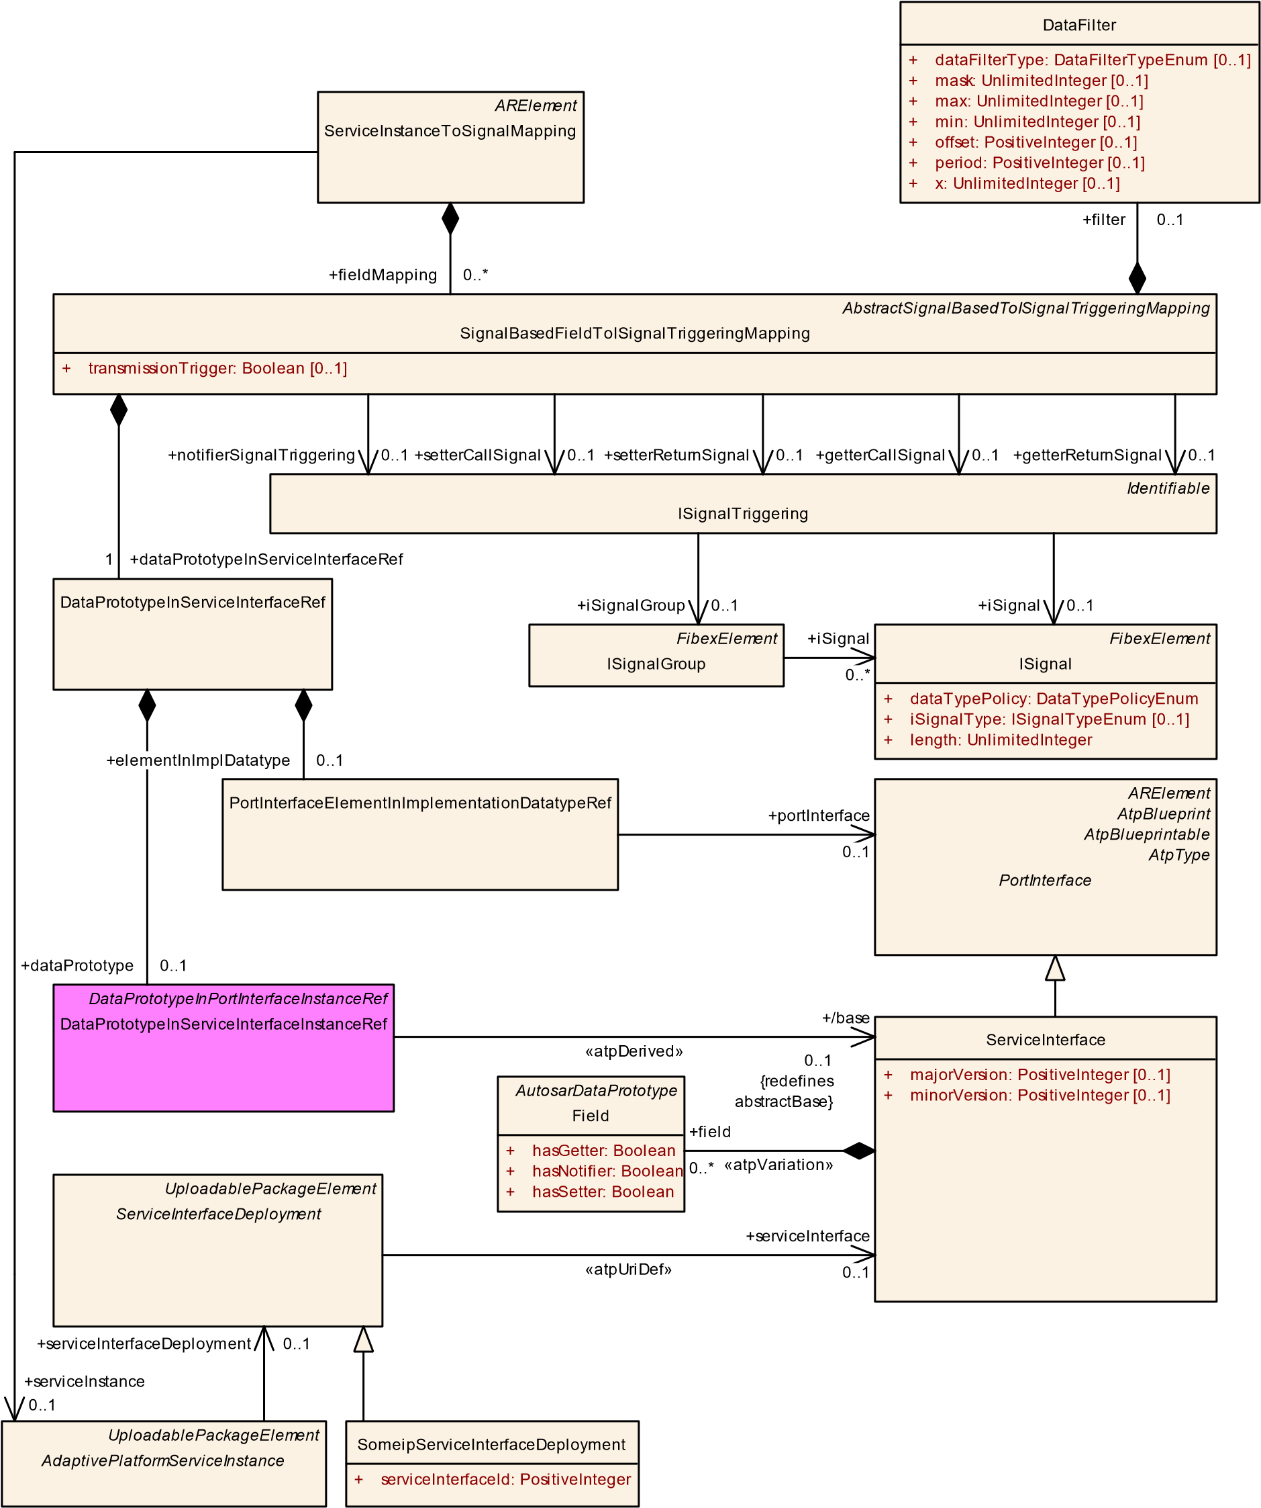

**Figure 12.11: Mapping of Fields to ISignals**

One SignalBasedFieldToISignalTriggeringMapping maps the *TestField* to ISignalTriggerings for the Setter-Call and Setter-Return. Here the dataPrototype role of DataPrototypeInServiceInterfaceRef is used to refer to the targetDataPrototype (field) according to the rules defined in [TPS_MANI_01136] and [TPS_MANI_01137].

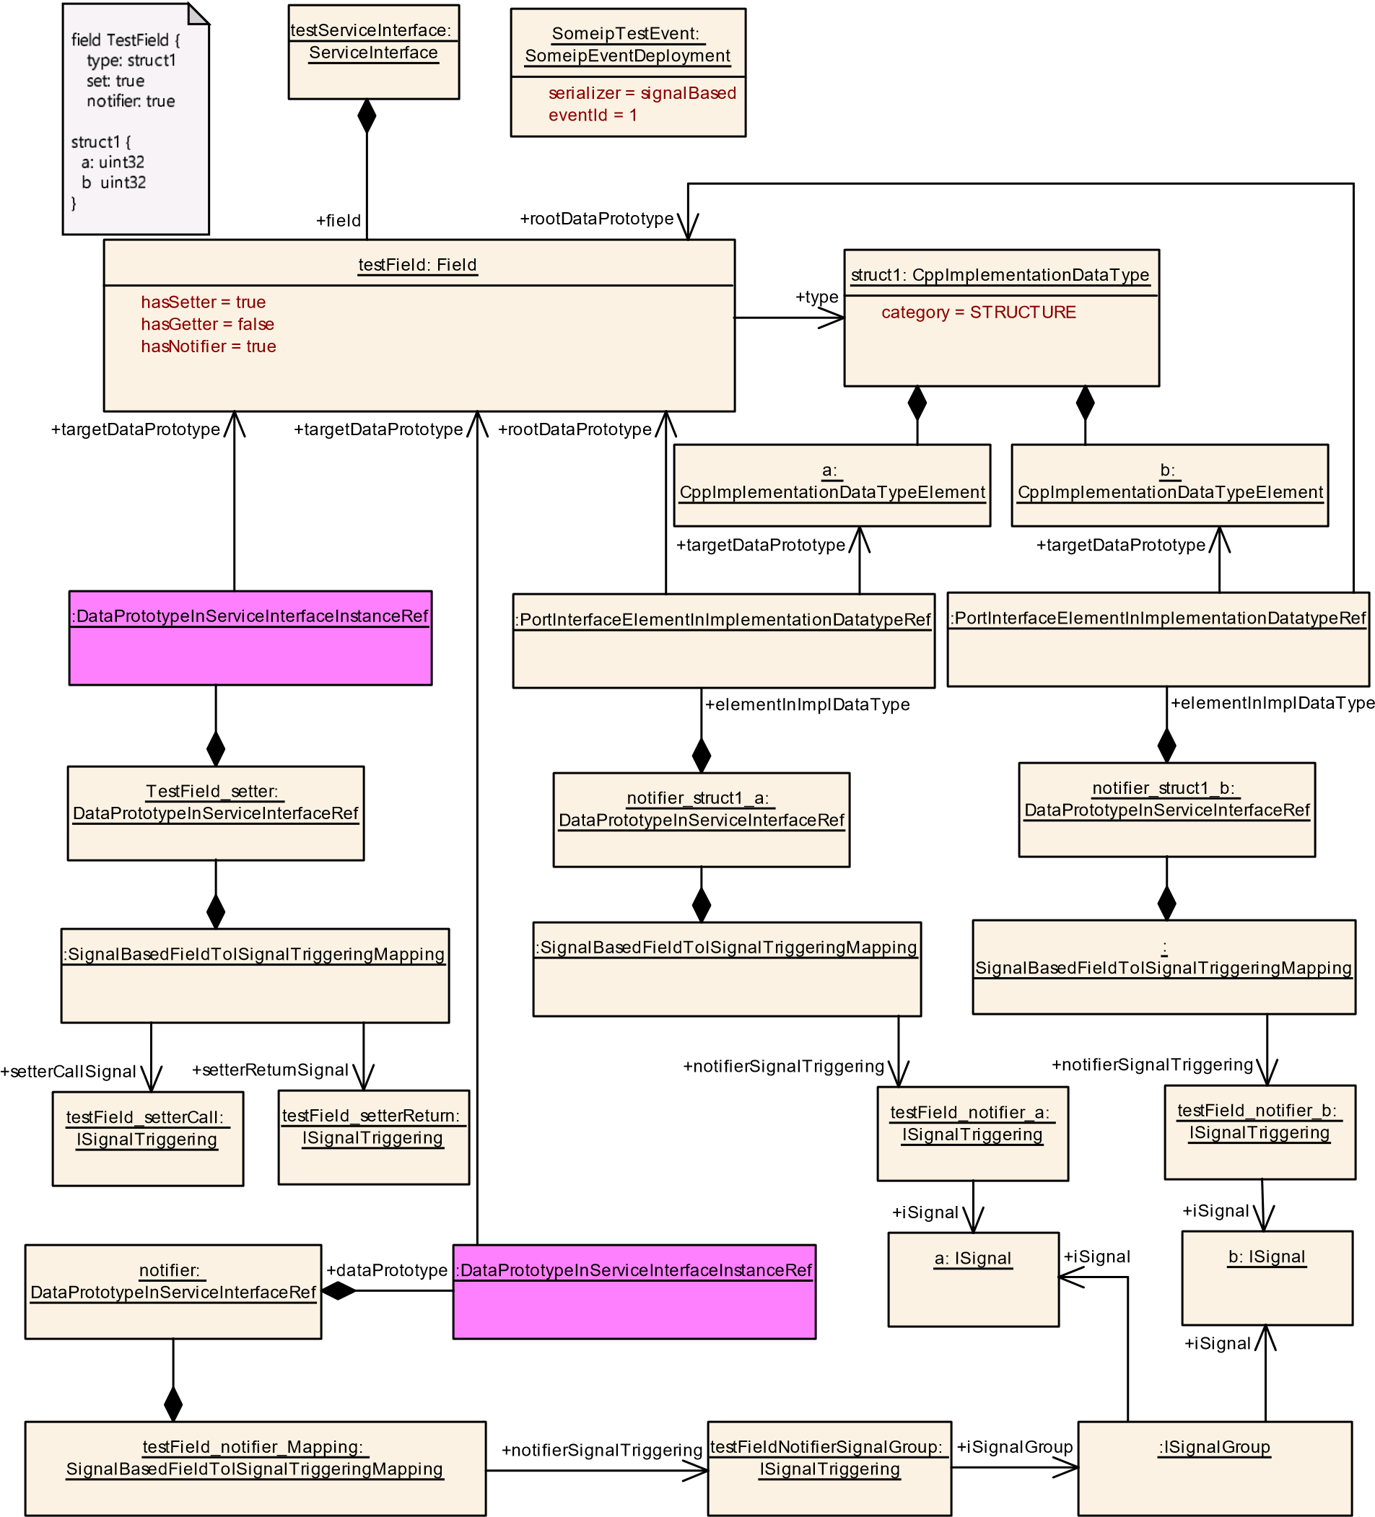

**Figure 12.12: Example for a mapping of a field to Signals**

Additional SignalBasedFieldToISignalTriggeringMappings are necessary to map the field notifier to the corresponding ISignalTriggerings. One SignalBasedFieldToISignalTriggeringMapping maps the *TestField* to the ISignalTriggering of the ISignalGroup that collects all ISignals that transport the content of the notifier.

The primitive DataPrototypes *a* and *b* are mapped by additional SignalBasedFieldToISignalTriggeringMappings to ISignalTriggerings of ISignals located in the ISignalGroup.

Here, the elementInImplDatatype role of DataPrototypeInServiceInterfaceRef is used to refer to the targetDataPrototype since it refers to the internal structure of an AutosarDataPrototype which is typed by a CppImplementationDataType. The context of this reference is defined by the *testField*.

**12.4.5 SignalBasedMethod Mapping**

**[TPS_MANI_03125]**{DRAFT} **ServiceInterface.method to ISignalTriggerings mapping** dThe SignalBasedMethodToISignalTriggeringMapping metaclass provides the ability to map a method to one ISignalTriggering for the ISignal representing the Method-Call and one ISignalTriggering for the ISignal representing the Method-Return.c*(RS_MANI_00029)*

|  |  |  |  |  |
| --- | --- | --- | --- | --- |
| ***Class*** | **SignalBasedMethodToISignalTriggeringMapping** | | | |
| ***Package*** | M2::AUTOSARTemplates::AdaptivePlatform::SignalBasedCommunication | | | |
| ***Note*** | This meta-class defines the mapping of a ServiceInterface method to a ISignalTriggering.  **Tags:**atp.Status=draft | | | |
| ***Base*** | *ARObject*, *AbstractSignalBasedToISignalTriggeringMapping*, *Identifiable*, *MultilanguageReferrable*,  *Referrable* | | | |
| ***Attribute*** | ***Type*** | ***Mult.*** | ***Kind*** | ***Note*** |
| callSignal Triggering | ISignalTriggering | 0..1 | ref | Reference to the ISignalTriggering that is used to transport the method call in a signal-based way over a communication channel. **Tags:**atp.Status=draft |
| method | ClientServerOperation | 1 | ref | Reference to a method defined in the context of a Service  Interface.  **Tags:**atp.Status=draft |
| returnSignal Triggering | ISignalTriggering | 0..1 | ref | Reference to the ISignalTriggering that is used to transport the method response in a signal-based way over a communication channel.  **Tags:**atp.Status=draft |

**Table 12.5: SignalBasedMethodToISignalTriggeringMapping**

Please note that the SignalBasedMethodToISignalTriggeringMapping shall also be used for the mapping of methods where the value of attribute method.fireAndForget is set to true. In this case, only the callSignalTriggering shall be used since in the fire and forget Message Exchange Pattern only one message is sent from the service consumer to the service provider.

*ARElement*

ServiceInstanceToSignalMapping

*Identifiable*

ISignalTriggering

*FibexElement*

ISignal

dataTypePolicy: DataTypePolicyEnum

+

iSignalType: ISignalTypeEnum

[0..1]

+

+

length: UnlimitedInteger

*PortInterface*

ServiceInterface

majorVersion: PositiveInteger

[0..1]

+

[0..1]

+

minorVersion: PositiveInteger

*UploadablePackageElement*

*ServiceInterfaceDeployment*

*UploadablePackageElement*

*AdaptivePlatformServiceInstance*

*AbstractSignalBasedToISignalTriggeringMapping*

SignalBasedMethodToISignalTriggeringMapping

*AtpStructureElement*

*Identifiable*

ClientServerOperation

fireAndForget: Boolean

[0..1]

+

SomeipServiceInterfaceDeployment

+

serviceInterfaceId: PositiveInteger

method

+

1

serviceInterfaceDeployment

+

0..1

+

callSignalTriggering

0..1

+

serviceInstance

0..1

returnSignalTriggering

+

0..1

+

methodMapping

0..1

«atpUriDef»

+

serviceInterface

0..1

iSignal

+

0..1

«atpVariation»

+

method

0..*

**Figure 12.13: Mapping of Methods to ISignals**

In the example sketched in Figure 12.14 the *Calibrate* method in the *TestServiceInterface2* is mapped with a single SignalBasedMethodToISignalTriggeringMapping to ISignalTriggerings for the Call and Return.

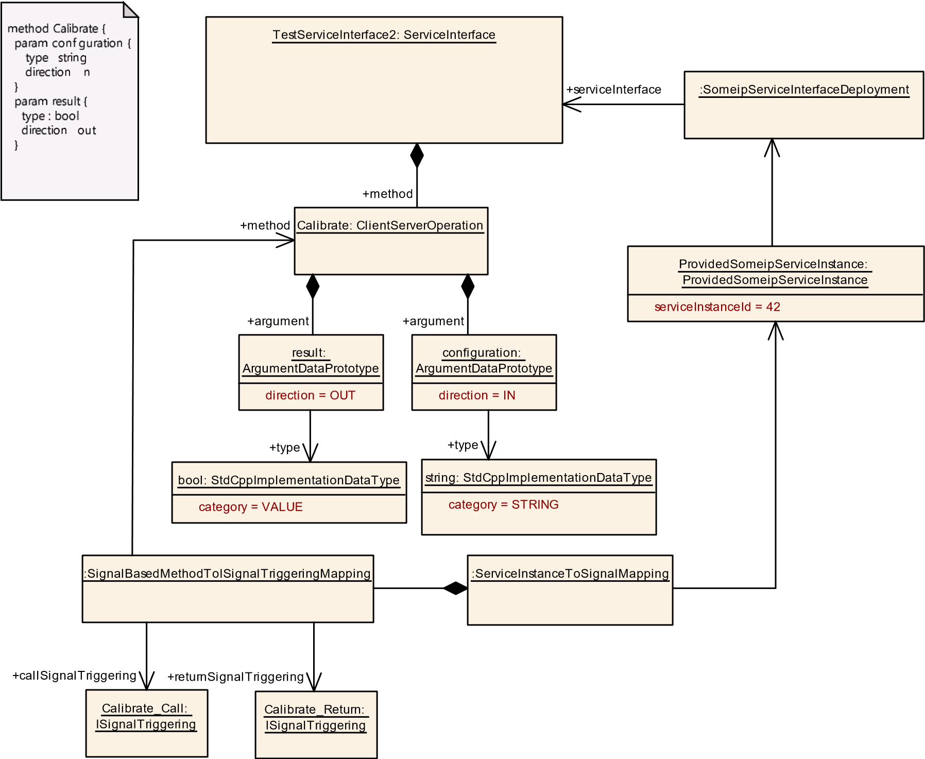

**Figure 12.14: Example for a mapping of a method to Signals**

## 12.5 Service Discovery and Static Communication Configuration

Although the ISignalIPdus, which are candidate for signal/service translation, may be communicated to/from CAN or FlexRay networks (where there is no service discovery support available) the messages still might be candidate for service discovery and event subscription on the Ethernet network. In such cases the gateway ECU connecting the Can/FlexRay networks to the Ethernet network is responsible to provide service discovery and event subscription support as part of the gateway operation.

Only SOME/IP services support service discovery configuration. Whether or not service discovery shall be done in case of the Partial SOME/IP Header approach is defined by the category of the RequiredSomeipServiceInstance or ProvidedSomeipServiceInstance. If no SOME/IP is used the possibility to define a static configuration is described in section 12.5.4.

**[TPS_MANI_03657]**{DRAFT} **Signal-service-translation SOME/IP Service Discovery Find** dIf there is a RequiredSomeipServiceInstance of categorySIGNALBASED_WITH_HEADER defined for the signal-service-translation, then this RequiredSomeipServiceInstance shall be handled using SOME/IP service discovery.c*(RS_MANI_00063)*

**[TPS_MANI_03658]**{DRAFT} **Service-signal-translation SOME/IP Service Discovery Offer** dIf there is a ProvidedSomeipServiceInstance of categorySIGNALBASED_WITH_HEADER defined for the service-signal-translation, then this ProvidedSomeipServiceInstance shall be handled using SOME/IP service discovery.c*(RS_MANI_00063)*

**[TPS_MANI_03659]**{DRAFT} **No signal-service-translation SOME/IP Service Discovery Find** dIf there is a RequiredSomeipServiceInstance of categorySIGNALBASED_NO_HEADER defined for the signal-service-translation, then this RequiredSomeipServiceInstance shall not be handled using SOME/IP service discovery.

This case is currently not supported as there is no support for static configuration of SOME/IP based communication.c*(RS_MANI_00063)*

**[TPS_MANI_03660]**{DRAFT} **No signal-service-translation SOME/IP Service Discovery Offer** dIf there is a ProvidedSomeipServiceInstance of categorySIGNALBASED_NO_HEADER defined for the service-signal-translation, then this ProvidedSomeipServiceInstance shall not be handled using SOME/IP service discovery.

This case is currently not supported as there is no support for static configuration of SOME/IP based communication.c*(RS_MANI_00063)*

**12.5.1 Service discovery control**

The signal/service translation needs to determine when the translated service (service which originates in signal-based messages) shall actually be offered/subscribed.

*Identifiable*

SignalServiceTranslationProps

:

serviceControl

+

SignalServiceTranslationControlEnum

«enumeration»

SignalServiceTranslationControlEnum

translationStart

serviceDiscovery

*Identifiable*

*AbstractSignalBasedToISignalTriggeringMapping*

*ARElement*

SignalServiceTranslationPropsSet

*Identifiable*

SignalServiceTranslationEventProps

+

safeTranslation: Boolean

+

secureTranslation: Boolean

+

signalServiceTranslationProps

0..*

+

serviceElementMapping

0..*

signalServiceTranslationEventProps

+

0..*

### **Figure 12.15: Signal/service translation properties**

Attributes defining the behavior of signal/service translation are available at the SignalServiceTranslationProps. The reference serviceElementMapping determines to which service instance these settings apply.

|  |  |  |  |  |
| --- | --- | --- | --- | --- |
| ***Class*** | **SignalServiceTranslationPropsSet** | | | |
| ***Package*** | M2::AUTOSARTemplates::CommonStructure::SignalServiceTranslation | | | |
| ***Note*** | Collection of SignalServiceTranslationProps.  **Tags:**atp.recommendedPackage=SignalServiceTranslationProps | | | |
| ***Base*** | *ARElement*, *ARObject*, *CollectableElement*, *Identifiable*, *MultilanguageReferrable*, *Packageable Element*, *Referrable* | | | |
| ***Attribute*** | ***Type*** | ***Mult.*** | ***Kind*** | ***Note*** |
| signalService  Translation  Props | SignalService  TranslationProps | * | aggr | Collection of SignalServiceTranslationProps. |

**Table 12.6: SignalServiceTranslationPropsSet**

|  |  |  |  |  |
| --- | --- | --- | --- | --- |
| ***Class*** | **SignalServiceTranslationProps** | | | |
| ***Package*** | M2::AUTOSARTemplates::CommonStructure::SignalServiceTranslation | | | |
| ***Note*** | This element allows to define the properties which are applicable for the signal/service translation service. | | | |
| ***Base*** | *ARObject*, *Identifiable*, *MultilanguageReferrable*, *Referrable* | | | |
| ***Attribute*** | ***Type*** | ***Mult.*** | ***Kind*** | ***Note*** |
| serviceControl | SignalService  TranslationControlEnum | 1 | attr | Defines how the service instance control shall behave. |
| signalService Translation  EventProps | SignalService  TranslationEventProps | * | aggr | Defines properties for a single translated event. |

**Table 12.7: SignalServiceTranslationProps**

|  |  |  |  |  |
| --- | --- | --- | --- | --- |
| ***Class*** | **SignalServiceTranslationEventProps** | | | |
| ***Package*** | M2::AUTOSARTemplates::CommonStructure::SignalServiceTranslation | | | |
| ***Note*** | This element allows to define the properties which are applicable for the signal/service translation event. | | | |
| ***Base*** | *ARObject*, *Identifiable*, *MultilanguageReferrable*, *Referrable* | | | |
| ***Attribute*** | ***Type*** | ***Mult.*** | ***Kind*** | ***Note*** |
| safeTranslation | Boolean | 1 | attr | Defined whether the translation shall happen in a safe way. |
| secure  Translation | Boolean | 1 | attr | Defined whether the translation shall happen in a secure way. |
| serviceElement Mapping | AbstractSignalBasedToI  SignalTriggering  Mapping | * | ref | Reference to the collection of SignalBased to ISignal Triggerung mappings the properties apply to.  **Tags:**atp.Status=draft |

**Table 12.8: SignalServiceTranslationEventProps**

At which point in time a specific service instance (originating from signal/service translation) is actually offered / subscribed at the service discovery can be defined per service instance:

Possible approaches for service availability/subscription are:

* translationStart - right after translation software is started
* serviceDiscovery - availability of related service instance

The attribute SignalServiceTranslationProps.serviceControl defines the service instance control behavior.

|  |  |
| --- | --- |
| ***Enumeration*** | **SignalServiceTranslationControlEnum** |
| ***Package*** | M2::AUTOSARTemplates::CommonStructure::SignalServiceTranslation |
| ***Note*** | This enumeration allows to define how the service instance offer/subscribe control shall behave. |
| ***Literal*** | ***Description*** |
| serviceDiscovery | Defines the start of service control when other service is available.  **Tags:**atp.EnumerationLiteralIndex=2 |
| translationStart | Defines the start of service control at translation start.  **Tags:**atp.EnumerationLiteralIndex=0 |

**Table 12.9: SignalServiceTranslationControlEnum**

**12.5.2 Service control right after translation start**

If the availability of the signal-based PDUs is not controlled then the respective translated services offers/subscriptions may be activated immediately at start of the translation software.

**[TPS_MANI_03580]**{DRAFT} **Service offer at startup** dFor a provided translated service instance, if the SignalServiceTranslationProps.serviceControl equals translationStart then the translation software shall - right after translation software start - *offer* the respective translated service instance.c*(RS_MANI_00063)*

**[TPS_MANI_03581]**{DRAFT} **Service find at startup** dFor a required translated service instance, if the SignalServiceTranslationProps.serviceControl equals translationStart then the translation shall right after translation software start issue the *find* of the respective translated service instance and *subscribe* to its event groups.c*(RS_MANI_00063)*

**12.5.3 Service control due to availability of related service instance**

There are scenarios where the signal-based PDUs are actually controlled using SOME/IP Service Discovery. So there are services defined using events/methods/fields and the service instances are offered / subscribed using the SOME/IP Service Discovery, just the payload of such services is not serialized according to the SOME/IP transformer rules (or a subset of events uses signal-based serialization). Therefore, a signal/service translation is required for the payload.

### **12.5.3.1 Signal-service-translation**

**[TPS_MANI_03582]**{DRAFT} **Service find for required signal** dFor a required translated service instance, if the SignalServiceTranslationProps.serviceControl equals serviceDiscovery then upon startup the translation software component shall issue a *service find* for the RequiredSomeipServiceInstance which is referenced by the ServiceInstanceToSignalMapping in the role serviceInstance.c*(RS_MANI_00063)*

**[TPS_MANI_03583]**{DRAFT} **Service subscribe for required signal** dFor a required translated service instance, if the SignalServiceTranslationProps.serviceControl equals serviceDiscovery and the *service find* of [TPS_MANI_03582] was successful then the translation software component shall issue a *subscribe* to all SomeipServiceInterfaceDeployment.eventGroups.c*(RS_MANI_00063)*

### **12.5.3.2 Service-signal-translation**

**[TPS_MANI_03606]**{DRAFT} **Service offer for provided signal** dFor a provided translated service instance, if the SignalServiceTranslationProps.serviceControl equals serviceDiscovery then upon startup the translation software component shall issue an *offer* for the ProvidedSomeipServiceInstance which is referenced by the ServiceInstanceToSignalMapping in the role serviceInstance.c*(RS_MANI_00063)*

**12.5.4 Static Communication Configuration**

In case no service discovery shall be applied, it is possible to define a static configuration for non SOME/IP communication. The actual representation of the required information is not standardized, thus the information can be provided using the model extension mechanism, as exemplified in appendix B.

**12.5.4.1 Static Communication Configuration for the Server**

If a ProvidedUserDefinedServiceInstance shall be statically configured for communication on Ethernet, then several elements need to be defined:

* localUdpPortNumber: a port number for the local UPD port needs to be defined on which the service will be provided using UDP protocol.
* localTcpPortNumber: a port number for the local TCP port needs to be defined on which the service will be provided using TCP protocol.
* UserDefinedServiceInstanceToMachineMapping: a mapping needs to be defined (for the local connection where the service will be provided) that associates the ProvidedUserDefinedServiceInstance to an EthernetCommunicationConnector (VLAN).
* remotePeers: a list of remote IP-Address and Port combinations needs to be defined where the messages will be sent to. A mix of unicast and multicast IPAddresses is supported.
* udpCollectionBufferTimeout: Maximum time, an outgoing message may be delayed, due to data collection.
* udpCollectionTrigger: Defines whether the element contributes to the triggering of the UDP data transmission if data collection is enabled.
* udpCollectionBufferSizeThreshold: Specifies the amount of data in bytes that shall be buffered for data transmission over the UDP connection in case data collection is enabled.

**12.5.4.2 Static Communication Configuration for the Client**

If a RequiredUserDefinedServiceInstance shall be statically configured for communication on Ethernet, then several elements need to be defined:

* localUdpPortNumber: a port number for the local UPD port needs to be defined on which the service will be consumed using UDP protocol.
* localTcpPortNumber: a port number for the local TCP port needs to be defined on which the service will be consumed using TCP protocol.
* UserDefinedServiceInstanceToMachineMapping: a mapping needs to be defined (for the local connection where the service will be consumed) that associates the RequiredUserDefinedServiceInstance to an EthernetCommunicationConnector (VLAN).
* eventMulticastUdpPort: a port number for the local UDP port in case of multicast reception may be defined.
* multicastIpAddress: an IP-Address where the events will be consumed in case of multicast reception.
* remotePeer: an IP-Address and Port combination needs to be defined for the remote provider of the service.

## 12.6 Translation behavior

The signal/service translation is defined as a network binding for the Communication Management [8] and it is not specified at which exact point in time or in which context the data transformation (i.e. signal-service-translation or service-signal-translation) will be executed.

The behavior of signal-service-translation is governed by the application software which calls ara::com-APIs to interact with the communication management.

**12.6.1 ServiceInterface representation of translation data**

Due to update-bits (see section 12.6.2) and data filtering (see section 12.6.3), the ServiceInterface – which is used to represent the signal/service translated information – needs to be able to represent partially available information. For such cases, the AUTOSAR data type systems has defined the isOptional feature of structured data (see also the Software Component Template [1] for details).

For ApplicationDataTypes, the optionality is configured at the ApplicationRecordElement.isOptional attribute.

For CppImplementationDataTypes, the optionality is configured at the CppImplementationDataTypeElement.isOptional attribute.

The goal of the signal/service translation mapping is to define the proper ServiceInterface representation for the corresponding ISignalIPdu, respecting update bits and filtering.

**12.6.1.1 Optional elements in case signal-service-translation**

The approach for the signal-service-translation direction is: if a received ISignal or ISignalGroup has an update-bit defined (see section 12.6.2) or the reception is guarded by a reception-filter (see section 12.6.3), then the corresponding element in the ServiceInterface event shall be defined as ApplicationRecordElement.isOptional (resp. CppImplementationDataTypeElement. isOptional).

Figure 12.16 illustrates the usage of update-bits in the source ISignalIPdu as the cause for the definition of isOptional members of the event.

The left part of figure 12.16 shows that the *signal group x1*, *signal y*, and *signal z* have update-bits defined and thus the resulting event definition for the ServiceInterface needs to respect this. In this example the event *xyz* is defined as an ApplicationRecordDataType containing 3 ApplicationRecordElements where each element has the attribute isOptional set to true.

The right part of figure 12.16 takes one specific ISignalIPdu instance with only the *updateBit_y* set to 1, thus only the *signal y* shall be considered as updated. Therefore the resulting event notification contains an event *xyz* where only the member *y* is defined. The other two members of *xyz* are not set in this example.

event xyz {

signal group x1 {

a : 3

b : 45

c : true

d : -23

}

signal y : 12

signal z : 65

updateBit_x1 = 0

updateBit_y= 1

updateBit_z= 0

event xyz {

y : 12

}

signal group x1 { x1 [optional] { a : uint8 a : uint8 b : uint16 b : uint16 c : boolean c : boolean d : sint8 d : sint8

} }

signal y : uint8 y [optional] : uint8

signal z : sint16 z [optional] : sint16

}

updateBit_x1 updateBit_y updateBit_z

**Figure 12.16: Example of update-bits for signal-service-translation**

**12.6.1.2 Optional elements in case service-signal-translation**

The approach for the service-signal-translation direction is: if the ServiceInterface event has a member with CppImplementationDataTypeElement. isOptional, then the corresponding ISignal or ISignalGroup shall have an update-bit defined. During runtime, it will be checked which optional elements are actually defined in the event / field and the corresponding values are put into the ISignalIPdu. Also the update-bits are set accordingly.

Figure 12.17 illustrates the usage of isOptional elements in the event / field definition as the cause for the definition of update-bits in the target ISignalIPdu.

The left part of figure 12.17 shows that the *event klm* has two optional members (*k* and *l*) and one mandatory member (*m*). These are mapped into an ISignalIPdu with two update-bits (*updateBit_k* and *updateBit_l*).

The right part of figure 12.17 takes one specific *event klm* instance with values defined for *l* (which is optional but present) and *m* (which is not optional and therefore has to be present). There is no value defined for the optional member *k*. The resulting ISignalIPdu takes the values for *l* and *m* and sets the update-bits accordingly (*updateBit_k=0* and *updateBit_l=1*). The values for the not-set optional members stay unchanged.

signal group k {

g : uint8

h : uint16

}

signal l : uint8

signal m : sint16

updateBit_k

updateBit_l

event klm

{

k

[

optional

]

{

g

:

uint

8

h

:

uint

16

}

l

[

optional

]

8

:

uint

m : sint16

}

signal group k {

g : 5

h : 2

}

signal l : 78

signal m

: -23

updateBit_k

=

0

updateBit_l

1

=

event klm

{

l : 78

m : -23

}

**Figure 12.17: Example of update-bits for service-signal-translation**

**12.6.2 Event and update-bit semantics**

A variety of sources may exist where the ISignalIPdus originate that are candidates for signal/service translation. And the ISignalIPdus produced by the signal/service translation may be routed to many different targets in the vehicle network. It is essential to understand the semantics of the received and sent data in the scope of the signal/service translation.

Often ISignalIPdus are transported using periodic transmission in order to not only transport data but also have a liveliness indication of the information producer and the communication path. If the sender would just transmit an ISignalIPdu when the value changes, a receiver would not be able to detect whether the sender just did not send anything because there is no new information or whether the sender (or the transport path) has a malfunction and therefore an intended sent message was not able to get through.

In the simplest case, the arrival of one ISignalIPdu actually represents the functional reception of all the included information. This means that the resulting event (resp. field) for the application software can be derived from the reception of that ISignalIPdu. In the opposite direction, the notification of an event (resp. field) from the application software results in the sending of the signal/service translationISignalIPdu.

But there are scenarios where the layout of the ISignalIPdu is composed of information from different sources or are produced at different points in time. In order to indicate which parts of the ISignalIPdu actually have been updated and which parts have just been send because they are part of the ISignalIPdu, the *update-bits* are used. These update-bits are part of the ISignalIPdu payload and indicate whether the associated information has actually been sent intentionally or just has been sent because the ISignalIPdu was sent as a whole.

If no update-bits are used, then every arrival of an ISignalIPdu has to be considered as being updated by the producer as a whole.

If update-bits are used, then not all of the included information may actually have been produced by the sender. In an extreme case – if all information of the ISignalIPdu has associated update-bits – all of the update-bits might not be set, resulting in reception of an ISignalIPdu but without any effect to the signal-service-translation.

Another way to influence the translation behavior is the usage of reception data filters during signal-service-translation (see also section 12.6.3). This also may lead to the situation that the reception of an ISignalIPdu only triggers a subset of the contained information (or none at all).

The third check during signal-service-translation is the evaluation of the SignalBasedEventElementToISignalTriggeringMapping.transmissionTrigger (resp. SignalBasedFieldToISignalTriggeringMapping. transmissionTrigger). If an ISignal was actually taken to update the resulting event, the transmissionTrigger defines whether that update actually causes the notification of the mapped event.

One use-case may be to define which signal-service-translation elements actually cause the sending of an event. So if – due to update-bits and filters – only least important elements have been translated, it can be defined that in such cases the event will not be triggered.

**[constr_3644]**{DRAFT} **No transmissionTrigger support for servicesignal-translation direction** dIf a ServiceInstanceToSignalMapping. serviceInstance refers to a ProvidedApServiceInstance then

* every SignalBasedEventElementToISignalTriggeringMapping aggregated in the role eventElementMapping and
* every SignalBasedFieldToISignalTriggeringMapping aggregated in the role fieldMapping

shall not have a SignalBasedEventElementToISignalTriggeringMapping. transmissionTrigger (respectively SignalBasedFieldToISignalTriggeringMapping.transmissionTrigger) defined.c*()*

**[TPS_MANI_03646]**{DRAFT} **Definition of transmission triggers for signalservice-translation** dThe attribute SignalBasedEventElementToISignalTriggeringMapping.transmissionTrigger, respectively SignalBasedFieldToISignalTriggeringMapping.transmissionTrigger, defines which translation parts contribute to the transmission triggering for the mapped payload.c *(RS_MANI_00063)*

**[TPS_MANI_03647]**{DRAFT} **Full translation before transmission triggering** dIn case there has been a transmission trigger caused by a source signal, the signal-

-service-translation shall first process all other mapped source signals for that target before sending out the target.c*(RS_MANI_00063)*

**[TPS_MANI_03648]**{DRAFT} **Transmission trigger for signal-servicetranslation** dIf the attribute SignalBasedEventElementToISignalTriggeringMapping.transmissionTrigger, respectively SignalBasedFieldToISignalTriggeringMapping.transmissionTrigger, equals *true* then the translation of the respective source signal causes the sending of the target (after all mapped sources have been processed, see [TPS_MANI_03647]).c*(RS_MANI_00063)*

**[TPS_MANI_03649]**{DRAFT} **No transmission trigger for signal-servicetranslation** dIf the attribute SignalBasedEventElementToISignalTriggeringMapping.transmissionTrigger, respectively SignalBasedFieldToISignalTriggeringMapping.transmissionTrigger, is not defined or has the value *false*, then the translation of that respective source signal does not cause the sending of the target.c*(RS_MANI_00063)*

Note that in case none of the SignalBasedEventElementToISignalTriggeringMapping or SignalBasedFieldToISignalTriggeringMapping contributing to the target of a signal-service-translation has the attribute

SignalBasedEventElementToISignalTriggeringMapping.transmissionTrigger (respectively SignalBasedFieldToISignalTriggeringMapping. transmissionTrigger) set to *true* then the translation target will not be sent.

The combination of update-bits, filters, and transmission triggers may be configured for one ISignal – resulting in a sequential processing according to figure 12.18.

**ISignalIPdu**

reception

for

each

**ISignal**

with

mapping

defined

**updateBit**

defined?

**filter**

defined?

**updateBit**

set?

no

yes

no

yes

**filter**

passed?

yes

no

copy

**ISignal**

value

to

target

**event**

yes

no

**transmission**

**Trigger**

defined?

trigger

**event**

notification

when

handling

of

the

**ISignalIPdu**

is

finished

no

yes

**Figure 12.18: Processing order reception**

**12.6.3 Data filtering**

Filtering can be used to potentially reduce the amount of generated event notifications in case of signal-service-translation direction. There is no filtering support available for the service-signal-translation direction, although the transmission mode selection can be used to influence the amount of sent ISignalIPdus (see section 12.8.5).

**[constr_3643]**{DRAFT} **No filter support for service-signal-translation direction** dIf a ServiceInstanceToSignalMapping.serviceInstance refers to a ProvidedApServiceInstance then

* every SignalBasedEventElementToISignalTriggeringMapping aggregated in the role eventElementMapping and
* every SignalBasedFieldToISignalTriggeringMapping aggregated in the role fieldMapping

shall not have a SignalBasedEventElementToISignalTriggeringMapping. filter (resp. SignalBasedFieldToISignalTriggeringMapping.filter) defined.c*()*

If a data filtering shall be applied during the signal-service-translation then it is possible to define a DataFilter at the SignalBasedEventElement-

ToISignalTriggeringMapping and SignalBasedFieldToISignalTriggeringMapping in the role filter.

**[TPS_MANI_03621]**{DRAFT} **Data filtering during the signal-servicetranslation** dIf there is a SignalBasedEventElementToISignalTriggeringMapping.filter (resp. SignalBasedFieldToISignalTriggeringMapping.filter) defined this filtering shall be implemented during the signal-service-translation.

This is the only supported application of filters for signal-service-translation.c*(RS_MANI_00063)*

**[TPS_MANI_03644]**{DRAFT} **Supported reception data filters** dThe following DataFilter settings are supported by the signal-service-translation:

* always
* maskedNewEqualsX
* maskedNewDiffersX
* maskedNewDiffersMaskedOld c*(RS_MANI_00063)*

Note that the setting of maskedNewDiffersMaskedOld requires the translation software to keep the previous (*old*) value for comparison.

The possibility to define an always filter allows to specify a filter for each mapped signal, even if that particular signal shall not contribute to the filter result - as it always yields *passed*. This allows to define a full set of filters and thus gives the possibility to check for complete filter definitions.

The usage of a *never* filter is not supported by the signal-service-translation. Such a filter would always yield *not passed*, which is equivalent to not having a SignalBasedEventElementToISignalTriggeringMapping defined at all for this specific ISignal.

Potentially there could be several SignalBasedEventElementToISignalTriggeringMapping.filters (resp. SignalBasedFieldToISignalTriggeringMapping.filters) defined in the context of one target element (in the example figure 12.19 the *event xyz* the *x1* and *z*).

In such a case ALL of the defined filters for the scoped filtered element have to pass in order to let the signal/service translation actually get effective. For the optional element *x1* to actually be set both, the *filter (a)* and *filter (c)*, have to pass. The optional element *z* will only be set if the *filter (z)* passes.

signal group x1 {

a : uint8

b : uint16

c : boolean

d : sint8

}

signal y : uint8

signal z : sint16

event xyz {

x1

]

optional

[

{

a : uint8

b : uint16

c : boolean

d : sint8

}

y : uint8

z

[

optional

]

:

sint

16

}

**Figure 12.19: Filter example during signal-service-translation**

In case the target event of the signal-service-translation has no optional elements defined and at least one filter does not pass then the whole event is not sent. This is illustrated in figure 12.20, where the *event xyz* is considered to be the scoped element.

signal group o1 {

k

:

uint

8

l : uint16

m : boolean

n : sint8

}

signal p

uint

:

8

signal q : sint16

event xyz {

o1 {

k : uint8

l

:

uint

16

}

p : uint8

q : sint16

}

**Figure 12.20: Filter example during signal-service-translation with no optional target elements**

The scoped filtered element is defined as either

* the filtered element, if it is defined as *optional*
* the closest *optional* element traversing from the filtered element and going towards the root element
* the root element itself, if there is no *optional* element traversing from the filtered element and going towards the root element.

**[TPS_MANI_03645]**{DRAFT} **Applicability of a filter to the scoped filtered element** dIf a filter does not pass then the scoped filtered element shall not be considered for signal-service-translation.c*(RS_MANI_00063)*

**12.6.4 Translation from one source**

The simplest translation approach is a one source translation. If the translation target is primitive then it has by nature only one source. If the translation target is a composite data then it depends on the structure of the sources whether a one source translation is possible.

**[TPS_MANI_03620]**{DRAFT} **Service discovery control** dIf the service discovery control is enabled for a specific service instance then any payload coming / going to that service instance shall be translated and forwarded to the mapped output(s).c *(RS_MANI_00063)*

Every time an input signal or event arrives it is translated to the mapped output path. Since this is a one source translation the arrival of the input signal or event is the trigger for the translation. Therefore, if all the translation mappings have been performed the target payload can be sent out.

The example in figure 12.21 illustrates the full approach of a signal-service-translation with application component forwarding of the payload.

On the reception side, the ISignalIPdu *uv1* is the source of the signal-service-translation. The payload of the ISignalIPdu is translated into an instance of the event *uv2*. The event is part of a ServiceInterface that types the RPortPrototype which defines the ara::com API at that RPortPrototype.

It is the job of the application component code to use the ara::com API and fetch the information from the RPortPrototype and forward it to the PPortPrototype. In this example, it is not further defined how that forwarding is implemented, but for such a simple use-case the usage of a PassThroughSwConnector could be used to express the desired forwarding. For further details on this approach, refer to section 12.7. Of course, also a custom code implementation can be used to fetch the data and forward it.

At the PPortPrototype a ServiceInterface with an event *uv3* is defined. This is the basis to provide the information is a service-oriented manner to further software components. What kind of network binding is used for the transport of the PPortPrototype payload is not in scope of this example. However, the PPortPrototype could be mapped to any available kind of network binding available (SOME/IP, DDS, IPC, or even another service-signal-translation).

Translation Executable

Signal-Service-Translation

Application

Component

P

R

Event uv2 {

u : uint8

v : sint16

}

Event uv3 {

u : uint8

v : uint16

}

ISignalIPdu

uv1 {

Signal u : uint8

Signal v : sint16

}

**Figure 12.21: Example signal-service-translation and forwarding from one source**

**12.6.5 Translation from several sources**

There is also the use-case to support the composition of data from different sources. However, because the sources will most likely not be received in a coordinated way, it would be hard to define an automatic behavior based on the usage of PassThroughSwConnectors for this setup. Thus, for the usage of PassThroughSwConnectors, it is required by the signal/service translation that the input for the signal/service translation comes from one source.

The merging of data from several sources can be implemented on application component level and still utilize the signal/service translation features to interface with ISignals and ISignalIPdus. The code, however, which reads several source data and produces a consistent set of information is considered to be custom code.

Translation Executable

Signal-Service-Translation

Application

Component

P

R

Event kl2 {

k : uint8

l : sint16

}

Event klm

{

k : uint8

l : uint16

m : unit32

}

ISignalIPdu

kl1 {

Signal k : uint8

Signal

l : sint16

}

Signal-Service-Translation

Event m2 {

m : uint32

}

ISignalIPdu

m1 {

Signal m : uint32

}

R

**Figure 12.22: Example signal-service-translation and forwarding from several sources**

The example in figure 12.22 shows a setup where several sources of information are coming from signal-service-translations. As the source information is accessed using ara::com APIs and the reception semantics is implementing a queue for each input source, the application component is responsible to fetch the data from the various sources and to decide which input data shall be put to the output event *klm*. As the output event *klm* does not have any optional members defined, it is required to provide all three members *k*, *l*, and *m* with valid values for each instance of *klm*.

Figure 12.23 shows an example for several sources coming from service-oriented communication. The task of the application component is to fetch the input information for the source events *x1*, *y*, and *z*. The output event *xyz1* does not have any optional members, also the output ISignalIPdu *xyz2* does not use any update bits, thus it is required for the application component to provide the full set of information for *a*, *b*, *y*, and *z* when the output event *xyz1* is produced.

Translation Executable

Service-Signal-Translation

Application

Component

P

R

Event xyz1 {

x1 {

a : uint8

b : uint16

}

y : uint8

z : sint16

}

Event x1 {

a : uint8

b : uint16

}

Event y : uint8

Event z : sint16



R

ISignalIPdu

xyz2 {

SignalGroup

x1 {

Signal a : uint8

Signal b : uint16

}

Signal y : uint8

Signal

z : sint16

}

**Figure 12.23: Example service-signal-translation and forwarding from several sources**

## 12.7 Translation pass-through composition

In case a *Pass-through Composition* is defined (see figure 12.3) the behavior for the defined pass-through definition shall be implemented. It is well possible to automatically generate the implementation of such a pass-through behavior out of the information given in the *Pass-through Composition*.

The mapping approach is already used in section 3.5 where the PassThroughSwConnector is used to define the matching PortPrototypes for the *facade* use-case. Specifically [constr_5056] applies as well for the signal/service translation.

SOME/IP services may consist of a mixture of events, fields and methods. While events and field notifiers are (potentially) subject to signal/service translation it is well-defined that methods (methods, getter- and setter-methods, and fire-and-forget methods) are serialized according to the SOME/IP serialization rules.

However, the mixed nature of a specific service instance makes it necessary that methods also have to be considered in the *Pass-through Composition*. It is not so much about the translation of the payload serialization, but the general wrapping of events, fields and methods in one service instance makes it necessary that methods get *passed through* as well.

## 12.8 Expected features of Classic platform

Classic AUTOSAR SWS-COM Specification provides a variety of possibilities to pack signals into PDUs - from a structural as well as from a behavioral perspective. Also, the further layers in the COM-Stack may influence the PDUs layout.

The goal of this section is to specify which of these Classic COM-Stack features shall also be available on the Adaptive Platform signal/service translation.

**12.8.1 Processing order**

For the features of the Classic platform COM-Stack there is a well-defined processing order in which the actions are performed upon Tx and Rx of data. It is required for the signal/service translation to ensure the same processing order.

**[TPS_MANI_03585]**{DRAFT} **Processing order of COM-Stack features** dFor the

COM-Stack features the signal/service translation supports the processing order shall be the same as on the Classic platform.c*(RS_MANI_00063)*

**12.8.2 Reception data filter**

The reception filter support for signal-service-translation is defined in section 12.6.3.

The potentially defined reception filters at an ISignalPort shall be ignored, as [TPS_MANI_03621] is the only supported way to define filters for signal-service-translation.

**[TPS_MANI_03589]**{DRAFT} **Reception data filter of COM-Stack** dIf the ISignalTriggering refers to an ISignalPort and that ISignalPort has a dataFilter defined then the signal-service-translation shall ignore the filter definition.c *(RS_MANI_00063)*

**12.8.3 Reception of invalid signal**

**[TPS_MANI_03592]**{DRAFT} **ISignal invalidation of COM-Stack** dIf the

ISignalTriggering refers to an ISignalPort with communicationDirection equal in then the following values for ISignalPort.handleInvalid shall be supported by the signal/service translation:

* dontInvalidate
* replace

c*(RS_MANI_00063)*

**[TPS_MANI_03593]**{DRAFT} **handleInvalid = dontInvalidate behavior of COM-Stack** dIf the ISignalTriggering refers to an ISignalPort with communicationDirection equal in and the ISignalPort.handleInvalid equals dontInvalidate then the signal/service translation shall not perform any invalidation handling.c*(RS_MANI_00063)*

**[TPS_MANI_03594]**{DRAFT}**handleInvalid = replace behavior of COM-Stack** dIf the ISignalTriggering refers to an ISignalPort with communicationDirection equal in and the ISignalPort.handleInvalid equals replace and the received value of the ISignal equals the ISignal.networkRepresentationProps.invalidValue then the signal/service translation shall *replace* the invalidValue with the ISignal.initValue.c*(RS_MANI_00063)*

**12.8.4 Update Bit handling**

For details on the handling of update bits refer to section 12.6.

**[TPS_MANI_03595]**{DRAFT} **Update Bit support for ISignal** dIf the ISignal-

Triggering refers to an ISignalPort with communicationDirection set to the value in and the ISignalTriggering refers to an ISignal and that ISignal is mapped into an ISignalIPdu with a ISignalToIPduMapping.updateIndicationBitPosition defined, then the following rules apply:

* If the received *update bit* is *true*, then the respective ISignal shall be considered for reception.
* If the received *update bit* is *false*, then the respective ISignal shall not be considered for reception.

c*(RS_MANI_00063)*

**12.8.5 Transfer properties and transmission modes for Service-Signal-**

### **Translation**

**[TPS_MANI_03590]**{DRAFT} **Transfer properties and transmission modes of COM-Stack** dIf the ISignalTriggering refers to an ISignalPort with communicationDirection equal out and the ISignalTriggering refers to an ISignal and that ISignal is mapped into an ISignalIPdu with an iPduTimingSpecification and the IPduTiming has a transmissionModeDeclaration defined and the TransmissionModeDeclaration has a transmissionModeCondition defined and the following values for TransmissionModeCondition.dataFilter shall be supported by the service-signal-translation:

* always
* never
* maskedNewEqualsX
* maskedNewDiffersX

c*(RS_MANI_00063)*

|  |  |  |  |  |
| --- | --- | --- | --- | --- |
| ***Class*** | **TransmissionModeCondition** | | | |
| ***Package*** | M2::AUTOSARTemplates::SystemTemplate::Fibex::FibexCore::CoreCommunication::Timing | | | |
| ***Note*** | Possibility to attach a condition to each signal within an I-PDU.  If at least one condition evaluates to true, TRANSMISSION MODE True shall be used for this I-Pdu. In all other cases, the TRANSMISSION MODE FALSE shall be used. | | | |
| ***Base*** | *ARObject* | | | |
| ***Attribute*** | ***Type*** | ***Mult.*** | ***Kind*** | ***Note*** |
| dataFilter | DataFilter | 1 | aggr | Possibilities to define conditions |
| iSignalInIPdu | ISignalToIPduMapping | 1 | ref | Reference to a signal to which a condition is attached. |

**Table 12.10: TransmissionModeCondition**

|  |  |  |  |  |
| --- | --- | --- | --- | --- |
| ***Class*** | **TransmissionModeDeclaration** | | | |
| ***Package*** | M2::AUTOSARTemplates::SystemTemplate::Fibex::FibexCore::CoreCommunication::Timing | | | |
| ***Note*** | AUTOSAR COM provides the possibility to define two different TRANSMISSION MODES (True and False) for each I-PDU.  As TransmissionMode selector the signal content can be evaluated via transmissionModeCondition  (implemented directly in the COM module) or mode conditions can be defined with the modeDrivenTrue  Condition or modeDrivenFalseCondition (evaluated by BswM and invoking Com_SwitchIpduTxMode COM API). If modeDrivenTrueCondition and modeDrivenFalseCondition are defined they shall never evaluate to true both at the same time.  The mixing of Transmission Mode Switch via API and signal value is not allowed. | | | |
| ***Base*** | *ARObject* | | | |
| ***Attribute*** | ***Type*** | ***Mult.*** | ***Kind*** | ***Note*** |
| modeDriven  FalseCondition | ModeDriven  TransmissionMode  Condition | * | aggr | Defines the trigger for the Com_SwitchIpduTxMode  Transmission Mode switch. Only if all defined modeDriven FalseConditions evaluate to true (AND associated) the transmissionModeFalseTiming shall be activated. mode DrivenTrueCondition and modeDrivenFalseCondition shall never evaluate to true both at the same time. |
| modeDriven  TrueCondition | ModeDriven  TransmissionMode  Condition | * | aggr | Defines the trigger for the Com_SwitchIpduTxMode  Transmission Mode switch. Only if all defined modeDriven TrueConditions evaluate to true (AND associated) the transmissionModeTrueTiming shall be activated. mode DrivenTrueCondition and modeDrivenFalseCondition shall never evaluate to true both at the same time. |

5

4

|  |  |  |  |  |
| --- | --- | --- | --- | --- |
| ***Class*** | **TransmissionModeDeclaration** | |  |  |
| transmission  ModeCondition | TransmissionMode  Condition | * | aggr | The Transmission Mode Selector evaluates the conditions for a subset of signals and decides which transmission mode should be used. In case only one transmission mode is used there is no need for the "TransmissionMode Condition" and its sub-structure. In case the transmission mode shall be switched using the COM-API "Com_Switch IpduTxMode" there is no need for the "TransmissionMode Condition" and its sub-structure. |
| transmission  ModeFalse  Timing | TransmissionMode  Timing | 0..1 | aggr | Timing Specification if the COM Transmission Mode is false. The Transmission Mode Selector is defined to be false, if all Conditions evaluate to false. |
| transmission  ModeTrue  Timing | TransmissionMode  Timing | 0..1 | aggr | Timing Specification if the COM Transmission Mode is true. The Transmission Mode Selector is defined to be true, if at least one Condition evaluates to true. |

**Table 12.11: TransmissionModeDeclaration**

**12.8.6 Deadline monitoring**

The application software is responsible for the deadline monitoring.

**12.8.7 Signal and IPdu Transmission**

The application software is responsible for the periodic production of data and triggering of sending.

**12.8.8 IPdu multiplexing**

On low-payload networks there is the usage of IPdu Multiplexing to handle the limited number of identifiers for the respective network transport (e.g. CAN-Ids). The potential alternatives of a MultiplexedIPdu shall be represented as optional alternative CppImplementationDataType of categorySTRUCTURE in the ServiceInterface event or field.

**[TPS_MANI_03597]**{DRAFT} **Support for MultiplexedIPdu** dThe signal/service translation shall support the handling of MultiplexedIPdu defined payload. The support shall be available for sending and receiving of MultiplexedIPdus.c*(RS_MANI_00063)*

**[TPS_MANI_03638]**{DRAFT} **Mapping of MultiplexedIPdu** dThe content of the

MultiplexedIPdu shall be mapped to a CppImplementationDataType of categorySTRUCTURE consisting of the elements:

* MultiplexedIPdu static part: directly mapped into the top-level structure
* MultiplexedIPdu dynamic part: each dynamic part alternative shall be mapped inside a CppImplementationDataTypeElement of category

STRUCTURE c*(RS_MANI_00063)*

**[TPS_MANI_03639]**{DRAFT} **Mapping of MultiplexedIPdu static part** dThe content of the MultiplexedIPdu static part shall be mapped to the a CppImplementationDataType of categorySTRUCTURE defined for the whole MultiplexedIPdu in [TPS_MANI_03638].c*(RS_MANI_00063)*

**[TPS_MANI_03640]**{DRAFT} **Mapping of MultiplexedIPdu dynamic part** dThe content of each MultiplexedIPdu dynamic part shall be mapped to one of the optional alternatives of the CppImplementationDataTypeElement of category STRUCTURE with CppImplementationDataTypeElement.isOptional set to *true* for each dynamic part in [TPS_MANI_03638].c*(RS_MANI_00063)*

Note that even in cases where there is just one member mapped from a MultiplexedIPdu dynamic part there shall still be a wrapping CppImplementationDataTypeElement of category STRUCTURE defined according to [TPS_MANI_03640].

**[TPS_MANI_03641]**{DRAFT} **No mapping of MultiplexedIPdu selector field value** dThe selector field value of a MultiplexedIPdu shall not be mapped in the context of signal-service-translation (or service-signal-translation).c*(RS_MANI_00063)*

* D0 • D1 • D2 • D3 • D4

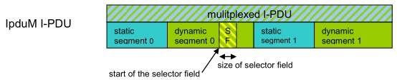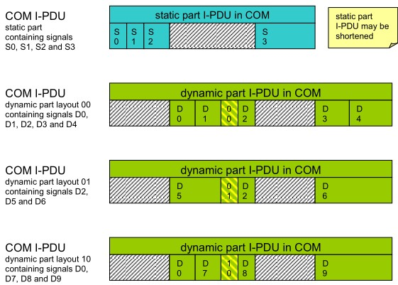

multiplexed

*record*

CppImplementationDataType

category = STRUCTURE

•

S0

•

S1

•

S2

•

S3

•

d00

*record -*

**OPTIONAL**

CppImplementationDataTypeElement

category = STRUCTURE

•

d01

*record -*

**OPTIONAL**

CppImplementationDataTypeElement

category = STRUCTURE

•

d10

*record -*

**OPTIONAL**

CppImplementationDataTypeElement

category = STRUCTURE

•

D7

•

D8

•

D9

* D2 • D5 • D6
* D0

**Figure 12.24: Example mapping for MultiplexedIPdu**

In order to keep the event or field of the ServiceInterface status consistent there shall only be exactly one of the optional alternatives used. **[TPS_MANI_03642]**{DRAFT} **Exactly one alternative defined for mapped event / field during runtime** dExactly one option (as defined in [TPS_MANI_03640] for the dynamic part) shall be defined in the event / field representing the MultiplexedIPdu during runtime.c*(RS_MANI_00063)*

In figure 12.24 an example for the mapping between a MultiplexedIPdu and the composite data type is illustrated.

## 12.9 End-to-End considerations

The signal/service translation on Adaptive platform follows a single-sided approach on ara::com. To the application software there is no difference whether the service is communicated using SOME/IP or DDS, or whether the service originates in a signal/service translation. As the translation is running in the same Process as the application software itself, the application software has direct access to the translated service payload.

In case there is an E2E header attached and/or a secure communication defined the translation software needs to check the validity (for reception) or calculate the CRC/MAC (for sending) of signal-based payload.

The information whether and which E2E / Security profile is configured is defined in the System Template [17] part belonging to the mapping information of sections 12.4.2, 12.4.4, and 12.4.5.

The assignment of the ISignals to ISignalIPdus which in turn are assigned to SecuredIPdus defines the security aspects.

The assignment of ISignals to EndToEndTransformationDescriptions define the safety aspects.

**12.9.1 Safety**

The attribute SignalServiceTranslationEventProps.safeTranslation is used to explicitly require that the translation shall be configured in a safe transport and that the translation software shall handle the translation activity in an end-to-end preserving way.

**[TPS_MANI_03607]**{DRAFT} **Handling of safe signal/service translation in one Executable** dIt is required that the signal-service-translation (and service-signal-translation) of one Service/SignalGroup pair which are mapped to each other, shall be handled in one Executable to also cover a closed mapping from one E2E profile to another, if necessary.

The signal/service translation of different (independent) Services/Signal-

Groups may be handled by different Executables.c*(RS_MANI_00063)* **[TPS_MANI_03608]**{DRAFT} **Support for safe signal/service translation** dThe translation of E2E protected data shall be supported in both directions, signal-service-translation and service-signal-translation.c*(RS_MANI_00063)*

**[TPS_MANI_03609]**{DRAFT} **Support for safe signal/service translation with same or different E2E profiles** dThe translation of E2E protected data shall support the occurrence of

* the same E2E profile on both sides of the communication and
* different E2E profiles on each side of the communication.

c*(RS_MANI_00063)*

**[TPS_MANI_03610]**{DRAFT} **1:n mapping for E2E protected data** dIt shall be possible to map the same E2E protected source data to several E2E protected target data (1:n).c*(RS_MANI_00063)*

**[TPS_MANI_03611]**{DRAFT} **E2E protected target out of E2E protected sources** dThe content of one E2E protected target shall only be composed out of data from E2E protected sources.c*(RS_MANI_00063)*

The rationale for [TPS_MANI_03611] is to support the use-case where target data shall be E2E protected and it is composed of several sources.

**[TPS_MANI_03614]**{DRAFT} **No translation of not OK E2E protected data out of several sources** dIf a E2E protected source data is mapped into a composed E2E

protected target data (according to [TPS_MANI_03611]) and if the E2E-Check for the source data returns any E2E error (not *E_OK*) then this source data shall not be forwarded to the respective target data and (if applicable) shall not trigger the transmission of the target.c*(RS_MANI_00063)*

If source data is not verified as *E_OK* it is not translated. If the translated E2E protected data comes from several sources there may occur correlation and synchronicity issues during translation.

**[TPS_MANI_03612]**{DRAFT} **Sufficient ASIL level of translation software** dIf the

SignalServiceTranslationEventProps.safeTranslation equals true then the implementation of the translation software shall fulfill a sufficient ASIL.c*(RS_MANI_00063)*

**[constr_3554]**{DRAFT} **E2E protection configuration check** dIf the SignalServiceTranslationEventProps.safeTranslation equals true then the signalbased payload shall have an EndToEnd profile defined.c*()*

The current EndToEnd profiles for Classic platform rely on a periodic communication paradigm. For the translation software of the Adaptive platform this requires to know the specified period the payload has to be updated / checked for. **[TPS_MANI_03598]**{DRAFT} **Expected check period of E2E-Protected payload** dIf the RPortPrototype has a ReceiverComSpec.receptionProps.dataUpdatePeriod defined for an event then the application software calling the ara::com APIs shall check periodically for updates using the specified period.c*(RS_MANI_00063)*

**[TPS_MANI_03599]**{DRAFT} **Expected update period of E2E-Protected payload** dIf the PPortPrototype has a SenderComSpec.transmissionProps.dataUpdatePeriod defined for an event then the application software calling the ara::com APIs shall periodically update the event using the specified period.c*(RS_MANI_00063)*

|  |  |  |  |  |
| --- | --- | --- | --- | --- |
| ***Class*** | **ReceptionComSpecProps** | | | |
| ***Package*** | M2::AUTOSARTemplates::SWComponentTemplate::Communication | | | |
| ***Note*** | This meta-class defines a set of reception attributes which the application software is assumed to implement. | | | |
| ***Base*** | *ARObject* | | | |
| ***Attribute*** | ***Type*** | ***Mult.*** | ***Kind*** | ***Note*** |
| dataUpdate Period | TimeValue | 0..1 | attr | This attribute defines the period in which the application shall check for updated data. This attribute is used for the configuration of the E2E protection, but may also indicate a general data reception period. |
| timeout | TimeValue | 0..1 | attr | This attribute defines the time interval after which the application shall assume that the to be received data reception has timed out, i.e. the respective data has not been received for that amount of time. |

**Table 12.12: ReceptionComSpecProps**

|  |  |  |  |  |
| --- | --- | --- | --- | --- |
| ***Class*** | **TransmissionComSpecProps** | | | |
| ***Package*** | M2::AUTOSARTemplates::SWComponentTemplate::Communication | | | |
| ***Note*** | This meta-class defines a set of transmission attributes which the application software is assumed to implement. | | | |
| ***Base*** | *ARObject* | | | |
| ***Attribute*** | ***Type*** | ***Mult.*** | ***Kind*** | ***Note*** |
| dataUpdate Period | TimeValue | 0..1 | attr | This attribute defines the period in which the application is assumed to transmit the respective data. |
| minimumSend  Interval | TimeValue | 0..1 | attr | This attribute defines the minimum interval between two consecutive transmissions of the respective data the application is assumed to ensure. |
| transmission  Mode | TransmissionMode  DefinitionEnum | 0..1 | attr | The attribute defines the mode in which the application is assumed to transmit the respective data. |

**Table 12.13: TransmissionComSpecProps**

|  |  |
| --- | --- |
| ***Enumeration*** | **TransmissionModeDefinitionEnum** |
| ***Package*** | M2::AUTOSARTemplates::SWComponentTemplate::Communication |
| ***Note*** | This meta-class defines possible settings for the transmission mode. |
| ***Literal*** | ***Description*** |
| cyclic | The data is assumed to be transmitted in a cyclic manner. The cycle is defined by dataUpdatePeriod.  **Tags:**atp.EnumerationLiteralIndex=0 |

5

4

|  |  |
| --- | --- |
| ***Enumeration*** | **TransmissionModeDefinitionEnum** |
| cyclicAndOn Change | The data is assumed to be transmitted in a cyclic manner (with cycle time dataUpdatePeriod) and additionally there may be arbitrary transmission if the data value changes (minimumSendInterval to be respected, if defined).  **Tags:**atp.EnumerationLiteralIndex=2 |
| triggered | The data is assumed to be transmitted in an arbitrary manner (minimumSendInterval to be respected, if defined).  **Tags:**atp.EnumerationLiteralIndex=1 |

**Table 12.14: TransmissionModeDefinitionEnum**

### **12.9.1.1 Signal-service-translation**

**[TPS_MANI_03600]**{DRAFT} **Signal-service-translation of E2E protected payload** dSignal-service-translation shall check the end-to-end status of every received signalbased payload. If the E2E-Check returns *E_OK* for the received payload then the data shall be forwarded to the respective sending of the translation software.c*(RS_MANI_00063)*

Error handling:

**[TPS_MANI_03601]**{DRAFT} **Signal-service-translation of E2E protected payload - timeout handling** dIf no message is received within the specified message cycle time (timeout is detected), then no data shall be transmitted to the service-based part.c *(RS_MANI_00063)*

**[TPS_MANI_03602]**{DRAFT} **Signal-service-translation of E2E protected payload - error handling** dIf the E2E-Check returns any E2E error (not *E_OK*), then the service-based message shall reflect that E2E error.c*(RS_MANI_00063)*

Note: This is necessary to provide E2E information to the application software and support an End-to-End view on the data exchange from sender to receiver / provider to consumer.

### **12.9.1.2 Service-signal-translation**

**[TPS_MANI_03603]**{DRAFT} **Service-signal-translation of E2E protected payload** dService-signal-translation shall check the end-to-end status of every received serviceoriented payload. If the E2E-Check returns *E_OK* for the received payload then the data can be forwarded to the respective sending of the translation software.c*(RS_MANI_00063)*

Error handling:

**[TPS_MANI_03604]**{DRAFT} **Service-signal-translation of E2E protected payload - timeout handling** dIf no message is received within the specified message cycle time (timeout is detected), then no data shall be transmitted to the signal-based part.c*(RS_MANI_00063)*

**[TPS_MANI_03605]**{DRAFT} **Service-signal-translation of E2E protected payload - error handling** dIf the service-oriented payload is handed over with any E2E error (not

*E_OK*), then the newly created signal-based E2E protected message shall reflect that E2E error.c*(RS_MANI_00063)*

Note: This is necessary to provide E2E information to the receiving application and support an End-to-End view on the data exchange from sender to receiver/provider to consumer.

**12.9.2 Security**

In the context of Signal Service Translation the Secure Onboard Communication *SecOC* [31] is the major security technology. Further technologies (like *IPSec* or *TLS*) have not been included in the considerations for signal/service translation.

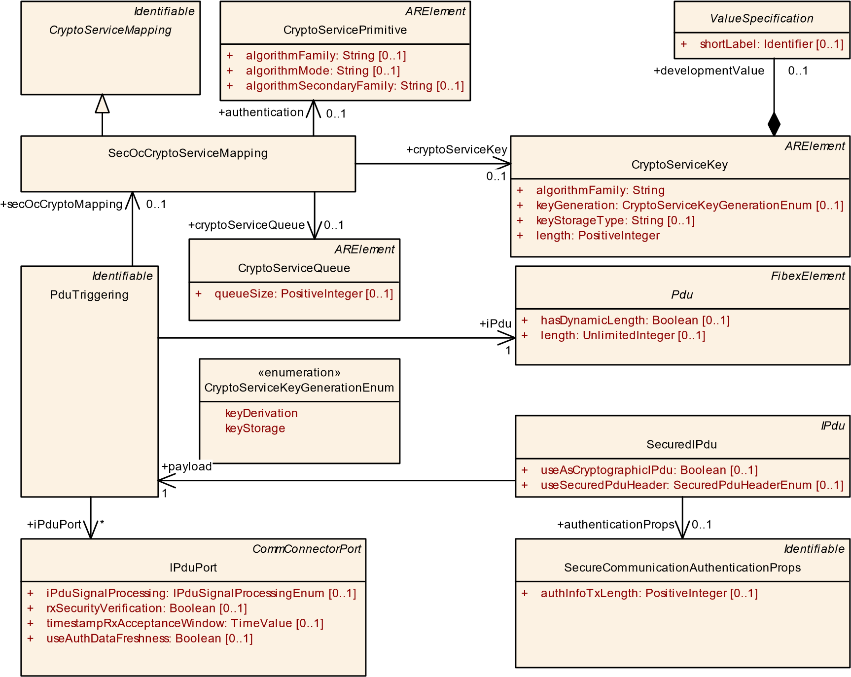

**Figure 12.25: SecOC configuration**

The configuration of *SecOC* on the signal-based communication is defined by having the ISignalTriggering used in one of the signal/service translation mappings refer to an ISignal and that ISignal is part of an ISignalIPdu. A PduTriggering of this ISignalIPdu is referenced by a SecuredIPdu in the role payload.

The SecuredIPdu defines all the details which are required to *generate* / *verify* the cryptographic information. The description of the configuration is provided in the System Template of Classic platform [17].

*IPdu*

SecuredIPdu

+

[0..1]

useAsCryptographicIPdu: Boolean

+

useSecuredPduHeader: SecuredPduHeaderEnum

[0..1]

SecureCommunicationProps

+

authDataFreshnessLength: PositiveInteger

[0..1]

+

[0..1]

authDataFreshnessStartPosition: PositiveInteger

+

authenticationBuildAttempts: PositiveInteger

[0..1]

authenticationRetries: PositiveInteger

+

+

dataId: PositiveInteger

+

freshnessValueId: PositiveInteger

[0..1]

+

[0..1]

messageLinkLength: PositiveInteger

+

messageLinkPosition: PositiveInteger

[0..1]

+

secondaryFreshnessValueId: PositiveInteger

[0..1]

[0..1]

securedAreaLength: PositiveInteger

+

[0..1]

+

securedAreaOffset: PositiveInteger

*Identifiable*

PduTriggering

*CommConnectorPort*

IPduPort

+

[0..1]

iPduSignalProcessing: IPduSignalProcessingEnum

[0..1]

rxSecurityVerification: Boolean

+

[0..1]

timestampRxAcceptanceWindow: TimeValue

+

useAuthDataFreshness: Boolean

+

[0..1]

*FibexElement*

SecureCommunicationPropsSet

*Identifiable*

SecureCommunicationFreshnessProps

+

freshnessCounterSyncAttempts: PositiveInteger

[0..1]

+

[0..1]

freshnessTimestampTimePeriodFactor: PositiveInteger

+

freshnessValueLength: PositiveInteger

[0..1]

+

freshnessValueTxLength: PositiveInteger

[0..1]

+

useFreshnessTimestamp: Boolean

[0..1]

*Identifiable*

SecureCommunicationAuthenticationProps

authInfoTxLength: PositiveInteger

+

[0..1]

«enumeration»

SecuredPduHeaderEnum

noHeader

securedPduHeader08Bit

securedPduHeader16Bit

securedPduHeader32Bit

+

authenticationProps

0..*

+

freshnessProps

0..*

+

iPduPort

*

+

secureCommunicationProps

1

+

authenticationProps

0..1

freshnessProps

+

0..1

payload

+

1

**Figure 12.26: Details on SecuredIPdu**

As the *SecOC* is highly embedded into the Classic platform architecture the signal/service translation approach on security is to use the same architecture for its specification.

**12.9.2.1 Restrictions on Classic Platform SecOC**

**[constr_3555]**{DRAFT} **No support for useAsCryptographicIPdu is true** dThe signal/service translation does not support the case where the PduTriggering is referencing a SecuredIPdu where the attribute useAsCryptographicIPdu is set to true.c*()*

The rationale for [constr_3555] is that the separate handling of two PDUs for the transport of one secured message is not supported by the SOME/IP protocol. In such cases the signal/service translation has to be performed on a Classic platform gateway ECU.

**12.9.2.2 Link between Classic Platform SecOC and CryptoKeySlot**

While most of the information how to configure the SecOC behavior are available in the Classic platform model, there is also the need to define which CryptoKeySlot shall be used for the processing of the SecOC message.

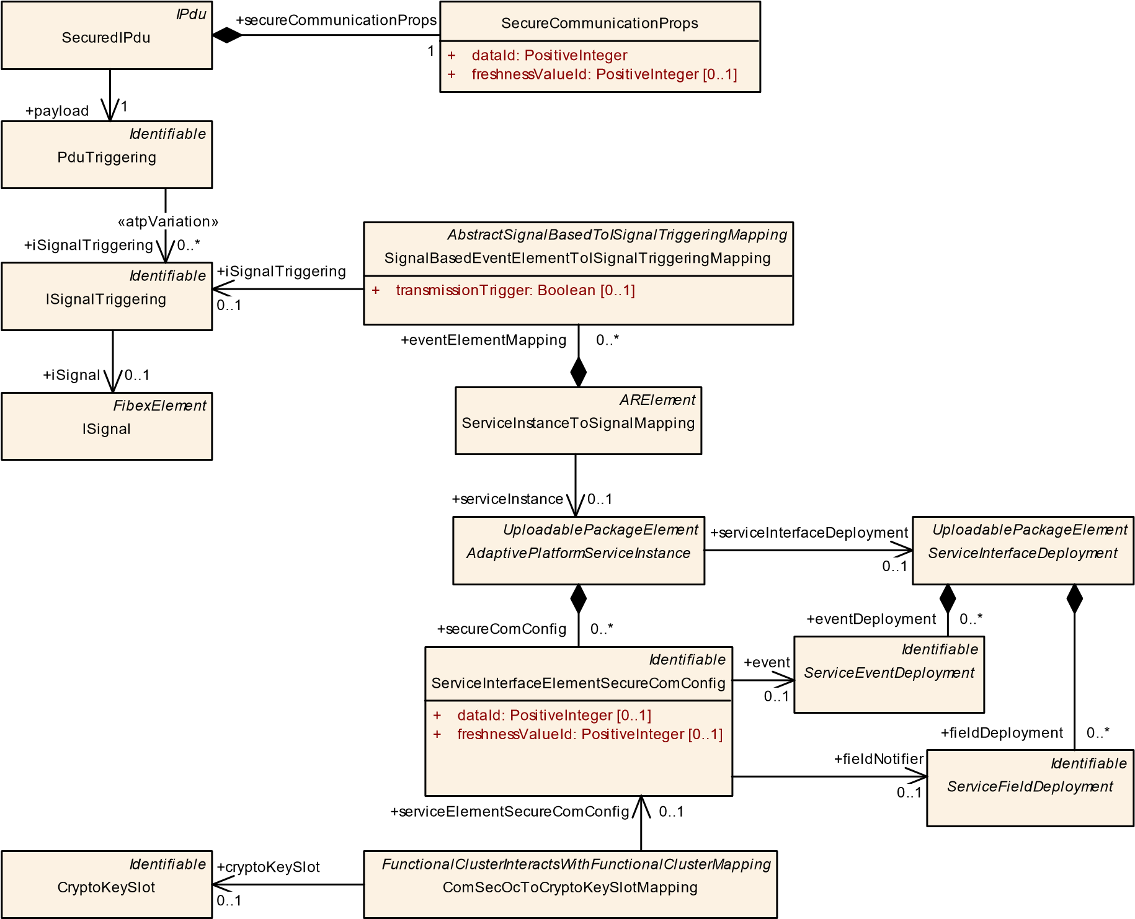

**Figure 12.27: Classic SecOC and Adaptive CryptoKeySlot**

**[TPS_MANI_03636]**{DRAFT} **Definition of ServiceInterfaceElementSecureComConfig in the context of signal/service translation** dA ServiceInterfaceElementSecureComConfig at the AdaptivePlatformServiceInstance shall be created for each Event or FieldNotifier if the following conditions apply:

* the AdaptivePlatformServiceInstance is target of a ServiceInstanceToSignalMapping in the role serviceInstance
* the ServiceInstanceToSignalMapping has a SignalBasedEventElementToISignalTriggeringMapping (resp. SignalBasedFieldToISignalTriggeringMapping) that refers to an ISignalTriggering that are part of an ISignalIPdu
* that ISignalIPdu is referenced by a PduTriggering which in turn is referenced by a SecuredIPdu in the role payload
* the SecuredIPdu is referenced by a PduTriggering and that PduTriggering refers to an IPduPort that has the attribute rxSecurityVerification set to true.

c*(RS_MANI_00063)*

**[TPS_MANI_03637]**{DRAFT} **Ignored attributes of ServiceInterfaceElementSecureComConfig in the context of signal/service translation** dIf a ServiceInterfaceElementSecureComConfig qualifies according to [TPS_MANI_03636] then any attributes (e.g. dataId and freshnessValueId) except the reference in the role event or fieldNotifier - shall be ignored. The information how to configure the SecOC shall be taken from the SecuredIPdu.c*(RS_MANI_00063)*

# 13 Cross-FunctionalCluster interaction

**[TPS_MANI_03268]**{DRAFT} **Semantics of FunctionalClusterInteractsWithFunctionalClusterMapping** dAbstract meta-class FunctionalClusterInteractsWithFunctionalClusterMapping provides an anchor for the specification of interaction between two functional clusters.

The identification of the interaction use case towards the functional cluster implementation is done by using an InstanceSpecifier of the concrete subclass of FunctionalClusterInteractsWithFunctionalClusterMapping that is used to define the concrete interaction.c*(RS_MANI_00023)*

PersistencyDeploymentToCryptoKeySlotMapping

[0..1]

keySlotUsage: CryptoKeySlotUsageEnum

+

[0..1]

verificationHash: String

+

*UploadablePackageElement*

*FunctionalClusterInteractsWithFunctionalClusterMapping*

PersistencyDeploymentElementToCryptoKeySlotMapping

+

[0..1]

keySlotUsage: CryptoKeySlotUsageEnum

+

verificationHash: String

[0..1]

ComKeyToCryptoKeySlotMapping

ComCertificateToCryptoCertificateMapping

ComSecOcToCryptoKeySlotMapping

TimeBaseProviderToPersistencyMapping

ArtifactChecksumToCryptoProviderMapping

PersistencyDeploymentToDltLogSinkMapping

**Figure 13.1: FunctionalClusterInteractsWithFunctionalClusterMapping Overview**

|  |  |  |  |  |
| --- | --- | --- | --- | --- |
| ***Class*** | ***FunctionalClusterInteractsWithFunctionalClusterMapping*** (abstract) | | | |
| ***Package*** | M2::AUTOSARTemplates::AdaptivePlatform::PlatformModuleDeployment::CryptoDeployment | | | |
| ***Note*** | This meta-class identifies a relation between functional clusters on the adaptive platform such one functional cluster can call APIs of the other functional cluster.  **Tags:**atp.Status=draft | | | |
| ***Base*** | *ARElement*, *ARObject*, *CollectableElement*, *Identifiable*, *MultilanguageReferrable*, *Packageable*  *Element*, *Referrable*, *UploadablePackageElement* | | | |
| ***Subclasses*** | ArtifactChecksumToCryptoProviderMapping, ComCertificateToCryptoCertificateMapping, ComKeyTo  CryptoKeySlotMapping, ComSecOcToCryptoKeySlotMapping, PersistencyDeploymentElementToCrypto  KeySlotMapping, PersistencyDeploymentToCryptoKeySlotMapping, PersistencyDeploymentToDltLogSink Mapping, TimeBaseProviderToPersistencyMapping | | | |
| ***Attribute*** | ***Type*** | ***Mult.*** | ***Kind*** | ***Note*** |
| – | – | – | – | – |

**Table 13.1: FunctionalClusterInteractsWithFunctionalClusterMapping**

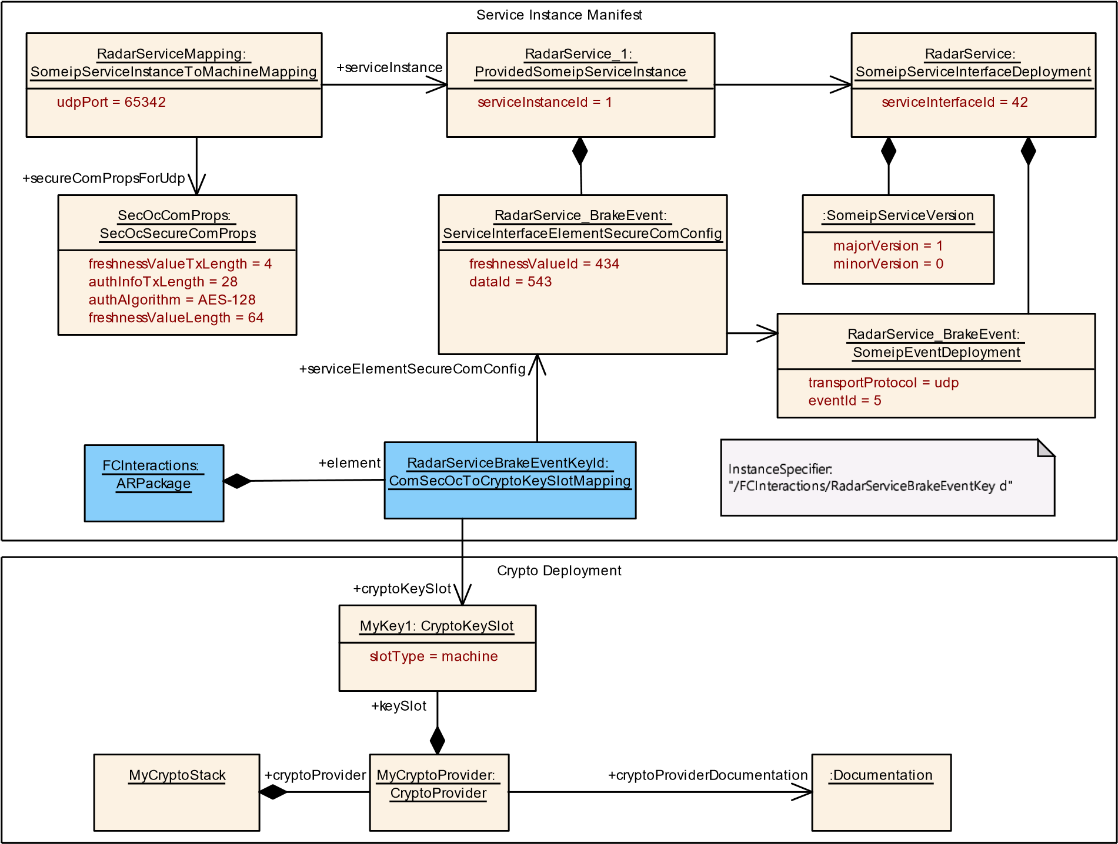

**Figure 13.2: Example for the usage of FunctionalClusterInteractsWithFunctionalClusterMapping**

In case of an application the model-path to an PortPrototype that is referencing a specific PortInterface defines the InstanceSpecifier that is used as identification towards the functional cluster implementation.

In case of a FunctionalCluster interaction the PortPrototype is not available. Therefore the path to a mapping element that is derived from FunctionalClusterInteractsWithFunctionalClusterMapping is used to define the InstanceSpecifier that is used in the API call.

The following figure shows the supported FunctionalClusterInteractsWithFunctionalClusterMapping subclasses that are available in the model.

The following Figure 13.2 shows an example for the usage of FunctionalClusterInteractsWithFunctionalClusterMapping. In this example, the Service Instance Manifest describes a configuration for a ProvidedSomeipServiceInstance that contains an Event that is protected by SecOC.

Inside of the Service Instance Manifest the “RadarServiceBrakeEventKeyId” represents the FunctionalClusterInteractsWithFunctionalClusterMapping that is located in the ARPackage “FCInteractions”.

These two elements in the manifest define the InstanceSpecifier “\FCInteractions\RadarServiceBrakeEventKeyId” that is used in the Crypto API call from the Communication Management. This InstanceSpecifier is resolved to a concrete CryptoKeySlot with the information that is available in the Crypto Deployment.

## 13.1 ComCertificateToCryptoCertificateMapping

**[TPS_MANI_03269]**{DRAFT} **Semantics of ComCertificateToCryptoCertificateMapping** dThe meta-class ComCertificateToCryptoCertificateMapping provides an anchor for the specification of interaction between the COM FunctionalCluster and the Crypto FunctionalCluster and is used to map a

CryptoServiceCertificate defined in COM to a CryptoCertificate defined in the Crypto Stack.c*(RS_MANI_00023)*

|  |  |  |  |  |
| --- | --- | --- | --- | --- |
| ***Class*** | **ComCertificateToCryptoCertificateMapping** | | | |
| ***Package*** | M2::AUTOSARTemplates::AdaptivePlatform::PlatformModuleDeployment::CryptoDeployment | | | |
| ***Note*** | This meta-class maps the CryptoServiceCertificate defined in the COM deployment to the Crypto Certificate defined in the Crypto Stack.  **Tags:**  atp.Status=draft  atp.recommendedPackage=FCInteractions | | | |
| ***Base*** | *ARElement*, *ARObject*, *CollectableElement*, *FunctionalClusterInteractsWithFunctionalClusterMapping*,  *Identifiable*, *MultilanguageReferrable*, *PackageableElement*, *Referrable*, *UploadablePackageElement* | | | |
| ***Attribute*** | ***Type*** | ***Mult.*** | ***Kind*** | ***Note*** |
| crypto  Certificate | CryptoCertificate | 0..1 | ref | Reference to the CryptoCertifcate in the Crypto Stack.  **Tags:**atp.Status=draft |
| cryptoService Certificate | CryptoService  Certificate | 0..1 | ref | Reference to the cryptoServiceCertificate in the Com deployment  **Tags:**atp.Status=draft |

**Table 13.2: ComCertificateToCryptoCertificateMapping**

Figure 13.3 shows the ComCertificateToCryptoCertificateMapping used to assign a CryptoServiceCertificate defined in the TLS configuration to a CryptoCertificate in the Crypto Stack.

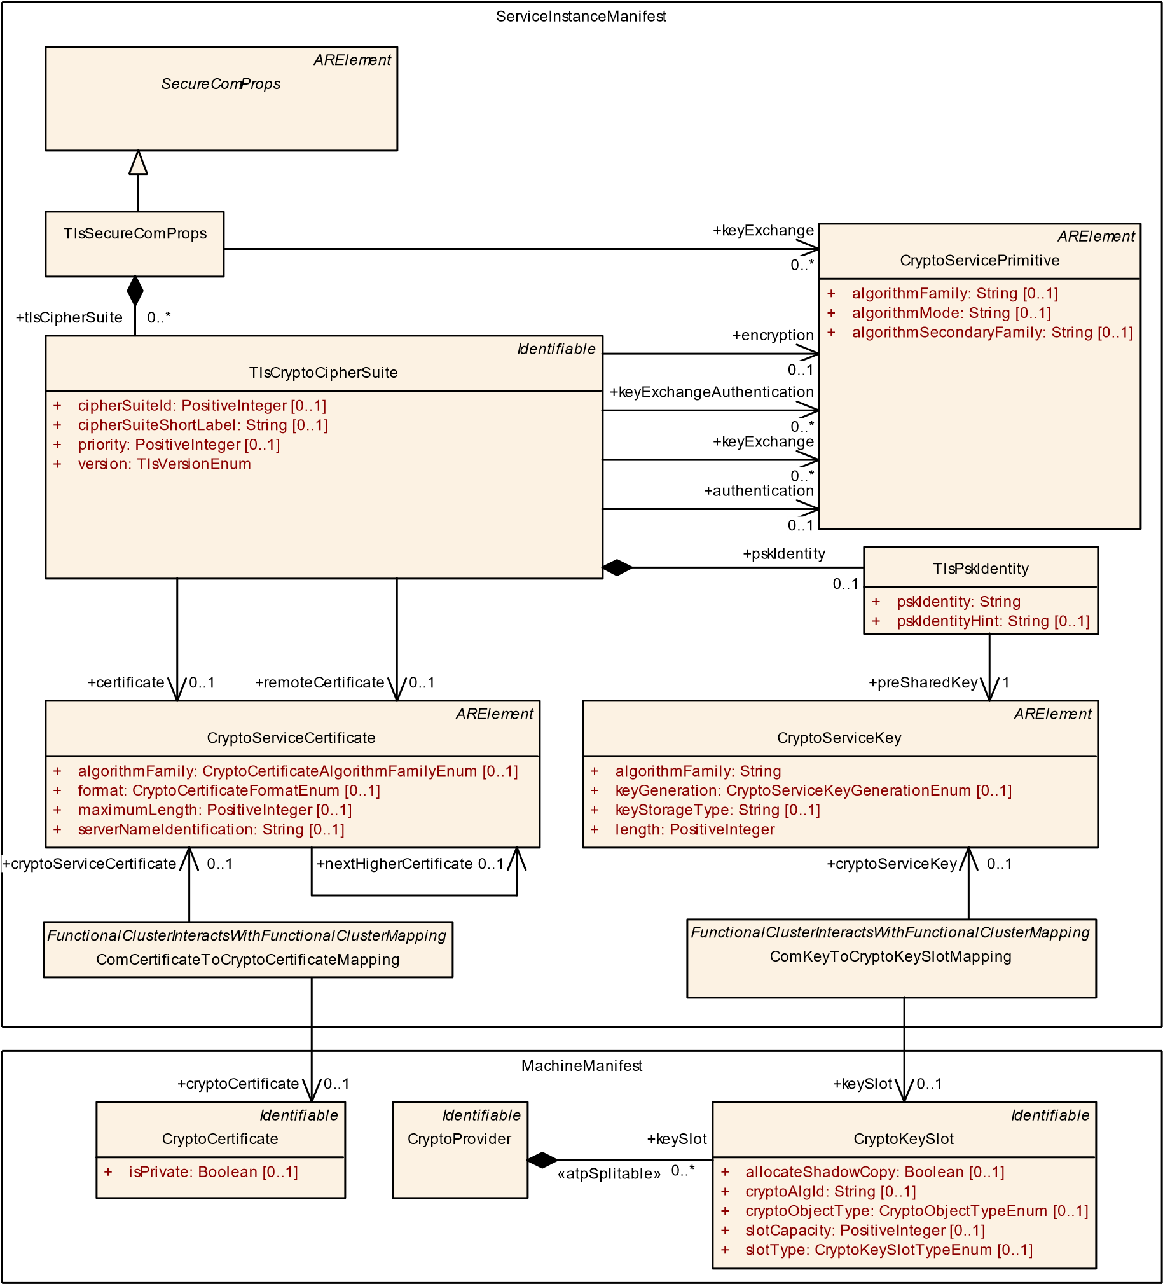

**Figure 13.3: Mapping of TLS config elements to crypto objects in the crypto stack**

## 13.2 ComKeyToCryptoKeySlotMapping

**[TPS_MANI_03270]**{DRAFT} **Semantics of ComKeyToCryptoKeySlotMapping** dThe meta-class ComKeyToCryptoKeySlotMapping provides an anchor for the specification of interaction between the COM FunctionalCluster and the Crypto FunctionalCluster and is used to map a CryptoServiceKey defined in COM to a CryptoKeySlot defined in the Crypto Stack.c*(RS_MANI_00023)*

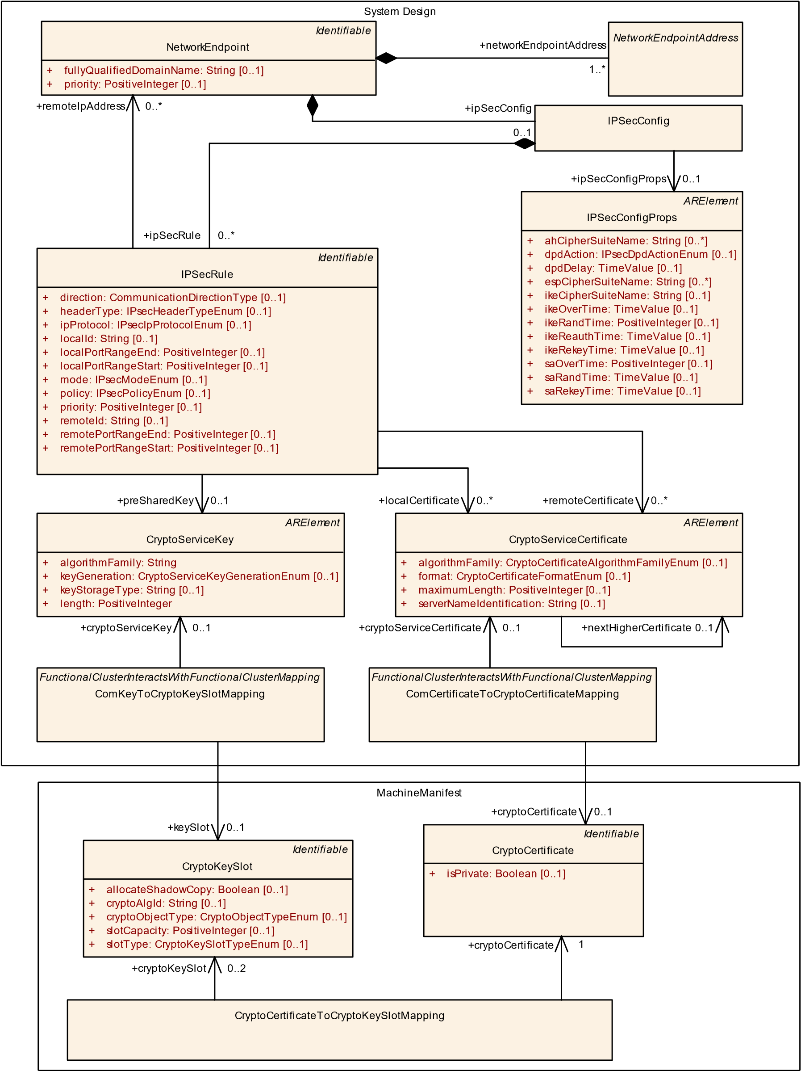

**Figure 13.4: Mapping of IPsec config elements to crypto objects in the crypto stack**

|  |  |  |  |  |
| --- | --- | --- | --- | --- |
| ***Class*** | **ComKeyToCryptoKeySlotMapping** | | | |
| ***Package*** | M2::AUTOSARTemplates::AdaptivePlatform::PlatformModuleDeployment::CryptoDeployment | | | |
| ***Note*** | This meta-class maps the CryptoServiceKey defined in the COM deployment to the CryptoKeySlot defined in the Crypto Stack.  **Tags:**  atp.Status=draft  atp.recommendedPackage=FCInteractions | | | |
| ***Base*** | *ARElement*, *ARObject*, *CollectableElement*, *FunctionalClusterInteractsWithFunctionalClusterMapping*,  *Identifiable*, *MultilanguageReferrable*, *PackageableElement*, *Referrable*, *UploadablePackageElement* | | | |
| ***Attribute*** | ***Type*** | ***Mult.*** | ***Kind*** | ***Note*** |
| cryptoService Key | CryptoServiceKey | 0..1 | ref | Reference to the cryptoServiceKey in the Com deployment  **Tags:**atp.Status=draft |
| keySlot | CryptoKeySlot | 0..1 | ref | Reference to the CryptoKeySlot in the Crypto Stack.  **Tags:**atp.Status=draft |

**Table 13.3: ComKeyToCryptoKeySlotMapping**

Figure 13.4 shows the ComKeyToCryptoKeySlotMapping used to assign a CryptoServiceKey defined in the IPsec configuration to CryptoKeySlot in the Crypto Stack.

## 13.3 ComSecOcToCryptoKeySlotMapping

**[TPS_MANI_03271]**{DRAFT} **Semantics of ComSecOcToCryptoKeySlotMapping** dThe meta-class ComSecOcToCryptoKeySlotMapping provides an anchor for the specification of interaction between the COM FunctionalCluster and the Crypto

FunctionalCluster and is used to map a ServiceInterfaceElementSecureCom-

Config defined in COM to a CryptoKeySlot defined in the Crypto Stack.c*(RS_-*

*MANI_00023)*

|  |  |  |  |  |
| --- | --- | --- | --- | --- |
| ***Class*** | **ComSecOcToCryptoKeySlotMapping** | | | |
| ***Package*** | M2::AUTOSARTemplates::AdaptivePlatform::PlatformModuleDeployment::CryptoDeployment | | | |
| ***Note*** | This meta-class maps the ServiceElementSecureComConfig defined in the COM deployment to the CryptoKeySlot defined in the Crypto Stack.  **Tags:**  atp.Status=draft  atp.recommendedPackage=FCInteractions | | | |
| ***Base*** | *ARElement*, *ARObject*, *CollectableElement*, *FunctionalClusterInteractsWithFunctionalClusterMapping*,  *Identifiable*, *MultilanguageReferrable*, *PackageableElement*, *Referrable*, *UploadablePackageElement* | | | |
| ***Attribute*** | ***Type*** | ***Mult.*** | ***Kind*** | ***Note*** |
| cryptoKeySlot | CryptoKeySlot | 0..1 | ref | Reference to the CryptoKeySlot in the Crypto Stack.  **Tags:**atp.Status=draft |
| serviceElement  SecureCom  Config | ServiceInterface  ElementSecureCom  Config | 0..1 | ref | Reference to the ServiceInterfaceElementSecureCom Config element in the COM config.  **Tags:**atp.Status=draft |

**Table 13.4: ComSecOcToCryptoKeySlotMapping**

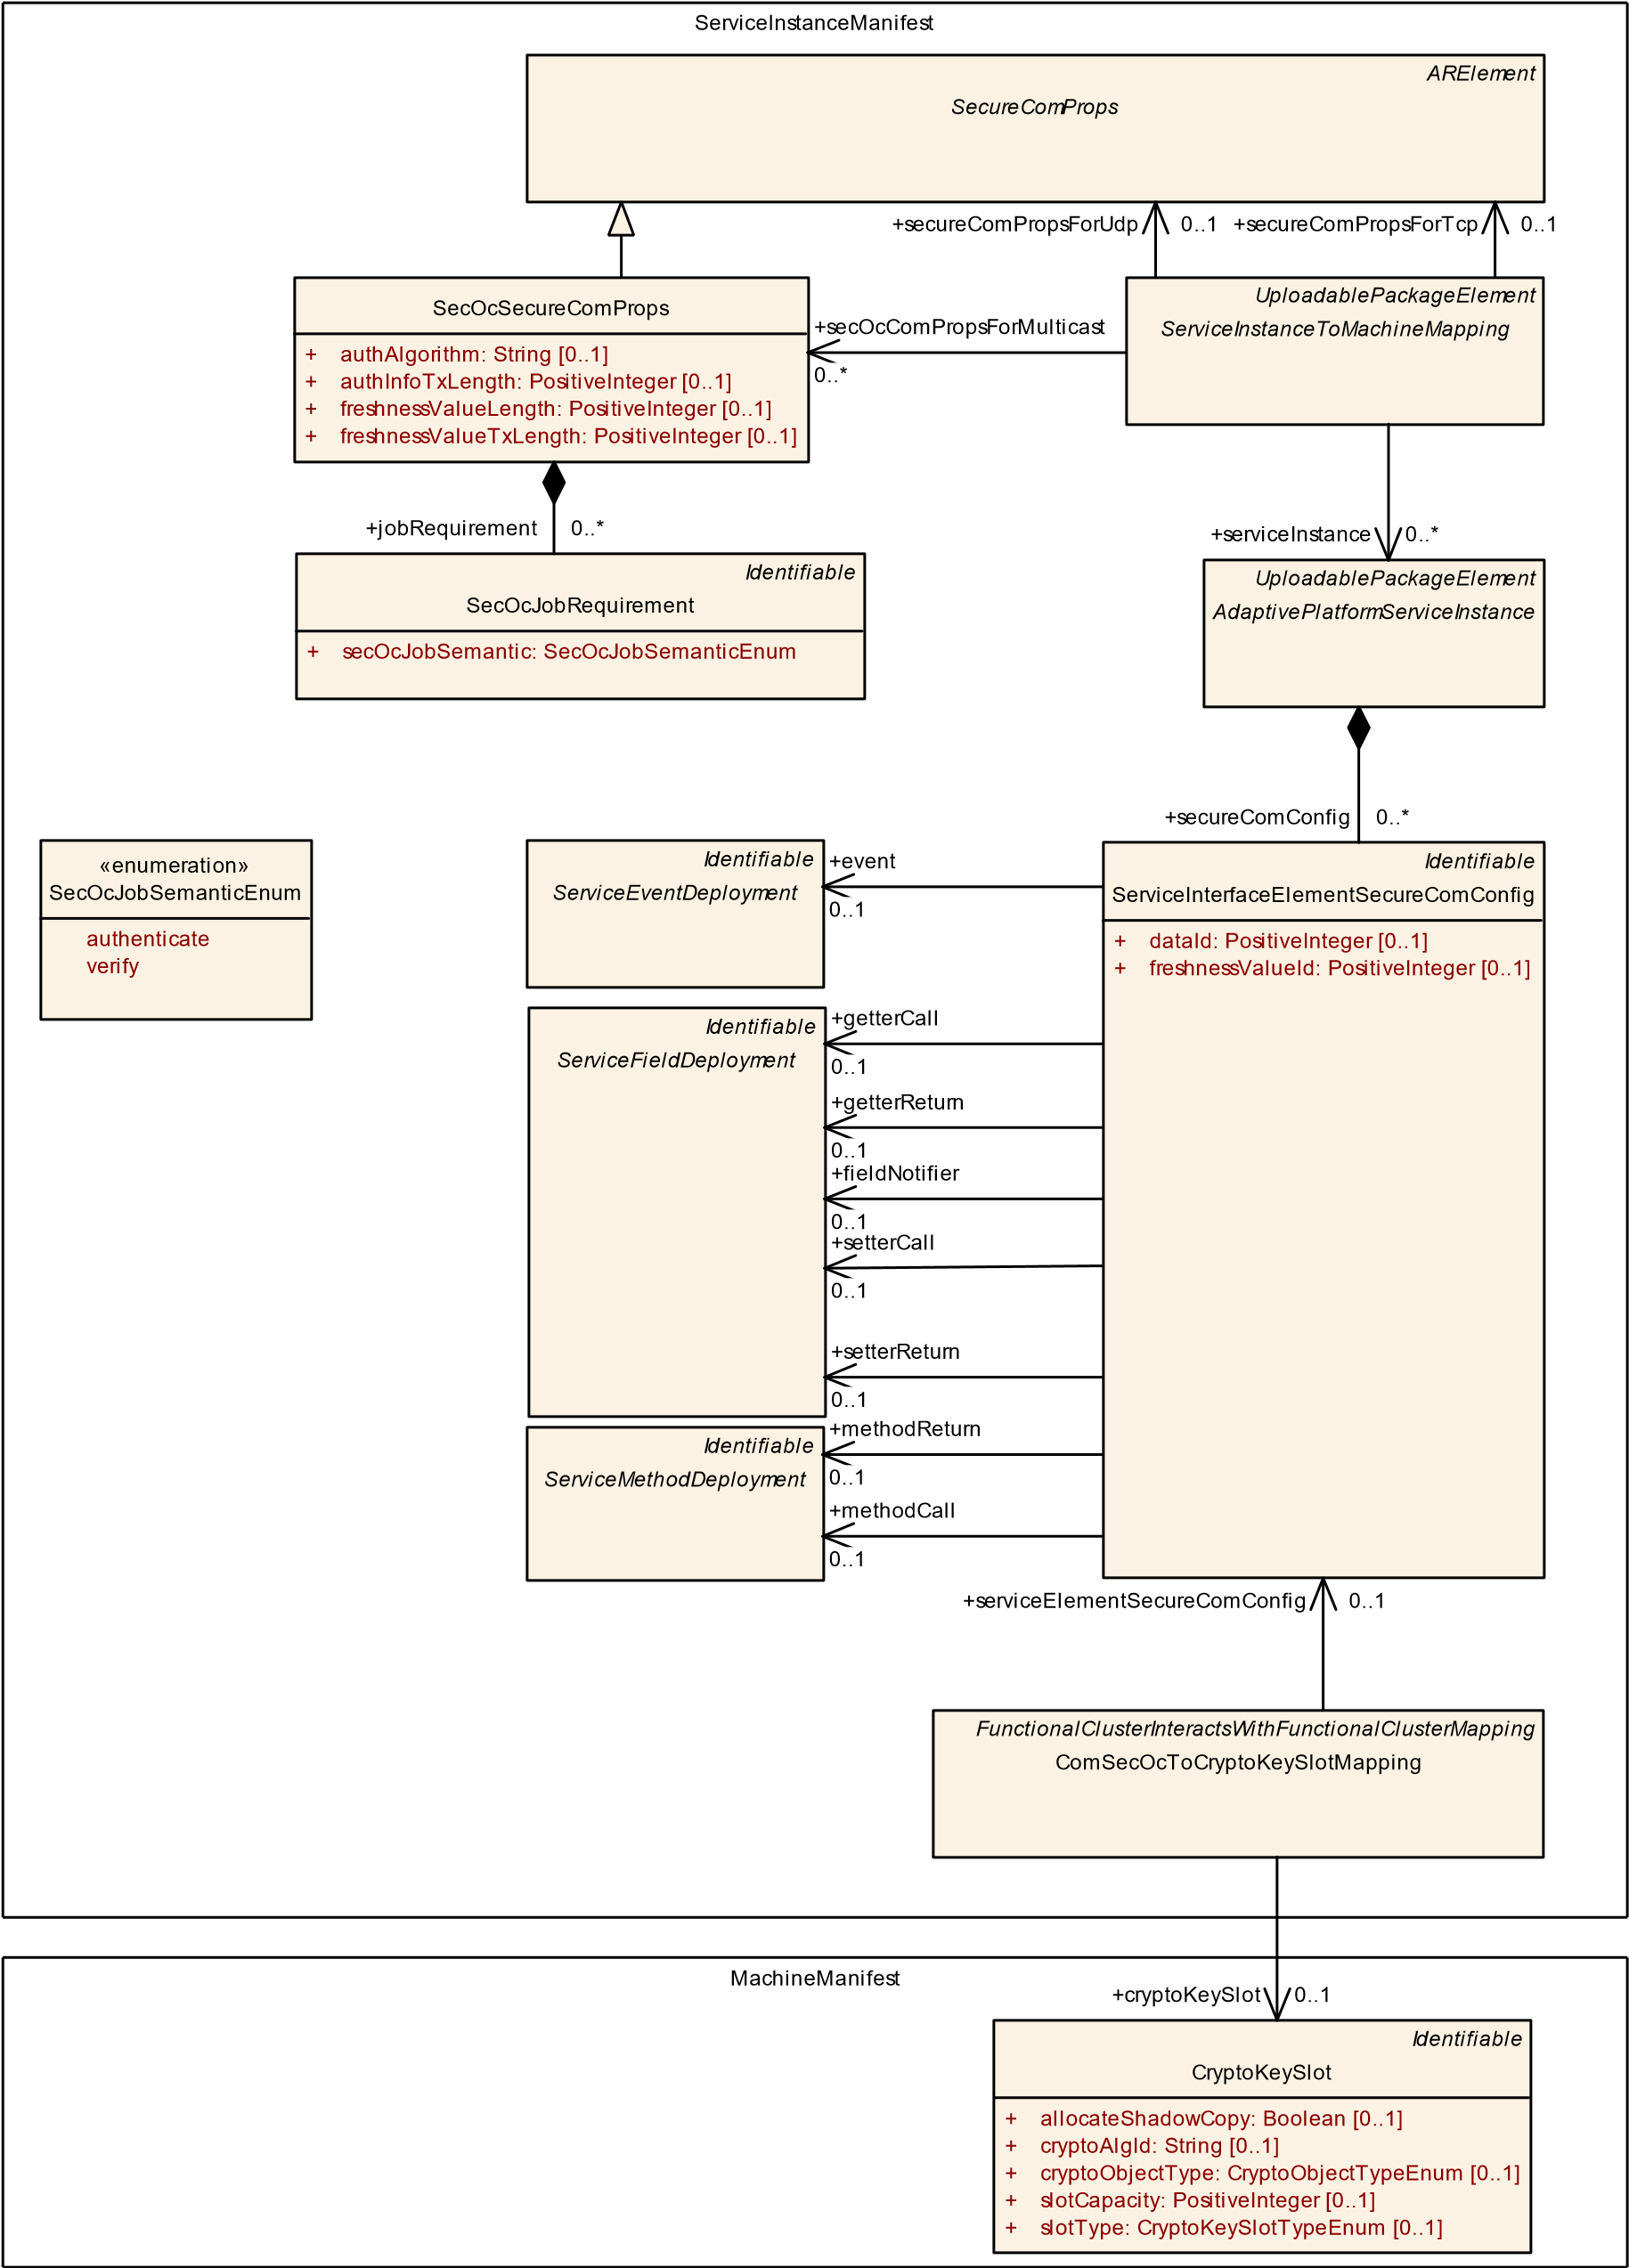

**Figure 13.5: Mapping of SecOC config elements to crypto objects in the crypto stack**

Figure 13.5 shows the ComSecOcToCryptoKeySlotMapping used to assign a ServiceInterfaceElementSecureComConfig defined in the SecOC configuration to CryptoKeySlot in the Crypto Stack.

## 13.4 PersistencyDeploymentToCryptoKeySlotMapping

**[TPS_MANI_03272]**{DRAFT} **Semantics of PersistencyDeploymentToCryptoKeySlotMapping** dThe meta-class PersistencyDeploymentToCryptoKeySlotMapping provides an anchor for the specification of interaction between the Persistency FunctionalCluster and the Crypto FunctionalCluster and is used to map a PersistencyDeployment defined in Persistency to a CryptoKeySlot defined in the Crypto Stack.c*(RS_MANI_00023)*

|  |  |  |  |  |
| --- | --- | --- | --- | --- |
| ***Class*** | **PersistencyDeploymentToCryptoKeySlotMapping** | | | |
| ***Package*** | M2::AUTOSARTemplates::AdaptivePlatform::PlatformModuleDeployment::CryptoDeployment | | | |
| ***Note*** | This meta-class represents the ability to define a mapping between the PersistencyDeployment and a CryptoKeySlot.  **Tags:**  atp.Status=draft  atp.recommendedPackage=FCInteractions | | | |
| ***Base*** | *ARElement*, *ARObject*, *CollectableElement*, *FunctionalClusterInteractsWithFunctionalClusterMapping*,  *Identifiable*, *MultilanguageReferrable*, *PackageableElement*, *Referrable*, *UploadablePackageElement* | | | |
| ***Attribute*** | ***Type*** | ***Mult.*** | ***Kind*** | ***Note*** |
| cryptoKeySlot | CryptoKeySlot | 0..1 | ref | This reference represents the mapped CryptoKeySlot.  **Tags:**atp.Status=draft |
| keySlotUsage | CryptoKeySlotUsage  Enum | 0..1 | attr | This attribute defines the role of the keySlot assignment.  **Tags:**atp.Status=draft |
| persistency  Deployment | PersistencyDeployment | 1 | ref | This reference represents the mapped Persistency Deployment.  **Tags:**atp.Status=draft |
| verificationHash | String | 0..1 | attr | This attribute defines the hash of the storage used in case of verification.  **Tags:**atp.Status=draft |

**Table 13.5: PersistencyDeploymentToCryptoKeySlotMapping**

|  |  |
| --- | --- |
| ***Enumeration*** | **CryptoKeySlotUsageEnum** |
| ***Package*** | M2::AUTOSARTemplates::AdaptivePlatform::PlatformModuleDeployment::CryptoDeployment |
| ***Note*** | This enum defines the possible roles of the keySlotUsage.  **Tags:**atp.Status=draft |
| ***Literal*** | ***Description*** |
| encryption | Key slot usage for encryption  **Tags:**  atp.EnumerationLiteralIndex=1 atp.Status=draft |

5

4

|  |  |
| --- | --- |
| ***Enumeration*** | **CryptoKeySlotUsageEnum** |
| verification | Key slot usage for verification  **Tags:**  atp.EnumerationLiteralIndex=0 atp.Status=draft |

**Table 13.6: CryptoKeySlotUsageEnum**

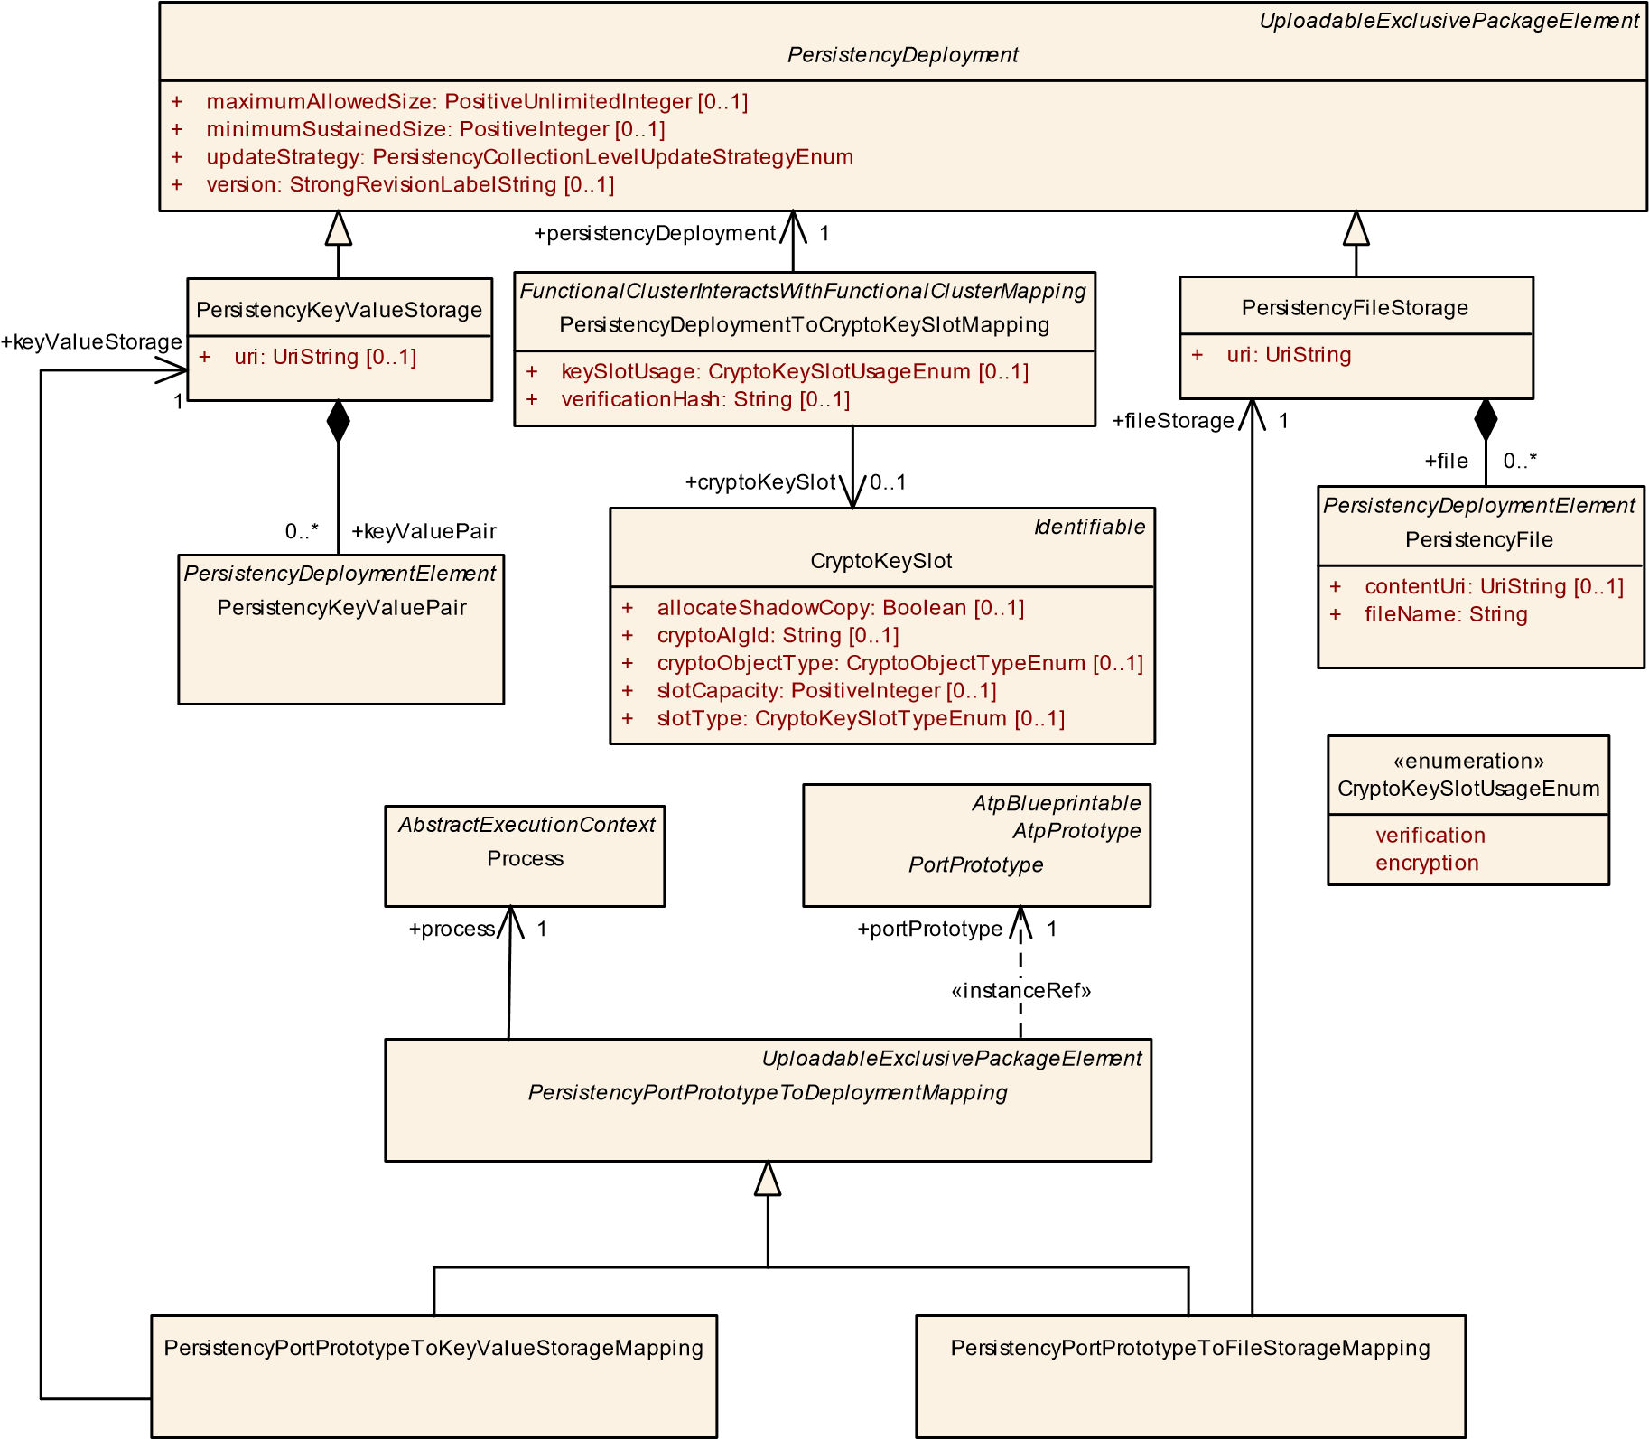

**Figure 13.6: Mapping of PersistencyDeployment to crypto objects in the crypto stack**

## 13.5 PersistencyDeploymentElementToCryptoKeySlotMapping

**[TPS_MANI_03273]**{DRAFT} **Semantics of PersistencyDeploymentElementToCryptoKeySlotMapping** dThe meta-class PersistencyDeploymentElementToCryptoKeySlotMapping provides an anchor for the specification of interaction between the Persistency FunctionalCluster and the Crypto FunctionalCluster and is used to map a PersistencyDeploymentElement defined in Persistency to a CryptoKeySlot defined in the Crypto Stack.c*(RS_MANI_00023)*

|  |  |  |  |  |
| --- | --- | --- | --- | --- |
| ***Class*** | **PersistencyDeploymentElementToCryptoKeySlotMapping** | | | |
| ***Package*** | M2::AUTOSARTemplates::AdaptivePlatform::PlatformModuleDeployment::CryptoDeployment | | | |
| ***Note*** | This meta-class represents the ability to define a mapping between the PersistencyDeploymentElement and a CryptoKeySlot.  **Tags:**  atp.Status=draft  atp.recommendedPackage=FCInteractions | | | |
| ***Base*** | *ARElement*, *ARObject*, *CollectableElement*, *FunctionalClusterInteractsWithFunctionalClusterMapping*,  *Identifiable*, *MultilanguageReferrable*, *PackageableElement*, *Referrable*, *UploadablePackageElement* | | | |
| ***Attribute*** | ***Type*** | ***Mult.*** | ***Kind*** | ***Note*** |
| cryptoKeySlot | CryptoKeySlot | 0..1 | ref | This reference represents the mapped CryptoKeySlot.  **Tags:**atp.Status=draft |
| keySlotUsage | CryptoKeySlotUsage  Enum | 0..1 | attr | This attribute defines the role of the keySlot assignment.  **Tags:**atp.Status=draft |
| persistency  Deployment  Element | PersistencyDeployment  Element | 0..1 | ref | This reference represents the mapped Persistency Deployment.  **Tags:**atp.Status=draft |
| verificationHash | String | 0..1 | attr | This attribute defines the hash of the storage used in case of verification.  **Tags:**atp.Status=draft |

**Table 13.7: PersistencyDeploymentElementToCryptoKeySlotMapping**

*Identifiable*

CryptoKeySlot

+

[0..1]

allocateShadowCopy: Boolean

cryptoAlgId: String

[0..1]

+

[0..1]

cryptoObjectType: CryptoObjectTypeEnum

+

[0..1]

slotCapacity: PositiveInteger

+

+

[0..1]

slotType: CryptoKeySlotTypeEnum

PersistencyFile

contentUri: UriString

[0..1]

+

fileName: String

+

«enumeration»

CryptoKeySlotUsageEnum

verification

encryption

*Identifiable*

*PersistencyDeploymentElement*

[0..1]

updateStrategy: PersistencyElementLevelUpdateStrategyEnum

+

*FunctionalClusterInteractsWithFunctionalClusterMapping*

PersistencyDeploymentElementToCryptoKeySlotMapping

keySlotUsage: CryptoKeySlotUsageEnum

[0..1]

+

+

verificationHash: String

[0..1]

PersistencyKeyValuePair

persistencyDeploymentElement

+

0..1

cryptoKeySlot

+

0..1

**Figure 13.7: Mapping of PersistencyDeploymentElement to crypto objects in the crypto stack**

## 13.6 PersistencyDeploymentToDltLogSinkMapping

**[TPS_MANI_03276]**{DRAFT} **Semantics of PersistencyDeployment-**

**ToDltLogSinkMapping** dThe meta-class PersistencyDeploymentToDltLogSinkMapping provides an anchor for the specification of interaction between the Persistency FunctionalCluster and Log & Trace and is used to map a PersistencyDeployment defined in Persistency to a DltLogSink defined in the

LogAndTraceInstantiation.c*(RS_MANI_00023)*

|  |  |  |  |  |
| --- | --- | --- | --- | --- |
| ***Class*** | **PersistencyDeploymentToDltLogSinkMapping** | | | |
| ***Package*** | M2::AUTOSARTemplates::AdaptivePlatform::PlatformModuleDeployment::LogAndTrace | | | |
| ***Note*** | This meta-class represents the ability to define a mapping between the PersistencyDeployment and a Dlt LogSink.  **Tags:**  atp.Status=draft  atp.recommendedPackage=FCInteractions | | | |
| ***Base*** | *ARElement*, *ARObject*, *CollectableElement*, *FunctionalClusterInteractsWithFunctionalClusterMapping*,  *Identifiable*, *MultilanguageReferrable*, *PackageableElement*, *Referrable*, *UploadablePackageElement* | | | |
| ***Attribute*** | ***Type*** | ***Mult.*** | ***Kind*** | ***Note*** |
| dltContext | DltContext | 0..1 | ref | Reference to the DltContext to which this mapping belongs.  **Tags:**atp.Status=draft |
| logSink | DltLogSink | 0..1 | ref | Reference to the DltLogSink to which the Persistency Deployment is mapped **Tags:**atp.Status=draft |
| persistency  Deployment | PersistencyDeployment | 0..1 | ref | This reference represents the mapped Persistency Deployment.  **Tags:**atp.Status=draft |

**Table 13.8: PersistencyDeploymentToDltLogSinkMapping**

*UploadableExclusivePackageElement*

*PersistencyDeployment*

[0..1]

maximumAllowedSize: PositiveUnlimitedInteger

+

minimumSustainedSize: PositiveInteger

+

[0..1]

+

updateStrategy: PersistencyCollectionLevelUpdateStrategyEnum

+

version: StrongRevisionLabelString

[0..1]

*FunctionalClusterInteractsWithFunctionalClusterMapping*

PersistencyDeploymentToDltLogSinkMapping

*UploadablePackageElement*

DltLogSink

bufferOutput: Boolean

[0..1]

+

[0..1]

defaultLogThreshold: LogTraceDefaultLogLevelEnum

+

[0..1]

defaultTraceState: Boolean

+

[0..1]

logChannelId: String

+

+

nonVerboseMode: Boolean

[0..1]

+

path: UriString

[0..1]

[0..1]

+

queueSize: PositiveInteger

*ARElement*

DltContext

+

contextDescription: String

[0..1]

+

contextId: String

[0..1]

persistencyDeployment

+

0..1

+

logSink

0..1

+

dltContext

0..1

**Figure 13.8: Mapping of PersistencyDeployment to DltLogSink**

# 14 Software Distribution

## 14.1 Overview

One of the key features of the *AUTOSAR adaptive platform* is the ability to extend the software on a given ECU without having to re-flash the entire ECU. Instead, software packages are uploaded to the ECU where the content is taken care of by responsible platform modules.

The reason why this topic is relevant for the modeling is the fact that an uploadable software package consists not only of software itself but also of manifest content required to support the integration of the uploaded software with the existing platform instance.

As far as the meta-model is concerned, the discussion about manifests and which manifest content needs to go with which other model elements doesn’t care about the file granularity. In other words, it would not make sense to formalize the uploadable software package on the basis of references to files that carry model elements.

Instead, the view on the manifest topic from the modeling point of view focuses on model elements that make up manifest content.

Therefore, the modeling of an uploadable software package allows for putting references to all the required model elements that, in their entirety, make up the manifest of the corresponding application software that is also going to end up in the uploadable software package.

From the formal point of view, such an uploadable software package is modeled as a so-called SoftwareCluster. This meta-class is the root element that in turn describes all the necessary content of an uploadable software package.

However, the software package obviously isn’t created out of thin air. It is the result of a workflow that starts from the formulation of requirements on the content of a SoftwareCluster.

These requirements are formalized by means of meta-class SoftwareClusterDesigns.

The relation between SoftwareClusterDesign and SoftwareCluster is depicted in Figure 14.1.

*ARElement*

SoftwareCluster

+

typeApproval: String

[0..1]

+

vendorId: PositiveInteger

+

version: StrongRevisionLabelString

*ARElement*

*AtpClassifier*

SoftwareClusterDesign

+

dependsOn

0..*

«atpSplitable»

+

subSoftwareCluster

0..*

«atpUriDef»

design

+

0..*

**Figure 14.1: Relation of SoftwareClusterDesign to SoftwareCluster**

**[TPS_MANI_01109]**{DRAFT} **Semantics of UploadablePackageElement** dIn order to keep the complexity of the modeling of SoftwareCluster as low as possible abstract meta-class UploadablePackageElement has been created.

This allows for the referencing of model elements derived from UploadablePackageElement that need to be considered in an uploadable software package from within a SoftwareCluster with just the reference containedPackageElement.

The same applies for SoftwareClusterDesign and the respective reference requiredPackageElement.c*(RS_MANI_00035)*

|  |  |  |  |  |
| --- | --- | --- | --- | --- |
| ***Class*** | ***UploadablePackageElement*** (abstract) | | | |
| ***Package*** | M2::AUTOSARTemplates::AdaptivePlatform::General | | | |
| ***Note*** | This meta-class acts as an abstract base class for all meta-classes that need to be added to an uploadable software package in order to complete the manifest content.  **Tags:**atp.Status=draft | | | |
| ***Base*** | *ARElement*, *ARObject*, *CollectableElement*, *Identifiable*, *MultilanguageReferrable*, *Packageable Element*, *Referrable* | | | |
| ***Subclasses*** | *AbstractExecutionContext*, *AdaptivePlatformServiceInstance*, CryptoCertificateToPortPrototypeMapping,  CryptoKeySlotToPortPrototypeMapping, CryptoProviderToPortPrototypeMapping, DdsSecure  Governance, DdsTopicAccessRule, DeterministicClient, DltApplicationToProcessMapping, DltLogSink,  DltLogSinkToPortPrototypeMapping, *FunctionalClusterInteractsWithFunctionalClusterMapping*, Nm  HandleToFunctionGroupStateMapping, PlatformHealthManagementContribution, ProcessExecution  Error, ProcessToMachineMappingSet, RawDataStreamDeployment, *RawDataStreamMapping*, Recovery  NotificationToPPortPrototypeMapping, SecurityEventMapping, *ServiceInstanceToMachineMapping*,  ServiceInstanceToPortPrototypeMapping, *ServiceInterfaceDeployment*, StartupConfigSet, TimeSyncPort PrototypeToTimeBaseMapping, *UploadableExclusivePackageElement* | | | |
| ***Attribute*** | ***Type*** | ***Mult.*** | ***Kind*** | ***Note*** |
| – | – | – | – | – |

**Table 14.1: UploadablePackageElement**

Please note that this approach to collecting elements is very similar in semantics to System.fibexElement or DiagnosticContributionSet.element.

## 14.2 Software Cluster

**14.2.1 Software Cluster General Modeling**

**[TPS_MANI_01110]**{DRAFT} **Semantics of SoftwareCluster**dThe existence of a

SoftwareCluster represents an uploadable software package.c*(RS_MANI_00035)*

**[TPS_MANI_01213]**{DRAFT} **Semantics of meta-class StrongRevisionLabelString** dMeta-class StrongRevisionLabelString supports the specification of a version number for a SoftwareCluster that consists of four components ([constr_1747] applies):

* Major version
* Minor version
* Patch version
* Additional labels for pre-release version and build metadata c*(RS_MANI_00035)*

*AbstractExecutionContext*

Process

+

functionClusterAffiliation: String

[0..1]

+

numberOfRestartAttempts: PositiveInteger

[0..1]

[0..1]

+

preMapping: Boolean

*ARElement*

SoftwareCluster

[0..1]

typeApproval: String

+

vendorId: PositiveInteger

+

version: StrongRevisionLabelString

+

ServiceInstanceToPortPrototypeMapping

*ARElement*

*UploadablePackageElement*

*PackageableElement*

*FibexElement*

*Identifiable*

*AdaptiveModuleInstantiation*

*ARElement*

*AtpStructureElement*

Machine

:

trustedPlatformExecutableLaunchBehavior

+

TrustedPlatformExecutableLaunchBehaviorEnum

*ARElement*

CryptoServiceCertificate

:

algorithmFamily

+

CryptoCertificateAlgorithmFamilyEnum [0..1]

+

format: CryptoCertificateFormatEnum

[0..1]

maximumLength: PositiveInteger

+

[0..1]

+

serverNameIdentification: String

[0..1]

*ARElement*

Documentation

releaseNotes

+

0..1

«atpSplitable»

+

containedPackageElement

0..*

license

+

0..*

+

vendorSignature

1

«atpSplitable»

moduleInstantiation

+

0..*

«atpSplitable»

+

process

0..1

containedProcess

+

0..*

+

nextHigherCertificate

0..1

containedFibexElement

+

0..*

«atpSplitable»

+

moduleInstantiation

0..*

**Figure 14.2: Modeling of SoftwareCluster**

|  |  |  |  |  |
| --- | --- | --- | --- | --- |
| ***Class*** | **SoftwareCluster** | | | |
| ***Package*** | M2::AUTOSARTemplates::AdaptivePlatform::SoftwareDistribution | | | |
| ***Note*** | This meta-class represents the ability to define an uploadable software-package, i.e. the SoftwareCluster shall contain all software and configuration for a given purpose.  **Tags:**  atp.Status=draft  atp.recommendedPackage=SoftwareClusters | | | |
| ***Base*** | *ARElement*, *ARObject*, *CollectableElement*, *Identifiable*, *MultilanguageReferrable*, *Packageable Element*, *Referrable* | | | |
| ***Attribute*** | ***Type*** | ***Mult.*** | ***Kind*** | ***Note*** |
| artifact  Checksum | ArtifactChecksum | * | aggr | This aggregation carries the checksums for artifacts contained in the enclosing SoftwareCluster.  **Stereotypes:** atpSplitable **Tags:**  atp.Splitkey=artifactChecksum.shortName, artifact Checksum.uri atp.Status=draft |

5

|  |  |  |  |  |
| --- | --- | --- | --- | --- |
| ***Class*** | **SoftwareCluster** | | | |
| claimed  FunctionGroup | ModeDeclarationGroup  Prototype | * | ref | Each SoftwareCluster can reserve the usage of a given functionGroup such that no other SoftwareCluster is allowed to use it  **Tags:**atp.Status=draft |
| conflictsTo | SoftwareCluster  DependencyFormula | 0..1 | aggr | This aggregation handles conflicts. If it yields true then the SoftwareCluster shall not be installed.  **Stereotypes:** atpSplitable **Tags:**  atp.Splitkey=conflictsTo atp.Status=draft |
| contained  ARElement | ARElement | * | ref | This reference represents the collection of model elements that cannot derive from UploadablePackage Element and that contribute to the completeness of the definition of the SoftwareCluster.  **Stereotypes:** atpSplitable **Tags:**  atp.Splitkey=containedARElement atp.Status=draft |
| containedFibex Element | FibexElement | * | ref | This allows for referencing FibexElements that need to be considered in the context of a SoftwareCluster.  **Tags:**atp.Status=draft |
| contained Package  Element | UploadablePackage  Element | * | ref | This reference identifies model elements that are required to complete the manifest content.  **Stereotypes:** atpSplitable **Tags:**  atp.Splitkey=containedPackageElement atp.Status=draft |
| contained Process | Process | * | ref | This reference represent the processes contained in the enclosing SoftwareCluster.  **Tags:**atp.Status=draft |
| dependsOn | SoftwareCluster  DependencyFormula | 0..1 | aggr | This aggregation can be taken to identify a dependency for the enclosing SoftwareCluster.  **Stereotypes:** atpSplitable **Tags:**  atp.Splitkey=dependsOn atp.Status=draft |
| design | SoftwareClusterDesign | * | ref | This reference represents the identification of all Software  ClusterDesigns applicable for the enclosing Software Cluster.  **Stereotypes:** atpUriDef **Tags:**atp.Status=draft |
| diagnostic Extract | DiagnosticContribution  Set | 0..1 | ref | This reference represents the definition of the diagnostic extract applicable to the referencing SoftwareCluster  **Tags:**atp.Status=draft |
| diagnosticProps | SoftwareCluster  DiagnosticProps | 0..1 | aggr | This aggregation represenst the diagnostic-related configuration of a SoftwareCluster.  **Tags:**atp.Status=draft |
| license | Documentation | * | ref | This attribute allows for the inclusion of the full text of a license of the enclosing SoftwareCluster. In many cases open source licenses require the inclusion of the full license text to any software that is released under the respective license.  **Tags:**atp.Status=draft |

5

|  |  |  |  |  |
| --- | --- | --- | --- | --- |
| ***Class*** | **SoftwareCluster** | | | |
| module  Instantiation | AdaptiveModule  Instantiation | * | ref | This reference identifies AdaptiveModuleInstantiations that need to be included with the SoftwareCluster in order to establish infrastructure required for the installation of the SoftwareCluster.  **Stereotypes:** atpSplitable **Tags:**  atp.Splitkey=moduleInstantiation atp.Status=draft |
| releaseNotes | Documentation | 0..1 | ref | This attribute allows for the explanations of changes since the previous version. The list of changes might require the creation of multiple paragraphs of test.  **Tags:**atp.Status=draft |
| typeApproval | String | 0..1 | attr | This attribute carries the homologation information that may be specific for a given country.  **Tags:**atp.Status=draft |
| vendorId | PositiveInteger | 1 | attr | Vendor ID of this Implementation according to the AUTOSAR vendor list.  **Tags:**atp.Status=draft |
| vendor  Signature | CryptoService  Certificate | 1 | ref | This reference identifies the certificate that represents the vendor’s signature.  **Tags:**atp.Status=draft |
| version | StrongRevisionLabel  String | 1 | attr | This attribute can be used to describe a version information for the enclosing SoftwareCluster.  **Tags:**atp.Status=draft |

**Table 14.2: SoftwareCluster**

**[constr_1747]**{DRAFT} **Completeness of the SoftwareCluster.version** dThe SoftwareCluster.version shall contain all the following parts:

* Major version
* Minor version
* Patch version
* Additional labels for pre-release version and build metadata

### c()

|  |  |
| --- | --- |
| ***Primitive*** | **StrongRevisionLabelString** |
| ***Package*** | M2::AUTOSARTemplates::GenericStructure::GeneralTemplateClasses::PrimitiveTypes |

5

**Table 14.3: StrongRevisionLabelString**

Please note that the build number does not necessarily have to be consecutively incremented between two builds. In some cases the build number is created by creating a hash over the build.

In such a case it would not make sense to include the build number in a greater/less comparison while a comparison for equality/inequality may positively make sense. This aspect shall be taken into account when processing the value of an attribute types by a StrongRevisionLabelString.

**[TPS_MANI_01331]**{DRAFT} **Standardized values of attribute SoftwareCluster.category** dAUTOSAR standardizes the following values of attribute SoftwareCluster.category

|  |  |
| --- | --- |
| ***Primitive*** | **StrongRevisionLabelString** |
| ***Note*** | This primitive represents a revision label which identifies an object under version control. It represents a pattern which requires three integer numbers separated by a dot, representing from left to right Major Version, MinorVersion, PatchVersion and additional labels for pre-release version and build metadata. Legal patterns are for example: 1.0.0-alpha+001 1.0.0+20130313144700 1.0.0-beta+exp.sha.5114f85  **Tags:**  atp.Status=draft  xml.xsd.customType=STRONG-REVISION-LABEL-STRING  xml.xsd.pattern=(0|[1-9]\d*)\.(0|[1-9]\d*)\.(0|[1-9]\d*)(-((0|[1-9]\d*|\d*[a-zA-Z-][0-9a-z A-Z-]*)(\.(0|[1-9]\d*|\d*[a-zA-Z-][0-9a-zA-Z-]*))*))?(\+([0-9a-zA-Z-]+(\.[0-9a-zA-Z-]+)*))?  xml.xsd.type=string |

* **PLATFORM_CORE**: a SoftwareCluster of this category typically represents any kind of platform software, e.g. bootloader, hypervisor, OS, adaptive platform module. Such a SoftwareCluster cannot be removed by a UCM, but updates are possible. Please note that it is not forbidden that such a Software Cluster contains application level software.
* **PLATFORM**: a SoftwareCluster of this category represents the parts of the platform software (e.g. configuration of functional clusters) that could be installed, removed, and updated.
* **APPLICATION_LAYER**: a SoftwareCluster of this category represents a driving-relevant function on application level, e.g. a lane keeping assistant, window lift controller, seat positioning. Such a SoftwareCluster can be installed, removed, and updated.

c*(RS_MANI_00035)*

Please note that [constr_1789] makes the definition of the PLATFORM_CORESoftwareCluster mandatory. Even if the AUTOSAR UCM is not used as the Update Management System on the Machine the PLATFORM_CORESoftwareCluster shall be defined for Methodology reasons in the Manifest file. But in such a case it is allowed to define a single PLATFORM_CORESoftwareCluster on the Machine that would contain all software that is deployed on this machine (platform software and application software).

Please also note that it is possible to (in addition to the standardized values) define custom values for attribute SoftwareCluster.category.

In this case, however, it is important to use custom values that don’t clash with future extensions of the standardized values. A good way to avoid a clash is, for example, to use specific pre- or postfixes that identify a company or project name.

**[constr_1788]**{DRAFT} **Restriction to SoftwareCluster of category PLATFORM_CORE** dOn each Machine, only a single SoftwareCluster of category PLATFORM_CORE shall be deployed.c*()*

**[TPS_MANI_01115]**{DRAFT} **Specification of executable software within SoftwareCluster**dOne of the most prominent contents of an uploadable software package is the reference to the executable software.

Within the definition of a SoftwareCluster, this reference is implicitly given by means of the reference SoftwareCluster.containedProcess.

The target of SoftwareCluster.containedProcess is a Process that represents an instance of the corresponding executable program (the software image), formalized as Executablec*(RS_MANI_00035)*

The prominence of the dedicated reference to Process is amplified by the fact that it would have been technically possible to let Process inherit from UploadablePackageElement and thus include the referenced Process(es) in the bulk of references to other required model elements.

These references are formalized in two different forms. For technical reasons it is not possible to let all model elements that need to be immediately referenced by a SoftwareCluster inherit from UploadablePackageElement.

The main reason is that further model elements need to be referenced by a SoftwareCluster that are also used on the *AUTOSAR classic platform*.

In other words, it would be very questionable to introduce the “useless” concept of an UploadablePackageElement into the scope of the *AUTOSAR classic platform* as a mere (and unwanted) side effect of providing a definition of the SoftwareCluster on the *AUTOSAR classic platform*.

SoftwareCluster

+

typeApproval: String

[0..1]

+

vendorId: PositiveInteger

+

version: StrongRevisionLabelString

*PackageableElement*

*ARElement*

«atpSplitable»

+

containedARElement

0..*

**Figure 14.3: SoftwareCluster can reference ARElement**

The scope of a single SoftwareCluster in terms of a relation to a Machine is that all software contained in one SoftwareCluster is supposed to be uploaded to one and only one Machine.

The definition of SoftwareCluster shall never include multiple Machines. This is expressed in [constr_1536].

**[constr_1536]**{DRAFT} **Definition of SoftwareCluster applies for a single Machine** dWithin the scope of a SoftwareCluster, each Process referenced in the role containedProcess shall be mapped (e.g. by means of the existence of a ProcessToMachineMapping) to the same Machine.c*()*

**[TPS_MANI_01116]**{DRAFT} **Reference to model elements included in an uploadable software package** dBeside the ability to explicitly reference a Process in the role containedProcess it is possible to define the following references to required model elements:

* references to meta-classes derived from UploadablePackageElement are formalized by way of SoftwareCluster.containedPackageElement.
* references to meta-classes derived from ARElement are formalized by way of SoftwareCluster.containedARElement.
* references to meta-classes derived from FibexElement are formalized by way of SoftwareCluster.containedFibexElement.

Technically, an UploadablePackageElement is also an ARElement, but it is still mandated to use the dedicated reference specifically for UploadablePackageElement.c*(RS_MANI_00035)*

To exemplify the reference to UploadablePackageElement, Figure 14.2 contains a subclass of UploadablePackageElement: ServiceInstanceToPortPrototypeMapping.

It is obvious that the uploaded software needs to integrate with the communication stack and ServiceInstanceToPortPrototypeMapping is a prominent model element for this purpose.

**[TPS_MANI_01202]**{DRAFT} **Semantics of reference SoftwareCluster.moduleInstantiation** dBy means of the reference SoftwareCluster.moduleInstantiation it is possible to express the need for updates of the platform infrastructure along with other resources referenced by the enclosing SoftwareCluster.c *(RS_MANI_00035)*

**[TPS_MANI_01218]**{DRAFT} **Cryptographic signature of SoftwareCluster** dA SoftwareCluster also needs to be signed cryptographically. For this purpose, metaclass CryptoServiceCertificate is referenced in the role vendorSignature.c *(RS_MANI_00035)*

**[TPS_MANI_01219]**{DRAFT} **License of software in included SoftwareCluster** dIt is possible to refer to licenses for software included in a SoftwareCluster by means of a reference to meta-class Documentation in the role license.c*(RS_-*

*MANI_00035)*

|  |  |  |  |  |
| --- | --- | --- | --- | --- |
| ***Class*** | **Documentation** | | | |
| ***Package*** | M2::AUTOSARTemplates::GenericStructure::DocumentationOnM1 | | | |
| ***Note*** | This meta-class represents the ability to handle a so called standalone documentation. Standalone means, that such a documentation is not embedded in another ARElement or identifiable object. The standalone documentation is an entity of its own which denotes its context by reference to other objects and instances.  **Tags:**atp.recommendedPackage=Documentations | | | |
| ***Base*** | *ARElement*, *ARObject*, *CollectableElement*, *Identifiable*, *MultilanguageReferrable*, *Packageable Element*, *Referrable* | | | |
| ***Attribute*** | ***Type*** | ***Mult.*** | ***Kind*** | ***Note*** |
| context | DocumentationContext | * | aggr | This is the context of the particular documentation. |
| documentation Content | PredefinedChapter | 0..1 | aggr | This is the content of the documentation related to the specified contexts.  **Tags:**xml.sequenceOffset=200 |

**Table 14.4: Documentation**

Please note that Documentation is an ARElement that cannot be owned by a SoftwareCluster. The latter can only refer to it.

This aspect also means that once a given license is formalized by means of a Documentation it is in general possible to refer to this formalization from within different SoftwareClusters.

**[TPS_MANI_01220]**{DRAFT} **Release notes of software in included SoftwareCluster**dIt is possible to refer to release notes for software included in a SoftwareCluster by means of a reference to meta-class Documentation in the role releaseNotes.c*(RS_MANI_00035)*

**[constr_1566]**{DRAFT} **Usage of SoftwareCluster.containedARElement**dThe reference SoftwareCluster.containedARElement shall not be used to refer to a SoftwareCluster or a SoftwareClusterDesign.c*()*

**14.2.2 Relevance of Software Cluster for Diagnostics**

**14.2.2.1 Diagnostic Props**

**[TPS_MANI_01349]**{DRAFT} **Configuration of diagnostic-related properties of a**

**SoftwareCluster**dThe diagnostics-related properties of a SoftwareCluster are configured in the context om meta-class SoftwareClusterDiagnosticProps, aggregated in the role SoftwareCluster.diagnosticProps.c*(RS_MANI_00035)*

**[constr_10069]**{DRAFT} **Existence of SoftwareClusterDiagnosticProps. powerDownTime** dThe attribute SoftwareClusterDiagnosticProps.powerDownTime shall exist **at the time when the creation of the manifest is finished** and have a value between 0 and 254 if the enclosing SoftwareCluster refers in the role diagnosticExtract to a DiagnosticContributionSet that in turn references in the role element a DiagnosticEcuReset where attribute category is set to the value ENABLE_RAPID_POWER_SHUT_DOWN.c*()*

*ARElement*

SoftwareCluster

+

typeApproval: String

[0..1]

+

vendorId: PositiveInteger

+

version: StrongRevisionLabelString

*SoftwareClusterDiagnosticAddress*

:

addressSemantics

+

SoftwareClusterDiagnosticAddressSemanticsEnum

SoftwareClusterDoipDiagnosticAddress

[0..1]

diagnosticAddress: PositiveInteger

+

«enumeration»

SoftwareClusterDiagnosticAddressSemanticsEnum

physicalAddress

functionalAddress

*ARElement*

DiagnosticContributionSet

DiagnosticSoftwareClusterProps

+

dtcStatusAvailabilityMask: PositiveInteger

*ARElement*

*DiagnosticCommonElement*

SoftwareClusterDiagnosticProps

+

[0..1]

powerDownTime: PositiveInteger

*DiagnosticSwMapping*

DiagnosticServiceValidationMapping

DiagnosticServiceValidationConfiguration

DiagnosticExternalAuthenticationIdentification

+

sourceAddressCode: PositiveInteger

[0..1]

[0..1]

sourceAddressMask: PositiveInteger

+

Diagnostic Extract

+

diagnosticExtract

0..1

«atpVariation,atpSplitable»

+

element

0..*

+

supplierValidationOrder

0..*

{

ordered

}

+

manufacturerValidationOrder

0..*

{

ordered

}

validationConfiguration

+

0..1

«atpSplitable»

+

diagnosticAddress

0..*

externalAuthentication

+

0..*

diagnosticProps

+

0..1

**Figure 14.4: Modeling of diagnostic properties of a SoftwareCluster**

|  |  |  |  |  |
| --- | --- | --- | --- | --- |
| ***Class*** | **SoftwareClusterDiagnosticProps** | | | |
| ***Package*** | M2::AUTOSARTemplates::AdaptivePlatform::SoftwareDistribution | | | |
| ***Note*** | This meta-class acts as the owner of all diagnostic-related properties of a SoftwareCluster.  **Tags:**atp.Status=draft | | | |
| ***Base*** | *ARObject* | | | |
| ***Attribute*** | ***Type*** | ***Mult.*** | ***Kind*** | ***Note*** |
| diagnostic Address | SoftwareCluster  DiagnosticAddress | * | aggr | This aggregation represents the collection of diagnostic addresses that apply for the SoftwareCluster.  **Stereotypes:** atpSplitable **Tags:**  atp.Splitkey=diagnosticAddress atp.Status=draft |

5

4

|  |  |  |  |  |
| --- | --- | --- | --- | --- |
| ***Class*** | **SoftwareClusterDiagnosticProps** | |  |  |
| external  Authentication | DiagnosticExternal  Authentication  Identification | * | aggr | This reference supports the configuration of the authentication of diagnostic clients.  **Tags:**atp.Status=draft |
| powerDown Time | PositiveInteger | 0..1 | attr | This attribute indicates the minimum time of the stand-by sequence the server will remain in the power-down sequence. The unit is seconds.  **Tags:**atp.Status=draft |
| validation  Configuration | DiagnosticService  ValidationConfiguration | 0..1 | aggr | This aggregation represents the ability to define the order of manufacturer and supplier validations in diagnostic management.  **Tags:**atp.Status=draft |

**Table 14.5: SoftwareClusterDiagnosticProps**

|  |  |  |  |  |
| --- | --- | --- | --- | --- |
| ***Class*** | **DiagnosticExternalAuthenticationIdentification** | | | |
| ***Package*** | M2::AUTOSARTemplates::AdaptivePlatform::SoftwareDistribution | | | |
| ***Note*** | This meta-class represents the ability to support the authentication of diagnostic clients.  **Tags:**atp.Status=draft | | | |
| ***Base*** | *ARObject* | | | |
| ***Attribute*** | ***Type*** | ***Mult.*** | ***Kind*** | ***Note*** |
| sourceAddress Code | PositiveInteger | 0..1 | attr | This attribute represents the value to exactly match after applying the mask to the source address of a client’s request.  **Tags:**atp.Status=draft |
| sourceAddress Mask | PositiveInteger | 0..1 | attr | This attribute represents the mask to apply to the source address of a client’s request.  **Tags:**atp.Status=draft |

**Table 14.6: DiagnosticExternalAuthenticationIdentification**

**14.2.2.2 Diagnostic Address**

**[TPS_MANI_01111]**{DRAFT} **Diagnostic Address of a SoftwareCluster** dAn uploadable software package formalized as a SoftwareCluster will typically be equipped with a diagnostics management component.

Therefore, the definition of the SoftwareCluster needs to provide information about the diagnostic address(es) to which the contained diagnostic management component shall respond.

This information is formalized by means of the attribute SoftwareCluster.diagnosticPropsdiagnosticAddress.

A SoftwareCluster may be required to respond to multiple (i.e. several functional plus one physical) diagnostic addresses, thus the multiplicity of diagnosticAddress is set to 0..*.c*(RS_MANI_00035)*

Please note that the modeling of the SoftwareClusterDiagnosticAddress has been created with the primary goal to support the usage of DoIP for diagnostics.

The secondary goal has been to make the modeling of the diagnostic address extensible such that the idiomatic ways in which other transport layers (CAN, LIN, FlexRay, etc.) define diagnostic addresses can also be supported by adding respective subclasses of SoftwareClusterDiagnosticAddress.

**[constr_1543]**{DRAFT} **Only one physical address per SoftwareCluster**dEach

SoftwareCluster shall only aggregate one SoftwareClusterDiagnosticAddress where the value of attribute addressSemantics is set to SoftwareClusterDiagnosticAddressSemanticsEnum.physicalAddress.c*()*

|  |  |  |  |  |
| --- | --- | --- | --- | --- |
| ***Class*** | ***SoftwareClusterDiagnosticAddress*** (abstract) | | | |
| ***Package*** | M2::AUTOSARTemplates::AdaptivePlatform::SoftwareDistribution | | | |
| ***Note*** | This meta-class represents the ability to define a diagnostic address in an abstract form. Sub-classes are supposed to clarify how the diagnostic address shall be defined according to the applicable addressing scheme (DoIP vs. CAN TP vs. ...).  **Tags:**atp.Status=draft | | | |
| ***Base*** | *ARObject* | | | |
| ***Subclasses*** | SoftwareClusterDoipDiagnosticAddress | | | |
| ***Attribute*** | ***Type*** | ***Mult.*** | ***Kind*** | ***Note*** |
| address  Semantics | SoftwareCluster  DiagnosticAddress  SemanticsEnum | 1 | attr | This attribute clarifies whether the address value shall be interpreted as a physical or a functional address.  **Tags:**atp.Status=draft |

**Table 14.7: SoftwareClusterDiagnosticAddress**

|  |  |
| --- | --- |
| ***Enumeration*** | **SoftwareClusterDiagnosticAddressSemanticsEnum** |
| ***Package*** | M2::AUTOSARTemplates::AdaptivePlatform::SoftwareDistribution |
| ***Note*** | This meta-class defines a list of semantics for the interpretation of diagnostic addresses in the context of a SoftwareCluster.  **Tags:**atp.Status=draft |
| ***Literal*** | ***Description*** |
| functionalAddress | This address represents a functional address.  **Tags:**  atp.EnumerationLiteralIndex=1 atp.Status=draft |
| physicalAddress | This address represents a physical address.  **Tags:**  atp.EnumerationLiteralIndex=0 atp.Status=draft |

**Table 14.8: SoftwareClusterDiagnosticAddressSemanticsEnum**

|  |  |
| --- | --- |
| ***Class*** | **SoftwareClusterDoipDiagnosticAddress** |
| ***Package*** | M2::AUTOSARTemplates::AdaptivePlatform::SoftwareDistribution |
| ***Note*** | This meta-class represents the ability to define a diagnostic address specifically for the DoIP case.  **Tags:**atp.Status=draft |

5

4

|  |  |  |  |  |
| --- | --- | --- | --- | --- |
| ***Class*** | **SoftwareClusterDoipDiagnosticAddress** | | | |
| ***Base*** | *ARObject*, *SoftwareClusterDiagnosticAddress* | | | |
| ***Attribute*** | ***Type*** | ***Mult.*** | ***Kind*** | ***Note*** |
| diagnostic Address | PositiveInteger | 0..1 | attr | This attribute represents the collection of diagnostic addresses the SoftwareCluster occupies.  **Tags:**atp.Status=draft |

**Table 14.9: SoftwareClusterDoipDiagnosticAddress**

**14.2.2.3 Relation to the Diagnostic Contribution Set**

**[TPS_MANI_01114]**{DRAFT} **Relation of DiagnosticContributionSet to SoftwareCluster** dIn AUTOSAR, the formalization of the external behavior of the diagnostic stack is rooted in meta-class DiagnosticContributionSet.

On the *AUTOSAR classic platform* the scope of the “external behavior of the diagnostic stack” is represented by an entire ECU.

This relation changes on the *AUTOSAR adaptive platform* where each uploadable software package is shipped with the definition of the “external behavior of the diagnostic stack” **as far as the software in the scope of respective uploadable software package is concerned**.

To fully support the different approaches of *AUTOSAR classic platform* and *AUTOSAR adaptive platform* it is necessary to provide means for specifying a DiagnosticContributionSet for a given SoftwareCluster.

In particular, this relation is created by means of the reference SoftwareCluster. diagnosticExtract.c*(RS_MANI_00035)*

In other words, the “external behavior of the diagnostic stack” of each SoftwareCluster shall only be described by a single DiagnosticContributionSet.

And since the DiagnosticContributionSet and all referenced elements are subject to the upload on a target platform it only makes sense that the SoftwareCluster references the DiagnosticContributionSet (instead of the other way round).

**[constr_1568]**{DRAFT} **Existence of SoftwareCluster.diagnosticExtract** dThe reference SoftwareCluster.diagnosticExtract shall only exist if the SoftwareCluster is not referenced by in the role SoftwareClusterDependencyCompareCondition.softwareCluster by a SoftwareClusterDependencyCompareCondition that is eventually aggregated by a SoftwareClusterDependencyFormula of categorySTRUCTURAL_DEPENDENCY.c*()*

Rationale for the existence of [constr_1562]: the definition of the diagnostic behavior is limited to the root level of a structure of SoftwareClusters in the same spirit that caused the existence of [constr_1564].

|  |  |  |  |  |
| --- | --- | --- | --- | --- |
| ***Class*** | **DiagnosticSoftwareClusterProps** | | | |
| ***Package*** | M2::AUTOSARTemplates::AdaptivePlatform::SoftwareDistribution | | | |
| ***Note*** | This meta-class represents the ability to specify properties for the relation between a Diagnostic ContributionSet and a SoftwareCluster.  **Tags:**  atp.Status=draft  atp.recommendedPackage=DiagnosticSoftwareClusterPropss | | | |
| ***Base*** | *ARElement*, *ARObject*, *CollectableElement*, *DiagnosticCommonElement*, *Identifiable*, *Multilanguage Referrable*, *PackageableElement*, *Referrable* | | | |
| ***Attribute*** | ***Type*** | ***Mult.*** | ***Kind*** | ***Note*** |
| dtcStatus  AvailabilityMask | PositiveInteger | 1 | attr | This attribute contains the value of the DTC status availability mask.  **Tags:**atp.Status=draft |

**Table 14.10: DiagnosticSoftwareClusterProps**

**[constr_1535]**{DRAFT} **Existence of DiagnosticSoftwareClusterProps in the context of a DiagnosticContributionSet**dEach DiagnosticContributionSet shall only reference a single DiagnosticSoftwareClusterProps in the role element.c*()*

**[constr_1564]**{DRAFT} **Existence of SoftwareCluster.diagnosticProps.diagnosticAddress** dThe aggregation of SoftwareClusterDiagnosticAddress at SoftwareCluster in the role diagnosticProps.diagnosticAddress shall only exist if the SoftwareCluster is not referenced by in the role SoftwareClusterDependencyCompareCondition.softwareCluster by a SoftwareClusterDependencyCompareCondition that is eventually aggregated by a SoftwareClusterDependencyFormula of categorySTRUCTURAL_DEPENDENCY.c*()*

Please note that the consequence of [constr_1564] is that a SoftwareCluster to which **no structural dependency** is defined represents a root software cluster. A diagnostic address can only be owned by a root software cluster.

**14.2.2.4 Diagnostic Service Validation**

The configuration of the diagnostic management is mostly done on design level by means of the diagnostic extract (see sections 3.10 and 4).

Some aspects, like the validation of service request by manufacturer-specific or supplier-specific checks, can only be decided on deployment level and in the context of the enclosing SoftwareCluster, see Figure 14.4.

**[TPS_MANI_01350]**{DRAFT} **Semantics of DiagnosticServiceValidationConfiguration** dFor the specific purpose of the validation prior to the execution of diagnostic services, meta-class DiagnosticServiceValidationConfiguration is defined. The main purpose of DiagnosticServiceValidationConfiguration is to define the order in which manufacturer-specific (by means of the reference in the role manufacturerValidationOrder) and (separately, via the reference in the role supplierValidationOrder) supplier-specific checks are executed.c*(RS_MANI_00005)*

|  |  |  |  |  |
| --- | --- | --- | --- | --- |
| ***Class*** | **DiagnosticServiceValidationConfiguration** | | | |
| ***Package*** | M2::AUTOSARTemplates::AdaptivePlatform::SoftwareDistribution | | | |
| ***Note*** | This meta-class has the ability to configure the order of manufacturer/supplier-checks.  **Tags:**  atp.Status=draft  atp.recommendedPackage=DiagnosticValueConfigurations | | | |
| ***Base*** | *ARObject* | | | |
| ***Attribute*** | ***Type*** | ***Mult.*** | ***Kind*** | ***Note*** |
| manufacturer  ValidationOrder  (ordered) | DiagnosticService  ValidationMapping | * | ref | This reference defines the order in which validations created by manufacturer are executed.  **Tags:**atp.Status=draft |
| supplier  ValidationOrder  (ordered) | DiagnosticService  ValidationMapping | * | ref | This reference defines the order in which validations created by supplier are executed.  **Tags:**atp.Status=draft |

**Table 14.11: DiagnosticServiceValidationConfiguration**

**[constr_10065]**{DRAFT} **Validity of DiagnosticServiceValidationConfiguration.manufacturerValidationOrder** dAny DiagnosticServiceValidationConfiguration.manufacturerValidationOrder shall only refer to a DiagnosticServiceValidationMapping where attribute category has been set to MANUFACTURER_VALIDATION.c*()*

**[constr_10066]**{DRAFT} **Validity of DiagnosticServiceValidationConfiguration.supplierValidationOrder** dAny DiagnosticServiceValidationConfiguration.supplierValidationOrder shall only refer to a Diagnostic-

ServiceValidationMapping where attribute category has been set to SUPPLIER_VALIDATION.c*()*

**14.2.3 Sub Software Cluster**

It is possible to logically subdivide a SoftwareCluster into smaller parts. The motivation for breaking down a SoftwareCluster might be that parts of the development are subcontracted to other organizations.

The formalization of the subdivision of SoftwareClusters is done by means of the definition of the specification of dependency among SoftwareClusters. The details are explained in chapter 14.2.4.

**14.2.4 Software Cluster Dependency**

**[TPS_MANI_01215]**{DRAFT} **Semantics of meta-class SoftwareClusterDependencyFormula** dMeta-class SoftwareClusterDependencyFormula allows for the definition of a formal condition that can be taken to decide about the dependency to or the conflict with a SoftwareCluster.

The modeling of SoftwareClusterDependencyFormula allows for the definition of nested conditions. The attribute operator is applied on the results of the evaluation of the parts.c*(RS_MANI_00035)*

|  |  |  |  |  |
| --- | --- | --- | --- | --- |
| ***Class*** | **SoftwareClusterDependencyFormula** | | | |
| ***Package*** | M2::AUTOSARTemplates::AdaptivePlatform::SoftwareDistribution | | | |
| ***Note*** | This meta-class represents the ability to define a dependency among SoftwareClusters.  **Tags:**atp.Status=draft | | | |
| ***Base*** | *ARObject*, *SoftwareClusterDependencyFormulaPart* | | | |
| ***Attribute*** | ***Type*** | ***Mult.*** | ***Kind*** | ***Note*** |
| category | CategoryString | 0..1 | attr | This attribute specializes the semantics of the enclosing SoftwareClusterDependencyFormula.  **Tags:**atp.Status=draft |
| operator | SoftwareCluster  DependencyLogical  OperatorEnum | 0..1 | attr | This logical operator can be used to relate the results of different SoftwareClusterDependencyParts.  **Tags:**atp.Status=draft |
| part (ordered) | SoftwareCluster  DependencyFormula  Part | * | aggr | This aggregation represents the ordered collection of the parts of the SoftwareClusterDependencyFormula.  **Tags:**atp.Status=draft |

**Table 14.12: SoftwareClusterDependencyFormula**

|  |  |
| --- | --- |
| ***Enumeration*** | **SoftwareClusterDependencyLogicalOperatorEnum** |
| ***Package*** | M2::AUTOSARTemplates::AdaptivePlatform::SoftwareDistribution |
| ***Note*** | This enumeration provides a set of operators to be used in a SoftwareClusterDependencyFormula.  **Tags:**atp.Status=draft |
| ***Literal*** | ***Description*** |
| logicalAnd | logical and  **Tags:**  atp.EnumerationLiteralIndex=0 atp.Status=draft |
| logicalOr | logical or  **Tags:**  atp.EnumerationLiteralIndex=1 atp.Status=draft |

**Table 14.13: SoftwareClusterDependencyLogicalOperatorEnum**

**[TPS_MANI_01335]**{DRAFT} **Semantics of SoftwareClusterDependencyFormula.category**dThe following values of attribute SoftwareClusterDependencyFormula.category are standardized by AUTOSAR:

**FUNCTIONAL_DEPENDENCY** The role of the SoftwareClusterDependencyFormula is to implement a **functional dependency**, i.e. the SoftwareCluster on

the top of the aggregation chain in the role dependsOn relies on the target of SoftwareClusterDependencyCompareCondition.softwareCluster.

**STRUCTURAL_DEPENDENCY** The SoftwareCluster on the top of the aggregation chain in the role dependsOn is considered a root SoftwareCluster and the SoftwareClusters referenced in the role SoftwareClusterDependencyCompareCondition.softwareCluster represent sub SoftwareClusters.

c*(RS_MANI_00035)*

**[TPS_MANI_01216]**{DRAFT} **Semantics of meta-class SoftwareClusterDependencyFormulaPart** dMeta-class SoftwareClusterDependencyFormulaPart represents a part of a SoftwareClusterDependencyFormula. The order of the parts of a SoftwareClusterDependencyFormula is significant.c*(RS_MANI_-*

*00035)*

|  |  |  |  |  |
| --- | --- | --- | --- | --- |
| ***Class*** | ***SoftwareClusterDependencyFormulaPart*** (abstract) | | | |
| ***Package*** | M2::AUTOSARTemplates::AdaptivePlatform::SoftwareDistribution | | | |
| ***Note*** | This meta-class represents an abstract base class for the definition of different formula parts of a SoftwareClusterDependencyFormula.  **Tags:**atp.Status=draft | | | |
| ***Base*** | *ARObject* | | | |
| ***Subclasses*** | SoftwareClusterDependencyCompareCondition, SoftwareClusterDependencyFormula | | | |
| ***Attribute*** | ***Type*** | ***Mult.*** | ***Kind*** | ***Note*** |
| – | – | – | – | – |

**Table 14.14: SoftwareClusterDependencyFormulaPart**

At the same time, SoftwareClusterDependencyFormulaPart is the base class of SoftwareClusterDependencyFormula.

This means that the SoftwareClusterDependencyFormula can aggregate all subclasses of SoftwareClusterDependencyFormulaPart, i.e. SoftwareClusterDependencyFormula and SoftwareClusterDependencyCompareCondition.

**[TPS_MANI_01164]**{DRAFT} **Semantics of SoftwareCluster.dependsOn** dA SoftwareCluster has the ability to express a dependency to other SoftwareClusters in the role dependsOn. The semantics of this aggregation depends itself on the value of attribute SoftwareClusterDependencyFormula.category.

Attribute SoftwareCluster.dependsOn allows for the definition of a **formal** (potentially nested) dependency condition. The dependency shall be applicable only if the condition defined by dependsOn yields True.c*(RS_MANI_00035)*

**[TPS_MANI_01217]**{DRAFT} **Semantics of meta-class SoftwareCluster-**

**DependencyCompareCondition** dMeta-class SoftwareClusterDependencyCompareCondition allows for the definition of a formal condition to compare against the version of the referenced softwareCluster using a given compareType.

The ability to specifically decide about whether to consider the build number in the comparison is implemented by means of attribute considerBuildNumber.c*(RS_MANI_00035)*

*ARElement*

SoftwareCluster

typeApproval: String

[0..1]

+

+

vendorId: PositiveInteger

+

version: StrongRevisionLabelString

SoftwareClusterDependencyFormula

+

[0..1]

category: CategoryString

[0..1]

operator: SoftwareClusterDependencyLogicalOperatorEnum

+

*SoftwareClusterDependencyFormulaPart*

SoftwareClusterDependencyCompareCondition

compareType: SoftwareClusterDependencyOperatorEnum

+

considerBuildNumber: Boolean

+

+

version: StrongRevisionLabelString

«enumeration»

SoftwareClusterDependencyOperatorEnum

isGreaterThan

isEqual

isLessThan

isGreaterThanOrEqual

isLessThanOrEqual

«enumeration»

SoftwareClusterDependencyLogicalOperatorEnum

logicalAnd

logicalOr

softwareCluster

+

0..1

«atpSplitable»

conflictsTo

+

0..1

«atpSplitable»

dependsOn

+

0..1

+

part

ordered

}

0..* {

**Figure 14.5: Modeling of dependencies in the context of a SoftwareCluster and SoftwareClusterDesign**

|  |  |  |  |  |
| --- | --- | --- | --- | --- |
| ***Class*** | **SoftwareClusterDependencyCompareCondition** | | | |
| ***Package*** | M2::AUTOSARTemplates::AdaptivePlatform::SoftwareDistribution | | | |
| ***Note*** | This meta-class represents the ability to specify a concrete dependency condition in the context of a SoftwareClusterDependencyFormula.  **Tags:**atp.Status=draft | | | |
| ***Base*** | *ARObject*, *SoftwareClusterDependencyFormulaPart* | | | |
| ***Attribute*** | ***Type*** | ***Mult.*** | ***Kind*** | ***Note*** |
| compareType | SoftwareCluster  DependencyOperator  Enum | 1 | attr | This attribute identifies the semantics of the compare operator.  **Tags:**atp.Status=draft |
| considerBuild Number | Boolean | 1 | attr | If this attribute is set to true then the build number shall be taken into account for the comparison. Build numbers don’t have to be consecutive but could be created by some kind of hashing algorithm. In such a case it might make sense to include the build number in a test for equality but it is probably not reasonable to apply e.g. a less-than comparison. **Tags:**atp.Status=draft |
| softwareCluster | SoftwareCluster | 0..1 | ref | This reference identifies the SoftwareCluster to which the dependency/conflict applies.  **Tags:**atp.Status=draft |

5

4

|  |  |  |  |  |
| --- | --- | --- | --- | --- |
| ***Class*** | **SoftwareClusterDependencyCompareCondition** | | | |
| version | StrongRevisionLabel  String | 1 | attr | This attribute represents the value of a version against which the comparison shall be executed.  **Tags:**atp.Status=draft |

**Table 14.15: SoftwareClusterDependencyCompareCondition**

|  |  |
| --- | --- |
| ***Enumeration*** | **SoftwareClusterDependencyOperatorEnum** |
| ***Package*** | M2::AUTOSARTemplates::AdaptivePlatform::SoftwareDistribution |
| ***Note*** | This enumeration provides a choice of operators for comparison within a SoftwareCluster DependencyCompareCondition.  **Tags:**atp.Status=draft |
| ***Literal*** | ***Description*** |
| isEqual | equal  **Tags:**  atp.EnumerationLiteralIndex=1 atp.Status=draft |
| isGreaterThan | greater than  **Tags:**  atp.EnumerationLiteralIndex=0 atp.Status=draft |
| isGreaterThanOr Equal | greater than or equal  **Tags:**  atp.EnumerationLiteralIndex=3 atp.Status=draft |
| isLessThan | less than  **Tags:**  atp.EnumerationLiteralIndex=2 atp.Status=draft |
| isLessThanOrEqual | less than or equal  **Tags:**  atp.EnumerationLiteralIndex=4 atp.Status=draft |

**Table 14.16: SoftwareClusterDependencyOperatorEnum**

EQUAL

1.2.3

-

0

SWCL2

SWCL3

GREATER

-

THAN

2.0.1

-

0

SWCL1

AND

AND

EQUAL

SWCL4

SWCL5

LESS

-

THAN

7.0.0

-

0

4.5.6

-

0

STRUCTURAL_DEPENDENCY

FUNCTIONAL_DEPENDENCY

dependsOn

**Figure 14.6: Example how dependencies among SoftwareClusters can be defined.**

This relation is exemplified by the following sketch (where the orange ellipsis represent SoftwareClusterDependencyFormula and the blue ellipsis represent SoftwareClusterDependencyCompareCondition) and a corresponding ARXML formalization:

**<SOFTWARE-CLUSTER>**

**<SHORT-NAME>**SWCL1**</SHORT-NAME>**

**<DEPENDS-ON>**

**<OPERATOR>**LOGICAL-AND**</OPERATOR>**

**<PARTS>**

**<SOFTWARE-CLUSTER-DEPENDENCY-FORMULA>**

**<CATEGORY>**STRUCTURAL_DEPENDENCY**</CATEGORY>**

**<PARTS>**

**<SOFTWARE-CLUSTER-DEPENDENCY-COMPARE-CONDITION>**

**<COMPARE-TYPE>**IS-EQUAL**</COMPARE-TYPE>**

**<SOFTWARE-CLUSTER-REF DEST=**"SOFTWARE-CLUSTER"**>**/SoftwareClusters /SWCL2**</SOFTWARE-CLUSTER-REF>**

**<VERSION>**1.2.3-0**</VERSION>**

**</SOFTWARE-CLUSTER-DEPENDENCY-COMPARE-CONDITION>**

**<SOFTWARE-CLUSTER-DEPENDENCY-COMPARE-CONDITION>**

**<COMPARE-TYPE>**IS-GREATER-THAN**</COMPARE-TYPE>**

**<SOFTWARE-CLUSTER-REF DEST=**"SOFTWARE-CLUSTER"**>**/SoftwareClusters /SWCL3**</SOFTWARE-CLUSTER-REF>**

**<VERSION>**2.0.1-0**</VERSION>**

**</SOFTWARE-CLUSTER-DEPENDENCY-COMPARE-CONDITION>**

**</PARTS>**

**</SOFTWARE-CLUSTER-DEPENDENCY-FORMULA>**

**<SOFTWARE-CLUSTER-DEPENDENCY-FORMULA>**

**<CATEGORY>**FUNCTIONAL_DEPENDENCY**</CATEGORY> <OPERATOR>**LOGICAL-AND**</OPERATOR>**

**<PARTS>**

**<SOFTWARE-CLUSTER-DEPENDENCY-COMPARE-CONDITION> <COMPARE-TYPE>**IS-EQUAL**</COMPARE-TYPE> <SOFTWARE-CLUSTER-REF DEST=**"SOFTWARE-CLUSTER"**>**/SoftwareClusters /SWCL4**</SOFTWARE-CLUSTER-REF>**

**<VERSION>**4.5.6-0**</VERSION>**

**</SOFTWARE-CLUSTER-DEPENDENCY-COMPARE-CONDITION>**

**<SOFTWARE-CLUSTER-DEPENDENCY-COMPARE-CONDITION>**

**<COMPARE-TYPE>**IS-LESS-THAN**</COMPARE-TYPE>**

**<SOFTWARE-CLUSTER-REF DEST=**"SOFTWARE-CLUSTER"**>**/SoftwareClusters /SWCL5**</SOFTWARE-CLUSTER-REF>**

**<VERSION>**7.0.0-0**</VERSION>**

**</SOFTWARE-CLUSTER-DEPENDENCY-COMPARE-CONDITION>**

**</PARTS>**

**</SOFTWARE-CLUSTER-DEPENDENCY-FORMULA>**

**</PARTS>**

**</DEPENDS-ON>**

**</SOFTWARE-CLUSTER>**

**Listing 14.1: Example for the definition of a dependency between SoftwareClusters**

Please note (as depicted in the example) that this modeling allows for the definition of a **functional dependency** and a **structural dependency** at the same time.

This configuration is possible by aggregating a SoftwareClusterDependencyFormula that does not define a value for attribute category but immediately aggregates:

* a SoftwareClusterDependencyFormula where attribute category is set to the value STRUCTURAL_DEPENDENCY
* a SoftwareClusterDependencyFormula where attribute category is set to the value FUNCTIONAL_DEPENDENCY

**[constr_10010]**{DRAFT} **Usage of attribute category in a SoftwareClusterDependencyFormula** dWithin an aggregation of (a chain of) SoftwareClusterDependencyFormula the values STRUCTURAL_DEPENDENCY and FUNCTIONAL_DEPENDENCY shall only be used once (preferably on the top-most or second nesting level).c

### ()

The existence of sub-software-clusters is restricted to one level, i.e. a sub-softwarecluster may not define further sub-software-clusters. This restriction is formalized in the existence of [constr_10011].

**[constr_10011]**{DRAFT} **Definition of sub-software-cluster** dA SoftwareCluster that is referenced in the role SoftwareClusterDependencyCompareCondition. softwareCluster by a SoftwareClusterDependencyCompareCondition that is eventually aggregated by a SoftwareClusterDependencyFormula of categorySTRUCTURAL_DEPENDENCY shall not itself aggregate (on any level) a SoftwareClusterDependencyFormula of categorySTRUCTURAL_DEPENDENCY.c*()*

**[TPS_MANI_01214]**{DRAFT} **Semantics of SoftwareCluster.conflictsTo** dA SoftwareCluster has the ability to express a conflict to other SoftwareClusters in the role conflictsTo. The semantics is to express that the functionality of the referenced SoftwareCluster **inhibits** the installation of the referencing SoftwareCluster.

Attribute SoftwareCluster.conflictsTo allows for the definition of a **formal** (potentially nested) dependency condition. The dependency shall be applicable only if the condition defined by conflictsTo yields False.c*(RS_MANI_00035)*

**14.2.5 References between Software Clusters**

There are several strong use cases for the need of referencing into different SoftwareClusters, for example:

* Reference to a ProvidedApServiceInstance of RequiredApServiceInstance defined in the context of a "host" SoftwareCluster.
* Reference to CommunicationConnectors defined on Machine level from within application SoftwareClusters.
* Reference from a Process in one SoftwareCluster to an Executable in another SoftwareCluster with the semantics that the referencing Process is just another instance of the Executable.

To support such use cases, AUTOSAR provides the definition of dependencies among

SoftwareClusters such that a SoftwareCluster that contains a reference can define a dependency to another SoftwareCluster that contains the referenced object.

**[TPS_MANI_01329]**{DRAFT} **Reference to model elements in different SoftwareClusters** dIf a model element inside a given SoftwareCluster defines a reference to another model element and the referenced model element is contained in a different SoftwareCluster, then the SoftwareCluster that contains the referencing model element shall establish a dependency to the other SoftwareCluster by means of an aggregation of SoftwareClusterDependencyFormula in the role dependsOn.c*(RS_MANI_00035)*

**[constr_1784]**{DRAFT} **Restriction for the reference to UploadableExclusivePackageElement** dA reference to an UploadableExclusivePackageElement shall not cross the boundary of the enclosing SoftwareCluster, i.e. the target UploadableExclusivePackageElement of such a reference shall not be located in a different SoftwareCluster than the owner of the reference.c*()*

Note that [constr_1784] forbids a reference across SoftwareClusters to an UploadableExclusivePackageElement, regardless of whether there is a dependency relation defined or not.

Referencing from one SoftwareCluster into another SoftwareCluster is only allowed if

* the referenced SoftwareCluster is in the list of dependent SoftwareClusters for the referencing SoftwareCluster and the value of attribute SoftwareClusterDependencyFormula.category is set to FUNCTIONAL_DEPENDENCY.
* between referencing and referenced SoftwareCluster a dependency exists where the value of SoftwareClusterDependencyFormula is set to STRUCTURAL_DEPENDENCY. This means that in the relation between a root-SoftwareCluster and a sub-SoftwareCluster references from "root to sub" and from" sub to root" are possible.

This restriction is formalized in [constr_1785].

**[constr_1785]**{DRAFT} **Restriction regarding the reference into another SoftwareCluster**dA reference from an element in one SoftwareCluster to an element located in another SoftwareCluster shall only exist if

* the SoftwareCluster that owns the referencing element aggregates a

SoftwareClusterDependencyFormula of category FUNCTIONAL_DEPENDENCY in the role dependsOn and the SoftwareCluster that owns the referenced element is referenced by a SoftwareClusterDependencyCompareCondition in the context of the mentioned SoftwareClusterDependencyFormula in the role part.softwareCluster or

* one (either referencing of referenced) of the SoftwareClusters owns a SoftwareClusterDependencyFormula of category STRUCTURAL_DEPENDENCY and the other (either referenced or referencing) SoftwareCluster is referenced in the role softwareCluster by a SoftwareClusterDependencyCompareCondition in the context of the enclosing SoftwareClusterDependencyFormula.

For these cases, [constr_1784] applies.c*()*

Please note that the motivation for creating a constellation of one root-SoftwareCluster and one or more sub-SoftwareCluster is entirely driven by development-logistics, i.e. the development of one SoftwareCluster is partly subcontracted to a different company.

From the semantical perspective, the root-SoftwareCluster may need to access elements of the sub-SoftwareCluster and vice versa.

**14.2.6 Software Cluster Artifact Checksum**

**[TPS_MANI_01345]**{DRAFT} **Ability to attach checksums to SoftwareCluster** dMeta-class SoftwareCluster supports the collection of checksums for artifacts like binary executable files, libraries, or persistency files by means of the aggregation of meta-class ArtifactChecksum in the role artifactChecksum.c*(RS_MANI_00035)*

|  |  |  |  |  |
| --- | --- | --- | --- | --- |
| ***Class*** | **ArtifactChecksum** | | | |
| ***Package*** | M2::AUTOSARTemplates::AdaptivePlatform::SoftwareDistribution | | | |
| ***Note*** | This meta-class provides the ability to associate a checksum with a given artifact identified by its URI.  **Tags:**atp.Status=draft | | | |
| ***Base*** | *ARObject*, *Identifiable*, *MultilanguageReferrable*, *Referrable* | | | |
| ***Attribute*** | ***Type*** | ***Mult.*** | ***Kind*** | ***Note*** |
| checksumValue | String | 0..1 | attr | This attributes carries the serialized checksum of the corresponding artifact. **Tags:**atp.Status=draft |
| uri | UriString | 0..1 | attr | This attribute represents the URI of the artifact on which the checksum shall be computed.  **Stereotypes:** atpIdentityContributor  **Tags:**atp.Status=draft |

**Table 14.17: ArtifactChecksum**

**[TPS_MANI_01346]**{DRAFT} **No formal definition of checksum algorithm** dThe checksum algorithm used for computing the ArtifactChecksum.checksumValue is not formally defined.

A description of the algorithm shall be contained in the CryptoProvider.cryptoProviderDocumentation of the CryptoProvider that is associated with a specific ArtifactChecksum via the existence of ArtifactChecksumToCrypto-

ProviderMapping.c*(RS_MANI_00035)*

*Identifiable*

ArtifactChecksum

checksumValue: String

[0..1]

+

«atpIdentityContributor»

[0..1]

uri: UriString

+

*ARElement*

SoftwareCluster

typeApproval: String

+

[0..1]

+

vendorId: PositiveInteger

+

version: StrongRevisionLabelString

*FunctionalClusterInteractsWithFunctionalClusterMapping*

ArtifactChecksumToCryptoProviderMapping

*Identifiable*

CryptoProvider

*ARElement*

Documentation

«atpSplitable»

artifactChecksum

+

0..*

+

artifactChecksum

0..*

+

cryptoProvider

0..1

+

license

0..*

+

cryptoProviderDocumentation

0..1

+

releaseNotes

0..1

**Figure 14.7: Modeling of the artifact checksum of a SoftwareCluster**

|  |  |  |  |  |
| --- | --- | --- | --- | --- |
| ***Class*** | **ArtifactChecksumToCryptoProviderMapping** | | | |
| ***Package*** | M2::AUTOSARTemplates::AdaptivePlatform::SoftwareDistribution | | | |
| ***Note*** | This meta-class provides the ability to associate a CryptoProvider with a collection of the checksums computed for artifacts.  **Tags:**  atp.Status=draft  atp.recommendedPackage=FCInteractions | | | |
| ***Base*** | *ARElement*, *ARObject*, *CollectableElement*, *FunctionalClusterInteractsWithFunctionalClusterMapping*,  *Identifiable*, *MultilanguageReferrable*, *PackageableElement*, *Referrable*, *UploadablePackageElement* | | | |
| ***Attribute*** | ***Type*** | ***Mult.*** | ***Kind*** | ***Note*** |

5

4

|  |  |  |  |  |
| --- | --- | --- | --- | --- |
| ***Class*** | **ArtifactChecksumToCryptoProviderMapping** | | | |
| artifact  Checksum | ArtifactChecksum | * | ref | This reference identifies the collection of Artifact Checksums associated with the corresponding Crypto Provider.  **Tags:**atp.Status=draft |
| cryptoProvider | CryptoProvider | 0..1 | ref | This reference identifies the applicable CryptoProvider.  **Tags:**atp.Status=draft |

**Table 14.18: ArtifactChecksumToCryptoProviderMapping**

## 14.3 Software Package

The existence of the SoftwareCluster by itself is not sufficient for installation. Actually, the SoftwareCluster gets wrapped into a so-called SoftwarePackage that comes with an own manifest format that is at least partly standardized.

The difference between the semantics of a SoftwareCluster and the semantics of SoftwarePackage is that a SoftwareCluster focuses on the structure of the software itself while the SoftwarePackage is created to handle the logistics aspect of the software installation.

**[TPS_MANI_01221]**{DRAFT} **Semantics of meta-class SoftwarePackage** dThe purpose of meta-class SoftwarePackage is to cover the "logistics" aspect of the software installation procedure.c*(RS_MANI_00035)*

**[constr_1690]**{DRAFT} **SoftwareCluster shall only be referenced by a single SoftwarePackage.** dEach SoftwareCluster shall only be referenced by a single

SoftwarePackage.c*()*

*ARElement*

SoftwarePackage

+

actionType: SoftwarePackageActionTypeEnum

:

+

activationAction

SoftwarePackageActivationActionEnum [0..1]

compressedSoftwarePackageSize: PositiveInteger

+

:

deltaPackageApplicableVersion

+

StrongRevisionLabelString [0..1]

estimatedDurationOfOperation: TimeValue

+

[0..1]

minimumSupportedUcmVersion: RevisionLabelString

+

packagerId: PositiveInteger

+

+

uncompressedSoftwareClusterSize: PositiveInteger

*ARElement*

SoftwareCluster

[0..1]

+

typeApproval: String

+

vendorId: PositiveInteger

version: StrongRevisionLabelString

+

*ARElement*

CryptoServiceCertificate

[0..1]

algorithmFamily: CryptoCertificateAlgorithmFamilyEnum

+

+

[0..1]

format: CryptoCertificateFormatEnum

+

maximumLength: PositiveInteger

[0..1]

[0..1]

+

serverNameIdentification: String

«enumeration»

SoftwarePackageActivationActionEnum

reboot

restartApplication

nothing

«enumeration»

CryptoCertificateAlgorithmFamilyEnum

rsa

ecc

«enumeration»

CryptoCertificateFormatEnum

x509

cvc

*ARElement*

Documentation

+

vendorSignature

1

softwareCluster

+

1

+

packagerSignature

1

license

+

0..*

+

releaseNotes

0..1

purposeOfUpdate

+

0..1

**Figure 14.8: Modeling of SoftwarePackage**

|  |  |  |  |  |
| --- | --- | --- | --- | --- |
| ***Class*** | **SoftwarePackage** | | | |
| ***Package*** | M2::AUTOSARTemplates::AdaptivePlatform::SoftwareDistribution | | | |
| ***Note*** | This meta-class represents the ability to formalize the content of a software package.  **Tags:**  atp.Status=draft  atp.recommendedPackage=SoftwarePackages | | | |
| ***Base*** | *ARElement*, *ARObject*, *CollectableElement*, *Identifiable*, *MultilanguageReferrable*, *Packageable Element*, *Referrable* | | | |
| ***Attribute*** | ***Type*** | ***Mult.*** | ***Kind*** | ***Note*** |
| actionType | SoftwarePackageAction  TypeEnum | 1 | attr | This attribute defines the action to be taken in the step of processing the enclosing SoftwarePackage.  **Tags:**atp.Status=draft |
| activationAction | SoftwarePackage  ActivationActionEnum | 0..1 | attr | This attribute governs the action to be taken after the installation of the SoftwareCluster completed.  **Tags:**atp.Status=draft |
| compressed Software  PackageSize | PositiveInteger | 1 | attr | This size represents the size of the compressed Software Package.  **Tags:**atp.Status=draft |
| deltaPackage  Applicable Version | StrongRevisionLabel  String | 0..1 | attr | This attribute identifies the version of the included  SoftwareCluster for which the enclosing SoftwarePackage can be used as a delta update  **Tags:**atp.Status=draft |
| estimated DurationOf Operation | TimeValue | 0..1 | attr | This attribute provides an estimation about how long the operation of the SoftwarePackage is going to take.  **Tags:**atp.Status=draft |
| minimum  SupportedUcm  Version | RevisionLabelString | 1 | attr | This attribute identifies the minimum supported version of the UCM for this SoftwarePackage.  **Tags:**atp.Status=draft |

5

4

|  |  |  |  |  |
| --- | --- | --- | --- | --- |
| ***Class*** | **SoftwarePackage** |  |  |  |
| packagerId | PositiveInteger | 1 | attr | This attribute identifies Id of the organization that provides the packager generating the SoftwarePackage.  **Tags:**atp.Status=draft |
| packager Signature | CryptoService  Certificate | 1 | ref | This reference identifies the certificate that represents the packager’s signature.  **Tags:**atp.Status=draft |
| purposeOf Update | Documentation | 0..1 | ref | The referenced Documentation is supposed to provide a description of the purpose of the update.  **Tags:**atp.Status=draft |
| softwareCluster | SoftwareCluster | 1 | ref | This reference identifies the SoftwareCluster that belongs to the SoftwarePackage. The nature of this relation is actually more like an aggregation than a reference. But the relation is still modelled as a reference because two ARElements cannot aggregate each other.  **Tags:**atp.Status=draft |
| uncompressed  SoftwareCluster  Size | PositiveInteger | 1 | attr | This attribute gives an indication about the storage that has to be available on the target.  **Tags:**atp.Status=draft |

**Table 14.19: SoftwarePackage**

|  |  |
| --- | --- |
| ***Primitive*** | **RevisionLabelString** |
| ***Package*** | M2::AUTOSARTemplates::GenericStructure::GeneralTemplateClasses::PrimitiveTypes |
| ***Note*** | This primitive represents an internal AUTOSAR revision label which identifies an engineering object. It represents a pattern which   * supports three integers representing from left to right MajorVersion, MinorVersion, PatchVersion. * may add an application specific suffix separated by one of ".", "_", ";".   Legal patterns are for example:   * 4.0.0 * 4.0.0.1234565 * 4.0.0_vendor specific;13 * 4.0.0;12   **Tags:**  xml.xsd.customType=REVISION-LABEL-STRING xml.xsd.pattern=[0-9]+\.[0-9]+\.[0-9]+([\._;].*)?  xml.xsd.type=string |

**Table 14.20: RevisionLabelString**

In other words, AUTOSAR factually assumes a 1:1 relation between SoftwarePackage and SoftwareCluster. Such a relation would otherwise typically be modeled by means of an aggregation with the multiplicity 1.

However, a SoftwareCluster is derived from base class PackageableElement which is only aggregated by ARPackage. Subclasses of PackageableElement – by convention – shall not be aggregated by any other meta-class.

**[TPS_MANI_01222]**{DRAFT} **Cryptographic signature of SoftwarePackage** dA

SoftwarePackage also needs to be signed cryptographically. For this purpose, meta-class CryptoServiceCertificate is referenced in the role packagerSignature.c*(RS_MANI_00035)*

**[TPS_MANI_01223]**{DRAFT} **Semantics of attribute SoftwarePackage.packagerId** dAttribute SoftwarePackage.packagerId contains the value of the

AUTOSAR vendor Id of the organization that created software tool that created the

SoftwarePackage.c*(RS_MANI_00035)*

For clarification, a UCM can only accept packages that are generated by a packaging tool developed by the same organization that also developed the UCM itself. The vendor of the SoftwareCluster contained in the SoftwarePackage can obviously be different.

|  |  |  |  |  |  |
| --- | --- | --- | --- | --- | --- |
| Software Package   |  |  |  | | --- | --- | --- | | Software Cluster   |  | | --- | | Software Cluster Manifest | | Software Cluster Signature | | | Software Package Manifest | | Software Package Signature | |

**Figure 14.9: Conceptual relation of SoftwarePackage and SoftwareCluster**

**[TPS_MANI_01225]**{DRAFT} **Actions taken during installation of a SoftwarePackage** dIt is necessary to define the concrete activity that shall be taken to handle the SoftwarePackage on the target machine. Possible actions are:

* Do a clean installation of a SoftwareCluster.
* Update a previously installed SoftwareCluster.
* Remove a SoftwareCluster

These options are formalized by means of meta-class SoftwarePackageAction-

TypeEnum and attribute SoftwarePackage.actionType.c*(RS_MANI_00035)*

|  |  |
| --- | --- |
| ***Enumeration*** | **SoftwarePackageActionTypeEnum** |
| ***Package*** | M2::AUTOSARTemplates::AdaptivePlatform::SoftwareDistribution |
| ***Note*** | This enumeration provides a choice of possible actions for the handling of a software package.  **Tags:**atp.Status=draft |
| ***Literal*** | ***Description*** |
| install | Do a clean installation of a SoftwareCluster.  **Tags:**  atp.EnumerationLiteralIndex=1 atp.Status=draft |
| remove | Remove a SoftwareCluster.  **Tags:**  atp.EnumerationLiteralIndex=2 atp.Status=draft |
| update | Update a previously installed SoftwareCluster.  **Tags:**  atp.EnumerationLiteralIndex=0 atp.Status=draft |

**Table 14.21: SoftwarePackageActionTypeEnum**

**[TPS_MANI_01344]**{DRAFT} **Actions taken after installation of a SoftwarePackage**dAfter a SoftwarePackage has been installed on the target machine it is possible to execute one of the following actions:

* Reboot the target platform.
* Restart the installed SoftwareCluster.
* Do nothing.

These options are formalized by means of meta-class SoftwarePackageActivationActionEnum and attribute SoftwarePackage.activationAction.c*(RS_MANI_00035)*

|  |  |
| --- | --- |
| ***Enumeration*** | **SoftwarePackageActivationActionEnum** |
| ***Package*** | M2::AUTOSARTemplates::AdaptivePlatform::SoftwareDistribution |
| ***Note*** | This enumeration provides a choice of possible actions to be executed on installing a Software Package to a target Machine.  **Tags:**atp.Status=draft |
| ***Literal*** | ***Description*** |
| nothing | The installation has no immediate consequences in terms of other software on the target.  **Tags:**  atp.EnumerationLiteralIndex=2 atp.Status=draft |
| reboot | Reboot the whole Machine.  **Tags:**  atp.EnumerationLiteralIndex=0 atp.Status=draft |

5

4

|  |  |
| --- | --- |
| ***Enumeration*** | **SoftwarePackageActivationActionEnum** |
| restartApplication | Restart the application software on the target Machine.  **Tags:**  atp.EnumerationLiteralIndex=1 atp.Status=draft |

**Table 14.22: SoftwarePackageActivationActionEnum**

## 14.4 Vehicle Package

**14.4.1 Overview**

The ability to handle SoftwarePackages is the prerequisite for an important further step: the execution of an **update campaign that applies for the whole vehicle**. The basis for the update campaign is the definition of meta-class VehiclePackage.

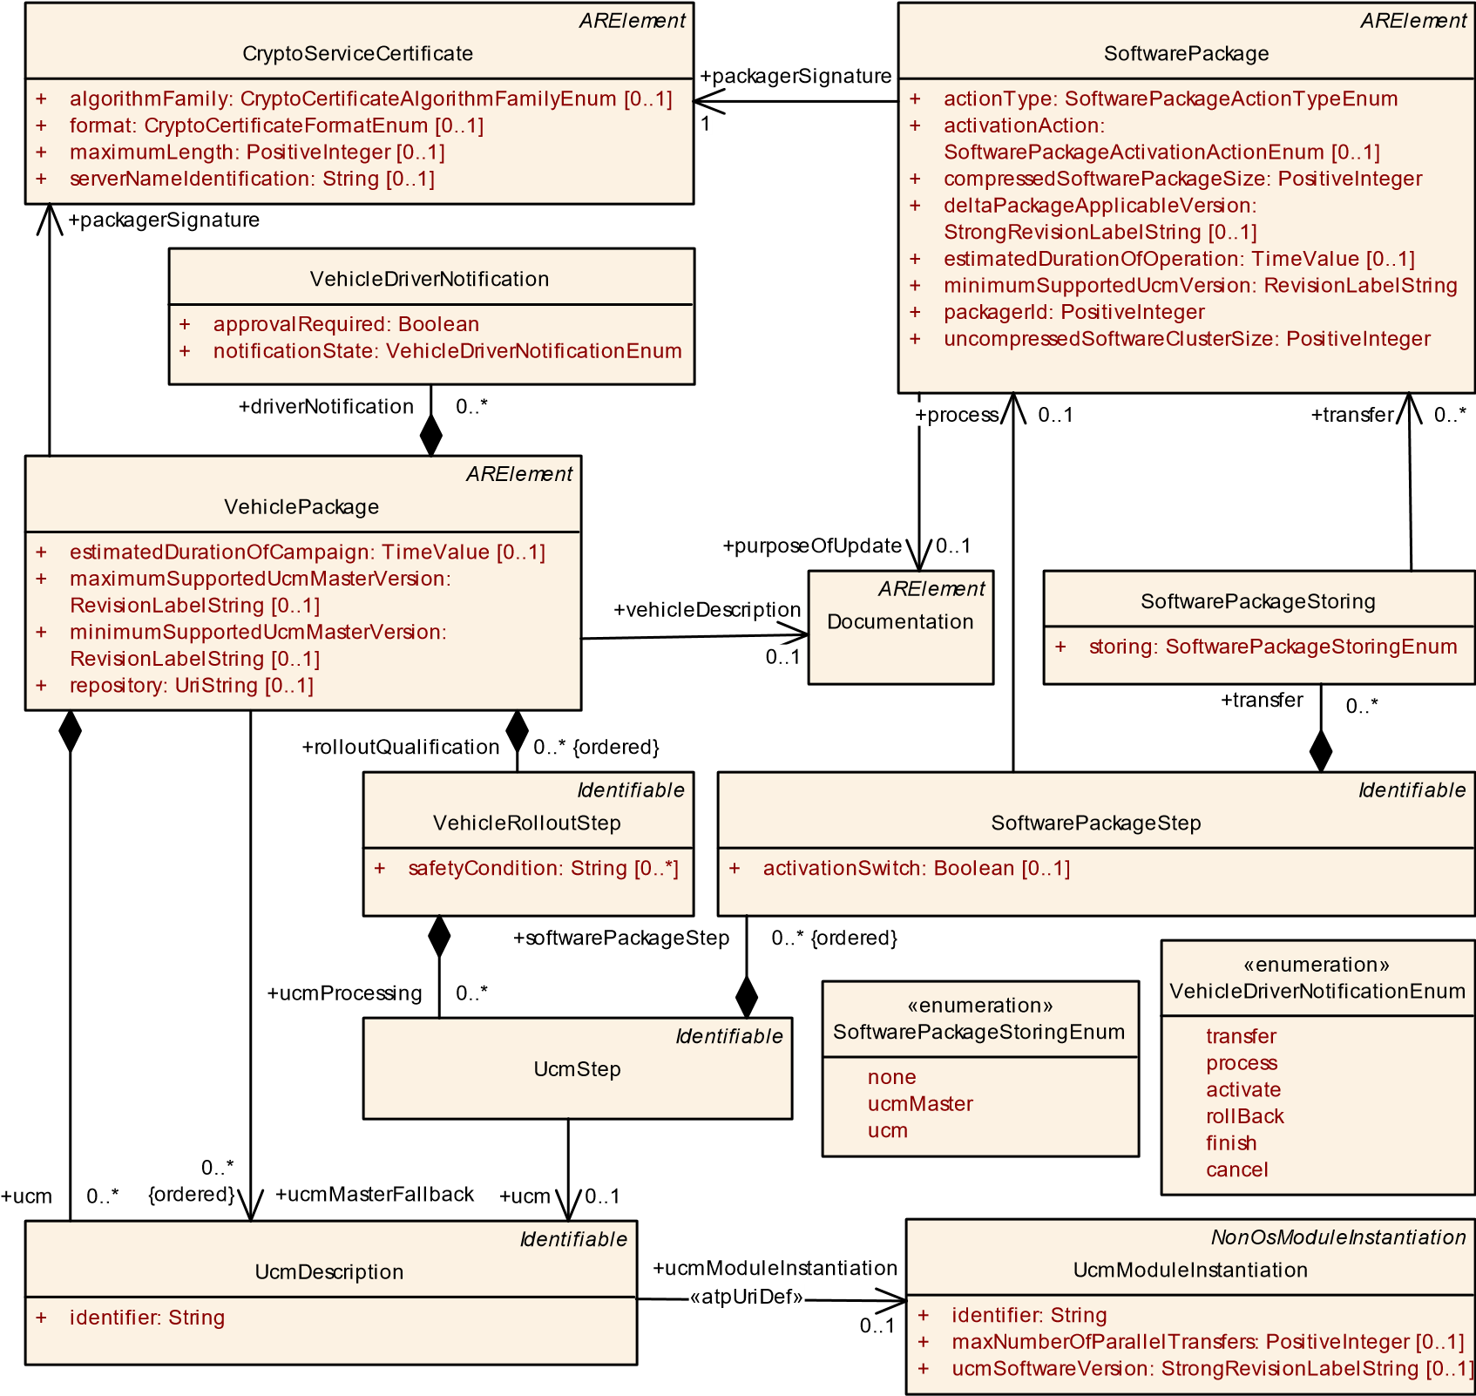1

**Figure 14.10: Modeling of VehiclePackage**

**[TPS_MANI_01290]**{DRAFT} **VehiclePackage names affected UCMs** dMetaclass VehiclePackage has the ability to describe the set of UCMs that are affected by the update campaign by means of aggregating meta-class UcmDescription in the role ucm.c*()*

**[TPS_MANI_01291]**{DRAFT} **Identification of an actual UCM in the context of an update campaign** dIt is necessary to unambiguously identify the individual UCMs that are affected in the update campaign. For this purpose, meta-class UcmDescription defines attribute identifier.

By means of the reference to UcmModuleInstantiation in the role ucmModuleInstantiation it is in addition possible to identify the actual UCMs (represented by a UcmModuleInstantiation) that are relevant for the update campaign.

In order to be able to resolve the reference it is necessary to have access to the manifest model of the target Machine.c*()*

**[constr_1731]**{DRAFT} **Value of UcmDescription.identifier in the scope of a VehiclePackage**dWithin the scope of any given VehiclePackage, no two UcmDescriptions shall define the same value of attribute identifier.c*()*

**[TPS_MANI_01292]**{DRAFT} **Definition of fallback-order for UCM master** dThe update campaign is executed under the management of one UCM that acts as a “master UCM”.

If this UCM goes down for some reason, VehiclePackage has the ability to define an **ordered** list of other candidates for becoming the “master UCM” by means of the reference to meta-class UcmDescription in the role ucmMasterFallback.c*()*

|  |  |  |  |  |
| --- | --- | --- | --- | --- |
| ***Class*** | **VehiclePackage** | | | |
| ***Package*** | M2::AUTOSARTemplates::AdaptivePlatform::SoftwareDistribution | | | |
| ***Note*** | This meta-class represents the ability to define a vehicle package for executing an update campaign.  **Tags:**  atp.Status=draft  atp.recommendedPackage=VehiclePackages | | | |
| ***Base*** | *ARElement*, *ARObject*, *CollectableElement*, *Identifiable*, *MultilanguageReferrable*, *Packageable Element*, *Referrable* | | | |
| ***Attribute*** | ***Type*** | ***Mult.*** | ***Kind*** | ***Note*** |
| driver  Notification | VehicleDriver  Notification | * | aggr | This aggregation provides the ability to configure the necessary driver notifications.  **Tags:**atp.Status=draft |
| estimated DurationOf  Campaign | TimeValue | 0..1 | attr | This attribute provides an estimation about how long the campaign based on the VehiclePackage is going to take.  **Tags:**atp.Status=draft |
| maximum SupportedUcm MasterVersion | RevisionLabelString | 0..1 | attr | This attribute identifies the maximum supported version of the UCM Master for this VehiclePackage.  **Tags:**atp.Status=draft |
| minimum SupportedUcm MasterVersion | RevisionLabelString | 0..1 | attr | This attribute identifies the minimum supported version of the UCM Master for this VehiclePackage.  **Tags:**atp.Status=draft |

5

4

|  |  |  |  |  |
| --- | --- | --- | --- | --- |
| ***Class*** | **VehiclePackage** |  |  |  |
| packager Signature | CryptoService  Certificate | 1 | ref | This reference identifies the certificate that represents the packager’s signature.  **Tags:**atp.Status=draft |
| repository | UriString | 0..1 | attr | This attribute identifies the repository where the Vehicle Package is stored.  **Tags:**atp.Status=draft |
| rollout  Qualification  (ordered) | VehicleRolloutStep | * | aggr | This represents the rollout qualification.  **Tags:**atp.Status=draft |
| ucm | UcmDescription | * | aggr | This aggregation represents the UcmDescriptions to be considered in the context of the VehiclePackage.  **Tags:**atp.Status=draft |
| ucmMaster  Fallback  (ordered) | UcmDescription | * | ref | This reference lists the fallback order of Ucms that can take over the master role if the master goes down.  **Tags:**atp.Status=draft |
| vehicle  Description | Documentation | 0..1 | ref | This reference identifies the vehicle description.  **Tags:**atp.Status=draft |

**Table 14.23: VehiclePackage**

|  |  |  |  |  |
| --- | --- | --- | --- | --- |
| ***Class*** | **UcmDescription** | | | |
| ***Package*** | M2::AUTOSARTemplates::AdaptivePlatform::SoftwareDistribution | | | |
| ***Note*** | This meta-class represents the ability to define an identifier for a given UCM.  **Tags:**atp.Status=draft | | | |
| ***Base*** | *ARObject*, *Identifiable*, *MultilanguageReferrable*, *Referrable* | | | |
| ***Attribute*** | ***Type*** | ***Mult.*** | ***Kind*** | ***Note*** |
| identifier | String | 1 | attr | This attribute represents the unique identification of the UcmIdentifier.  **Tags:**atp.Status=draft |
| ucmModule  Instantiation | UcmModuleInstantiation | 0..1 | ref | This reference identifies the applicable UcmModule  Instantiation.  **Stereotypes:** atpUriDef  **Tags:**atp.Status=draft |

**Table 14.24: UcmDescription**

**[TPS_MANI_01294]**{DRAFT} **Update campaign depends on driver’s acceptance** dFor obvious reasons, it is not possible to arbitrarily trigger the execution of an update campaign at any time. It is the prerogative of the vehicle driver to decide about the amount and consequence of the UCM activities with respect to an update campaign.

For this purpose VehiclePackage aggregates meta-class VehicleDriverNotification in the role driverNotification.c*()*

|  |  |
| --- | --- |
| ***Class*** | **VehicleDriverNotification** |
| ***Package*** | M2::AUTOSARTemplates::AdaptivePlatform::SoftwareDistribution |

5

|  |  |  |  |  |
| --- | --- | --- | --- | --- |
| ***Class*** | **VehicleDriverNotification** | | | |
| ***Note*** | This meta-class provides the ability to configure a notification of the vehicle driver with respect to the update of vehicle software.  **Tags:**atp.Status=draft | | | |
| ***Base*** | *ARObject* | | | |
| ***Attribute*** | ***Type*** | ***Mult.*** | ***Kind*** | ***Note*** |
| approval Required | Boolean | 1 | attr | This attribute controls whether approval is required for the driver notification.  **Tags:**atp.Status=draft |
| notificationState | VehicleDriver  NotificationEnum | 1 | attr | This attribute is used to configure the notification state.  **Tags:**atp.Status=draft |

**Table 14.25: VehicleDriverNotification**

|  |  |
| --- | --- |
| ***Enumeration*** | **VehicleDriverNotificationEnum** |
| ***Package*** | M2::AUTOSARTemplates::AdaptivePlatform::SoftwareDistribution |
| ***Note*** | This meta-class provides available options for vehicle driver notification.  **Tags:**atp.Status=draft |
| ***Literal*** | ***Description*** |
| activate | Software package shall be activated.  **Tags:**  atp.EnumerationLiteralIndex=2 atp.Status=draft |
| cancel | Cancellation of the campaign.  **Tags:**  atp.EnumerationLiteralIndex=5 atp.Status=draft |
| finish | Finish notification  **Tags:**  atp.EnumerationLiteralIndex=4 atp.Status=draft |
| process | Processing of software package shall be executed  **Tags:**  atp.EnumerationLiteralIndex=1 atp.Status=draft |
| rollBack | Software package shall be rolled back.  **Tags:**  atp.EnumerationLiteralIndex=3 atp.Status=draft |
| transfer | Software shall be transferred to the vehicle.  **Tags:**  atp.EnumerationLiteralIndex=0 atp.Status=draft |

**Table 14.26: VehicleDriverNotificationEnum**

**14.4.2 VehicleRolloutStep**

**[TPS_MANI_01295]**{DRAFT} **Semantics of VehicleRolloutStep** dThe purpose of an update campaign is to roll out the installation or update of SoftwarePackages in the context of given UCMs. Each VehicleRolloutStep may apply to several

UCMs at the same time.c*()*

Vehicle Package

1

2

3

SWP1 || SWP2

UCM1

reboot

UCM3

restart

UCM2

reboot

UCM4

reboot

1

SWP3

2

SWP4 || SWP5

1

SWP1 || SWP2

1

SWP8

1

VehicleRolloutStep

UcmStep

SoftwarePackageStep

**Figure 14.11: Conceptual view on an update campaign**

Figure 14.11 takes a conceptual view on the structure of an update campaign and associates the relevant aspects of this view to meta-classes explained in this chapter. Associations that are labeled by a number indicate that an ordering is implied with the respective step.

For example, the execution of the update campaign happens in dedicated steps formalized as VehicleRolloutStep, as explained in [TPS_MANI_01295]. Each of the three steps sketched in the picture would be modeled as an individual VehicleRolloutStep.

The rollout action is formalized by UcmStep.softwarePackageStep. In other words, it is possible to specify a different softwarePackageStep for each individual UCM.

The individual VehicleRolloutSteps are executed in the order in which they are aggregated at the enclosing VehiclePackage. This aspect is in more detail explained by [TPS_MANI_01296].

|  |  |  |  |  |
| --- | --- | --- | --- | --- |
| ***Class*** | **VehicleRolloutStep** | | | |
| ***Package*** | M2::AUTOSARTemplates::AdaptivePlatform::SoftwareDistribution | | | |
| ***Note*** | This meta-class represents the ability to define a rollout-condition for a vehicle update campaign.  **Tags:**atp.Status=draft | | | |
| ***Base*** | *ARObject*, *Identifiable*, *MultilanguageReferrable*, *Referrable* | | | |
| ***Attribute*** | ***Type*** | ***Mult.*** | ***Kind*** | ***Note*** |
| safetyCondition | String | * | attr | This attribute represents a list of textual safety conditions (e.g.: close the driver window) that need to be fulfilled before the rollout step can proceed.  **Tags:**atp.Status=draft |

5

|  |  |  |  |  |
| --- | --- | --- | --- | --- |
| ***Class*** | **VehicleRolloutStep** | |  |  |
| ucmProcessing | UcmStep | * | aggr | This aggregation collects the UcmProcessingSteps that make up the rollout step. **Tags:**atp.Status=draft |

**Table 14.27: VehicleRolloutStep**

**[TPS_MANI_01296]**{DRAFT} **Ordered execution of rollout steps in an update campaign** dThe individual VehicleRolloutSteps defined in the context of a given

VehiclePackage are executed in the defined order and therefore the aggregation of

VehicleRolloutStep at VehiclePackage is ordered.c*()*

**14.4.3 UcmStep**

**[TPS_MANI_01297]**{DRAFT} **Semantics of meta-class UcmStep** dEach VehicleRolloutStep consists of a number of UcmSteps (aggregated by VehicleRolloutStep in the role ucmProcessing). Each UcmStep refers to a specific UCM (represented by UcmDescription) in the role ucm.

The campaign is executed in steps formalized as UcmStep that each are associated with a specific activation action (restart a SoftwareCluster or reboot the entire Machine) formalized by means of softwarePackageStep.c*()*

**[TPS_MANI_01298]**{DRAFT} **No ordering of VehicleRolloutStep.ucmProcessing**dEach UcmStep defined in the context of an enclosing VehicleRolloutStep can be handled without the consideration of a dedicated order. Therefore, the aggregation VehicleRolloutStep.ucmProcessing is not labeled as ordered.c*()*

|  |  |  |  |  |
| --- | --- | --- | --- | --- |
| ***Class*** | **UcmStep** | | | |
| ***Package*** | M2::AUTOSARTemplates::AdaptivePlatform::SoftwareDistribution | | | |
| ***Note*** | This meta-class represents the ability to define a rollout-condition for a vehicle update campaign.  **Tags:**atp.Status=draft | | | |
| ***Base*** | *ARObject*, *Identifiable*, *MultilanguageReferrable*, *Referrable* | | | |
| ***Attribute*** | ***Type*** | ***Mult.*** | ***Kind*** | ***Note*** |
| software PackageStep  (ordered) | SoftwarePackageStep | * | aggr | This aggregation represents the sequence of activities to be carried out in the context of the respective UCM.  **Tags:**atp.Status=draft |
| ucm | UcmDescription | 0..1 | ref | This reference identifies the UCM for which the rollout step applies.  **Tags:**atp.Status=draft |

**Table 14.28: UcmStep**

**14.4.4 SoftwarePackageStep**

**[TPS_MANI_01299]**{DRAFT} **Aggregation of SoftwarePackageSteps at UcmStep** dEach UcmStep consists of an ordered collection of SoftwarePackageSteps. This means that the order in which SoftwarePackages are handled in the scope of one UcmStep is significant.c*()*

|  |  |  |  |  |
| --- | --- | --- | --- | --- |
| ***Class*** | **SoftwarePackageStep** | | | |
| ***Package*** | M2::AUTOSARTemplates::AdaptivePlatform::SoftwareDistribution | | | |
| ***Note*** | This meta-class represents the configuration of an activation step in the context of software package activation.  **Tags:**atp.Status=draft | | | |
| ***Base*** | *ARObject*, *Identifiable*, *MultilanguageReferrable*, *Referrable* | | | |
| ***Attribute*** | ***Type*** | ***Mult.*** | ***Kind*** | ***Note*** |
| activationSwitch | Boolean | 0..1 | attr | If set to True, the enclosing SoftarePackageStep represents the actual activation of all affected Software Packages.  **Tags:**atp.Status=draft |
| process | SoftwarePackage | 0..1 | ref | This reference identifies the SoftwarePackage to be processed in the enclosing SoftwarePackageStep.  **Tags:**atp.Status=draft |
| transfer | SoftwarePackage  Storing | * | aggr | This aggregation clarifies the storing of the Software Package.  **Tags:**atp.Status=draft |

**Table 14.29: SoftwarePackageStep**

**[TPS_MANI_01300]**{DRAFT} **Semantics of reference SoftwarePackageStep. transfer.transfer** dThe reference SoftwarePackageStep.transfer.transfer identifies the SoftwarePackages that are supposed to be transferred in the context of the enclosing SoftwarePackageStep.

It is positively supported that SoftwarePackages are transferred in parallel and therefore the multiplicity of the reference in the role transfer has been set to 0..*.c*()*

**[TPS_MANI_01301]**{DRAFT} **Semantics of aggregation SoftwarePackageStep. transfer**dBy means of the aggregation of SoftwarePackageStoring it is possible to specify for each individual SoftwarePackage to specify whether and where the SoftwarePackage is stored in the vehicle.

This information is specifically provided by attribute SoftwarePackageStoring.

storing of type SoftwarePackageStoringEnum.c*()*

|  |  |
| --- | --- |
| ***Class*** | **SoftwarePackageStoring** |
| ***Package*** | M2::AUTOSARTemplates::AdaptivePlatform::SoftwareDistribution |
| ***Note*** | This meta-class provides the ability to specify whether and where the referenced SoftwarePackage is stored.  **Tags:**atp.Status=draft |

5

|  |  |  |  |  |
| --- | --- | --- | --- | --- |
| ***Class*** | **SoftwarePackageStoring** | |  |  |
| ***Base*** | *ARObject* | |  |  |
| ***Attribute*** | ***Type*** | ***Mult.*** | ***Kind*** | ***Note*** |
| storing | SoftwarePackage  StoringEnum | 1 | attr | This attribute clarifies whether and where the referenced SoftwarePackage is stored.  **Tags:**atp.Status=draft |
| transfer | SoftwarePackage | * | ref | This reference identifies the SoftwarePackage(s) to be transferred in the enclosing SoftwarePackageStep.  **Tags:**atp.Status=draft |

**Table 14.30: SoftwarePackageStoring**

|  |  |
| --- | --- |
| ***Enumeration*** | **SoftwarePackageStoringEnum** |
| ***Package*** | M2::AUTOSARTemplates::AdaptivePlatform::SoftwareDistribution |
| ***Note*** | This enumeration controls where software packages are stored.  **Tags:**atp.Status=draft |
| ***Literal*** | ***Description*** |
| none | No storing in vehicle.  **Tags:**  atp.EnumerationLiteralIndex=0 atp.Status=draft |
| ucm | Storing in UCM (subordinate).  **Tags:**  atp.EnumerationLiteralIndex=2 atp.Status=draft |
| ucmMaster | Storing in Ucm Master.  **Tags:**  atp.EnumerationLiteralIndex=1 atp.Status=draft |

**Table 14.31: SoftwarePackageStoringEnum**

**[TPS_MANI_01302]**{DRAFT} **Semantics of reference SoftwarePackageStep. process** dThe reference SoftwarePackageStep.process identifies the SoftwarePackage that is supposed to be processed in the context of the enclosing SoftwarePackageStep.

The processing of SoftwarePackages happens strictly one after the other and therefore the reference process can only have the multiplicity 0..1. The strict order of processing is guaranteed by the aggregation of the SoftwarePackageStep at UcmStep.c*()*

**[TPS_MANI_01305]**{DRAFT} **Semantics of attribute SoftwarePackageStep.activationSwitch** dThe usage of attribute activationSwitch in a given SoftwarePackageStep indicates that the enclosing SoftwarePackageStep represents the *activation switch step* in the activation workflow.c*()*

**[constr_1732]**{DRAFT} **Existence of attribute activationSwitch set to True in the context of the enclosing UcmStep** dWithin the context of any given UcmStep, only a single SoftwarePackageStep shall exist that sets the value of attribute activationSwitch to the value True.c*()*

**[TPS_MANI_01306]**{DRAFT} **Simultaneous existence of attributes SoftwarePackageStep.transfer and SoftwarePackageStep.process** dIt is possible that the references SoftwarePackageStep.transfer and SoftwarePackageStep.process simultaneously exist to the identical SoftwarePackage in the context of the same SoftwarePackageStep.

The semantics of such a configuration is that the SoftwarePackage that is referenced by the two roles owned by the same SoftwarePackageStep is "streamed", i.e. transferred and processed in one step represented by the SoftwarePackageStep.c*()*

**[constr_1734]**{DRAFT} **Restriction for attribute SoftwarePackageStep.activationSwitch** dIf attribute SoftwarePackageStep.activationSwitch is set to True then the enclosing SoftwarePackageStep shall not refer to a SoftwarePackage in any of the possible roles.c*()*

**14.4.5 Examples for the Usage of SoftwarePackageStep**

The semantics of the references

* transfer
* process

shall be explained along a set of examples.

**14.4.5.1 Examples for the Usage of transfer and process**

The first example (as depicted in Figure 14.12) assumes a scenario where three SoftwarePackages shall be activated and the three SoftwarePackages are transferred in parallel in the context of one SoftwarePackageStep.

UcmStep

SoftwarePackageStep_1

SoftwarePackageStep_2

SoftwarePackageStep_3

SoftwarePackageStep_4

SoftwarePackage_A

SoftwarePackage_B

SoftwarePackage_C

1

2

3

4

**Steps for Software Activation**

. Transfer all three SoftwarePackages

1

2

. Process SoftwarePackage_A

3

. Process SoftwarePackage_B

. Process SoftwarePackage_C

4

transfer

process

transfer

transfer

process

process

**Figure 14.12: Example 1 of the configuration of SoftwarePackageStep**

After that, the three SoftwarePackages are processed one by one in the context of three further SoftwarePackageSteps.

The ordering of the SoftwarePackageSteps in the context of the enclosing UcmStep is depicted explicitly by assigning numerical values to the aggregation as well as naming the respective SoftwarePackageStep using the same numerical values.

The second example introduces a scenario where the three SoftwarePackages are transferred in the first SoftwarePackageStep. One of the SoftwarePackages is additionally referenced in the role process and this indicates that the respective SoftwarePackage is streamed.

Because the first SoftwarePackage is streamed, only three[3] SoftwarePackageSteps are needed to model the example.

The rest of the SoftwarePackages are processed in a dedicated SoftwarePackageStep. The example is depicted in Figure 14.13.

UcmStep

SoftwarePackageStep_1

SoftwarePackageStep_2

SoftwarePackageStep_3

SoftwarePackage_A

SoftwarePackage_B

SoftwarePackage_C

1

2

3

process

transfer

transfer

transfer

process

process

**Steps for Software Activation**

1. Transfer all three SoftwarePackages and process SoftwarePackage_A (streaming)
2. Process SoftwarePackage_B
3. Process SoftwarePackage_C

**Figure 14.13: Example 2 of the configuration of SoftwarePackageStep**

The third example, depicted in Figure 14.14, sketches a scenario where three SoftwarePackages are streamed one after the other.

Consequently, this scenario requires the existence of three SoftwarePackageSteps that each reference the same SoftwarePackage in the roles transfer and process.

UcmStep

SoftwarePackageStep_1

SoftwarePackageStep_2

SoftwarePackageStep_3

SoftwarePackage_A

SoftwarePackage_B

SoftwarePackage_C

1

2

3

process

transfer

transfer

process

transfer

process

**Steps for Software Activation**

1. Transfer and process (i.e. stream) SoftwarePackage_A
2. Transfer and process (i.e. stream) SoftwarePackage_B
3. Transfer and process (i.e. stream) SoftwarePackage_C

**Figure 14.14: Example 3 of the configuration of SoftwarePackageStep**

# 15 Interoperability between Classic Platform and Adaptive Platform

This chapter collects restrictions for interoperability between Classic Platform and Adaptive Platform.

## 15.1 Usage of majorVersion in the SOME/IP network binding

In case of a SOME/IP communication between Classic Platform and Adaptive Platform the usage of SomeipServiceInterfaceDeployment.serviceInterfaceVersion.majorVersion is restricted.

If several ProvidedSomeipServiceInstances are defined with the same

SomeipServiceInterfaceDeployment.serviceInterfaceId and different SomeipServiceInterfaceDeployment.serviceInterfaceVersion.majorVersions and these ProvidedSomeipServiceInstances are mapped to the same Socket Address (UDP/TCP Port and IP Address) by SomeipService-

InstanceToMachineMapping then particular restrictions apply in case that the ProvidedSomeipServiceInstances **are consumed on a Classic Platform ECU**.

In such a scenario the same MessageId may be used for ServiceInterface elements like an event in the different ProvidedSomeipServiceInstances that have different majorVersions. On the Classic Platform in the SoAd module this will result in different Pdus that have the same headerId in the same SocketConnection. In the AUTOSAR Architecture of the Classic Platform one part of the SOME/IP Header is evaluated in the SOME/IP Transformer (RequestId, Protocol Version, Interface Version, Message Type, Return Code) and the other part in the Socket Adaptor (MessageId, Length). This means that the Socket Adaptor is not able to evaluate the MajorVersion in the Pdu and can not determine the source of the Pdu.

The following restrictions apply in case that the ServiceInterface contains methods and/or fields with hasGetter or hasSetter set to true: If two or more ProvidedSomeipServiceInstances are defined using the same serviceInterfaceId and different majorVersions and these ProvidedSomeipServiceInstances are mapped to the same Socket Address (same UDP/TCP Port and IP Address) then the destination IP address, the destination port number, and the Level 4 protocol (Udp/Tcp) fields of header of IP packets containing calls that are sent to the

ProvidedSomeipServiceInstances are identical. In such a scenario, the ProvidedSomeipServiceInstances may still use identical methodIds if the following condition applies:

**a)** At any point in time only one of the ProvidedSomeipServiceInstances is active, and only clients of that ProvidedSomeipServiceInstance send requests to the ProvidedSomeipServiceInstance.

In all other cases, the methodIds of the two ProvidedSomeipServiceInstances should not overlap.

The following restrictions apply for ServiceInterfaceevents and fields with hasNotifier set to true: If two or more ProvidedSomeipServiceInstances are defined using the same serviceInterfaceId and different majorVersions, and these ProvidedSomeipServiceInstances are mapped to the same Socket Address (same UDP/TCP Port and IP Address) then the source IP address, the source port number, and the Level 4 protocol (Udp) fields of header of IP packets containing event PDUs that are sent to the clients of the ProvidedSomeipServiceInstances are identical. In such a scenario, the ProvidedSomeipServiceInstances may use identical eventIds if at least one of the following conditions holds for any pair of the ProvidedSomeipServiceInstances:

1. At any point in time only one of the ProvidedSomeipServiceInstances is ac-

tive

1. If two or more ProvidedSomeipServiceInstances can send events or Field notifiers at the same time, the ProvidedSomeipServiceInstances may still use identical eventIds if at least one of the following IP header fields of the IP packet containing the event is different for any pair of SomeipEventDeployments identified by the same eventId:

**b1)** Destination IP address (== IP address of client) **b2)** Destination port number (== client port number)

1. The characters “x” and “X” are not considered as identical characters for this purpose.
2. In the explanations the direction signal-service-translation is usually used, the servicesignal-translation direction is supported as well. For simplicity this is only mentioned explicitly if the mapping behavior is not symmetrical.
3. As opposed to four SoftwarePackageSteps required to model the first example.